# **E-commerce**

## **Definition**

E-commerce, EC for short (E-commerce) is a concept referring to transactions, purchase and sale of goods and services by the internet.

E-commerce was first known in the 1960s. After years of development, as mobile devices became popular, social media increasingly affirmed the power and the boom of the webpage.

## **Types**

Currently, there are many forms of e-commerce, including the following basic forms:

B2B (business – to‐ business) is a kind of e-commerce, which refers to a company selling or buying from other companies. One company communicates with other companies through electronic Medias. Some of these transactions include sending and receiving orders, invoice and shopping orders. It was an attractive alternative to the current process of printing, mailing various business documents.

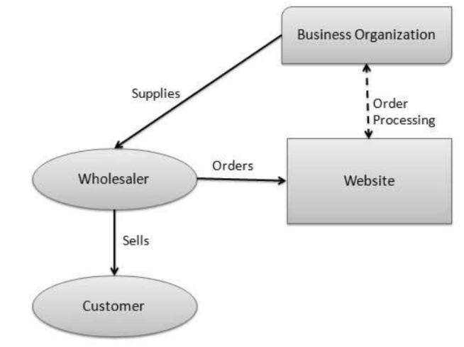

Business – to Consumer [B2C] e‐commerce consists of the sale of products or services from a business to the general public.

Sellers that use B2C business model can increase their benefits by eliminating the middlemen. This is called disintermediation because businesses sell products directly to consumers without using traditional retail channels. Business – to Consumer [B2C] is basically a concept of online marketing and distributing of products and services over the internet.

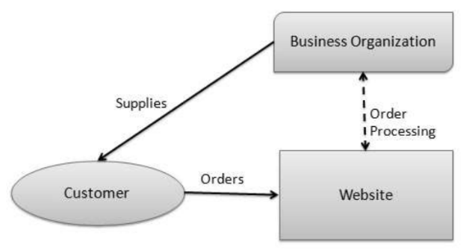

C2B (Consumer to Business): In this model, a consumer approaches a website showing multiple business organizations for a particular service. The consumer places an estimate of amount he/she wants to spend for a particular service. A business organization who fulfills the consumer's requirement within the specified budget, approaches the customer and provides its services.

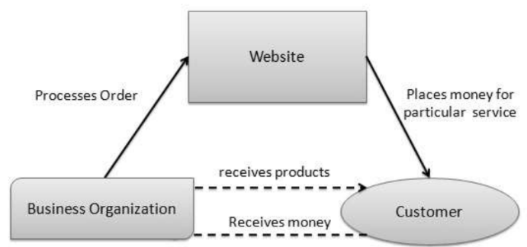

C2C (Consumer to Consumer): A website following the C2C business model helps consumers to sell their assets like residential property, cars, motorcycles, etc., or rent a room by publishing their information on the website. Website may or may not charge the consumer for its services. Another consumer may opt to buy the product of the first customer by viewing the post/advertisement on the website. Examples: Olx.com.

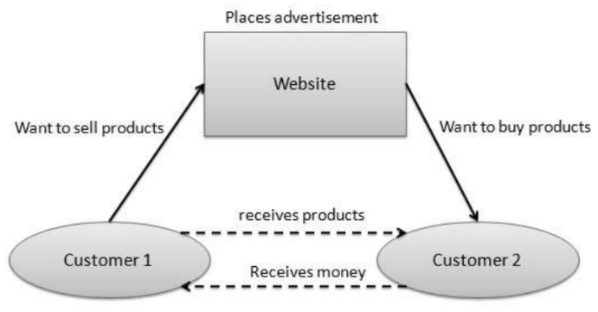

**Business - to - Government**

Business - to - Government B2G model is a variant of B2B model. Such websites are used by governments to trade and exchange information with various business organizations. Such websites are accredited by the government and provide a medium to businesses to submit application forms to the government.



**Government-to-Business (G2B)**  
Governments use **G2B model websites** to interact with business organizations. These websites facilitate functions such as **auctions**, **tenders**, and **application submissions**.****

**Government - to - Citizen**

Governments use G2C model websites to approach citizen in general. Such websites support auctions of vehicles, machinery, or any other material. Such website also provides services like registration for birth, marriage or death certificates. The main objective of G2C websites is to reduce the average time for fulfilling citizen’s requests for various government services.



## **Advantages**

Global market: Clearly, when you open a physical store, you will only be able to deliver your goods and services in a small geographic area. E-commerce will help you solve that problem. E-commerce helps you reach the market quickly, expanding the market to the maximum level compared to direct sales, so that products and services are easily introduced, purchased and sold through retailers and online market.

Always open: In e-commerce, running an online business is much easier, it's always open 24h / 7/365. For businesses, it's a great opportunity to increase sales opportunities all the time.

Budget savings: Compared with traditional forms of commercial business, all costs when e-commerce business are reduced: the cost of renting booths, salespeople and management is much more economical. . Naturally, when sellers save operating costs, they can offer more incentives and better discounts for their customers. At this time, the customer is the next beneficiary. Mutual benefit, isn't it great?

Inventory management: By using electronic tools to speed up the ordering, delivery, and payment processes, e-commerce businesses can save billions of operating costs and reduce amount of inventory.

Most accurate customer marketing: With access to customer data and the opportunity to track customers' buying habits, e-commerce businesses can quickly identify and market products and services, Service most suitable for consumers.

Work anywhere, buy anywhere: Running an e-commerce business allows you to not need to sit in the office, and buying does not force you to go to the supermarket. Everything the seller and the buyer needs is an internet-connected device and that's all.

## **Challenges**

Internet access required: When participating in the EC, to be able to buy and sell, you need a device connected to the internet. Currently, most people have internet access but, in many areas, it is still very limited.

Not enough to trust: Products and services that cannot be seen, touched, held or felt directly, are not allowed to try as a prudent buyer. Doubt in both buyers and sellers leads to many incomplete transactions, especially when they have dealt with untrusted partners before.

Limited payment methods: Currently, the most popular payment method in Egypt when buying goods online is to receive and pay or buy Visa, master card, Vodafone cash , …etc . Payment gateway in Egypt is growing quite strong, but not reliable enough for users to use as the main payment method. Therefore, it also contributes to teething.