GENERATIVE AI / PROJECT REPORT
FlexiGrid AI
A local-LLM agent that plans household energy over MCP tools: hybrid RAG, Elia Open Data, and a deterministic optimizer-critic
PROJECT THESIS A small local language model interprets free-text missions and drives the tool loop; deterministic code owns feasibility. Every stage is typed, traced, measured separately, and reproducible without any cloud API key.

4 + 1  advanced techniques  local transformer, agent, hybrid RAG, MCP + deterministic critic | 93  automated tests  85 backend + 8 interface, all passing | 0.988  retrieval recall@4  hybrid BM25 + dense, 40 labelled queries

AUTHORS
Nima Asadi and project partner
Team of two • August 2026 • Howest

Executive summary
FlexiGrid AI is a household energy flexibility copilot for Belgium. A resident types a free-text mission such as 'charge the EV and run the dishwasher before 07:00'. A local language model (Qwen2.5-3B-Instruct served by Ollama) extracts typed constraints from that text, then drives an agent loop over Model Context Protocol tools: hybrid retrieval over a 51-chunk household/grid corpus, an Elia grid snapshot with a derived stress signal, a joint constrained-search optimizer, and an independent validator. Only after the validator passes does the model generate an explanation, and it may cite only the chunk IDs that retrieval actually returned. The design principle throughout: the model proposes, deterministic code disposes.
TECHNIQUES DEMONSTRATED Transformer (local 3B instruct model with schema-constrained decoding and a repair loop) · Agent (model-driven tool selection with guardrails) · RAG (BM25 + dense embeddings fused by reciprocal rank) · MCP (FastMCP server + a real stdio client session) · plus a deterministic optimizer-critic that the evaluation shows the model cannot replace.

Problem definition
Households with an EV, heat pump and flexible appliances face competing objectives: finish tasks before deadlines, maintain comfort, avoid a connection-capacity peak and shift consumption away from grid-stress periods. Existing energy dashboards expose curves but still require the resident to translate those curves into a schedule. A generic chatbot is not sufficient because fluent text can violate power limits or confuse market prices with consumer tariffs.

Target user and success definition
The target user is a Belgian household or energy-coaching professional who needs an understandable next-day plan. Success is not defined as 'helpful text'. A successful response must satisfy every time window stated in the mission, stay at or below the connection-capacity cap (default 4.6 kW, adjustable per mission), respect requested avoid-hours, cite only retrieved evidence, keep retail pricing separate from Elia imbalance-market concepts, and reproduce exactly when the inputs are unchanged.

Project objectives
- Turn arbitrary free-text household missions into typed, sanitized planning constraints with a local model.
- Let the model drive the tool loop itself, over real MCP contracts, with every decision visible in a trace.
- Ground device, comfort and data-source claims in a retrievable corpus with stable citation IDs.
- Generate explanations only after a deterministic validator passes, with citations restricted to an allow-list.
- Measure retrieval, intent extraction, planning and generation separately, including an LLM-only baseline and a greedy-search ablation.

1. Data selection and pipeline
Elia, Belgium's transmission system operator, publishes open datasets through an Opendatasoft API. Three datasets define the grid-data contract. The derivation pipeline (backend/flexigrid/derive.py) is implemented and unit-tested: quarter-hour day-ahead forecasts are bucketed into hourly means, load and wind are min-max normalized over the day, and stress(h) = norm(load) − 0.5·norm(wind), rescaled to 0–100. With ELIA_USE_LIVE=true the adapter fetches live records and derives the signal with provenance and a retrieval timestamp; the examination demo defaults to a clearly labelled frozen fixture so every number reproduces offline. The second data asset is the retrieval corpus: 15 documents / 51 chunks covering device manuals, household policies, the Flemish capacity tariff, dynamic-contract semantics, Elia dataset documentation, and the derivation methodology itself, each labelled with a source type (public-summary, synthetic-representative, user-policy, project-doc).
Dataset | Official content | Role in FlexiGrid
ods002 | Measured and forecast total Belgian load | Intended peak/load-pressure feature
ods086 | Intraday, day-ahead and week-ahead wind forecast | Intended renewable-opportunity feature
ods201 | Actual generation aggregated by fuel type | Generation-mix context and future carbon proxy

Official sources: ods002 | ods086 | ods201

Data contract
- Fetch up to 100 recent records per dataset from Elia's v2.1 records endpoint; preserve dataset ID, raw records and an ISO retrieval timestamp.
- Derive the hourly 0-100 stress series from ods002 + ods086 with the tested derivation module; record the method and wind weight in the output.
- On any live failure, fall back to the frozen fixture and label the response mode accordingly — the pipeline degrades, it never breaks.
- Every snapshot carries provenance: mode (live-derived / frozen-demo-fixture), source, and an explicit warning on fixture data.
IMPORTANT SEMANTIC GUARDRAIL Elia imbalance prices are settlement signals for balance responsible parties, not a household retail tariff. FlexiGrid therefore uses a separate labelled retail-tariff fixture for cost optimization.

Privacy and EU constraints
The submitted prototype uses no personal smart-meter records and stores no user identity. A production pilot would require explicit household consent, data minimization, retention limits, device authentication, audit logs and a controller/processor assessment under GDPR. The prototype remains advisory: it does not send commands to physical devices.

2. Technical architecture
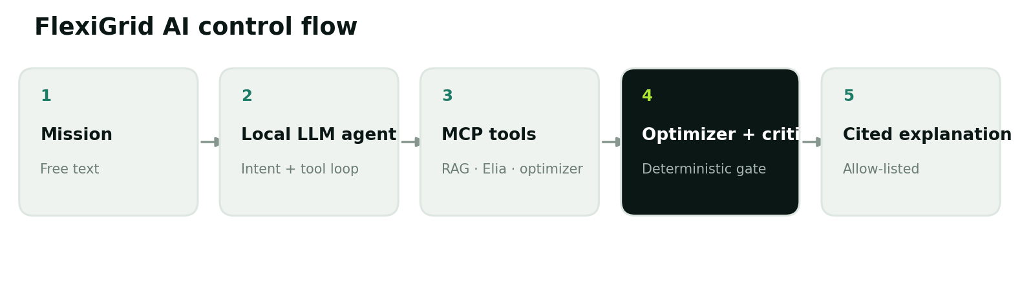
Figure 1. The language model interprets and explains; typed tools, the optimizer and the critic bound everything it does.

Local transformer and structured output
All generation runs on a local model — Qwen2.5-3B-Instruct served by Ollama on the demo machine's 8 GB GPU — through a provider-agnostic OpenAI-compatible client, so no cloud key or network access is required and household text never leaves the machine. Small local models are not reliable JSON emitters, so every structured call follows the same discipline: the JSON schema is embedded in the prompt, json-mode is requested when the server supports it, the first balanced JSON object is extracted from the reply, validated against a Pydantic schema, repaired once through a round-trip quoting the validation errors, and abandoned to a deterministic fallback if it still fails. The response's mode flags state which path actually ran.

Intent extraction: the model becomes load-bearing
The mission text is not decoration: the model converts it into a typed MissionSpec (tasks with power, duration and windows; objective; capacity cap; avoid-hours). A deterministic sanitizer then clamps every value against a device catalog — implausible powers are reset, impossible windows widened, duplicates dropped — and reports each adjustment in the trace. A rule-based parser provides the no-model fallback and doubles as the ablation baseline for the intent evaluation.

Agent workflow
Planning runs as a genuine tool-using loop: at each step the model sees the mission, the tool catalog and a digest of gathered state, and returns a schema-validated decision naming the next tool. Guardrails keep the loop honest — repeated tools and premature finishes are overruled, a bounded step budget applies, and any stage the model skipped is completed deterministically. Every step is recorded with its arguments, duration, transport and who decided it (llm or guardrail), and the interface renders that trace verbatim.

Model Context Protocol
One registry backs every consumer: the FastMCP server exposes the five tools below over MCP, the bundled MCP host (backend/flexigrid/mcp_host.py) spawns that server and runs the same agent through a real stdio client session, and the FastAPI layer reuses the registry in-process. The tool contracts are themselves a retrievable corpus document, so the model can read the guarantees of its own tools.
MCP tool | Input | Output / responsibility
get_grid_snapshot | use_live: bool | Tariff + derived stress series with provenance
retrieve_evidence | query, top_k, mode | Ranked chunks, stable citation IDs, per-mode scores
extract_constraints | mission: str | Typed, sanitized MissionSpec + adjustment log
optimize_schedule | spec, objective | Schedule, validation, earliest-start baseline
validate_schedule | schedule, cap | Independent hour-by-hour critic verdict

Retrieval-Augmented Generation
Retrieval is hybrid: Okapi BM25 over the chunk text and tags, dense cosine similarity over embeddings, and reciprocal-rank fusion of the two rankings as the default mode. The embedding backend resolves through a chain — Ollama's nomic-embed-text when the local runtime serves it, sentence-transformers when installed, and a deterministic TF-IDF/LSA fallback that needs no downloads — and every trace, health response and evaluation records which backend produced its numbers. Retrieved chunk IDs form the only citation allow-list the generator may use; the backend rejects any explanation that cites outside it.

3. Planning algorithm and design choices
Tasks are modelled as power, duration, earliest start, latest end and source ID. For each task, the optimizer enumerates feasible start hours and scores them using a weighted combination of normalized retail tariff and grid stress. A depth-first exhaustive search explores joint assignments and prunes branches whose partial score already exceeds the best complete solution.
score(h) = w · normalized tariff(h) + (1 - w) · grid stress(h)
VALIDATION FINDING The first greedy implementation could place the EV in a locally attractive slot and leave no feasible heat-pump window. The greedy optimizer is deliberately kept as a measured ablation: in the current harness it fails outright on 3 case(s), including the standard morning mission, while joint constrained search fails on none.

Why not let the LLM schedule directly?
This is now a measured claim, not a design opinion. Baseline B in the evaluation asks the model (mock-planner-1) to assign start hours directly, with the tasks, windows, tariff and cap in the prompt and a validated output schema — everything except the optimizer. Its constraint violation-or-failure rate is 0.667 in the current harness run, against 0 for the deterministic search. Language models produce locally plausible schedules that are globally capacity-blind; the hybrid design exists because of exactly this measurement.

Why not fine-tune? Why not diffusion or multimodal?
Fine-tuning is argued out, not ignored: the intent evaluation shows where it would help (per-task deadlines, unusual phrasings), and a LoRA pass on synthetic mission-to-JSON pairs is the natural next step once prompting is demonstrably the bottleneck — today the sanitizer plus repair loop closes most of the gap at zero training cost. Diffusion and multimodal models are excluded because the problem contains no image or audio modality and no generative sampling need; including them would be technique tourism. The included techniques each carry a measurable role, which we consider the stronger answer to 'choose multiple technologies'.

Complexity and scalability
Exhaustive search is appropriate for the four-device prototype but grows combinatorially. A production version should replace it with a mixed-integer linear program or constraint-programming solver, preserve the same tool contract and compare solution quality and latency against the exhaustive oracle on small fixtures.

4. Prototype implementation
The interface is wired to the backend: the dashboard probes the API on load, shows which model and embedding backend are live, sends the free-text mission to the real agent, and renders the returned trace verbatim — every tool call with its duration and whether the model or a guardrail decided it, the extracted constraints with sanitizer adjustments, retrieval scores per chunk, the model's cited explanation, and the critic's verdict. When the backend is down, the interface degrades to a clearly labelled offline simulation of the same fixture; nothing simulated is ever presented as live.
Layer | Technology | Purpose
Interface | React 19, TypeScript, Vinext | Free-text missions, live agent trace, honest constraint metrics
LLM runtime | Ollama · Qwen2.5-3B-Instruct | Intent extraction, tool-loop decisions, cited explanation — fully local
Agent | Python, Pydantic schemas | Bounded tool loop with guardrails and a complete trace
Retrieval | BM25 + dense + RRF | 51-chunk corpus, three switchable modes, backend chain
MCP | FastMCP server + stdio client host | Same registry over the protocol and in-process
Data | Elia v2.1 API + derive.py + fixtures | Live-derived or frozen stress signal with provenance
API | FastAPI + CORS | /health, /api/agent/plan, /api/retrieve, /api/intent, snapshots
Tests | unittest + node:test (93 tests) | Optimizer, retrieval, intent, agent, API, MCP round-trip, UI render

Primary demonstration flow
- Start Ollama, the FastAPI backend and the interface; the top-bar chip confirms 'Live pipeline' with the model name.
- Type or edit a free-text mission and run the agent; walk through the trace — intent chips, each tool call, the guardrail column.
- Compare optimized and earliest-start schedules on the 24-hour chart against the capacity cap and high-stress bands.
- Type an impossible mission (e.g. an EV charge due 01:00 under a 2 kW cap) and show the critic rejecting it instead of displaying it.
- Run `python -m flexigrid.mcp_host "..."` in a terminal to show the identical agent over a real MCP stdio session, then open Evaluation and Architecture.

Reproducibility
No cloud key exists anywhere in the system. `python -m flexigrid.doctor` verifies the environment (corpus, retrieval, adapter, LLM endpoint, structured output, agent, MCP round-trip) with actionable hints. A deterministic mock LLM server ships with the repository so the full agent code path is testable on machines without model weights, and the evaluation records the model and embedding backend behind every number. All 93 tests run without network access.

5. Evaluation
Evaluation is split by subsystem so a fluent answer can never hide a retrieval, intent, planning or grounding failure. Numbers in this section come from evaluation/results.json, generated 2026-08-24T12:07:24+00:00 with LLM mock-planner-1 and embedding backend ollama (mock-embed) over 51 corpus chunks. Re-running the harness on the demo machine refreshes every table with that machine's provenance.
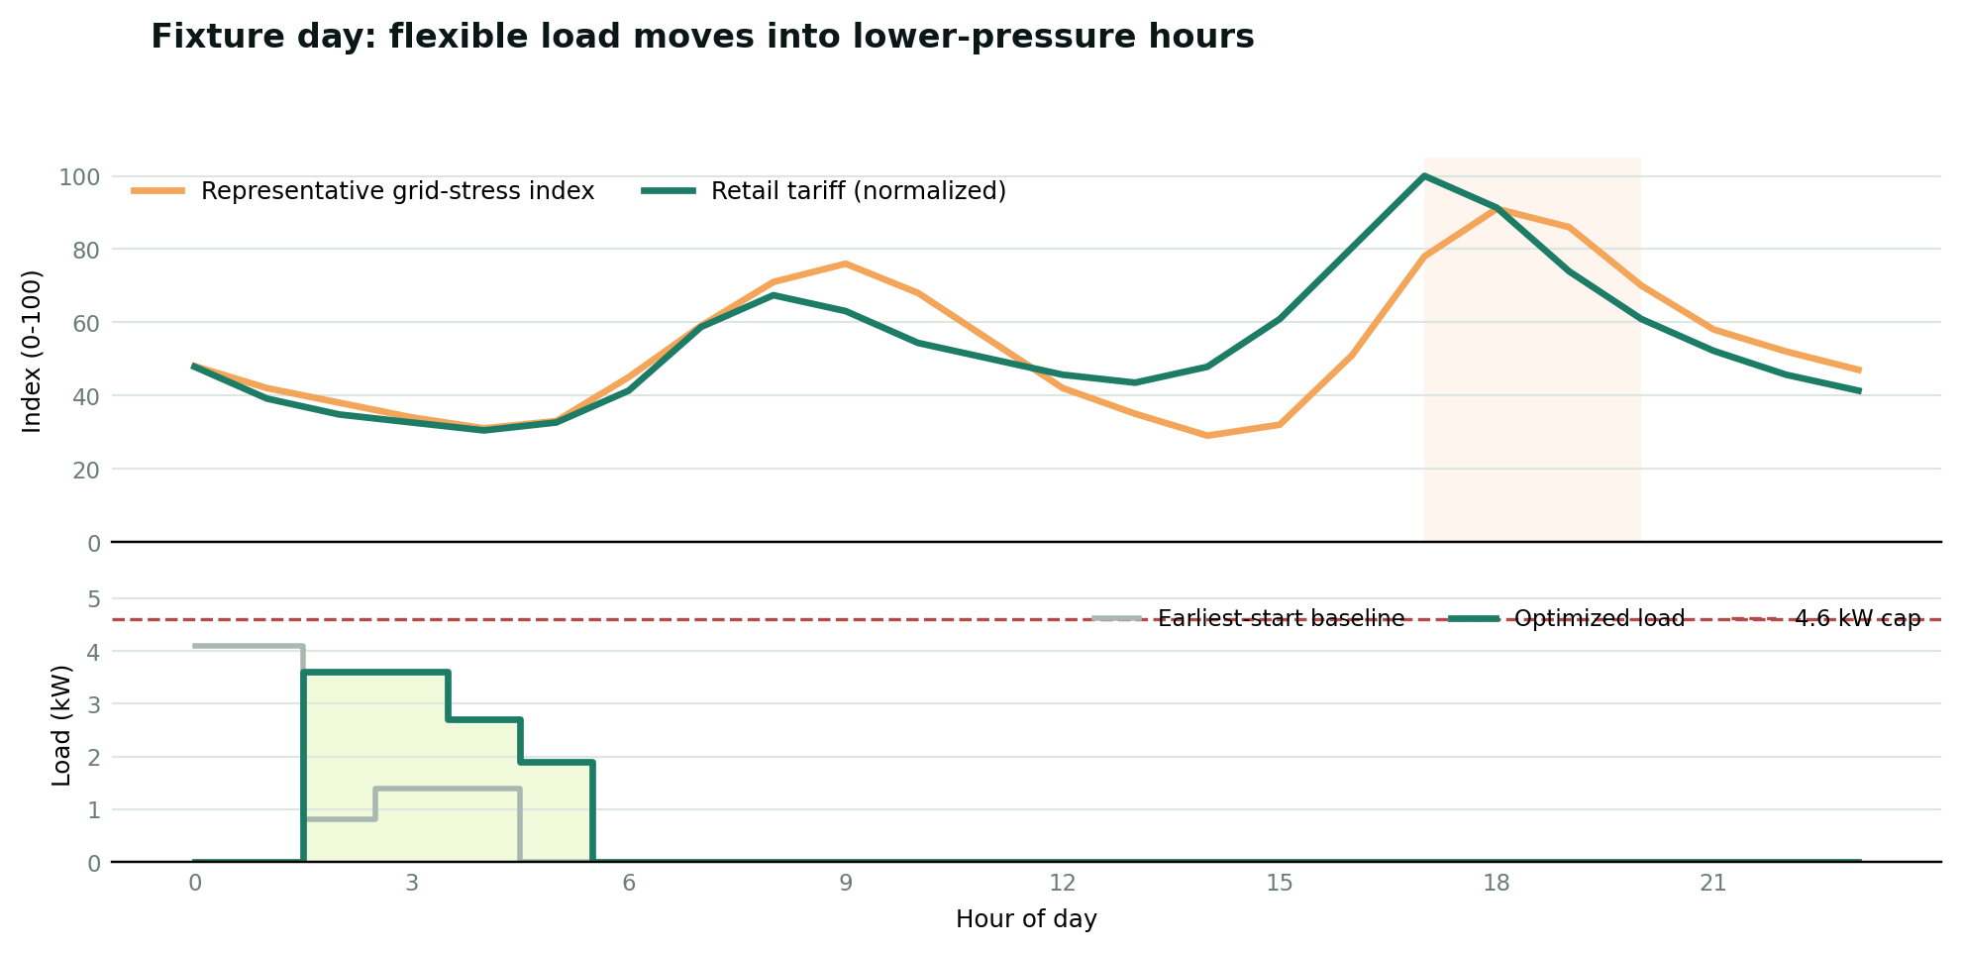
Figure 2. Reproducible fixture: retail tariff and representative grid-stress index above; baseline and optimized controllable load below.

Retrieval (40 labelled queries)
Mode | hit@1 | recall@4 | MRR
bm25 | 0.95 | 0.988 | 0.969
dense | 0.65 | 0.9 | 0.762
hybrid | 0.875 | 0.988 | 0.938

Relevance is labelled at document level over the 15-document corpus, which contains deliberate distractors (battery/PV, safety, generation-mix documents). BM25 is a strong baseline on this in-domain corpus; the dense and hybrid rows expose the embedding backend's real contribution, and the same harness re-scores any backend swap in one command.

Intent extraction (15 labelled missions)
Extractor | exact | devices | deadline | objective | avoid
rules | 0.733 | 0.933 | 0.933 | 0.867 | 1.0
llm | 0.733 | 0.933 | 0.933 | 0.867 | 1.0

The rule-based parser is the ablation: it handles single global deadlines well and fails on per-task deadlines and unusual phrasing — precisely the residual the language model is there to close. Every model extraction still passes through the sanitizer before planning.

Baseline B — LLM-only scheduling, and the greedy ablation
Planner | Constraint safety | Cost quality | Role
Joint constrained search (ours) | 0 violations | optimal on fixture | the shipped planner
Greedy placement (ablation) | 3 infeasible case(s) | equal cost when it survives | reproduces the historical defect
LLM-only (mock-planner-1) | 0.667 violation/failure rate | -0.21 € avg gap when valid | why generation never owns feasibility

Agent properties
Property | Result | Mechanism
Citation precision | 1.0 | explanations may cite only retrieved chunk IDs; violations are rejected
Guard rejections | 0 | count of model explanations the allow-list guard refused
Deterministic replay | pass | identical mission + fixture ⇒ byte-identical plan
End-to-end validity | all valid | validator gates every displayed plan
Morning fixture | €1.79 · 3.6 kW peak | vs €2.18 earliest-start baseline, 4.6 kW cap

Guardrail behaviour is itself under test: a configurable rogue mode of the mock model tries to finish before planning and is demonstrably overruled, and malformed-JSON injection exercises the repair round-trip. What remains future work: a broader mission set with confidence intervals, a groundedness grader beyond citation checking, and per-model comparisons across several local models.

6. Limitations, risk and responsible use
Risk | Current control | Production requirement
Hallucinated rationale | Citation allow-list, structured output, repair-then-fallback | Groundedness grader + human review
Rogue agent behaviour | Schema-validated decisions, bounded loop, guardrail completion | Policy tests across model versions
Unsafe schedule | Independent hour-by-hour validator gates every displayed plan | Device-specific safety envelope and fail-safe
Stale or synthetic grid signal | Tested live derivation + labelled frozen fixture with provenance | Freshness SLO and monitoring
Tariff confusion | Retail and imbalance concepts separated in data and corpus | Supplier-specific billing contract tests
Privacy leakage | Fully local model; no cloud calls, no personal meter data | Consent, minimization, encryption, retention policy
Search scalability | Exhaustive search on ≤4 tasks (measured vs greedy) | MILP/CP-SAT optimizer with time budget

Team collaboration
The work should be divided without creating knowledge silos. Both students must review the complete code path and rehearse the same demo. A practical division is shown below; names can be assigned in the repository issue board while responsibilities remain shared.
Workstream | Team member A | Team member B | Shared verification
Data and backend | Elia adapter, optimizer, MCP tools | API integration and RAG corpus | Pair review + backend test run
Interface and evaluation | Dashboard and chart | Fixture labels and evaluation harness | UI walkthrough + benchmark review
Documentation and defense | Methods and implementation | Results, limitations and demo script | Cross-question rehearsal

Conclusion
FlexiGrid AI connects the course's advanced techniques into one measured workflow rather than a showcase of disconnected parts. A local transformer makes free text load-bearing through typed intent extraction; a genuine agent loop selects real MCP tools and is provably guarded; hybrid RAG grounds every claim in a corpus with stable citations; and the evaluation quantifies why the deterministic optimizer-critic must own feasibility — the model that explains the plan measurably cannot schedule it. Everything runs offline on one machine, every number carries its provenance, and every mode the system can degrade into is labelled in the interface. The Belgian Elia integration and capacity-tariff framing keep the project locally real; the 93-test suite and the mock-model harness keep it reproducible under exam conditions.

References
- Elia Open Data - measured and forecast total load (ods002)
- Elia Open Data - wind power forecast (ods086)
- Elia Open Data - total generation by fuel type (ods201)
- Model Context Protocol - specification
- Ollama - OpenAI compatibility API
- Qwen2.5 - technical report
- Robertson & Zaragoza - The Probabilistic Relevance Framework: BM25 and Beyond
- Cormack, Clarke & Buettcher - Reciprocal Rank Fusion

