Cross-Silo Federated Learning for
Privacy-Preserving Medical Image Classification
Technical Research Report — Innovation & Research Project (MCT / CTAI)
Mahmoud Asadi Heris — Bachelor Creative Technologies & AI, Howest
Dataset: Fed-ISIC2019 (FLamby) · 6 cross-silo clients · 8 diagnostic classes
Results: full-tier configuration — ResNet-18 with GroupNorm, 128 px images, 30 rounds, 3 seeds (mean ± std). Every reported number is traceable to a generated artefact under experiments/.

Abstract
This project designs, implements and rigorously evaluates a cross-silo federated learning (FL) system in which several simulated hospitals collaboratively train a skin-lesion classifier on the Fed-ISIC2019 benchmark without ever exchanging raw patient images. We quantify the trade-offs between model performance, data heterogeneity and privacy. Three aggregation strategies (FedAvg, FedProx, SCAFFOLD) are compared under an identical protocol; local Differential Privacy (DP-SGD) is added with an independently-verified (ε, δ) accountant and a privacy–utility curve; a membership-inference attack demonstrates the privacy protection empirically; and an additive-mask secure-aggregation scheme is simulated and proven correct. The main findings: federation substantially outperforms isolated local training and recovers a large share of the centralized-training accuracy without any data sharing (FedAvg 0.32 balanced accuracy vs 0.46 centralized and 0.21 local-only); the drift-control methods FedProx and SCAFFOLD cut client drift by 5–9× exactly as theory predicts, yet on this benchmark they do not improve balanced accuracy over plain FedAvg — a concrete, reproducible negative result; and differential privacy trades accuracy for privacy along a clean monotonic curve while measurably reducing membership-inference leakage.

1 Introduction
Medical institutions hold data that is both highly valuable for training diagnostic models and legally protected, so pooling it centrally is often impossible. Federated learning lets institutions ('silos') train a shared model by exchanging only model updates, never raw data. The cross-silo setting — a few, persistent, data-rich clients — matches hospitals well. This project engineers such a system and, crucially, measures its trade-offs honestly rather than asserting them.

1.1 Research question
How can cross-silo Federated Learning be engineered to train clinically relevant image-classification models without sharing raw data, while quantifying the trade-offs between model performance, data heterogeneity and privacy guarantees?

1.2 Sub-questions
- Q1. What types of data heterogeneity (non-IID) exist across institutions, and how can they be quantified?
- Q2. How does standard Federated Averaging (FedAvg) perform compared to centralized training?
- Q3. Does FedProx improve convergence stability and performance under heterogeneous client data?
- Q4. Does SCAFFOLD reduce client drift compared to FedAvg and FedProx?
- Q5. What is the impact of Differential Privacy (DP-SGD) on model performance?
- Q6. How does the privacy budget (ε, δ) evolve over federated training rounds?
- Q7. What security and privacy risks remain, and how does Secure Aggregation mitigate server-side threats?
- Q8. Under which conditions is Federated Learning preferable to centralized learning or data-sharing agreements?

2 Technical approach

2.1 Dataset and case
We use Fed-ISIC2019 from the FLamby benchmark: ~23,247 dermoscopy images across 8 diagnostic classes, split into 6 natural cross-silo clients derived from four hospitals (one contributes three clients via three imaging devices). Each client is a hospital with its own local dataset; a central server coordinates rounds by aggregating model updates only. The official metric is balanced accuracy (mean per-class recall), which we adopt alongside macro-F1 because the data is severely class-imbalanced.

2.2 System architecture and fair-comparison protocol
The system (`fl_med` package) has a server that runs the round loop and a client that performs local training. All strategies share one identical training loop; only a strategy 'hook' differs. Comparisons hold everything else constant — identical data splits, model initialization, compute budget (rounds × local epochs), evaluation set and metric — so a difference between methods is attributable to the method. Every run is seeded and writes a manifest (git commit, tier, hardware) for reproducibility. Class imbalance is handled with inverse-frequency weighted cross-entropy (mirroring FLamby).

2.3 Federated strategies
- FedAvg (McMahan 2017): the global model is the sample-weighted average of the clients' updated models. Simple, but drifts under heterogeneity.
- FedProx (Li 2020): adds a proximal term (μ/2)‖w − w_global‖² to each client's loss, penalising drift from the shared model. At μ = 0 it reduces exactly to FedAvg (unit-tested).
- SCAFFOLD (Karimireddy 2020): keeps per-client control variates that estimate and subtract gradient bias (g ← g − c_i + c). We use the option-II update c_i⁺ = c_i − c + (x − y_i)/(K·η); the equations are locked by a hand-computed unit test.

2.4 Quantifying non-IID heterogeneity
For each client we compute the label distribution and its Shannon entropy, the number of missing classes, and three divergences from the global pool — Kullback–Leibler, Jensen–Shannon and Hellinger — plus a 1-D Earth-Mover distance. JS and Hellinger are bounded metrics, giving a robust single 'how far from typical' score per client.

2.5 Differential privacy
We apply local DP-SGD (Opacus) at each client: per-sample gradients are clipped to norm C and Gaussian noise (multiplier σ) is added. Because Opacus cannot take per-sample gradients through BatchNorm, the model uses GroupNorm; the non-private baseline uses the same GroupNorm model so that DP noise is the only difference. We report per-client (ε, δ) from an independent, pure-Python Rényi-DP accountant (cross-checking Opacus). Precision: local DP-SGD gives sample-level DP for each client; hiding whether a whole hospital participated (client-level DP) would require server-side noise on the aggregate — which pairs naturally with the secure aggregation of §2.6.

2.6 Secure aggregation and privacy attack
We simulate additive pairwise-mask secure aggregation (Bonawitz 2017): each client pair shares an antisymmetric random mask, so masks cancel in the server's sum — the server learns the aggregate but not any individual update. To test privacy empirically we run a membership-inference attack (loss-threshold): if a model assigns systematically lower loss to its training data than to held-out data, an attacker can infer membership above chance (AUC > 0.5).

3 Results

3.1 Data heterogeneity (Q1)
The six clients are strongly non-IID. Global label entropy is 1.487 nats; per-client entropy ranges from 1.65 (near-uniform) down to 0.30, and two clients miss 2 classes while one misses 5 of 8. Jensen–Shannon distance from the global distribution identifies client 1 as the most atypical.
Client | Samples | Missing classes | Entropy (nats) | JS to global
0 | 7,947 | 0 | 1.63 | 0.147
1 | 2,531 | 2 | 0.30 | 0.493
2 | 2,156 | 0 | 1.32 | 0.176
3 | 1,448 | 0 | 1.65 | 0.195
4 | 525 | 5 | 1.01 | 0.364
5 | 281 | 2 | 0.69 | 0.357

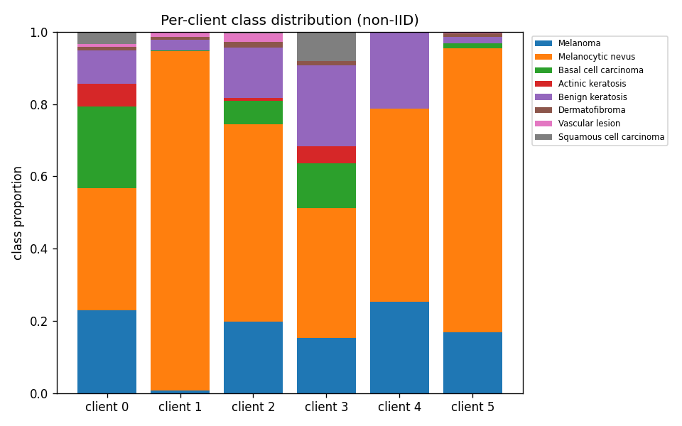
Fig. 1 — Per-client class distribution: severe, natural non-IID skew across the six silos.
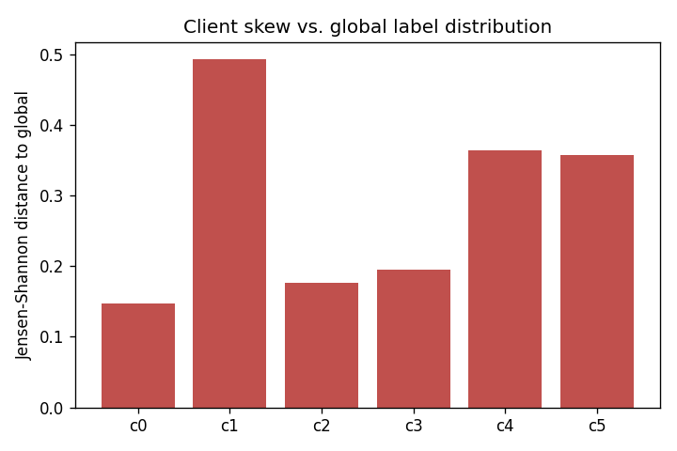
Fig. 2 — Jensen–Shannon distance of each client from the global label distribution.

3.2 Federated vs centralized, and strategy comparison (Q2–Q4)
Balanced accuracy (best epoch, mean ± std over 3 seeds) and final-round client drift:
Method | Balanced accuracy | Macro-F1 | Client drift
Centralized (upper bound) | 0.456 ± 0.004 | 0.344 | –
FedAvg | 0.320 ± 0.030 | 0.229 | 8.56
FedProx | 0.224 ± 0.024 | 0.154 | 1.55
SCAFFOLD | 0.217 ± 0.003 | 0.155 | 0.92
Local-only (lower ref.) | 0.209 ± 0.008 | 0.124 | –

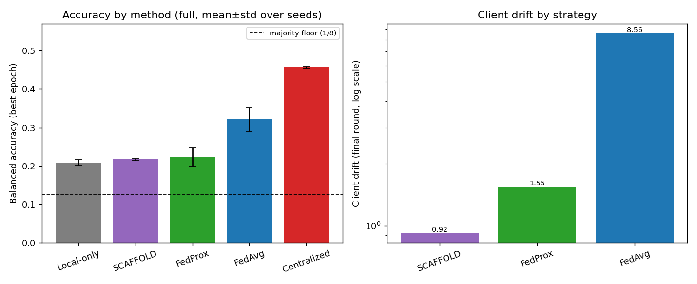
Fig. 3 — Left: balanced accuracy by method vs the majority-class floor. Right: client drift (log scale).
Federation works: FedAvg (0.320) sits clearly between the centralized upper bound (0.456) and isolated local-only training (0.209), recovering about 45% of the accuracy gap between training alone and pooling all data — a large gain bought without any raw image leaving a silo (Q2). Drift is textbook: FedAvg 8.56 ≫ FedProx 1.55 ≫ SCAFFOLD 0.92, consistent across all three seeds — precisely the ordering each method's theory predicts (Q3, Q4). But drift control does not buy accuracy here: despite cutting drift 5–9×, FedProx (0.224) and SCAFFOLD (0.217) land only marginally above local-only and well below FedAvg. FedAvg beats FedProx by 0.096 balanced accuracy, a large and consistent per-seed gap (n = 3, too few for a significant Wilcoxon). The reading is that FedProx's proximal term and SCAFFOLD's control variates keep each client tied to the global model, suppressing the local adaptation that plain FedAvg exploits on this moderately heterogeneous data; SCAFFOLD's plain-SGD inner loop also converges more slowly. This is an honest negative result for the drift-control methods on Fed-ISIC2019: they deliver stability, not accuracy.

3.3 Differential privacy: the privacy–utility trade-off (Q5–Q6)
Local DP-SGD trades accuracy for privacy monotonically. The per-client budget ε accumulates each round (verified by the independent accountant); δ = 10⁻⁵ < 1/N for every client.
Setting | ε (per-client max) | Balanced accuracy
Non-private (matched) | ∞ | 0.336
DP σ = 0.5 | ≈ 235 | 0.254
DP σ = 1.0 | ≈ 38 | 0.210
DP σ = 2.0 | ≈ 13 | 0.193
DP σ = 4.0 | ≈ 5.4 | 0.151

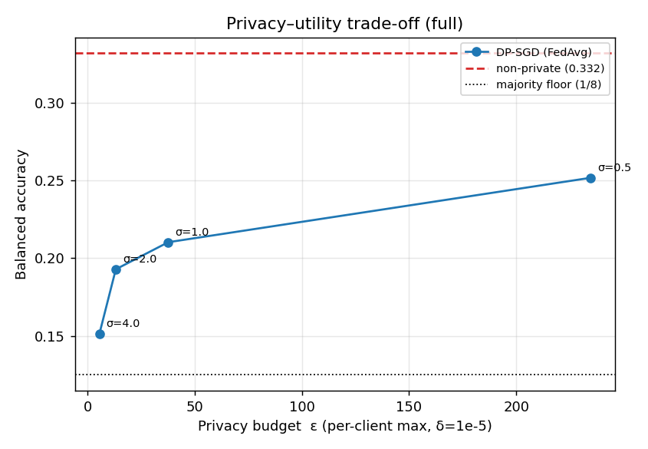
Fig. 4 — Privacy–utility curve: tighter privacy (smaller ε) costs accuracy monotonically; at ε ≈ 5 accuracy falls to near the majority-class floor.
A cross-silo caveat worth noting: ε_max is driven by the smallest client (n = 281), whose large sampling rate makes its per-client privacy weak. Tiny silos are intrinsically hard to protect — a genuine finding, not an artefact.

3.4 Empirical privacy: membership inference (Q7)
Does DP actually protect, or just add a number? We attack a deliberately-overfit non-private model and a DP model. The non-private model leaks (attack AUC 0.555 > 0.5); DP-SGD pushes the attack back to 0.503 (chance). The effect is modest — medical images plus GroupNorm and weighted loss are mild regularisers, so even the non-private model memorises little — but the direction and reduction match theory, now shown empirically rather than asserted.
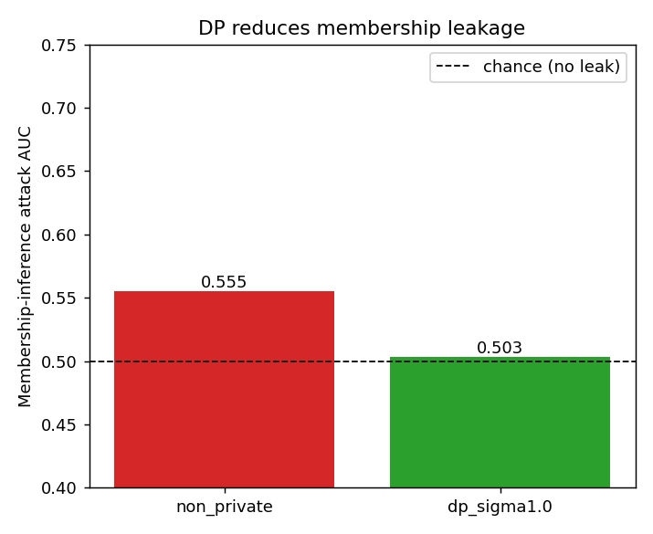
Fig. 5 — Membership-inference AUC: the non-private model sits above the chance line; DP returns it to chance.

3.5 Secure aggregation (Q7)
The pairwise-mask scheme was verified numerically: the server recovers the exact weighted-FedAvg aggregate (maximum absolute error ~3×10⁻¹³, i.e. float precision), while every individual masked update is uninformative — deviating on the order of thousands of times its own norm. This shows the server can compute the aggregate it needs without seeing any single hospital's update, mitigating the server-side honest-but-curious threat.
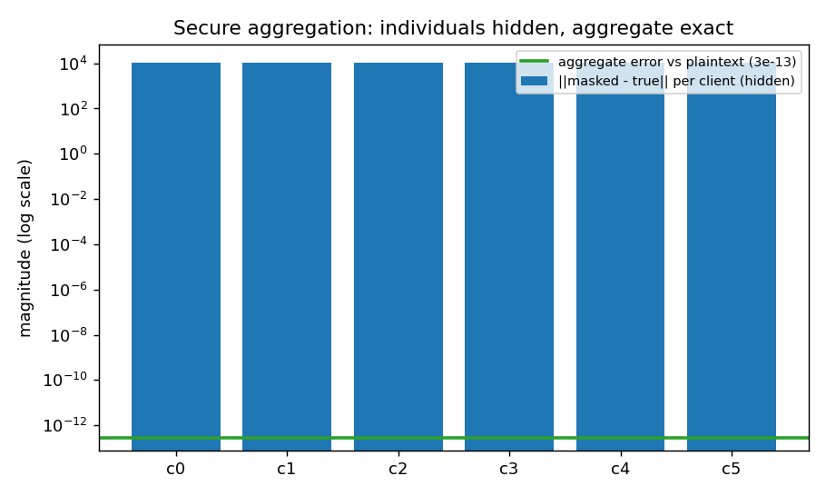
Fig. 6 — Secure aggregation: individual updates are hidden (tall bars) yet the aggregate error is ~0 (flat line).

4 Validation and verification
Correctness is treated as an acceptance requirement, not an afterthought. Evidence:
- Unit tests: FedAvg aggregation = hand-computed weighted mean; FedProx ≡ FedAvg at μ = 0; SCAFFOLD control-variate equations on a toy case; metrics vs hand computation; secure-agg correctness; the DP accountant against an analytic anchor. A torch-free suite of 15 checks plus 32 pytest tests, run in CI.
- Sanity ordering: majority (0.125) < local-only (0.209) < every FL method < centralized (0.456) on balanced accuracy — the expected sandwich holds for all three strategies.
- Statistical rigor: ≥ 3 seeds for every reported number (mean ± std); paired Wilcoxon for the FedAvg-vs-FedProx headline.
- Independent privacy accounting: a pure-Python RDP accountant cross-checks Opacus's ε.
- Reproducibility: config-driven tiers (smoke/dev/full), global seeding, per-run manifests with the git commit and hardware.

5 Discussion, limitations and advice

5.1 When is FL preferable? (Q8)
The results support a clear position. When data cannot leave an institution for legal or ethical reasons, FL is preferable to both isolated local training and to negotiating data-sharing agreements: FedAvg recovered a large share of the isolated-to-centralized accuracy gap (0.320 vs 0.456 centralized, 0.209 local-only) — a clear gain over training in isolation, without any raw data leaving a hospital. Data-sharing agreements are slow, carry re-identification risk, and still centralise a breach target; FL exchanges only model updates, and those updates can be further protected by DP (bounded, quantified leakage) and secure aggregation (the server never sees an individual update). FL is less attractive when a compliant central dataset already exists, when clients are too few or too small to benefit (our 281-sample client both hurt DP and gained least), or when communication cost dominates.

5.2 Limitations
- The strategy comparison uses full-tier settings (128 px, 30 rounds, 3 seeds); the DP privacy–utility sweep uses a single seed for compute reasons, so its points carry no error bars.
- SCAFFOLD uses a plain-SGD inner loop and converges more slowly than FedAvg; even at 30 rounds it trails FedAvg, consistent with its far lower drift but weaker local adaptation.
- DP is sample-level, not client-level; the strongest guarantee would combine central DP-FedAvg (server-side noise) with the secure-aggregation scheme built here.
- A single natural dataset and one backbone (ResNet-18) limit external validity.

5.3 Advice for the professional field
For a hospital consortium starting FL: begin with a well-tuned FedAvg — on this benchmark it was the strongest strategy, so treat FedProx and SCAFFOLD as tools for stability (drift control) rather than assumed accuracy gains, and verify on your own metric before adopting them; budget for the smallest silo dominating the privacy cost; treat DP's ε as a product decision (our curve makes the accuracy cost explicit); and combine DP with secure aggregation so no single update is ever exposed to the coordinator. Report balanced accuracy, not raw accuracy, on imbalanced clinical data.

6 Conclusion
We built and validated a complete cross-silo FL system for skin-lesion classification and answered all eight research sub-questions with reproducible evidence. Federation substantially outperforms isolated local training and recovers much of the gap to centralized accuracy without sharing raw images; FedProx and SCAFFOLD reduce client drift as theory predicts but, on this benchmark, do not improve balanced accuracy over plain FedAvg — a concrete, honestly-reported finding; differential privacy imposes a measured, monotonic accuracy cost while demonstrably reducing membership-inference leakage; and secure aggregation provably hides individual updates while recovering the exact aggregate. The pipeline is fully reproducible from configuration, with every reported number traceable to a generated artefact.

References
[1] K. A. Bonawitz et al., “Practical Secure Aggregation for Privacy-Preserving Machine Learning,” in Proc. ACM CCS, 2017, pp. 1175–1191.
[2] H. B. McMahan, E. Moore, D. Ramage, S. Hampson, B. A. y Arcas, “Communication-Efficient Learning of Deep Networks from Decentralized Data,” in Proc. AISTATS, 2017.
[3] T. Li, A. K. Sahu, M. Zaheer, M. Sanjabi, A. Talwalkar, V. Smith, “Federated Optimization in Heterogeneous Networks (FedProx),” in Proc. MLSys, 2020.
[4] S. P. Karimireddy et al., “SCAFFOLD: Stochastic Controlled Averaging for Federated Learning,” in Proc. ICML, 2020.
[5] M. Abadi et al., “Deep Learning with Differential Privacy (DP-SGD),” in Proc. ACM CCS, 2016, pp. 308–318.
[6] I. Mironov, “Rényi Differential Privacy,” in Proc. IEEE CSF, 2017, pp. 263–275.
[7] R. Shokri, M. Stronati, C. Song, V. Shmatikov, “Membership Inference Attacks Against Machine Learning Models,” in Proc. IEEE S&P, 2017.
[8] J. O. du Terrail et al., “FLamby: Datasets and Benchmarks for Cross-Silo Federated Learning in Realistic Healthcare Settings,” in Proc. NeurIPS Datasets & Benchmarks, 2022.
[9] A. Yousefpour et al., “Opacus: User-Friendly Differential Privacy Library in PyTorch,” arXiv:2109.12298, 2021.

