


Ministry of Communications and Information Technology
Digital Egypt Pioneers Initiative
JAVA OBJECT-ORIENTED PROGRAMMING

Title: STUDENT MANAGEMENT SYSTEM
Graduation Project Documentation
Team Members:
Mahmoud Bakri AbdelSamea Ahmed
Developer / Team Lead
Project Manager / Instructor:
Dr. Mina Younan
mina.younan@mu.edu.eg
DEPI: ONL5_SWD6_G1 • Academic Year: 2026/2027

Table of Contents
Table of Contents 2
1. Introduction 3
1.1 Project Overview 3
1.2 Domain 3
2. Main Contract Basis 4
2.1 Project Objective 4
2.2 Scope 4
2.3 Deliverables 4
3. Functional Requirements 4
4. Non-Functional Requirements 5
5. Constraints and Work Plan 5
5.1 Constraints 5
5.2 Work Plan 6
6. Use Cases 6
6.1 Use Case Specification Template (Example: UC-05) 7
7. Test Cases 7
7.1 Test Case Identification and Traceability 7
7.2 Requirement–Use Case–Test Case Traceability Matrix 8
8. Main Class Hierarchy and Relationships 8
8.1 Class Relationship and Degree (Multiplicity) 9
9. Database Design and ERD 10
10. Conclusion 10
11. Appendices 11
Team Contribution Matrix 11

1. Introduction

1.1 Project Overview
The Student Management System is a Java-based object-oriented application designed to manage core academic activities within a university department. The system models students, instructors, courses, grades, attendance, and departmental relationships while applying object-oriented design principles and validation rules.
The implementation emphasizes maintainability, encapsulation, inheritance, abstraction, polymorphism, exception handling, collection management, stream-based processing, and professional HTML report generation. The application provides a console-driven workflow and supports HTML reporting through a dedicated reporting service.

1.2 Domain
The project contains the following classes and interface:
- Person — abstract base class containing common identity and contact information; implements RoleProvider.
- RoleProvider — interface defining the getRole() contract.
- Student — abstract class inheriting from Person (major, year level, GPA).
- UndergraduateStudent — inherits from Student.
- GraduateStudent — inherits from Student and stores research area.
- Instructor — abstract class inheriting from Person (department, specialization, experience).
- FullTimeInstructor — inherits from Instructor and stores monthly salary.
- PartTimeInstructor — inherits from Instructor and stores hourly rate and working hours.
- Course — manages course data, instructor assignment, and enrolled students (max 50).
- Grade — stores student/course score and derives letter grade.
- Attendance — stores student attendance for a course and date.
- Department — aggregates students and courses.
- StudentManagementSystem — central service coordinating all operations.
- HTMLReportService — generates professional HTML academic reports.
- CourseEnrollmentException — domain exception for enrollment rule violations.
- Enums: StudentType, InstructorType, AttendanceStatus.

2. Main Contract Basis

2.1 Project Objective
Develop a Java application that demonstrates encapsulation, inheritance, polymorphism, abstraction/interfaces, collections, exception handling, and appropriate class relationships through a complete academic management domain.

2.2 Scope
- Manage students (undergraduate and graduate) with full CRUD operations.
- Manage instructors (full-time and part-time) with type-specific compensation data.
- Create courses, assign instructors, and control enrollment with capacity rules.
- Record grades and automatically derive letter grades and GPA.
- Record and summarize attendance.
- Generate professional HTML reports.
- Demonstrate inheritance, interface implementation, validation, and exception handling.
- Provide complete source code, documentation, presentation, and testing evidence.

2.3 Deliverables
Deliverable | Description
Documentation | Complete project documentation following the official template structure.
Presentation | Slides explaining requirements, design, OOP concepts, testing, and demo.
Java Source Code | Complete working source code with layered package structure.
UML / Class Diagram | Classes, inheritance, interface implementation, and associations.
ERD | Not applicable — project is an in-memory Java application (see Section 9).
Test Evidence | Completed test cases with actual console results and HTML report outputs.

3. Functional Requirements
ID | Requirement | Description
FR-01 | Student Management | The system shall add, edit, delete, search, and list student records (undergraduate and graduate).
FR-02 | Instructor Management | The system shall manage full-time and part-time instructor information including compensation data.
FR-03 | Course Management | The system shall create, update, delete courses and assign instructors.
FR-04 | Enrollment | The system shall enroll and remove students while enforcing duplicate and capacity (max 50) rules.
FR-05 | Grades | The system shall record scores (0–100) and automatically derive letter grades and update GPA.
FR-06 | Attendance | The system shall record present/absent status and calculate attendance rates.
FR-07 | Statistics | The system shall display live counts of students, instructors, courses, grades, and attendances.
FR-08 | HTML Reporting | The system shall export professional HTML reports for students, instructors, courses, grades, student report, and dashboard.
FR-09 | Student Full Report | The system shall display a complete student profile including grades and attendance history.
FR-10 | Top Students | The system shall list students sorted by GPA in descending order.

4. Non-Functional Requirements
ID | Requirement | Description
NFR-01 | Usability | The console menu should be clear, numbered, and easy to operate.
NFR-02 | Performance | Normal operations should execute without noticeable delay.
NFR-03 | Maintainability | Classes and methods should have clear responsibilities and layered structure.
NFR-04 | Reliability | Invalid operations should be rejected through validation and domain exceptions.
NFR-05 | Extensibility | New student or instructor types should be addable without unnecessary changes.
NFR-06 | Readability | Code should use meaningful names, enums, and consistent formatting.

5. Constraints and Work Plan

5.1 Constraints
- The project must be implemented in Java.
- The project must demonstrate OOP concepts covered in the course.
- The developer must document and test the implemented functionality.
- Data is stored in memory only (no external database in the current phase).
- Only standard Java libraries and approved tools may be used.

5.2 Work Plan
Week | Activity | Responsible
1 | Idea, scope, and requirements | Mahmoud Bakri
2 | Use cases and analysis | Mahmoud Bakri
3 | Class / UML design | Mahmoud Bakri
4–6 | Java implementation (models, service, reports) | Mahmoud Bakri
7 | Testing and bug fixing | Mahmoud Bakri
8 | Documentation | Mahmoud Bakri
9 | Presentation and demo | Mahmoud Bakri
10 | Final review and submission | Mahmoud Bakri

6. Use Cases
Each use case is connected to one or more functional requirements and later to one or more test cases.
ID | Use Case | Actor | Brief Description | Requirements
UC-01 | Add Student | User | Create undergraduate or graduate student. | FR-01
UC-02 | Edit / Delete Student | User | Update or remove an existing student. | FR-01
UC-03 | Add Instructor | User | Create full-time or part-time instructor. | FR-02
UC-04 | Manage Course | User | Create, edit, or delete a course. | FR-03
UC-05 | Enroll Student | User | Enroll student in course with rule checks. | FR-04
UC-06 | Record Grade | User | Record score and derive letter grade + GPA. | FR-05
UC-07 | Record Attendance | User | Record present/absent for enrolled student. | FR-06
UC-08 | View Statistics | User | Display live entity counts. | FR-07
UC-09 | Export HTML Report | User | Generate professional HTML academic reports. | FR-08
UC-10 | Student Full Report | User | View complete student academic profile. | FR-09, FR-10

6.1 Use Case Specification Template (Example: UC-05)
Field | Specification
Use Case ID | UC-05
Use Case Name | Enroll Student in Course
Primary Actor | User (Administrator)
Preconditions | Student and Course must already exist in the system.
Main Flow | 1. Enter Student ID. 2. Enter Course ID. 3. System validates both. 4. System checks capacity and duplicate. 5. Student is enrolled. 6. Success message displayed.
Exception Flow | Student/Course not found; already enrolled; capacity exceeded → CourseEnrollmentException with clear message.
Postconditions | Student appears in the course enrollment list; enrollment count increased.
Related Requirements | FR-04
Related Test Cases | TC-06, TC-07, TC-08

7. Test Cases
Testing provides evidence that the implemented system satisfies the functional requirements. Every functional requirement has at least one positive test case. Important error and edge conditions are also tested. Actual results were recorded after console execution.

7.1 Test Case Identification and Traceability
Test ID | Traceability | Test Scenario | Expected Result | Actual Result
TC-01 | UC-01 / FR-01 | Create valid undergraduate | Student created with ID. | Pass
TC-02 | UC-01 / FR-01 | Create valid graduate | Graduate created with research area. | Pass
TC-03 | UC-01 / FR-01 | Invalid age / email / phone | IllegalArgumentException raised. | Pass
TC-04 | UC-03 / FR-02 | Create full-time instructor | Instructor created with salary. | Pass
TC-05 | UC-04 / FR-03 | Create course with instructor | Course added successfully. | Pass
TC-06 | UC-05 / FR-04 | Enroll student once | Student enrolled. | Pass
TC-07 | UC-05 / FR-04 | Duplicate enrollment | CourseEnrollmentException raised. | Pass
TC-08 | UC-05 / FR-04 | Enroll when not found | Clear not-found message. | Pass
TC-09 | UC-06 / FR-05 | Record grade 90 | Letter A; GPA = 4.00. | Pass
TC-10 | UC-06 / FR-05 | Grade when not enrolled | Rejected with clear message. | Pass
TC-11 | UC-07 / FR-06 | Record attendance present | Attendance stored; rate 100%. | Pass
TC-12 | UC-08 / FR-07 | View statistics | Counts match live data. | Pass
TC-13 | UC-09 / FR-08 | Export HTML reports | Reports generated under reports/. | Pass
TC-14 | UC-10 / FR-09 | Student full report | Profile + grades + attendance shown. | Pass

7.2 Requirement–Use Case–Test Case Traceability Matrix
Requirement | Requirement Name | Use Case | Test Cases
FR-01 | Student Management | UC-01, UC-02 | TC-01, TC-02, TC-03
FR-02 | Instructor Management | UC-03 | TC-04
FR-03 | Course Management | UC-04 | TC-05
FR-04 | Enrollment | UC-05 | TC-06, TC-07, TC-08
FR-05 | Grades | UC-06 | TC-09, TC-10
FR-06 | Attendance | UC-07 | TC-11
FR-07 | Statistics | UC-08 | TC-12
FR-08 | HTML Reporting | UC-09 | TC-13
FR-09/10 | Student Report / Top GPA | UC-10 | TC-14

8. Main Class Hierarchy and Relationships
The UML class diagram below shows inheritance, interface implementation, attributes, methods, and associations.
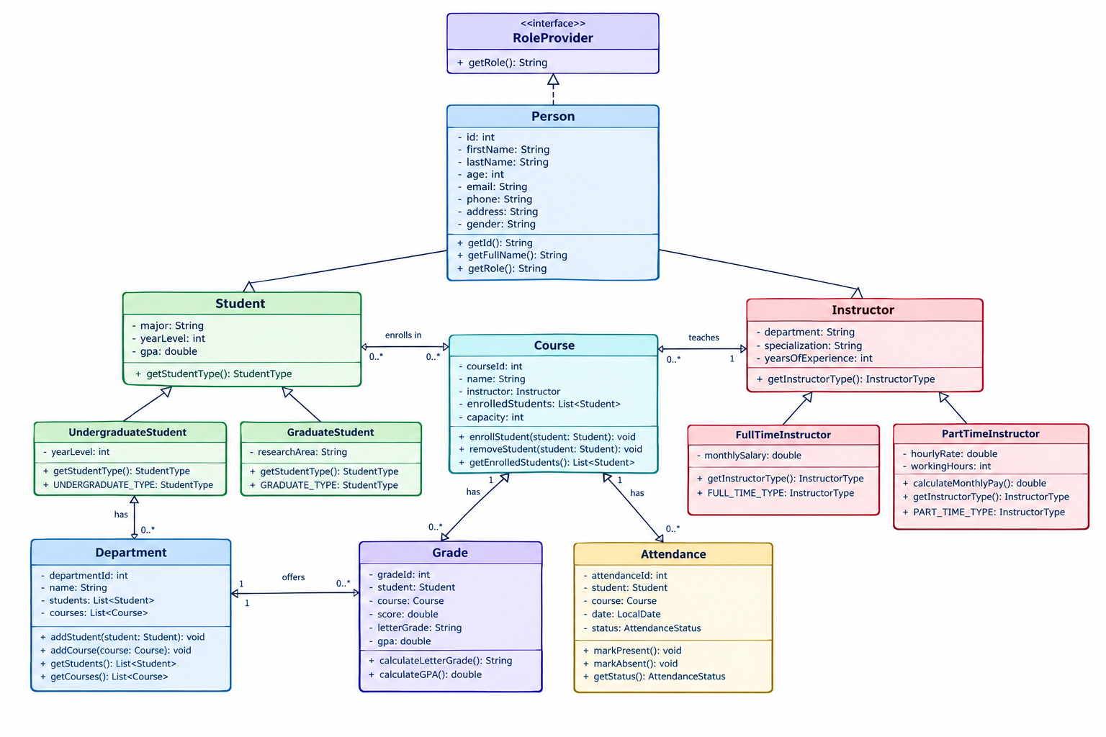

The hierarchy is centered on the abstract Person class, which implements the RoleProvider interface. Student and Instructor specialize Person. Concrete subclasses provide type-specific behavior. Course associates with one Instructor and zero-to-many Students (maximum capacity 50). Grade and Attendance link students to courses.

8.1 Class Relationship and Degree (Multiplicity)
Classes | Relationship | UML Meaning | Degree / Multiplicity
Student → Person | Inheritance | Generalization | 1 parent / specialized subclasses
Instructor → Person | Inheritance | Generalization | 1 parent / specialized subclasses
Person → RoleProvider | Implementation | Realization | Person implements interface
UndergraduateStudent → Student | Inheritance | Generalization | Concrete specialization
GraduateStudent → Student | Inheritance | Generalization | Concrete specialization
FullTimeInstructor → Instructor | Inheritance | Generalization | Concrete specialization
PartTimeInstructor → Instructor | Inheritance | Generalization | Concrete specialization
Course → Instructor | Association | Has-one | 1 Course → 1 Instructor
Course → Student | Association / Aggregation | Has-many | 1 Course contains 0..50 Students
Grade → Student, Course | Association | Links | 1 Grade → 1 Student + 1 Course
Attendance → Student, Course | Association | Links | 1 Attendance → 1 Student + 1 Course
Department → Student, Course | Aggregation | Has-many | 1 Department contains 0..* Students/Courses

9. Database Design and ERD
The current project is an in-memory Java application. All data (students, instructors, courses, grades, attendance) is held in Java collections within the StudentManagementSystem service and is lost when the application terminates. Therefore, an Entity-Relationship Diagram (ERD) is not applicable for the current phase.
Future enhancement (Phase 1 of the completeness roadmap) will introduce persistence using JSON file storage or SQLite. At that stage, a full ERD will be provided covering entities such as Student, Instructor, Course, Enrollment, Grade, and Attendance with appropriate primary and foreign keys.

10. Conclusion
The Student Management System successfully demonstrates the practical application of Java Object-Oriented Programming concepts in a realistic academic domain. The project implements encapsulation through private fields and validated setters, inheritance through the Person–Student–Instructor hierarchy, abstraction via abstract classes, polymorphism through type-specific subclass behavior, and interface-based design via RoleProvider.
Domain rules are enforced through validation and the dedicated CourseEnrollmentException. Collections and streams support efficient querying. Professional HTML reports separate presentation concerns from domain logic.
Console-based testing confirmed that all principal functional requirements pass, including positive paths and key error conditions (invalid input, duplicate enrollment, capacity limits, grade boundaries).
Identified gaps for the next phase include data persistence, automated JUnit tests, instructor deletion, and optional graphical interface. These items form a clear completeness roadmap while the current implementation remains a solid educational and demonstrable foundation.

11. Appendices
- Appendix A — Complete Source Code / Package Structure
- Appendix B — UML Class Diagram (embedded in Section 8)
- Appendix C — Use Case Diagram (derived from Section 6)
- Appendix D — ERD (not applicable — in-memory application; see Section 9)
- Appendix E — Test Evidence / Console Screenshots and HTML Report Samples
- Appendix F — Team Contribution Matrix

Team Contribution Matrix
Student | Role | Main Tasks / Contribution %
Mahmoud Bakri AbdelSamea Ahmed | Developer / Team Lead | Requirements, UML, Java implementation, testing, documentation, presentation — 100%

