Type | Image | Frequency | Storage | Reading distance | price | Link
Wristband MIFARE  RFID TAG | 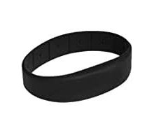 | 13.56 MHz | 144 bytes | 20 mm | 55 LE | link
UHF Sticker PVC anti metal | 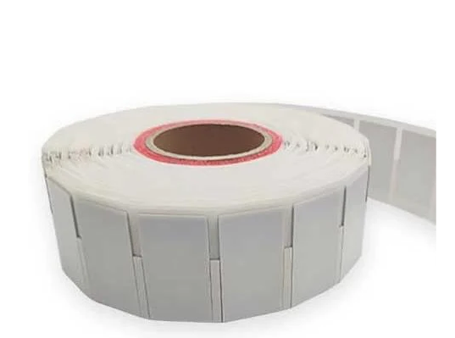 | 860-960MHz |  | 0-10m | 180 LE | link | Read/ Write
NFC Card 13.56MHz – NTAG215 Chip (White PVC) | 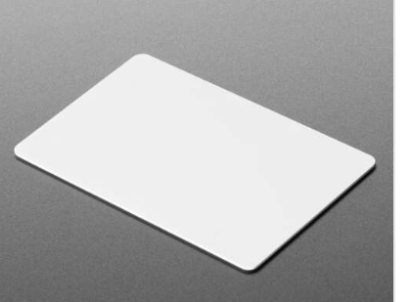 | 13.56MHz RFID/NFC Card with an NTAG215 chip | 504 Bytes | Up to 10 cm | 15 LE | link
UHF RFID Sticker Tag 9654 Chip 93x19mm | 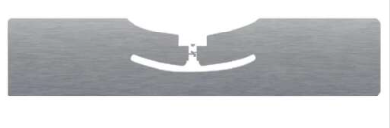 | 860-960 MHz | 512 Bits | Up to 13 m |  | link
UHF RFID Sticker (Long Range) | 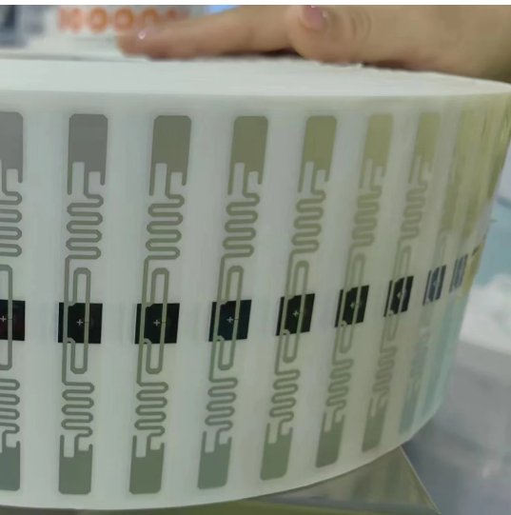 | 860MHz~960MHz |  | 4m to 6m, with a maximum of more than 10m | LE 6.00 | link | Read/ Write
NFC Sticker 25 mm Round (13.56 MHz - NTAG213 ) NTAG-213 | 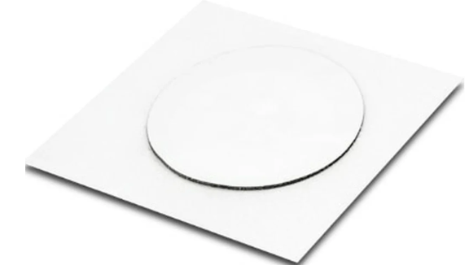 | 13.56 MHz |  |  | LE 15.00 | link

Readers:
- 125 KHz
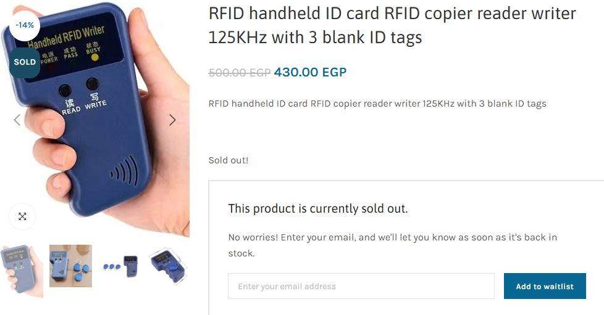
Link: https://microohm-eg.com/product/rfid-handheld-id-card-rfid-copier-reader-writer-125khz-with-3-blank-id-tags/
- 13.56 MHz
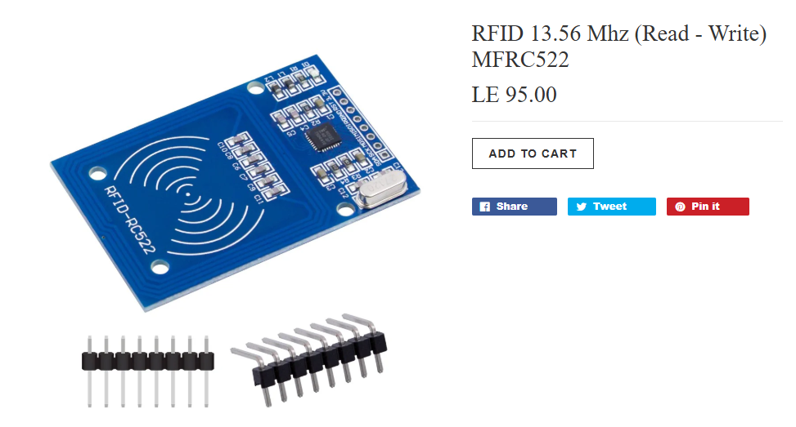
Link: https://store.fut-electronics.com/collections/rfid/products/125khz-rfid-code-reader-uart
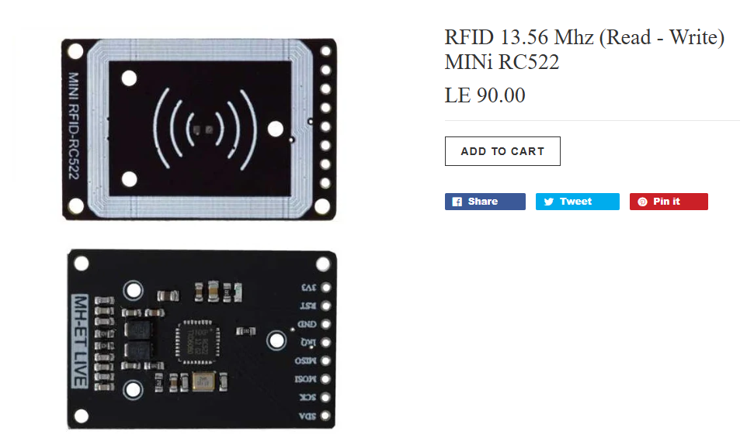
Link: https://store.fut-electronics.com/collections/rfid/products/rfid-13-56-mhz-read-write-mini-rc522

