**Answer-Sheet**

**Basic Questions:**

1. How many customers do not have DOB information available?

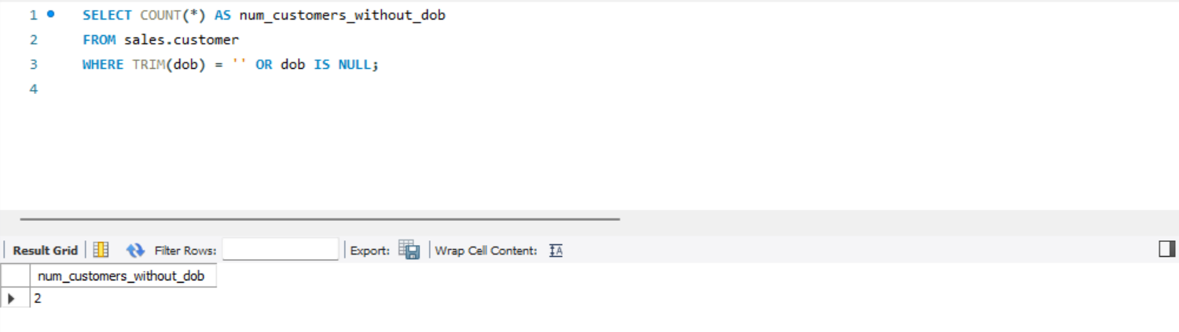  
- Code:  
SELECT COUNT(*) AS num_customers_without_dob

FROM sales.customer

WHERE TRIM(dob) = '' OR dob IS NULL;

2. How many customers are there in each pincode and gender combination?  
- Code is :  
SELECT primary_pincode, gender, COUNT(*) AS num_customers

FROM sales.customer

GROUP BY primary_pincode, gender;

3. Print product name and mrp for products which have more than 50000 MRP?

- Code is:

SELECT product_name, mrp

FROM sales.product

where mrp > 5000;

4. How many delivery personal are there in each pincode?

- Code:   
SELECT delivery_person_id, pincode, count(*) as num_delivery_person

FROM sales.`delivery-person` group by delivery_person_id, pincode;

5. For each Pin code, print the count of orders, sum of total amount paid, average amount

paid, maximum amount paid, minimum amount paid for the transactions which were

paid by 'cash'. Take only 'buy' order types

- Answer is:

- Code is:

SELECT

delivery_pincode,

COUNT(order_id) AS order_count,

SUM(total_amount_paid) AS total_amount_paid,

AVG(total_amount_paid) AS avg_amount_paid,

MAX(total_amount_paid) AS max_amount_paid,

MIN(total_amount_paid) AS min_amount_paid

FROM sales.orders

WHERE order_type = 'buy' AND payment_type = 'cash'

GROUP BY delivery_pincode;

6. For each delivery_person_id, print the count of orders and total amount paid for

product_id = 12350 or 12348 and total units > 8. Sort the output by total amount paid in

descending order. Take only 'buy' order types

- Code is:  
SELECT

delivery_person_id,

COUNT(order_id) AS order_count,

SUM(total_amount_paid) AS total_amount_paid

FROM sales.orders

WHERE order_type = 'buy'

AND (product_id = 12350 OR product_id = 12348)

AND tot_units > 8

GROUP BY delivery_person_id

ORDER BY total_amount_paid DESC;

7. Print the Full names (first name plus last name) for customers that have email on

"gmail.com"?

- Code is:  
SELECT concat(first_name, last_name) As Full_names

from sales.customer

where email like '%@gmail.com%';

8. Which pincode has average amount paid more than 150,000? Take only 'buy' order

Types

- Code is:

SELECT delivery_pincode, AVG(total_amount_paid) AS avg_amount_paid

FROM sales.orders

WHERE order_type = 'buy'

GROUP BY delivery_pincode

HAVING avg_amount_paid > 150000;

9. Create following columns from order_dim data -

▪ order_date

▪ Order day

▪ Order month

▪ Order year

SELECT

order_date,

DAY(STR_TO_DATE(order_date, '%d-%m-%Y')) AS order_day,

MONTH(STR_TO_DATE(order_date, '%d-%m-%Y')) AS order_month,

YEAR(STR_TO_DATE(order_date, '%d-%m-%Y')) AS order_year

FROM sales.orders;

10. How many total orders were there in each month and how many of them were

returned? Add a column for return rate too.

return rate = (100.0 * total return orders) / total buy orders

Hint: You will need to combine SUM() with CASE WHEN

- Code is:

SELECT

MONTH(STR_TO_DATE(order_date, '%d-%m-%Y')) AS order_month,

COUNT(*) AS total_orders,

SUM(CASE WHEN order_type = 'return' THEN 1 ELSE 0 END) AS returned_orders,

(100.0 * SUM(CASE WHEN order_type = 'return' THEN 1 ELSE 0 END)) / COUNT(*) AS return_rate

FROM sales.orders

GROUP BY order_month;

**Question On SQL Joins:**

11. How many units have been sold by each brand? Also get total returned units for each

brand.

**\*\* at first I run a query on sales schema to rename the empty column name on the product table to product_id  
(USE sales;**

**ALTER TABLE product**

**CHANGE COLUMN MyUnknownColumn product_id INT;)**   
- Code is:   
SELECT

p.brand,

SUM(o.tot_units) AS total_units_sold,

SUM(CASE WHEN o.order_type = 'return' THEN o.tot_units ELSE 0 END) AS total_returned_units

FROM

orders o

JOIN

product p ON o.product_id = p.product_id

GROUP BY

p.brand;

12. How many distinct customers and delivery boys are there in each state?

- Code is:

SELECT

p.state,

COUNT(DISTINCT c.cust_id) AS distinct_customers,

COUNT(DISTINCT d.delivery_person_id) AS distinct_delivery_boys

FROM

pincode p

LEFT JOIN

customer c ON p.pincode = c.primary_pincode

LEFT JOIN

orders o ON c.cust_id = o.cust_id

LEFT JOIN

`delivery-person` d ON p.pincode = d.pincode

GROUP BY

p.state;

13. For every customer, print how many total units were ordered, how many units were

ordered from their primary_pincode and how many were ordered not from the

primary_pincode. Also calulate the percentage of total units which were ordered from

primary_pincode(remember to multiply the numerator by 100.0). Sort by the

percentage column in descending order.

- Code is:   
SELECT

c.cust_id,

SUM(o.tot_units) AS total_units_ordered,

SUM(CASE WHEN o.delivery_pincode = c.primary_pincode THEN o.tot_units ELSE 0 END) AS units_ordered_primary_pincode,

SUM(CASE WHEN o.delivery_pincode != c.primary_pincode THEN o.tot_units ELSE 0 END) AS units_ordered_other_pincode,

(100.0 * SUM(CASE WHEN o.delivery_pincode = c.primary_pincode THEN o.tot_units ELSE 0 END)) / SUM(o.tot_units) AS percentage_primary_pincode

FROM

customer c

LEFT JOIN

orders o ON c.cust_id = o.cust_id

GROUP BY

c.cust_id

ORDER BY

percentage_primary_pincode DESC;

14. For each product name, print the sum of number of units, total amount paid, total

displayed selling price, total mrp of these units, and finally the net discount from selling

price.

(i.e. 100.0 - 100.0 * total amount paid / total displayed selling price) &

the net discount from mrp (i.e. 100.0 - 100.0 * total amount paid / total mrp)

-Code is:

SELECT

p.product_name,

SUM(o.tot_units) AS total_units,

SUM(o.total_amount_paid) AS total_amount_paid,

SUM(o.displayed_selling_price_per_unit * o.tot_units) AS total_displayed_selling_price,

SUM(p.mrp * o.tot_units) AS total_mrp,

100.0 - 100.0 * SUM(o.total_amount_paid) / SUM(o.displayed_selling_price_per_unit * o.tot_units) AS net_discount_selling_price,

100.0 - 100.0 * SUM(o.total_amount_paid) / SUM(p.mrp * o.tot_units) AS net_discount_mrp

FROM

product p

JOIN

orders o ON p.product_id = o.product_id

GROUP BY

p.product_name;

**Advance Questions:**

15. For every order_id (exclude returns), get the product name and calculate the discount

percentage from selling price. Sort by highest discount and print only those rows where

discount percentage was above 10.10%

- Code is:

SELECT o.order_id, p.product_name,

(100.0 - 100.0 * o.total_amount_paid / (o.displayed_selling_price_per_unit * o.tot_units)) AS discount_percentage

FROM orders o

JOIN

product p ON o.product_id = p.product_id

WHERE

o.order_type != 'return'

HAVING discount_percentage > 10.10

ORDER BY

discount_percentage DESC;

16. Using the per unit procurement cost in product_dim, find which product category has

made the most profit in both absolute amount and percentage

Absolute Profit = Total Amt Sold - Total Procurement Cost

Percentage Profit = 100.0 * Total Amt Sold / Total Procurement Cost - 100.0

- Code is:

SELECT

p.category,

SUM(o.total_amount_paid) - SUM(p.procurement_cost_per_unit * o.tot_units) AS absolute_profit,

(100.0 * SUM(o.total_amount_paid) / SUM(p.procurement_cost_per_unit * o.tot_units)) - 100.0 AS percentage_profit

FROM

product p

JOIN

orders o ON p.product_id = o.product_id

GROUP BY

p.category

ORDER BY

absolute_profit DESC;

17. For every delivery person(use their name), print the total number of order ids (exclude

returns) by month in separate columns i.e. there should be one row for each

delivery_person_id and 12 columns for every month in the year

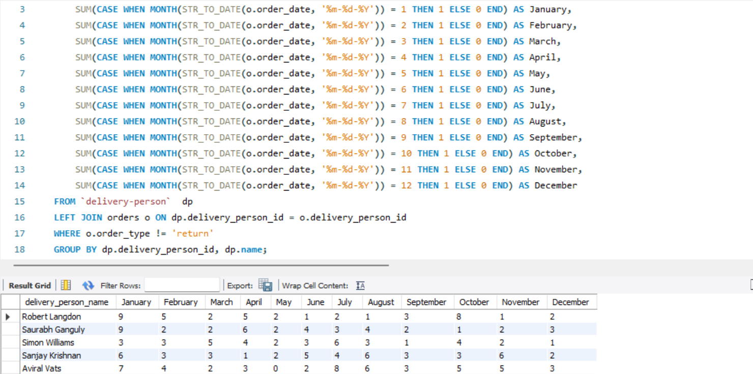

- Code is:   
USE sales; SELECT

dp.name AS delivery_person_name,

SUM(CASE WHEN MONTH(STR_TO_DATE(o.order_date, '%m-%d-%Y')) = 1 THEN 1 ELSE 0 END) AS January,

SUM(CASE WHEN MONTH(STR_TO_DATE(o.order_date, '%m-%d-%Y')) = 2 THEN 1 ELSE 0 END) AS February,

SUM(CASE WHEN MONTH(STR_TO_DATE(o.order_date, '%m-%d-%Y')) = 3 THEN 1 ELSE 0 END) AS March,

SUM(CASE WHEN MONTH(STR_TO_DATE(o.order_date, '%m-%d-%Y')) = 4 THEN 1 ELSE 0 END) AS April,

SUM(CASE WHEN MONTH(STR_TO_DATE(o.order_date, '%m-%d-%Y')) = 5 THEN 1 ELSE 0 END) AS May,

SUM(CASE WHEN MONTH(STR_TO_DATE(o.order_date, '%m-%d-%Y')) = 6 THEN 1 ELSE 0 END) AS June,

SUM(CASE WHEN MONTH(STR_TO_DATE(o.order_date, '%m-%d-%Y')) = 7 THEN 1 ELSE 0 END) AS July,

SUM(CASE WHEN MONTH(STR_TO_DATE(o.order_date, '%m-%d-%Y')) = 8 THEN 1 ELSE 0 END) AS August,

SUM(CASE WHEN MONTH(STR_TO_DATE(o.order_date, '%m-%d-%Y')) = 9 THEN 1 ELSE 0 END) AS September,

SUM(CASE WHEN MONTH(STR_TO_DATE(o.order_date, '%m-%d-%Y')) = 10 THEN 1 ELSE 0 END) AS October,

SUM(CASE WHEN MONTH(STR_TO_DATE(o.order_date, '%m-%d-%Y')) = 11 THEN 1 ELSE 0 END) AS November,

SUM(CASE WHEN MONTH(STR_TO_DATE(o.order_date, '%m-%d-%Y')) = 12 THEN 1 ELSE 0 END) AS December

FROM `delivery-person` dp

LEFT JOIN orders o ON dp.delivery_person_id = o.delivery_person_id

WHERE o.order_type != 'return'

GROUP BY dp.delivery_person_id, dp.name;

18. For each gender - male and female - find the absolute and percentage profit (like in

Q15) by product name

- Code is:

SELECT

c.gender,

p.product_name,

SUM(o.total_amount_paid) - SUM(p.procurement_cost_per_unit * o.tot_units) AS absolute_profit,

(100.0 * SUM(o.total_amount_paid) / SUM(p.procurement_cost_per_unit * o.tot_units)) - 100.0 AS percentage_profit

FROM

orders o

JOIN

product p ON o.product_id = p.product_id

JOIN

customer c ON o.cust_id = c.cust_id

GROUP BY

c.gender, p.product_name

HAVING

percentage_profit > 10.10;

19. Generally the more numbers of units you buy, the more discount seller will give you. For

'Dell AX420' is there a relationship between number of units ordered and average

discount from selling price? Take only 'buy' order types.

-Code is:

SELECT

o.tot_units AS number_of_units,

AVG(1 - o.total_amount_paid / (o.displayed_selling_price_per_unit * o.tot_units)) AS average_discount

FROM

orders o

JOIN

product p ON o.product_id = p.product_id

WHERE

p.product_name = 'Dell AX420'

AND o.order_type = 'buy'

GROUP BY

o.tot_units

ORDER BY number_of_units;