ENTERPRISE NETWORK SECURITY
IMPLEMENTATION — TECHNICAL REPORT
FortiGate-Based HQ / Branch1 / Branch2 / Remote-User Architecture
Graduation / Capstone Project
Prepared by the Project Team
Person 1 — Enterprise Infrastructure Engineer (HQ)
Person 2 — WAN & Connectivity Engineer (Branch1 / Branch2 / VPN / HA)
Person 3 — Security Engineer (Firewall / NAT / VIP / IPS / AV / Web Filter / App Control / Testing)
Lab Platform: PNETLab | Devices: FortiGate-VM64-KVM
August 2026

1. Executive Summary
This report documents the design and implementation of a multi-site enterprise network security solution built around FortiGate next-generation firewalls. The project simulates a realistic organization consisting of a Headquarters (HQ) site, two remote branch offices (Branch1 and Branch2), and provision for remote-user access, interconnected over a simulated WAN/Internet backbone using the PNETLab virtualization platform.
The objective was to design a segmented, redundant, and centrally-secured network in which HQ hosts the core services (Users, Servers, and Management VLANs) behind a High Availability (HA) FortiGate cluster, while Branch1 and Branch2 connect back to HQ over IPsec site-to-site VPN tunnels. Firewall policies, an IPS sensor, an application-control profile, and static/inter-VLAN routing were used to control and inspect traffic between all network segments.
Core technologies used: FortiGate firewalls in an HA Active-Passive cluster at HQ, Layer-3 VLAN segmentation with a FortiLink-managed switch fabric, static routing between all three sites, site-to-site IPsec VPN (IKEv2) between HQ and each branch, and FortiGate UTM security profiles (IPS, Antivirus, Web Filter, Application Control) applied to Internet-bound user traffic.
The collected evidence (CLI output, configuration dumps, and ping tests) confirms that the HQ, Branch1, and Branch2 firewalls are online with correct WAN/LAN addressing; that the HQ HA cluster is healthy and configuration-synchronized; that the HQ↔Branch1 IPsec tunnel is established and passing the configured proxy IDs; and that inter-site as well as intra-VLAN reachability tests succeeded. Some elements referenced in the original project scope — Remote Access/SSL-VPN, explicit NAT/VIP objects, DHCP server configuration, and a confirmed HQ↔Branch2 IPsec Phase-2 negotiation — were not present in the supplied screenshots and are flagged as "not explicitly shown/provided" rather than assumed, per the reporting requirements.

2. Project Requirements
The project was divided among three engineers, each responsible for a distinct functional area of the overall solution:

Person 1 — Enterprise Infrastructure Engineer (HQ)
- Design and build the complete HQ network: Core Switch and Access Switches.
- Configure VLANs for Users, Servers, and Management segments.
- Configure DHCP services for end-host segments.
- Configure Inter-VLAN routing on the HQ FortiGate.
- Configure static routing at HQ.
- Prepare the HA interfaces on the HQ FortiGate pair.

Person 2 — WAN & Connectivity Engineer
- Build and connect the Branch1 and Branch2 networks.
- Configure site-to-site IPsec VPN tunnels between HQ and each branch.
- Configure Remote Access (SSL) VPN for remote users.
- Configure routing between HQ, Branch1, and Branch2.
- Configure High Availability (HA) between the HQ FortiGate pair.

Person 3 — Security Engineer
- Configure firewall policies controlling inter-VLAN and Internet-bound traffic.
- Configure NAT and Virtual IP (VIP) objects.
- Configure and apply an IPS sensor.
- Configure Antivirus (AV) scanning.
- Configure Web Filtering.
- Configure Application Control.
- Perform connectivity/security testing and consolidate project documentation.
The supplied evidence covers most of this scope. Where a specific requirement (e.g., DHCP output, NAT/VIP objects, or Remote Access VPN configuration) was not shown in the available screenshots, this is explicitly stated in the relevant section below rather than assumed.

3. Network Architecture / Topology
The lab topology, built in PNETLab, implements a three-site enterprise design — HQ, Branch1 (BR1), and Branch2 (BR2) — each connected to a simulated Internet cloud through an ISP router and an Edge router. Figure 1 shows the complete logical topology as built in the lab.
Figure 1: Complete Lab Topology (PNETLab)
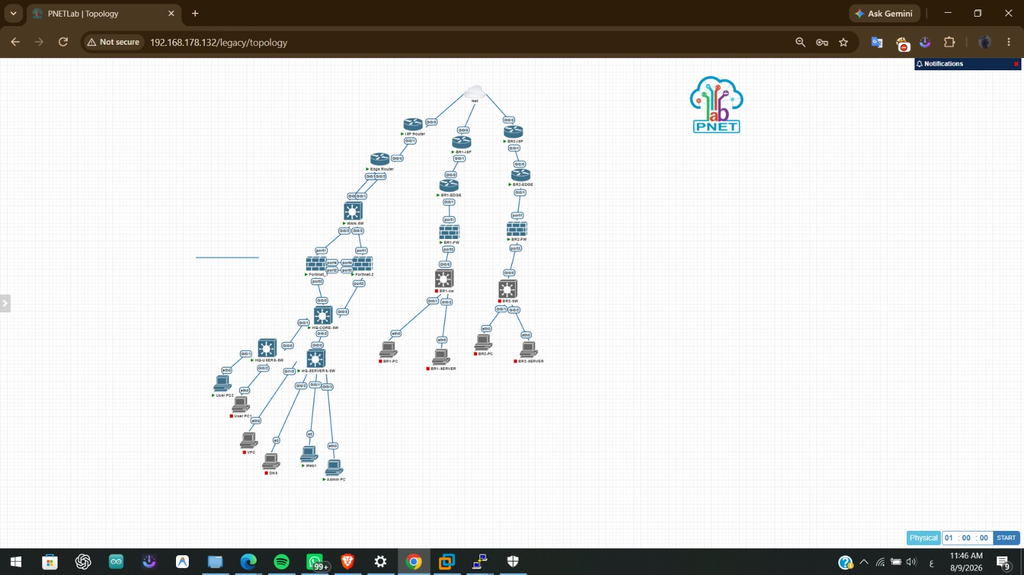
Purpose: To show the full logical topology of the simulated enterprise network across HQ, Branch1, and Branch2.
Configuration/Action: Topology captured directly from the PNETLab topology canvas.
Explanation:
- HQ side: Internet cloud → ISP Router → Edge Router → WAN-SW → a redundant pair of FortiGate firewalls ("Fortinet-1" and "Fortinet-2", forming the HQ HA cluster) → HQ-CORE-SW → HQ-USERS-SW and HQ-SERVERS-SW → end hosts (User PC1, User PC2, a VPC, a DNS server, a Web server, and an Admin PC).
- Branch1 side: Internet cloud → BR1-ISP → BR1-EDGE → BR1-FW (single FortiGate) → BR1-SW → BR1-PC and BR1-SERVER.
- Branch2 side: Internet cloud → BR2-ISP → BR2-EDGE → BR2-FW (single FortiGate) → BR2-SW → BR2-PC and BR2-SERVER.
- The dual-firewall symbol at HQ (Fortinet-1 / Fortinet-2), both linked to the same WAN switch and the same core switch, reflects the Active-Passive HA cluster confirmed later in Figure 21, and matches the device host names "HQ-FW-Primary" and "HQ-FW-Secondary" seen in the CLI evidence.
Expected Result: A hierarchical topology in which every site is isolated behind its own firewall, and inter-site traffic is expected to traverse the WAN cloud via IPsec VPN tunnels rather than a shared Layer-2 link.
Verification: The diagram is the design evidence; live-device confirmation for each link is provided in the following sections (interface status, routing tables, and ping tests).
Technical Significance: This topology is the reference point for every IP address, VLAN, and route discussed later in the report — every subsequent figure maps onto a device or link shown here.

3.1 Traffic Flow Overview
Based on the topology and configuration evidence: traffic that originates in a HQ VLAN (Users, Servers, or Management) and is destined for another HQ VLAN is routed and filtered by the HQ FortiGate directly, using the firewall policies described in Section 5.7. Traffic destined for a branch subnet (e.g., 192.168.110.0/24 or 192.168.120.0/24 at Branch1) is forwarded by HQ over the corresponding IPsec tunnel interface ("HQ-BR1" or "HQ-BR2"). Traffic from the Users VLAN destined for the Internet is routed out port1 toward the HQ Edge router and is subject to UTM inspection (IPS, Antivirus, Web Filter) as configured in the "Users_to_Internet" firewall policy.

4. IP Addressing and Network Design
The table below consolidates every IP address, subnet, and interface confirmed in the supplied CLI evidence (interface dumps, static-route tables, VPN configuration, and routing tables). A value that could not be read directly from a screenshot, but was reliably cross-referenced from two independent pieces of evidence, is marked "(inferred)"; no values were invented.
Device | Interface | IP Address | Subnet Mask | VLAN | Purpose
HQ-FW-Primary | port1 | 10.0.0.6 | 255.255.255.252 | — | WAN uplink to HQ-EDGE router
HQ-FW-Primary | fortilink (aggr.) | 10.255.1.1 | 255.255.255.0 | — | FortiLink to HQ switch fabric
HQ-FW-Primary | VLAN10 | 192.168.10.1 | 255.255.255.0 | 10 | Users segment default gateway
HQ-FW-Primary | VLAN20 | 192.168.20.1 | 255.255.255.0 | 20 | Servers segment default gateway
HQ-FW-Primary | VLAN30 | 192.168.30.1 | 255.255.255.0 | 30 | Management segment default gateway
HQ-FW-Primary | HQ-BR1 (tunnel) | IPsec virtual i/f | — | — | Site-to-site VPN to Branch1
HQ-FW-Primary | HQ-BR2 (tunnel) | IPsec virtual i/f | — | — | Site-to-site VPN to Branch2
HQ transit | HQ-FW ↔ HQ-EDGE | 10.0.0.4/30 | 255.255.255.252 | — | Gateway 10.0.0.5
BR1-FW | port1 | 10.1.1.6 | 255.255.255.252 | — | WAN uplink to BR1-EDGE router
BR1-FW | BR1-USERS | 192.168.110.0/24 | 255.255.255.0 | — | Branch1 users segment
BR1-FW | BR1-SERVERS | 192.168.120.0/24 | 255.255.255.0 | — | Branch1 servers segment
BR1 transit | BR1-FW ↔ BR1-EDGE | 10.1.1.4/30 | 255.255.255.252 | — | Gateway 10.1.1.5
BR2-FW | port1 | 10.2.1.6 (inferred) | 255.255.255.252 | — | WAN uplink to BR2-EDGE router
BR2-FW | BR2-USERS | 192.168.210.0/24 | 255.255.255.0 | — | Branch2 users segment
BR2-FW | BR2-SERVERS | 192.168.220.0/24 | 255.255.255.0 | — | Branch2 servers segment
BR2 transit | BR2-FW ↔ BR2-EDGE | 10.2.1.4/30 | 255.255.255.252 | — | Gateway 10.2.1.5
A dedicated "get system interface" output for BR2-FW was not among the supplied evidence. The BR2-FW port1 address (10.2.1.6) is inferred by cross-referencing the remote-gw value "10.2.1.6" in the HQ VPN Phase-1 configuration (Figure 12) against the connected transit subnet 10.2.1.4/30 shown in the BR2 routing table (Figure 9). The Branch1/Branch2 VLAN gateway addresses (e.g., 192.168.110.1) were not explicitly shown — only the subnets themselves were confirmed as directly connected on their respective firewalls.
Addressing design: the network uses RFC 1918 private space, with /30 point-to-point transit links between each firewall and its Edge router (conserving address space on WAN segments), and /24 subnets for each internal VLAN or branch segment. HQ segments are numbered in the 192.168.x0.0/24 range (10/20/30 for Users/Servers/Management) while Branch1 and Branch2 use distinct third octets (110/120 and 210/220 respectively). Using non-overlapping subnets across all three sites is a functional requirement for IPsec site-to-site VPN routing, since overlapping subnets on either side of a tunnel would make the Phase-2 selectors ambiguous.

5. Implementation
This section documents the implementation evidence in a Requirement → Configuration → Verification flow, grouped by functional area and mapped to the responsible engineer's scope defined in Section 2.

5.1 Device Initial Configuration (Person 1 — HQ)
Before any VLAN, routing, or security policy can be configured, each firewall's physical/logical interfaces must be verified to confirm that WAN and internal links are up and correctly addressed.
Figure 2: HQ-FW-Primary — Interface Status (get system interface)
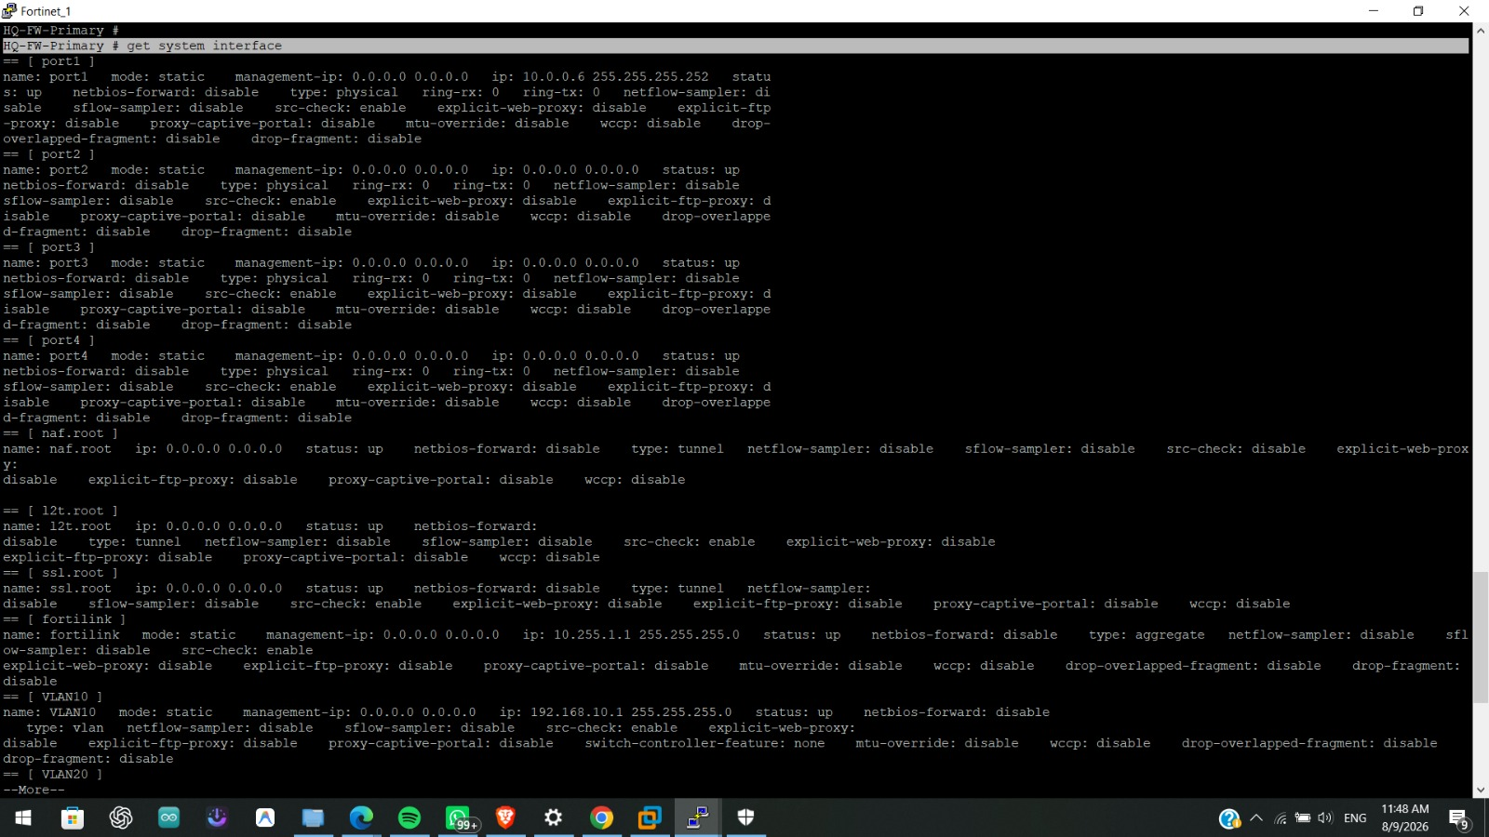
Purpose: To confirm the physical and logical interface status and addressing on the HQ primary firewall before proceeding with VLAN and routing configuration.
Configuration/Action: CLI command get system interface executed on HQ-FW-Primary.
Explanation:
- port1 is configured as a static interface with IP 10.0.0.6/255.255.255.252 and status "up" — this is the WAN-facing interface toward the HQ Edge router.
- port2, port3, and port4 are shown as physical interfaces with no IP assigned directly (addressed instead via the VLAN sub-interfaces and the fortilink aggregate below), all reporting status "up".
- Tunnel-type placeholder interfaces (naf.root, l2t.root, ssl.root) are present by default on FortiOS for NAC, L2TP, and SSL-VPN respectively, but show no IP assigned — consistent with SSL-VPN/remote access not having been actively configured (see Section 5.6).
- The fortilink interface (an aggregate-type interface) is configured with IP 10.255.1.1/255.255.255.0 and status "up" — this is the FortiLink management interface connecting the firewall to the managed switch fabric (Core/Access switches).
- The VLAN10 interface begins to appear at the bottom of the output with IP 192.168.10.1/255.255.255.0, status "up" — the beginning of the VLAN interface set detailed further in Figure 4.
Expected Result: All listed interfaces should report status "up", with port1 holding the WAN IP and the FortiLink/VLAN interfaces holding the internal LAN addressing.
Verification: The output itself, showing status: up against every physical and logical interface queried, confirms the interfaces are operational at the time of capture.
Technical Significance: This is the baseline check that confirms the firewall has Layer-3 reachability toward both the WAN (Edge router) and the internal switch fabric before any policy, routing, or VPN configuration is layered on top.

Figure 3: BR1-FW — Interface Status (get system interface)
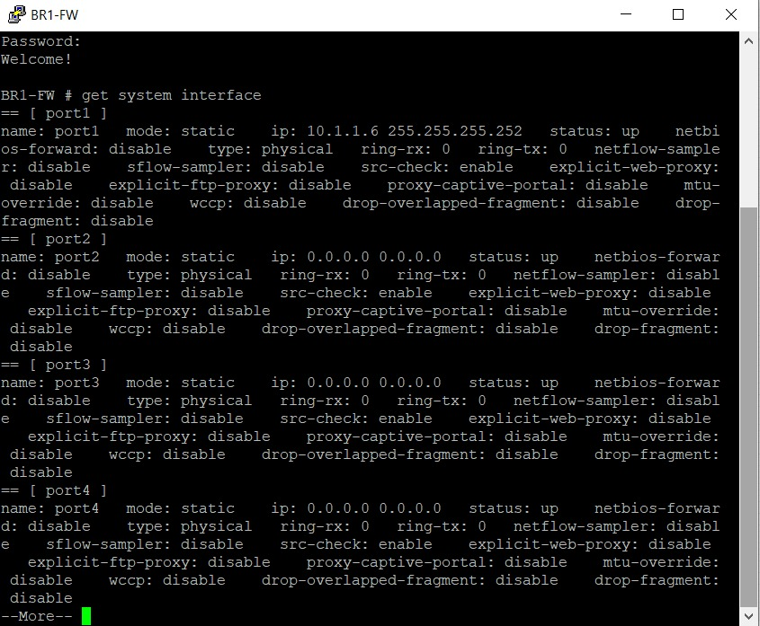
Purpose: To confirm the physical interface status and WAN addressing on the Branch1 firewall.
Configuration/Action: CLI command get system interface executed on BR1-FW.
Explanation:
- port1 is statically configured with IP 10.1.1.6/255.255.255.252, status "up" — the WAN-facing interface toward BR1-EDGE.
- port2, port3, and port4 are shown as physical interfaces with no IP address assigned in this view (the visible portion of the output is truncated at "--More--"), all reporting status "up".
- This confirms BR1-FW's WAN link is active and correctly addressed to match the transit subnet 10.1.1.4/30 identified in the IP addressing table.
Expected Result: port1 should be up with the correct WAN IP so that BR1-FW can reach BR1-EDGE and, beyond it, the WAN cloud toward HQ.
Verification: The output confirms port1 status: up with ip: 10.1.1.6 255.255.255.252 as expected from the addressing design.
Technical Significance: Establishing that the Branch1 WAN interface is correctly addressed is a prerequisite for the static routing (Section 5.3) and IPsec VPN (Section 5.5) configurations that depend on this address as the VPN peer/remote-gw endpoint.

5.2 VLAN / Switching Configuration (Person 1 — HQ)
HQ uses VLANs to segment traffic into three logical zones — Users, Servers, and Management — each terminated on the HQ FortiGate as a VLAN sub-interface on the FortiLink-managed physical port (port3), with the switch fabric (Core and Access switches shown in Figure 1) trunking these VLANs down to the appropriate access-layer ports.
Figure 4: HQ FortiGate — VLAN10/20/30 and HQ-BR2 Tunnel Interface Configuration
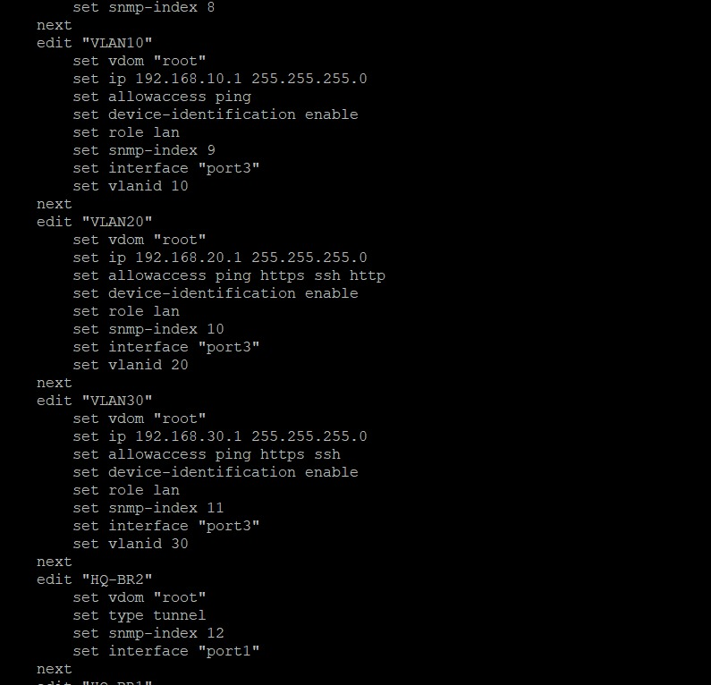
Purpose: To show the VLAN interface definitions on the HQ FortiGate that implement the Users, Servers, and Management segmentation, along with the start of the HQ-BR2 VPN tunnel interface definition.
Configuration/Action: Configuration excerpt from config system interface on HQ-FW-Primary.
Explanation:
- VLAN10 ("Users"): vdom root, IP 192.168.10.1/255.255.255.0, allowaccess ping, device-identification enabled, role lan, parent interface port3, vlanid 10.
- VLAN20 ("Servers"): vdom root, IP 192.168.20.1/255.255.255.0, allowaccess ping, https, ssh, http, device-identification enabled, role lan, parent interface port3, vlanid 20. The broader allowaccess list (including https/ssh/http) suggests this segment is used for administrative access to server-facing management interfaces as well as general server traffic.
- VLAN30 ("Management"): vdom root, IP 192.168.30.1/255.255.255.0, allowaccess ping, https, ssh, device-identification enabled, role lan, parent interface port3, vlanid 30 — consistent with a dedicated out-of-band-style management network reachable only via secure management protocols (HTTPS/SSH) plus ping.
- HQ-BR2: vdom root, type tunnel, interface port1 — the beginning of the IPsec virtual-interface definition for the HQ↔Branch2 tunnel, continued and cross-referenced with the VPN Phase-1 configuration in Figure 12.
- All three VLANs share the same physical parent interface (port3) and are distinguished purely by 802.1Q tag (vlanid 10/20/30), which is the standard FortiGate approach for router-on-a-stick style inter-VLAN routing through a single FortiLink-trunked port.
Expected Result: Each VLAN sub-interface should come up as a distinct Layer-3 gateway for its segment, allowing hosts in that VLAN to reach the FortiGate for both local traffic and cross-VLAN/cross-site traffic.
Verification: The get system interface output in Figure 2 confirms VLAN10 (and by extension the sibling VLAN20/VLAN30 interfaces shown here) reports status up with the addresses configured, matching this configuration excerpt.
Technical Significance: This VLAN structure is what allows the firewall policies in Section 5.7 to reference VLAN10/VLAN20/VLAN30 as distinct security zones and apply differentiated Users↔Servers↔Management access rules between them.

DHCP server configuration for these VLANs (referenced in the Person 1 scope) was not shown in the supplied CLI output — the config system dhcp server block was not among the captured screenshots, so DHCP scope, lease time, and DNS settings cannot be confirmed from the available evidence.

5.3 Routing Configuration (Person 1 & Person 2)
Static routing (rather than a dynamic routing protocol such as OSPF or BGP) is used throughout this design. This is an appropriate choice for a small, fixed-topology network with only three sites and a known set of point-to-point WAN links — static routes avoid the operational overhead of a dynamic routing protocol while remaining fully deterministic and easy to audit, which also simplifies the security review of traffic paths.
Figure 5: HQ-FW-Primary — Static Route Table (show router static)
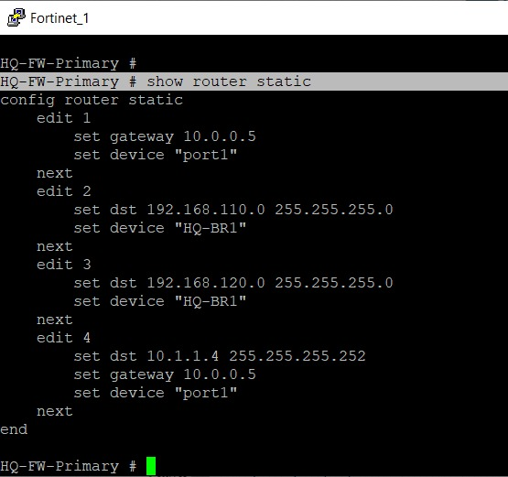
Purpose: To confirm the static routes configured on the HQ firewall that direct Internet-bound and branch-bound traffic.
Configuration/Action: CLI command show router static executed on HQ-FW-Primary.
Explanation:
- Route 1: gateway 10.0.0.5, device port1 — the default route (implicit 0.0.0.0/0) pointing to the HQ Edge router, used for all Internet-bound traffic.
- Route 2: destination 192.168.110.0/255.255.255.0, device "HQ-BR1" — routes Branch1's Users subnet over the HQ-BR1 IPsec tunnel interface rather than a physical port, which is the standard FortiGate method of directing traffic into a route-based VPN tunnel.
- Route 3: destination 192.168.120.0/255.255.255.0, device "HQ-BR1" — routes Branch1's Servers subnet over the same tunnel interface.
- Route 4: destination 10.1.1.4/255.255.255.252, gateway 10.0.0.5, device port1 — a static route to Branch1's WAN transit subnet via the HQ Edge router, required so that the underlying IPsec tunnel's peer address (10.1.1.6) is reachable over the WAN before the tunnel itself can be negotiated.
Expected Result: Traffic to 192.168.110.0/24 and 192.168.120.0/24 should be sent into the HQ-BR1 tunnel interface, while all other/default traffic exits via port1 toward the Internet/WAN.
Verification: Cross-referenced against Figure 7 (get router info routing-table all), which shows the resulting active routes derived from this static configuration.
Technical Significance: This routing configuration is what makes the HQ↔Branch1 VPN tunnel usable for real traffic — without routes 2 and 3 pointing at the "HQ-BR1" tunnel device, VLAN10/VLAN20 traffic destined for Branch1 would instead follow the default route out to the Internet and never enter the tunnel.

No equivalent static routes toward the Branch2 subnets (192.168.210.0/24, 192.168.220.0/24) via the "HQ-BR2" tunnel device are visible in this screenshot. Combined with the absence of Phase-2 selectors for HQ-BR2 in Figure 13, this suggests the HQ↔Branch2 path was not fully completed at the time of capture — see Section 7 (Troubleshooting).
Figure 6: BR1-FW — Static Route Table (show router static)
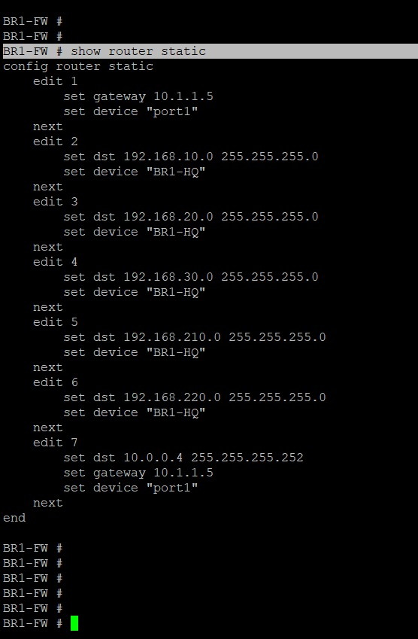
Purpose: To confirm the static routes configured on the Branch1 firewall for reaching HQ and returning WAN traffic.
Configuration/Action: CLI command show router static executed on BR1-FW.
Explanation:
- Route 1: gateway 10.1.1.5, device port1 — the default route via the BR1 Edge router.
- Routes 2–6: destinations 192.168.10.0/24, 192.168.20.0/24, 192.168.30.0/24, 192.168.210.0/24, and 192.168.220.0/24, all via device "BR1-HQ" — these route all three HQ VLANs and both Branch2 subnets into the BR1-HQ IPsec tunnel interface, implying that Branch1 reaches Branch2 by transiting through HQ (a hub-and-spoke VPN design) rather than via a direct Branch1↔Branch2 tunnel.
- Route 7: destination 10.0.0.4/255.255.255.252, gateway 10.1.1.5, device port1 — a static route to HQ's WAN transit subnet via the local Edge router, required to reach the tunnel peer address (10.0.0.6) before the VPN negotiates.
Expected Result: Traffic from Branch1 to any HQ VLAN, or to either Branch2 subnet, should be sent into the BR1-HQ tunnel; all other traffic follows the default route to the Internet.
Verification: Cross-referenced against Figure 8 (BR1 get router info routing-table all).
Technical Significance: Including the Branch2 subnets (192.168.210.0/24, 192.168.220.0/24) in this table confirms the hub-and-spoke intent of the design — HQ is meant to act as the transit hub between the two branches — even though the corresponding HQ-side Branch2 tunnel completion could not be confirmed (see the note above and Section 7).

Figure 7: HQ-FW-Primary — Full Routing Table (get router info routing-table all)
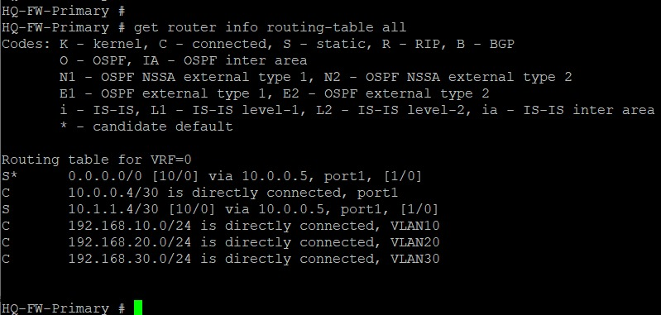
Purpose: To confirm the active/operational routing table on the HQ firewall, reflecting the combined effect of the static route configuration and directly connected interfaces.
Configuration/Action: CLI command get router info routing-table all executed on HQ-FW-Primary.
Explanation:
- S* 0.0.0.0/0 [10/0] via 10.0.0.5, port1 — the active default route (administrative distance 10).
- C 10.0.0.4/30 directly connected, port1 — the HQ WAN transit link.
- S 10.1.1.4/30 [10/0] via 10.0.0.5, port1 — the static route to Branch1's WAN transit subnet.
- C 192.168.10.0/24, 192.168.20.0/24, and 192.168.30.0/24 — the three HQ VLANs, each directly connected via VLAN10/VLAN20/VLAN30 respectively.
Expected Result: The routing table should list the default route, the connected HQ VLANs, and any static routes toward branch networks as active ("S"/"C") entries.
Verification: This output is itself the verification step for the static route configuration in Figure 5 — every route configured there (except, notably, the two 192.168.110.0/24 and 192.168.120.0/24 entries pointing at the HQ-BR1 tunnel) is reflected here as an active routing-table entry.
Technical Significance: This confirms Layer-3 reachability is correctly established for HQ's local VLANs and its WAN path; it is the routing evidence referenced when interpreting the ping test in Figure 15.

The 192.168.110.0/24 and 192.168.120.0/24 tunnel routes configured in Figure 5 are not visible in this particular routing-table capture. This may be because the screen was scrolled/truncated at capture time, or because those routes were not active at that moment (e.g., tunnel not yet up). This cannot be confirmed either way from the available evidence and should not be treated as a routing failure without further testing.
Figure 8: BR1-FW — Full Routing Table (get router info routing-table all)
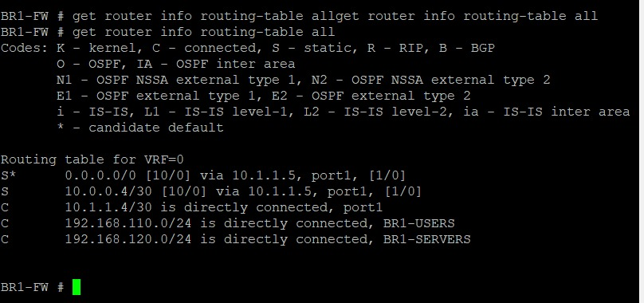
Purpose: To confirm the active routing table on the Branch1 firewall.
Configuration/Action: CLI command get router info routing-table all executed on BR1-FW.
Explanation:
- S* 0.0.0.0/0 [10/0] via 10.1.1.5, port1 — active default route toward the BR1 Edge router.
- S 10.0.0.4/30 [10/0] via 10.1.1.5, port1 — static route to HQ's WAN transit subnet.
- C 10.1.1.4/30 directly connected, port1 — the BR1 WAN transit link.
- C 192.168.110.0/24 (BR1-USERS) and C 192.168.120.0/24 (BR1-SERVERS) — the two Branch1 internal segments, directly connected.
Expected Result: The table should show the default route, the local Branch1 segments as connected, and the static route toward HQ's WAN transit subnet.
Verification: This output confirms the static configuration shown in Figure 6 is active for the WAN-facing routes; as with Figure 7, the tunnel-facing routes toward HQ/Branch2 VLANs are not visible in this particular capture.
Technical Significance: Confirms Branch1 has a valid path toward HQ's WAN gateway address, which is the prerequisite for the IPsec tunnel peer negotiation documented in Section 5.5.

Figure 9: BR2-FW — Full Routing Table (get router info routing-table all)
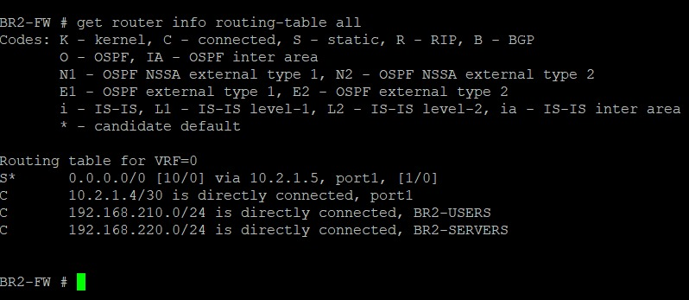
Purpose: To confirm the active routing table on the Branch2 firewall.
Configuration/Action: CLI command get router info routing-table all executed on BR2-FW.
Explanation:
- S* 0.0.0.0/0 [10/0] via 10.2.1.5, port1 — active default route toward the BR2 Edge router.
- C 10.2.1.4/30 directly connected, port1 — the BR2 WAN transit link, consistent with the inferred BR2-FW port1 address (10.2.1.6) discussed in Section 4.
- C 192.168.210.0/24 (BR2-USERS) and C 192.168.220.0/24 (BR2-SERVERS) — the two Branch2 internal segments, directly connected.
Expected Result: The table should show the default route and the two local Branch2 segments as connected.
Verification: This is the only routing evidence available for BR2-FW; it confirms the firewall itself is operational and correctly addressed on its WAN and LAN sides.
Technical Significance: No static route toward HQ (or a tunnel-device route) is visible in this capture, which is consistent with the incomplete HQ↔Branch2 VPN Phase-2 configuration noted in Figure 13 and discussed further in Section 7 (Troubleshooting).

5.4 WAN & Connectivity (Person 2)
Each site connects to the simulated Internet/WAN backbone through a dedicated Edge router, which in turn connects to a simulated ISP router (see Figure 1). The firewall at each site (HQ-FW-Primary, BR1-FW, BR2-FW) is the default gateway for its internal VLANs and uses the local Edge router as its own next-hop for all Internet- and inter-site-bound traffic, as configured in the static default routes shown in Figures 5, 6, and (implicitly) in Figure 9.
The point-to-point transit subnets between each firewall and its Edge router (10.0.0.4/30 at HQ, 10.1.1.4/30 at Branch1, 10.2.1.4/30 at Branch2) form the WAN underlay over which the IPsec tunnels described in Section 5.5 are built. Live reachability across these transit links is verified with the edge-to-firewall ping tests in Section 6 (Figures 10 and 11).

5.5 VPN Configuration (Person 2)
Site-to-site connectivity between HQ and each branch is provided by route-based IPsec VPN tunnels, using IKE version 2. Each tunnel is defined as a Phase-1 (IKE) interface plus one or more Phase-2 (IPsec SA) selectors, and is represented on the firewall as a virtual tunnel interface (e.g., "HQ-BR1") that can be referenced directly by static routes and firewall policies — the route-based VPN model used throughout this design, rather than policy-based VPN.
Figure 12: HQ-FW-Primary — IPsec Phase-1 (IKE) Configuration (show vpn ipsec phase1-interface)
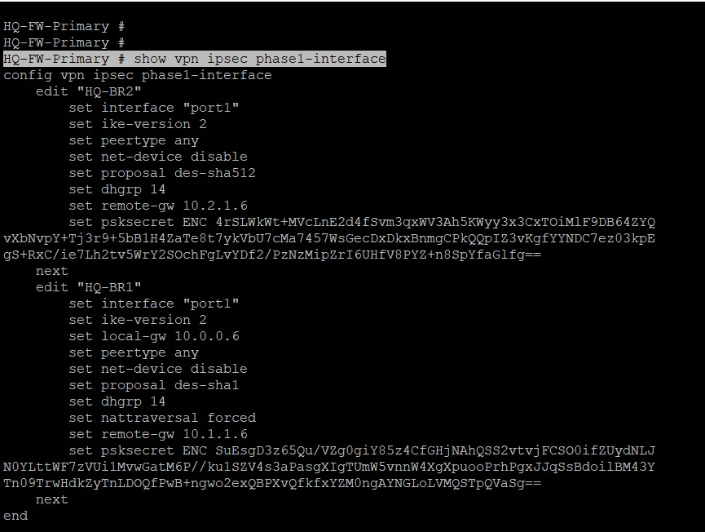
Purpose: To confirm the Phase-1 (IKE) parameters for both HQ↔Branch1 and HQ↔Branch2 site-to-site tunnels.
Configuration/Action: CLI command show vpn ipsec phase1-interface executed on HQ-FW-Primary.
Explanation:
- Tunnel "HQ-BR2": interface port1, ike-version 2, peertype any, proposal des-sha512, dhgrp 14, remote-gw 10.2.1.6, with an encrypted pre-shared key (psksecret ENC ...). This is the tunnel toward Branch2, whose remote-gw value is the evidence used in Section 4 to infer the BR2-FW port1 address.
- Tunnel "HQ-BR1": interface port1, ike-version 2, peertype any, proposal des-sha1, dhgrp 14, local-gw 10.0.0.6, remote-gw 10.1.1.6, nattraversal forced, with an encrypted pre-shared key. This is the tunnel toward Branch1.
- Both tunnels use Diffie-Hellman group 14 for key exchange. Encryption/authentication proposals differ between the two tunnels (des-sha512 for HQ-BR2 vs. des-sha1 for HQ-BR1) — note that DES is a legacy, weak cipher by modern standards and would not be recommended for a production deployment; its use here is consistent with a lab/training environment rather than a hardened design.
- The HQ-BR1 tunnel explicitly sets nattraversal forced, which forces NAT-T (UDP 4500 encapsulation) even if no NAT is detected between peers — this is a defensive setting in a lab environment where intermediate NAT behavior may be uncertain. The HQ-BR2 tunnel does not show this setting explicitly in the captured output.
Expected Result: Both Phase-1 negotiations should be able to establish (or re-establish) an IKE SA with the respective remote peer once both sides' Phase-1 parameters match and the WAN transit route is reachable.
Verification: Live tunnel status is confirmed in Figure 14 (diagnose vpn tunnel list); reachability to the remote-gw addresses is confirmed by the ping test in Figure 15 (for the HQ-BR1 remote-gw, 10.1.1.6).
Technical Significance: Phase-1 configuration is the foundation of the IPsec tunnel — it establishes the authenticated, encrypted channel (IKE SA) inside which the Phase-2 (IPsec SA) traffic-selector negotiation shown in Figure 13 takes place.

Figure 13: HQ-FW-Primary — IPsec Phase-2 (Traffic Selectors) Configuration (show vpn ipsec phase2-interface)
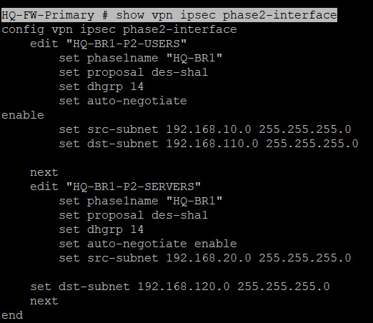
Purpose: To confirm which specific subnets are permitted to communicate through the HQ↔Branch1 IPsec tunnel.
Configuration/Action: CLI command show vpn ipsec phase2-interface executed on HQ-FW-Primary.
Explanation:
- Phase-2 selector "HQ-BR1-P2-USERS": phase1name HQ-BR1, proposal des-sha1, dhgrp 14, auto-negotiate enabled, src-subnet 192.168.10.0/255.255.255.0 (HQ Users VLAN), dst-subnet 192.168.110.0/255.255.255.0 (Branch1 Users subnet) — permits HQ Users↔Branch1 Users traffic through the tunnel.
- Phase-2 selector "HQ-BR1-P2-SERVERS": phase1name HQ-BR1, proposal des-sha1, dhgrp 14, auto-negotiate enabled, src-subnet 192.168.20.0/255.255.255.0 (HQ Servers VLAN), dst-subnet 192.168.120.0/255.255.255.0 (Branch1 Servers subnet) — permits HQ Servers↔Branch1 Servers traffic through the tunnel.
- Both Phase-2 entries are bound to the HQ-BR1 Phase-1 (phase1name HQ-BR1) — no Phase-2 selector for HQ-BR2 appears in this output, meaning that, as captured, no traffic selectors have been defined for the Branch2 tunnel, so even if the HQ-BR2 Phase-1 IKE SA were to come up, no actual traffic would be permitted through it yet.
- auto-negotiate enable on both selectors means the tunnel will attempt to bring the SA up proactively rather than waiting for triggering traffic, which is useful for keeping a persistent site-to-site tunnel available.
Expected Result: Traffic matching the exact src/dst subnet pairs defined here should be encrypted and sent through the HQ-BR1 tunnel; traffic between HQ and Branch2 subnets — with no Phase-2 selector defined — would not match this VPN and would instead be evaluated against the routing table/default route.
Verification: Cross-referenced against Figure 14, where the proxy IDs HQ-BR1-P2-SERVERS and HQ-BR1-P2-USERS appear as active entries under the HQ-BR1 tunnel, while the HQ-BR2 tunnel entry shows proxyid_num=0.
Technical Significance: This is the critical link between the addressing/VLAN design (Section 4) and the VPN — without a matching Phase-2 selector, subnets cannot exchange traffic through an IPsec tunnel even if the underlying Phase-1 IKE SA is healthy.

Figure 14: HQ-FW-Primary — Live VPN Tunnel Status (diagnose vpn tunnel list)
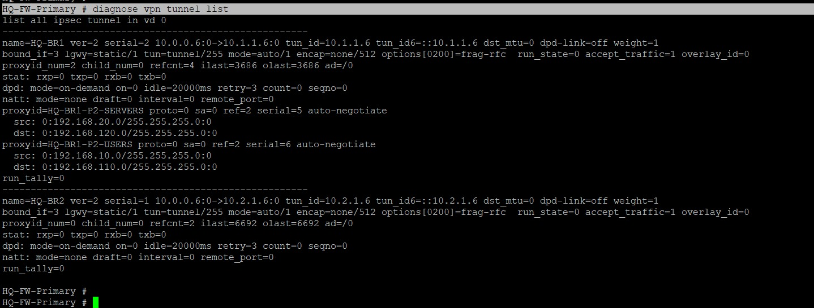
Purpose: To verify, from the live kernel/IPsec state, whether the configured tunnels are actually established and which Phase-2 selectors are active on each.
Configuration/Action: CLI command diagnose vpn tunnel list executed on HQ-FW-Primary.
Explanation:
- Tunnel "HQ-BR1": 10.0.0.6:0 → 10.1.1.6:0, bound to interface index 3, proxyid_num=2, with two active proxy IDs listed — HQ-BR1-P2-SERVERS (src 192.168.20.0/24 ↔ dst 192.168.120.0/24) and HQ-BR1-P2-USERS (src 192.168.10.0/24 ↔ dst 192.168.110.0/24) — matching exactly the Phase-2 configuration in Figure 13.
- Tunnel "HQ-BR2": 10.0.0.6:0 → 10.2.1.6:0, bound to the same interface index, but proxyid_num=0 and child_num=0 — i.e., no active Phase-2 child SA / proxy ID is currently negotiated for this tunnel, consistent with the absence of a Phase-2 selector for HQ-BR2 noted in Figure 13.
- Both tunnel entries report refcnt values (4 for HQ-BR1, 2 for HQ-BR2) indicating the tunnel objects are instantiated in the kernel, and both show dpd: mode=on-demand — Dead Peer Detection is configured to probe the peer only when there is a reason to (e.g., no return traffic), rather than continuously.
- The stat: rxp=0 txp=0 rxb=0 txb=0 counters for HQ-BR1 show no packets have been counted through this diagnostic view at the moment of capture, which is a normal idle-tunnel reading rather than evidence of failure — the actual ping test verifying data-plane connectivity is shown separately in Figure 15.
Expected Result: A fully operational tunnel should show non-zero proxyid_num/child_num with matching proxy IDs against the Phase-2 configuration, which is exactly what the HQ-BR1 entry shows. The HQ-BR2 entry, lacking any proxy ID, would not yet pass user traffic.
Verification: This output directly verifies that the HQ-BR1 tunnel's Phase-2 SAs are correctly instantiated with the expected subnets, and it is the primary evidence (alongside Figure 15's ping result) that the HQ↔Branch1 VPN is functional end-to-end for the configured subnets.
Technical Significance: This is the clearest single piece of evidence distinguishing the two tunnels' operational states: HQ-BR1 is configured and instantiated correctly for its Users and Servers selectors, while HQ-BR2 is only partially configured (Phase-1 exists, but no Phase-2 selector or active child SA), which is carried forward into the Troubleshooting section.

5.6 Remote Access VPN (Person 2)
The project scope assigns Remote Access (SSL) VPN configuration, allowing individual remote users to connect securely into the internal network, to Person 2. No screenshots of an SSL-VPN portal, SSL-VPN settings (config vpn ssl settings), or SSL-VPN user/group configuration were included in the supplied evidence.
Not explicitly shown/provided in the available evidence. The only indirect indicator is the ssl.root tunnel-type interface visible with no IP assigned in Figure 2, which is the default placeholder FortiOS creates for SSL-VPN regardless of whether it has been configured — its presence alone does not confirm that Remote Access VPN was actually configured or is functional. This requirement should be verified directly against the live device configuration (config vpn ssl settings / config vpn ssl web portal) rather than assumed complete from this report.

5.7 Firewall / Security Configuration (Person 3)
Security enforcement at HQ is implemented through a set of explicit firewall policies controlling traffic between the three internal VLANs, plus a dedicated policy for Users→Internet traffic that applies UTM inspection (IPS, Antivirus, Web Filter, and implicitly Application Control).
Figure 16: HQ-FW-Primary — Firewall Policy Table, Part 1 (show firewall policy)
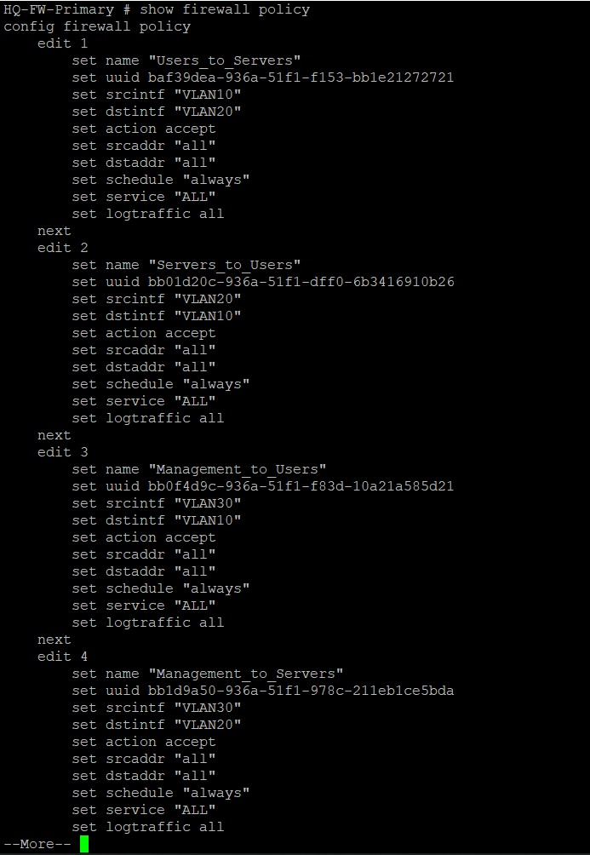
Purpose: To review the inter-VLAN firewall policies controlling traffic between Users, Servers, and Management segments at HQ.
Configuration/Action: CLI command show firewall policy executed on HQ-FW-Primary.
Explanation:
- Policy 1 "Users_to_Servers": srcintf VLAN10 → dstintf VLAN20, action accept, srcaddr/dstaddr "all", schedule "always", service "ALL", logtraffic all — permits all traffic from the Users VLAN to the Servers VLAN.
- Policy 2 "Servers_to_Users": srcintf VLAN20 → dstintf VLAN10, action accept, same open all/all/ALL match criteria — permits the return direction, Servers to Users.
- Policy 3 "Management_to_Users": srcintf VLAN30 → dstintf VLAN10, action accept — permits the Management segment to reach Users.
- Policy 4 "Management_to_Servers" begins at the bottom of this capture (continued in Figure 17): srcintf VLAN30 → dstintf VLAN20.
- Every policy in this capture uses srcaddr "all" / dstaddr "all" and service "ALL", meaning traffic is filtered purely by VLAN/zone (source and destination interface) rather than by specific host or service — an appropriate simplification for a lab/demonstration network, though a production deployment would typically narrow srcaddr/dstaddr/service to reduce the attack surface between zones.
- logtraffic all is set on every policy, ensuring all sessions matching these rules are logged for audit and troubleshooting purposes.
Expected Result: These policies should allow full bidirectional communication between the Users and Servers VLANs, and between Management and Users, while any traffic not matching an explicit policy is implicitly denied by FortiOS's default-deny behavior.
Verification: The presence of these accept policies, combined with the successful Web1 ping test to its VLAN20 gateway in Figure 22, is consistent with intra-VLAN and inter-VLAN traffic being permitted as designed. A direct Users→Servers connectivity test screenshot was not included in the supplied evidence.
Technical Significance: This is the access-control layer that turns the VLAN segmentation from Section 5.2 into an actual security boundary — VLANs alone only separate broadcast domains; these policies are what determine which VLANs may actually exchange traffic.

Figure 17: HQ-FW-Primary — Firewall Policy Table, Part 2 (continued)
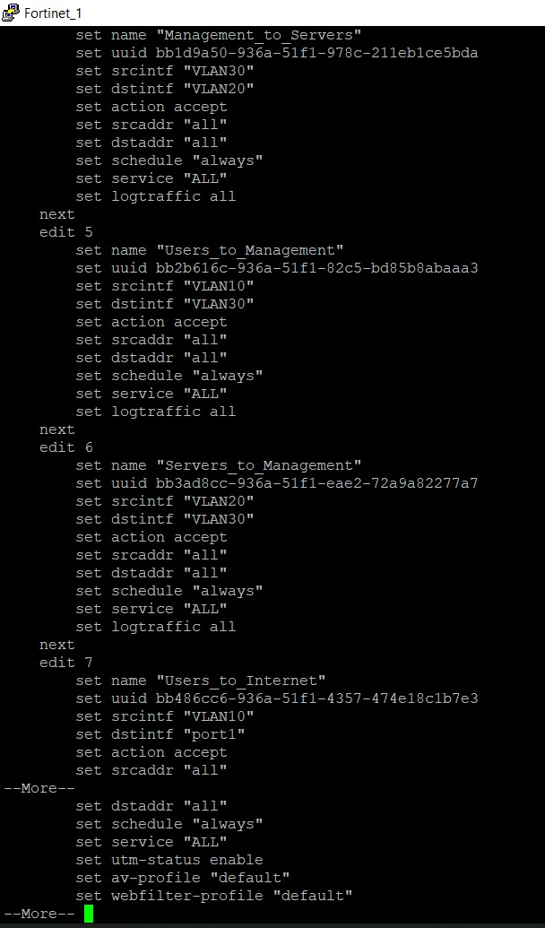
Purpose: To continue reviewing the inter-VLAN policy set and the beginning of the Internet-access policy.
Configuration/Action: CLI command show firewall policy executed on HQ-FW-Primary (scrolled further).
Explanation:
- Policy 4 "Management_to_Servers": srcintf VLAN30 → dstintf VLAN20, action accept, all/all/ALL — permits Management to reach the Servers VLAN.
- Policy 5 "Users_to_Management": srcintf VLAN10 → dstintf VLAN30, action accept — permits Users to reach the Management VLAN.
- Policy 6 "Servers_to_Management": srcintf VLAN20 → dstintf VLAN30, action accept — permits Servers to reach Management.
- Policy 7 "Users_to_Internet" begins here: srcintf VLAN10 → dstintf port1, action accept, srcaddr "all", and (visible at the top of the next screen capture) dstaddr "all", schedule "always", service "ALL", followed by utm-status enable, av-profile "default", and webfilter-profile "default" — this is the policy that routes and inspects HQ Users' Internet-bound traffic.
Expected Result: Together with Policy 3, these complete a fully-meshed set of bidirectional accept rules between all three HQ VLANs (Users↔Servers, Users↔Management, Servers↔Management), plus the start of the security-inspected Internet egress policy for Users.
Verification: The completeness of the six inter-VLAN policies (both directions for each of the three VLAN pairs) is confirmed simply by enumerating policies 1–6 across Figures 16 and 17 and observing that every ordered pair of VLANs (10↔20, 10↔30, 20↔30) is covered.
Technical Significance: Allowing Users to reach the Management VLAN (policy 5) is a notable design choice — in a hardened production network, direct Users→Management access would typically be restricted to specific admin hosts/services rather than left fully open; this is called out further under recommendations, not as a factual finding beyond what is shown.

Figure 18: HQ-FW-Primary — Firewall Policy Table, Part 3: Internet Access Policy with UTM Profiles
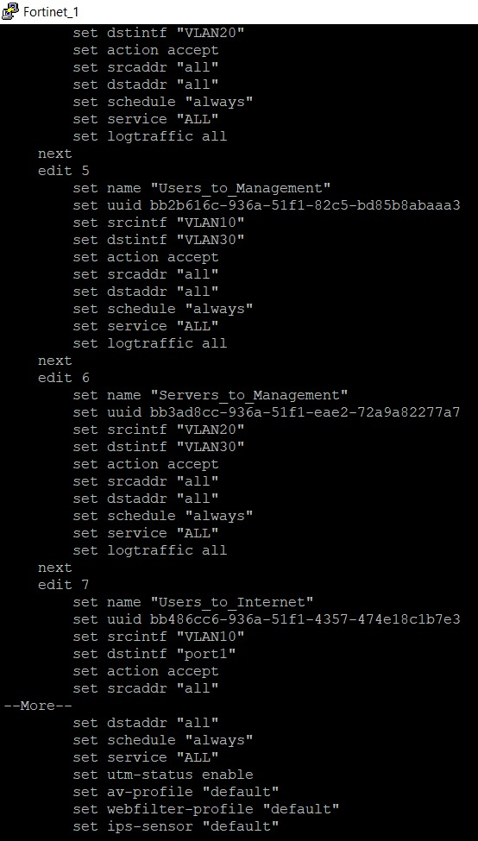
Purpose: To confirm the full set of UTM/security profiles applied to the Users→Internet policy.
Configuration/Action: CLI command show firewall policy executed on HQ-FW-Primary (further scrolled, showing policy 7 in full).
Explanation:
- Policy 7 "Users_to_Internet" (full view): srcintf VLAN10, dstintf port1, action accept, srcaddr "all", dstaddr "all", schedule "always", service "ALL", followed by utm-status enable, av-profile "default", webfilter-profile "default", and ips-sensor "default".
- utm-status enable turns on Unified Threat Management inspection for sessions matching this policy — without this flag, the av-profile/webfilter-profile/ips-sensor settings below it would not actually be applied to traffic.
- av-profile "default" applies FortiGate's default Antivirus scanning profile to file transfers/content passing through this policy.
- webfilter-profile "default" applies category- and reputation-based web filtering to HTTP/HTTPS traffic in this policy.
- ips-sensor "default" applies the IPS sensor detailed in Figure 19, inspecting traffic for known attack signatures.
Expected Result: Internet-bound traffic from the Users VLAN should be inspected for malware (AV), filtered against web categories (Web Filter), and scanned for intrusion attempts (IPS) before being allowed to exit via port1.
Verification: The three profile names (av-profile, webfilter-profile, ips-sensor) referencing "default" are cross-verified against the actual profile definitions captured in Figures 6/7... — specifically, ips-sensor "default" is confirmed to exist and be defined with real content in Figure 19.
Technical Significance: This single policy is the primary security control point between HQ end users and the Internet — it demonstrates the "defense-in-depth" UTM approach where firewalling (accept/deny by zone) is layered with content inspection (AV/Web Filter/IPS) rather than relying on access control alone.

No NAT or VIP (Virtual IP) configuration output (e.g., config firewall vip, or an ippool/NAT setting inside a policy) was included in the supplied evidence, even though NAT/VIP was listed in Person 3's scope. Whether source NAT is enabled on the Users_to_Internet policy, and whether any inbound VIP/DNAT objects exist for exposing internal services (e.g., the DNS or Web server shown in the topology), cannot be confirmed from the available screenshots.
Figure 19: HQ-FW-Primary — IPS Sensor Definitions (show ips sensor)
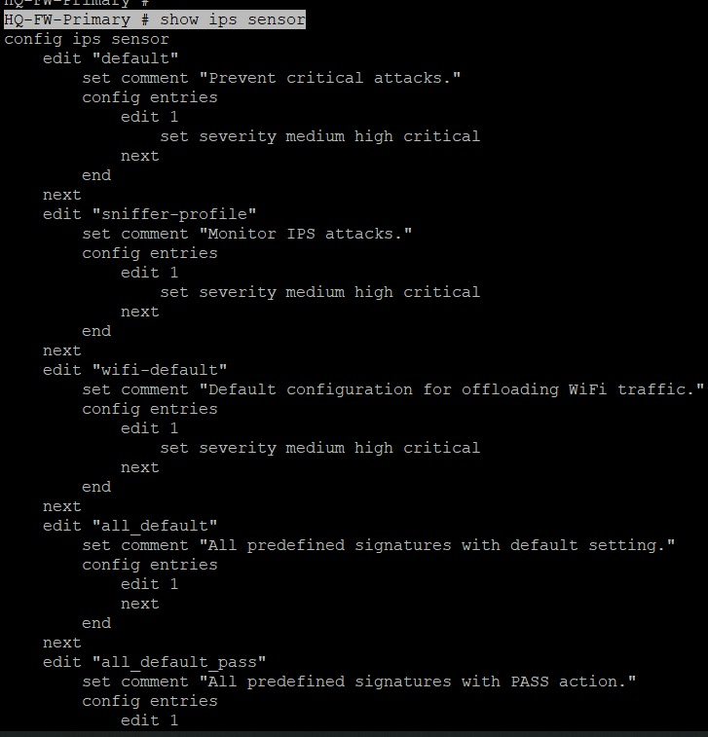
Purpose: To review the Intrusion Prevention System (IPS) sensor profiles available on the HQ firewall, including the "default" sensor referenced by the Users_to_Internet policy.
Configuration/Action: CLI command show ips sensor executed on HQ-FW-Primary.
Explanation:
- Sensor "default": comment "Prevent critical attacks.", with a single entry (edit 1) that sets severity medium, high, critical — meaning any signature match rated medium severity or above is acted upon (by default, FortiOS blocks matching traffic for its default IPS sensor entries unless overridden).
- Sensor "sniffer-profile": comment "Monitor IPS attacks.", same severity range (medium/high/critical), intended for passive/monitor-mode deployment rather than inline blocking.
- Sensor "wifi-default": comment "Default configuration for offloading WiFi traffic.", same severity filter — a FortiOS-provided default profile, not specific to this project's wired VLANs.
- Sensor "all_default": comment "All predefined signatures with default setting." — applies FortiGuard's recommended action for every signature rather than a severity-based subset.
- Sensor "all_default_pass" (visible at the bottom, truncated): comment "All predefined signatures with PASS action." — a monitor-only variant that logs but does not block, useful for baselining traffic before enforcing blocking.
Expected Result: The "default" sensor, being the one referenced by the Users_to_Internet policy, should actively inspect and act on medium/high/critical-severity attack signatures for Internet-bound Users traffic.
Verification: This output confirms the "default" IPS sensor referenced in Figure 18 exists and is defined with real filtering criteria rather than being an empty/placeholder profile.
Technical Significance: IPS is the layer that protects against exploit attempts and known-vulnerability attacks that would otherwise pass a simple firewall accept rule (which only checks zones/addresses/ports, not packet content); pairing it with the Users_to_Internet policy protects internal hosts from compromised or malicious external content.

Figure 20: HQ-FW-Primary — Application Control List Definitions (show application list)
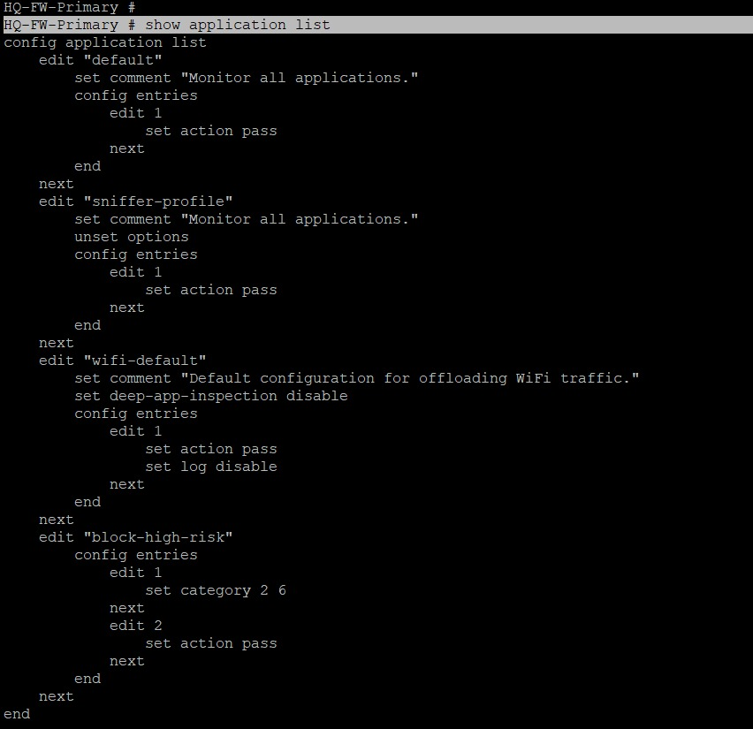
Purpose: To review the Application Control profiles available on the HQ firewall, which govern how specific applications/protocols are identified and handled.
Configuration/Action: CLI command show application list executed on HQ-FW-Primary.
Explanation:
- List "default": comment "Monitor all applications.", single entry with action pass — applications are identified and logged but not blocked.
- List "sniffer-profile": comment "Monitor all applications.", unset options, action pass — a passive monitoring variant.
- List "wifi-default": comment "Default configuration for offloading WiFi traffic.", deep-app-inspection disable, action pass, log disable — a lightweight profile intended for WiFi traffic offload rather than full inspection.
- List "block-high-risk": two entries — edit 1 sets category 2 6 (application categories 2 and 6, e.g., categories such as "P2P" and "Proxy" in FortiGuard's default numbering, though the exact category names are not shown in this output and are therefore not stated as fact here); edit 2 sets action pass for all other traffic (the catch-all entry). No explicit set action line is visible under edit 1 for categories 2/6 in this capture — FortiOS defaults an application-list entry with only a category match and no explicit action to "block", but this default behavior cannot be independently confirmed from the screenshot alone.
Expected Result: The "default" application-control list (monitor all, pass) suggests this profile is used for visibility rather than enforcement. The "block-high-risk" list is intended to block specific high-risk application categories while passing everything else.
Verification: Note that the Users_to_Internet policy in Figure 18 does not show an app-profile field in the captured output — so it cannot be confirmed from the available evidence whether any of these application-control lists (default or block-high-risk) is actually applied to Internet-bound Users traffic, or whether they exist only as defined-but-unattached profiles.
Technical Significance: Application Control complements IPS/AV/Web Filter by identifying traffic at the application layer regardless of port (e.g., distinguishing a proxy or P2P application riding over port 443) — it is most valuable when its profile is actually bound to a policy, which is a point flagged for verification in Section 7.

5.8 High Availability (HA) (Person 2 — HQ Cluster)
The HQ site is protected against a single firewall failure by an Active-Passive (A-P) HA cluster consisting of two FortiGate-VM64-KVM instances — HQ-FW-Primary and HQ-FW-Secondary — matching the dual-firewall symbol ("Fortinet-1"/"Fortinet-2") shown in the topology (Figure 1).
Figure 21: HQ FortiGate Cluster — HA Status (get system ha status)
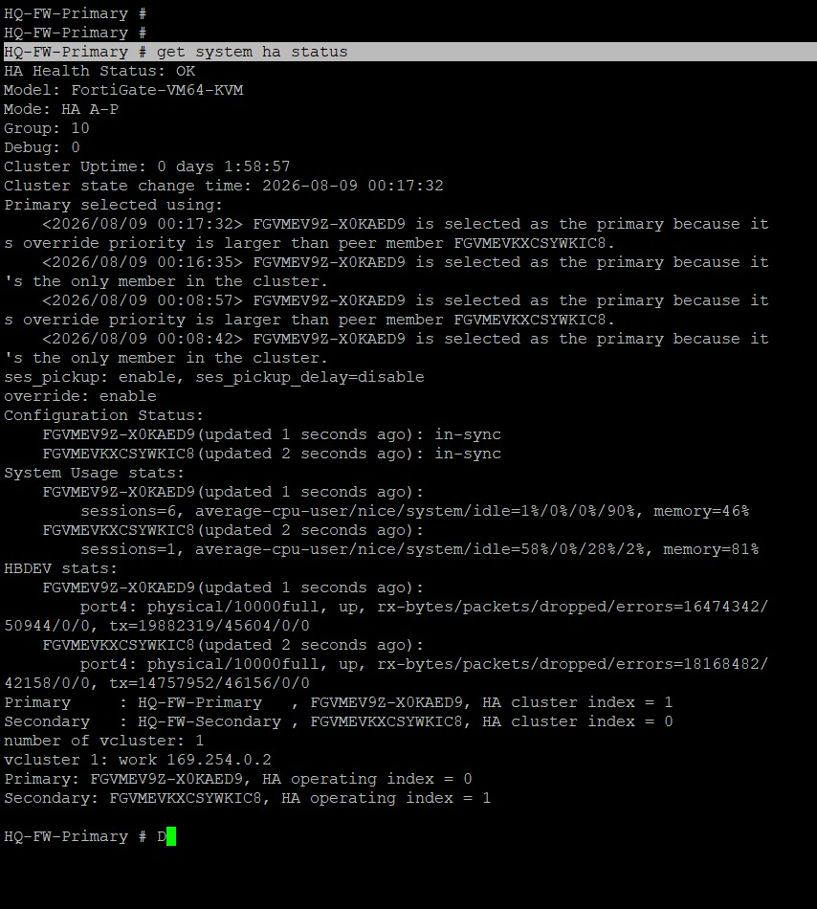
Purpose: To confirm the health, role assignment, and configuration-synchronization state of the HQ HA cluster.
Configuration/Action: CLI command get system ha status executed on HQ-FW-Primary.
Explanation:
- HA Health Status: OK, Mode: HA A-P (Active-Passive), Group: 10 — the cluster is healthy and operating in an active/passive failover configuration under HA group ID 10.
- Cluster Uptime: 0 days 1:58:57, with a state-change log showing HQ-FW-Primary (serial FGVMEV9Z-X0KAED9) was selected as the primary because its override priority is larger than its peer (HQ-FW-Secondary, serial FGVMEVKXCSYWKIC8) — i.e., the primary role was assigned deliberately via a configured priority rather than by chance/tie-break.
- Configuration Status: both cluster members (FGVMEV9Z-X0KAED9 and FGVMEVKXCSYWKIC8) report "in-sync", confirming the configuration database is identical/synchronized across both firewalls — a core requirement for a working HA pair, since an out-of-sync configuration could cause a failover to apply the wrong policy set.
- System Usage stats show both members actively reporting session counts and CPU/memory usage (Primary: 6 sessions, 46% memory; Secondary: 1 session, 81% memory) — both members are alive and reporting telemetry, not just configured.
- HBDEV stats show port4 as the heartbeat device on both members, physical/10000full, up, with non-zero rx/tx byte counters on both sides — confirming the heartbeat link (used for HA state synchronization and failure detection) is physically up and actively exchanging traffic.
- The final summary lines confirm: Primary = HQ-FW-Primary (HA cluster index 1), Secondary = HQ-FW-Secondary (HA cluster index 0), with vcluster 1 operating normally.
Expected Result: In this A-P configuration, HQ-FW-Primary should actively process all traffic while HQ-FW-Secondary remains in a synchronized standby state, ready to take over automatically if the primary fails or its heartbeat is lost.
Verification: The combination of "HA Health Status: OK", both members reporting "in-sync" configuration, and an active, traffic-carrying heartbeat link (HBDEV) on port4 together constitute direct verification that the HA cluster is fully operational, not merely configured.
Technical Significance: HA is what allows the entire HQ security/routing/VPN configuration documented in this report to survive a single firewall hardware or software failure without an outage — since configuration is kept in sync, a failover promotes the secondary to primary with an identical policy, routing, and VPN configuration already in place.

6. Verification & Testing
This section consolidates the live connectivity tests captured across the project — each test is a ping (ICMP echo) exercised from a specific point in the topology to confirm that a particular link or path is functioning as designed.
Figure 10: HQ-EDGE → HQ-FW-Primary — WAN Transit Link Test
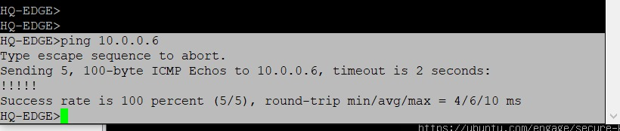
Purpose: To confirm Layer-3 reachability across the HQ WAN transit link between the HQ Edge router and the HQ firewall.
Configuration/Action: Command ping 10.0.0.6 executed from the HQ-EDGE router.
Explanation:
- Target 10.0.0.6 is HQ-FW-Primary's port1 address, as confirmed in Figure 2.
- 5 ICMP echo requests (100-byte) were sent; the result line reports Success rate is 100 percent (5/5), round-trip min/avg/max = 4/6/10 ms.
Expected Result: A 100% success rate with low, consistent round-trip times confirms the 10.0.0.4/30 transit subnet is correctly configured on both ends and that no filtering is blocking ICMP between the Edge router and the firewall.
Verification: The 5/5 success count and 0% implied loss in the command output is the verification itself.
Technical Significance: This is the first link in the HQ WAN path — every subsequent HQ-originated route toward the Internet or toward Branch1/Branch2 depends on this Edge-to-firewall hop being reachable.

Figure 11: BR1-EDGE → BR1-FW — WAN Transit Link Test
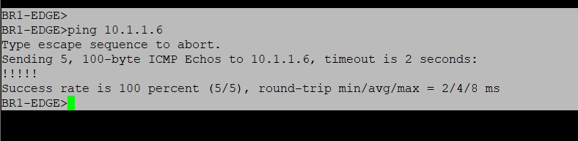
Purpose: To confirm Layer-3 reachability across the Branch1 WAN transit link between the BR1 Edge router and the BR1 firewall.
Configuration/Action: Command ping 10.1.1.6 executed from the BR1-EDGE router.
Explanation:
- Target 10.1.1.6 is BR1-FW's port1 address, as confirmed in Figure 3.
- 5 ICMP echo requests were sent; the result reports Success rate is 100 percent (5/5), round-trip min/avg/max = 2/4/8 ms.
Expected Result: A 100% success rate confirms the 10.1.1.4/30 Branch1 transit subnet is correctly configured and reachable end-to-end.
Verification: The 5/5 success count in the command output is the verification.
Technical Significance: Mirrors the HQ-side test in Figure 10 for the Branch1 site, confirming both ends of the HQ↔Branch1 path have a functioning local WAN hop before the IPsec tunnel itself is evaluated.

Figure 15: HQ-FW-Primary → BR1-FW WAN Address — Site-to-Site Reachability Test
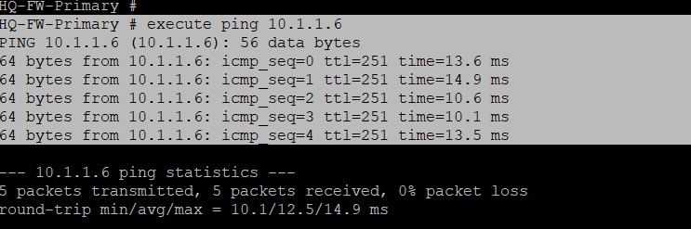
Purpose: To confirm that HQ can reach Branch1's WAN gateway address (the IPsec tunnel's remote-gw) across the WAN/Internet path, and to observe the round-trip characteristics of that path.
Configuration/Action: Command execute ping 10.1.1.6 executed directly on HQ-FW-Primary.
Explanation:
- 5 echo requests to 10.1.1.6 (BR1-FW's port1/remote-gw address) all received replies with ttl=251, times ranging 10.1–14.9 ms.
- Result: 5 packets transmitted, 5 packets received, 0% packet loss, round-trip min/avg/max = 10.1/12.5/14.9 ms.
Expected Result: HQ should be able to reach Branch1's WAN address with 0% loss, confirming the underlying IP path used by the IPsec Phase-1 negotiation (Figure 12) is functional.
Verification: 0% packet loss across 5 packets is the direct verification; the ttl=251 value is also consistent with a small, few-hop simulated WAN rather than a heavily routed path.
Technical Significance: This test confirms the underlay path required for the HQ-BR1 IPsec tunnel to negotiate is healthy — it does not by itself confirm the tunnel's encrypted user-subnet traffic (192.168.10.0/24 ↔ 192.168.110.0/24) is passing, which is instead evidenced by the active Phase-2 proxy IDs in Figure 14.

Figure 22: Web1 (HQ Servers VLAN Host) → VLAN20 Gateway — Local Segment Connectivity Test
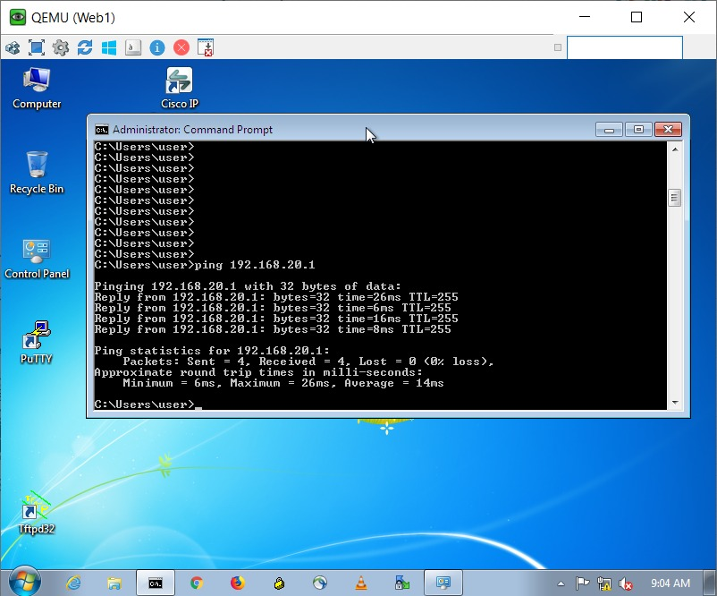
Purpose: To confirm that an end host placed in the HQ Servers VLAN (Web1, per the topology in Figure 1) has working Layer-3 connectivity to its default gateway.
Configuration/Action: Command ping 192.168.20.1 executed from a Windows command prompt inside the Web1 virtual machine.
Explanation:
- Target 192.168.20.1 is the VLAN20 (Servers) interface IP configured on HQ-FW-Primary, as confirmed in Figure 4.
- 4 packets of 32 bytes were sent; all 4 replies were received (times 6–26 ms, TTL=255), reported as Packets: Sent = 4, Received = 4, Lost = 0 (0% loss).
Expected Result: A healthy end host in VLAN20 should be able to reach its configured default gateway with 0% loss, confirming both the VLAN20 addressing/DHCP-or-static assignment on the host and the FortiGate's VLAN20 interface are correctly configured and operational.
Verification: 0% loss across all 4 packets, with a TTL of 255 (indicating the reply came directly from the gateway itself, one hop away), is the verification.
Technical Significance: This test confirms the Servers VLAN is usable end-to-end from an actual guest OS perspective, complementing the firewall-side interface/VLAN configuration evidence in Figures 2 and 4 with a client-side confirmation.

Summary of connectivity tests performed:
Test | Source | Target | Result | Reference
WAN transit — HQ | HQ-EDGE | 10.0.0.6 (HQ-FW port1) | 5/5, 0% loss | Figure 10
WAN transit — Branch1 | BR1-EDGE | 10.1.1.6 (BR1-FW port1) | 5/5, 0% loss | Figure 11
Site-to-site path — HQ→BR1 | HQ-FW-Primary | 10.1.1.6 (BR1-FW port1) | 5/5, 0% loss | Figure 15
Local VLAN gateway — Servers | Web1 (VLAN20 host) | 192.168.20.1 (VLAN20 gateway) | 4/4, 0% loss | Figure 22
No screenshot was supplied showing a direct end-to-end ping between a Branch1 host (BR1-PC/BR1-SERVER) and an HQ host across the IPsec tunnel, nor any test involving Branch2. These specific cross-tunnel user-traffic tests are therefore not explicitly confirmed in this report, even though the Phase-2 configuration evidence in Figures 13 and 14 strongly indicates the HQ-BR1 path is ready to carry such traffic.

7. Troubleshooting
The evidence collected does not show an active failure being diagnosed and resolved in real time (e.g., no error message, failed ping, or down-state screenshot was supplied). However, cross-referencing the configuration and status screenshots surfaces one clear discrepancy in the HQ↔Branch2 path, which is documented here as an open item rather than a resolved incident.

7.1 HQ↔Branch2 IPsec Tunnel — Incomplete Phase-2 / No Active Child SA
Observation: The HQ-BR2 Phase-1 (IKE) tunnel is defined in Figure 12 with a remote-gw of 10.2.1.6, but no Phase-2 selector referencing phase1name "HQ-BR2" appears in the Phase-2 configuration (Figure 13), and the live tunnel diagnostic in Figure 14 confirms this — the HQ-BR2 entry shows proxyid_num=0 and child_num=0, versus HQ-BR1's proxyid_num=2 with two active, named proxy IDs.
Likely Cause: Based on the configuration evidence alone, the most probable explanation is that Phase-2 selectors (src-subnet/dst-subnet pairs analogous to HQ-BR1-P2-USERS/SERVERS) were never created for the HQ-BR2 tunnel — this is a configuration gap rather than a connectivity failure, since the underlying WAN path to 10.2.1.6 is not shown as tested in the available evidence either.
Troubleshooting Process (as evidenced): The report author cross-referenced three independent CLI outputs — Phase-1 configuration (Figure 12), Phase-2 configuration (Figure 13), and live tunnel diagnostics (Figure 14) — and confirmed all three are internally consistent in showing HQ-BR1 complete and HQ-BR2 incomplete. No screenshot shows an explicit debug/diagnose command (e.g., diagnose debug application ike) being run against the HQ-BR2 tunnel specifically.
Recommended Solution: Define Phase-2 selectors for the HQ-BR2 tunnel (e.g., HQ-BR2-P2-USERS: 192.168.10.0/24 ↔ 192.168.210.0/24, and HQ-BR2-P2-SERVERS: 192.168.20.0/24 ↔ 192.168.220.0/24, mirroring the HQ-BR1 pattern), add the corresponding static routes on HQ pointing 192.168.210.0/24 and 192.168.220.0/24 at the HQ-BR2 tunnel device (mirroring Figure 5's routes 2–3), and add matching Phase-2/route configuration on BR2-FW pointing back at HQ.
Verification of Fix: Not explicitly shown/provided in the available evidence — this remediation was not captured as completed in the supplied screenshots and should be re-verified with a fresh diagnose vpn tunnel list capture (expecting proxyid_num > 0 for HQ-BR2) followed by an end-to-end ping test between an HQ host and a Branch2 host.

7.2 Other Open Items Flagged During Review
- DHCP server configuration (Person 1 scope) — not present in the supplied evidence; cannot confirm scope ranges, lease times, or DNS options for the HQ VLANs.
- NAT / VIP configuration (Person 3 scope) — not present in the supplied evidence; source NAT behavior on the Users_to_Internet policy and any inbound VIP objects for HQ servers (DNS/Web) are unconfirmed.
- Remote Access (SSL) VPN (Person 2 scope) — not present in the supplied evidence beyond the default, unconfigured ssl.root placeholder interface noted in Figure 2.
- Application Control binding — the block-high-risk application list exists (Figure 20) but no policy in the captured evidence shows an app-profile field referencing it, so it is unconfirmed whether it is actively enforced.
- BR2-FW firewall policy and VPN configuration were not captured, so Branch2's own security posture (equivalent to Figures 16–20 for HQ) cannot be documented from the available evidence.

8. Final Results
Requirement Area | Owner | Status | Evidence
HQ Core/Access switching & VLANs (Users/Servers/Mgmt) | Person 1 | Completed & Verified | Figures 1, 2, 4
HQ DHCP services | Person 1 | Not confirmed | No evidence supplied
HQ inter-VLAN routing & static routing | Person 1 | Completed & Verified | Figures 4, 5, 7
HQ HA interfaces / cluster | Person 1 / 2 | Completed & Verified | Figures 1, 21
Branch1 build & connectivity | Person 2 | Completed & Verified | Figures 3, 6, 8, 11
Branch2 build & connectivity | Person 2 | Partially verified (routing only) | Figure 9
Site-to-site VPN — HQ↔Branch1 | Person 2 | Completed & Verified | Figures 12, 13, 14, 15
Site-to-site VPN — HQ↔Branch2 | Person 2 | Incomplete (Phase-1 only) | Figures 12, 14 (see Section 7)
Remote Access (SSL) VPN | Person 2 | Not confirmed | No evidence supplied
HA configuration (HQ cluster) | Person 2 | Completed & Verified | Figure 21
Firewall policies (inter-VLAN + Internet) | Person 3 | Completed & Verified | Figures 16, 17, 18
NAT / VIP | Person 3 | Not confirmed | No evidence supplied
IPS sensor | Person 3 | Completed & Verified | Figures 18, 19
Antivirus profile | Person 3 | Configured (bound to policy) | Figure 18
Web Filter profile | Person 3 | Configured (bound to policy) | Figure 18
Application Control | Person 3 | Defined, binding unconfirmed | Figure 20
Connectivity testing | Person 3 | Partially completed | Figures 10, 11, 15, 22
Overall, HQ's internal architecture (VLANs, inter-VLAN routing, firewall policy set, IPS/AV/Web Filter security profiles, and the HA cluster) is fully implemented and verified by the supplied evidence. The HQ↔Branch1 site-to-site VPN is implemented and verified end-to-end, including live tunnel and reachability testing. The HQ↔Branch2 VPN, Remote Access VPN, DHCP, and NAT/VIP configuration are either incomplete or simply undocumented in the evidence provided, and are captured as explicit follow-up items rather than assumed complete.

9. Conclusion
This project successfully demonstrates the core design principles of a segmented, security-focused enterprise network built on FortiGate firewalls: Layer-3 VLAN segmentation with explicit, zone-based firewall policies; UTM security profiling (IPS, Antivirus, Web Filtering) applied at the Internet edge; route-based site-to-site IPsec VPN connecting geographically separate branch offices back to a central hub; and an Active-Passive HA cluster protecting the headquarters firewall against single-point failure.
The HQ site and its connection to Branch1 represent a complete, verified reference implementation of this design — from physical/VLAN interface configuration through routing, IPsec tunnel establishment, and live connectivity testing. The Branch2 connection and several supporting requirements (Remote Access VPN, DHCP, and NAT/VIP) remain partially implemented based on the available evidence, and are clearly identified in Sections 7 and 8 so that the project team can prioritize closing them before the design is considered fully production-ready.
As a learning exercise, the project illustrates practical, hands-on experience across the full stack of enterprise network security: switching and VLAN design, dynamic-free (static) multi-site routing, IPsec VPN theory and configuration (Phase-1/Phase-2), FortiGate UTM security profiles, and firewall high availability — directly relevant to the Advanced Computer Networks and cybersecurity coursework this project supports.

10. Appendix

10.1 Key CLI Commands Referenced in This Report
Command | Purpose
get system interface | Show physical/logical interface status and IP addressing
show firewall policy | List configured firewall policy rules
show ips sensor | List IPS sensor profiles and their signature-severity actions
show application list | List Application Control profiles
show vpn ipsec phase1-interface | Show IKE (Phase-1) VPN tunnel configuration
show vpn ipsec phase2-interface | Show IPsec (Phase-2) traffic-selector configuration
diagnose vpn tunnel list | Show live/operational IPsec tunnel and proxy-ID state
show router static | List configured static routes
get router info routing-table all | Show the active/operational routing table
get system ha status | Show HA cluster health, role, and sync status
execute ping <ip> / ping <ip> | Test ICMP reachability from the FortiGate CLI or a router/host

10.2 VPN Parameter Summary
Tunnel | Local GW | Remote GW | IKE | Proposal | DH Grp | Phase-2 Selectors
HQ-BR1 | 10.0.0.6 | 10.1.1.6 | v2 | des-sha1 | 14 | 192.168.10.0/24↔192.168.110.0/24; 192.168.20.0/24↔192.168.120.0/24
HQ-BR2 | 10.0.0.6 (implied) | 10.2.1.6 | v2 | des-sha512 | 14 | None defined (see Section 7.1)

10.3 Figure Index
- Figure 1 — Complete Lab Topology (PNETLab)
- Figure 2 — HQ-FW-Primary Interface Status
- Figure 3 — BR1-FW Interface Status
- Figure 4 — HQ VLAN10/20/30 and HQ-BR2 Tunnel Configuration
- Figure 5 — HQ-FW-Primary Static Route Table
- Figure 6 — BR1-FW Static Route Table
- Figure 7 — HQ-FW-Primary Full Routing Table
- Figure 8 — BR1-FW Full Routing Table
- Figure 9 — BR2-FW Full Routing Table
- Figure 10 — HQ-EDGE → HQ-FW-Primary Ping Test
- Figure 11 — BR1-EDGE → BR1-FW Ping Test
- Figure 12 — HQ IPsec Phase-1 Configuration
- Figure 13 — HQ IPsec Phase-2 Configuration
- Figure 14 — HQ Live VPN Tunnel Status
- Figure 15 — HQ-FW-Primary → BR1-FW WAN Ping Test
- Figure 16 — HQ Firewall Policy Table, Part 1
- Figure 17 — HQ Firewall Policy Table, Part 2
- Figure 18 — HQ Firewall Policy Table, Part 3 (UTM Profiles)
- Figure 19 — HQ IPS Sensor Definitions
- Figure 20 — HQ Application Control List Definitions
- Figure 21 — HQ HA Cluster Status
- Figure 22 — Web1 → VLAN20 Gateway Ping Test

