

**Is 301: E-Commerce**

**Books of knowledge**

**Supervised by:**

**DR. Mona Nasr**

**T.A Mai Mohamed**

**Prepared by.**

Mahmoud Khaled 62324

Bassem Yehia 56598

**Intro**

In this project we made a website called books of knowledge, through it we can sell various types of useful books either it’s legal or not, books concerning dark magic, scientific, astronomy,…etc.

Our goal is to help the customers look and deal with our website with ease which is why we made it look simple and we did our best to make it a lot easier to use than a lot of other sites, and of course we made sure this site is secured and keeps the identity of the users hidden, which is why we didn’t make a registration page.

All the user needs to enter our site is to enter fake info in the login form to access our site, that was necessary to keep bots away from accessing this site.

And obviously we aren’t responsible if anyone got caught using this site, we already done our part by making this site easy to access and warn the user in the first page about what might happen to him/her if they aren’t careful, in short access our site at your own risk.

Of course, we sell the books at a reasonable price, not cheap and not expensive except the illegal ones they are obviously expensive.

More importantly, about the design of the page, firstly we used html to create the text, buttons, paragraphs, header, footer and many other things.

And then we used css to make the design of the site more gorgeous, we colored the header part and used bootstrap to design the footer and make it look more cooler, we used css to color the hovering function too of course and add a gradient color to the background, we’ll talk about all of this in more details in the next part.

And lastly we used java script to add more functionality to the buttons and to do more cool things in the login screen.

When we first open the project a warning screen will appear to tell us it’s dangerous to enter this site carelessly, obviously because we sell some illegal books here in the dark magic section.

**HTML & CSS description:**

Here we made only two files one for the login screen, the other for the rest of the site and many other css files, we’ll talk later about why we made only one file for all of the site.

First let’s talk about the login.html, here we made many classes and a lot of work to make the login screen more beautiful then the normal ones, we used css to make the background color fade between dark grey to normal grey color then to white.

About the colors we followed a certain color pallet to make the design of the site more comfortable to the eyes then we used gradient colors to make the site looks more advanced and beautiful than the normal dull look of the 90s.

We get the pallet from color hunt site, it’s a good site which have a lot of cool combination of colors made by expert designers.

Then we colored the buttons red to suit the gorgeous background color which fades from dark grey to white with a circular shape in the side.

After clicking login a Pop-down screen will appear, this screen is the login form as showen in the next figure.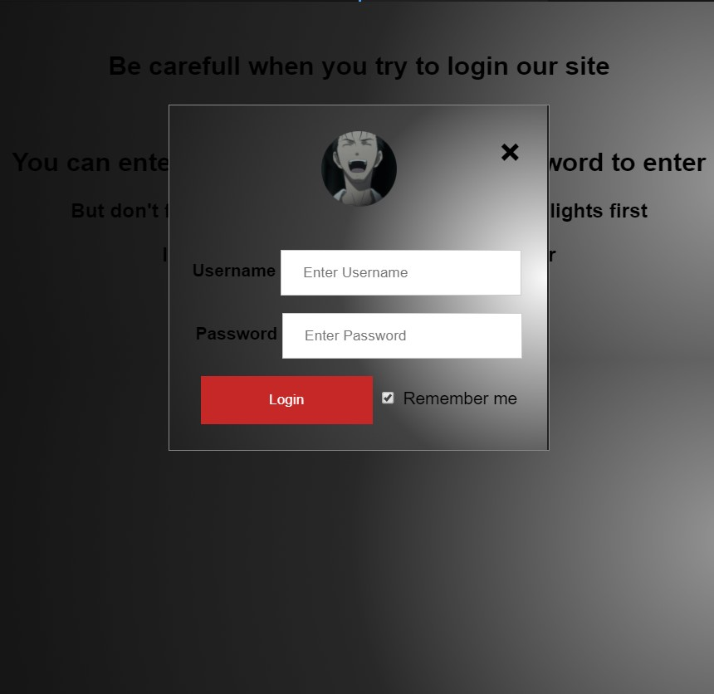

As we can see the combination of colors is superb and comfortable to the eyes all thanks to the css code we wrote and the pallet we followed to make this design.

We used css to align the text next to the labels and to position everything around each other which was a lot of work.

Now we’ll talk about the design of the index.html, which is the design of our site.

First let’s talk about the header, we used colors close to those in the login screen and gradient too of course, then we used css to add hovering function to the texts there which was the site name “books of knowledge” and the other texts which are home, about and welcome to our site which of course appears because we are already logged in the site, oh and by the way no one can access the index file without logging in the site obviously.

Under the header we’ll find a menu bar which was designed the same way as the header, except that the buttons there were accessible.

Each button can change the content in the body of the site to one of the sections where we sell our books as shown in the next few figures.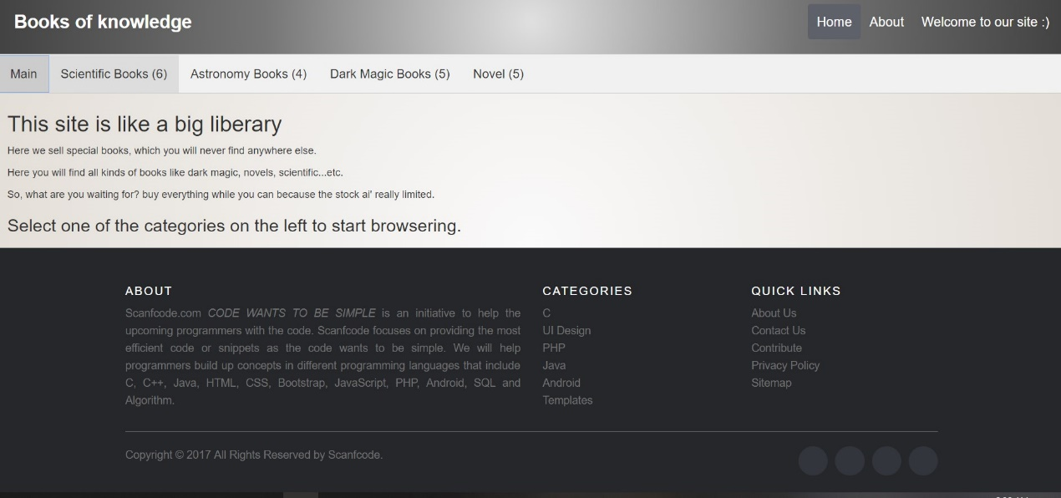

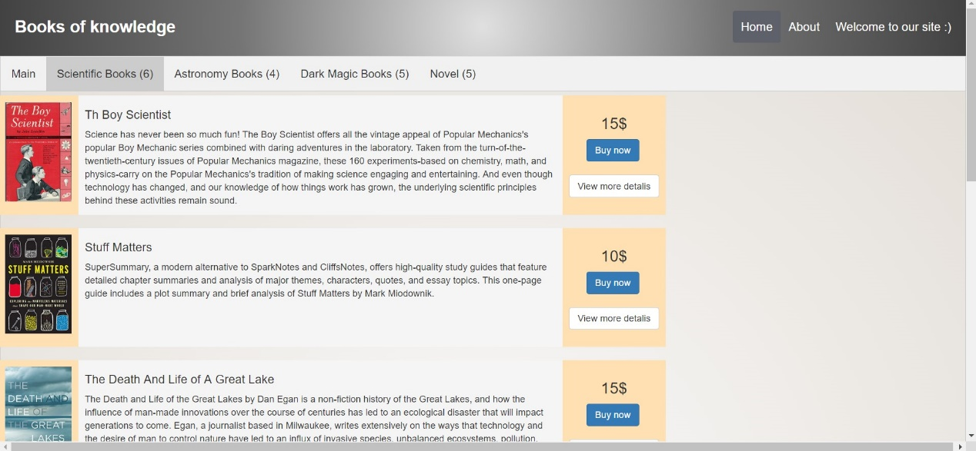

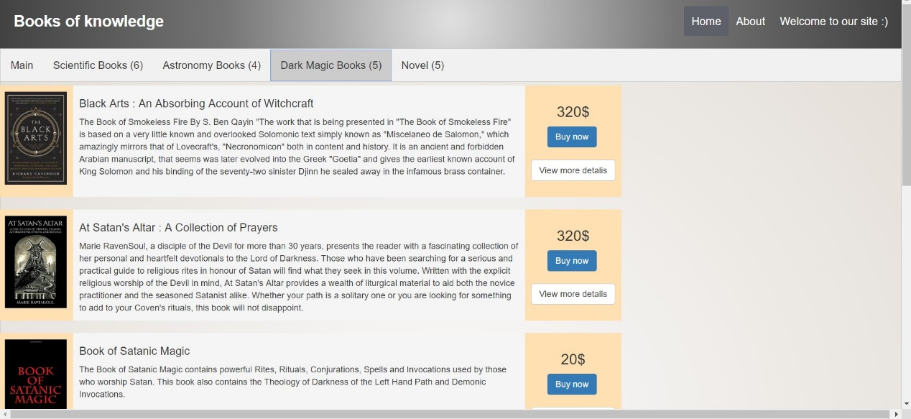

As we can see each button in the menu direct us to a different section which is why we don’t need any more html files for the site.

Making this work was one of the hardest parts in the project and was very challenging.

We’ll talk about how we done it later in the html description.

So, the next part we’ll talk about is how we designed the books next to the description next to the buttons, we made it as a table with three unequal columns, we set the right and left columns to auto while giving the middle part a width of 50% with padding as shown in the next figure:

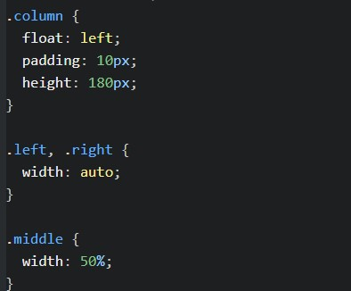

By creating this table we are allowed to sort it’s content in a vertical manner instead of the default horizontal one.

Then we added two buttons using bootstrap to make them look more advanced and to suit the rest of the site, and for the changes to show we needed to include a.k.a link some bootstrap libraries which unexpectedly took us a lot of time to figure out.

In default the button will be in vertical lines so to make them horizontal as seen in the figures above we simply added two break lines and we added break lines after each book table of course to make the spaces between them as seen in the figure.

That was simply how we solved the problem of adding all of the book section in a single vertical table, next we’ll talk about the footer as seen in the second figure.

The footer was made using bootstrap classes so to make it look like as we can see now we needed to link some bootstrap libraries, without adding those libraries all of the paragraphs will appear in top of each other which was really chaotic and ugly, so in short every time adding code from bootstrap we need to link the library in order for it to work as we except it to.

That was in short all we did to make the site as organized and beautiful as we can see now which was really hard and took us a lot of time to accomplish, next we’ll talk about the few java script code we wrote.

**JAVA SCRIPT**

Most of the java script files in our project was bootstrap libraries which we needed as we talked in the previous section, the rest are for some minor tasks we needed to accomplish.

The first one was to switch from one tap to another, which was really hard to do and took us a lot of time to come up with this idea, so first let’s take a look at how the code looks like and then we’ll explain how it was made, look at the next figure:

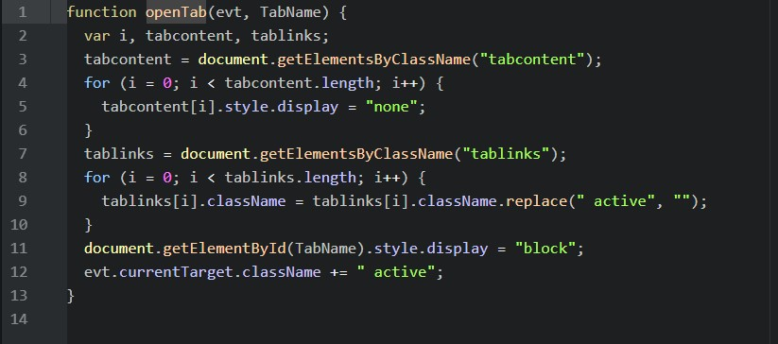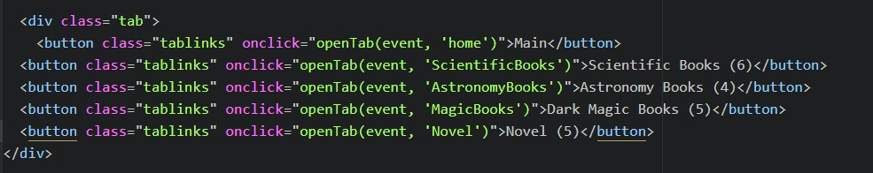

The first picture shows the java script code and the second one shows how we accessed it in the html file.

So, what the js file simply do is it takes the active tab name and make it visible and hides the rest of the inactive tab contents, we made two variables tab content and tab links, the content refers to the div which contain the tab content and the links refers to the classes as shown in the figure, in the html code there is an attribute named onclick in the button which calls the java script function named open tab and there we pass the event which turns to active when we click on it and next to it is the name of the tab (the id of the div).

That was simply how we made this part, next we’ll talk about the other java script file which is the last part we made.

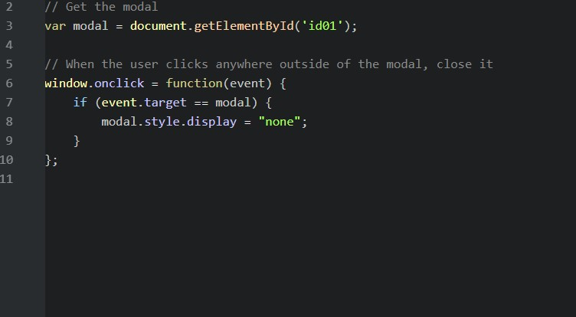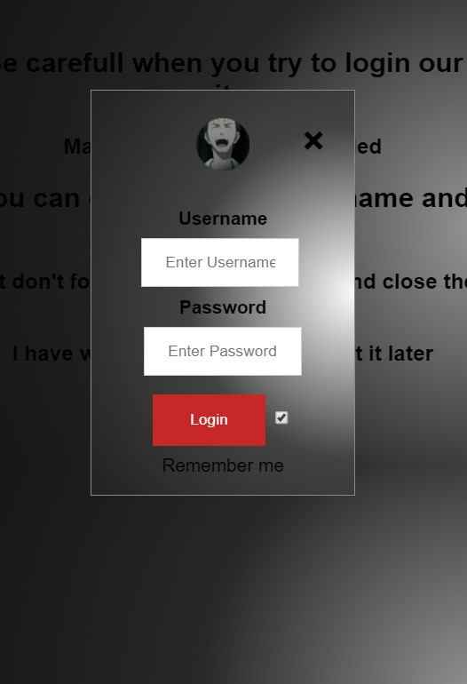

This part is very simple and easy, all this code does is close the login form tab when we click in any place outside the form.

The form name is medal and the code detect if we are targeting the medal or not, if we click anyplace outside this medal the display value becomes non, in other words it closes the medal, that is simply all what this code does.

That was all concerning this project, we talked about most of the functionality of html, css and java script code in a simple manner without going in any complicated details