**Database Facebook project**

**Participations: -**

|  |  |
| --- | --- |
| ID | Name |
| 20221427861 | عبدالله حسين إبراهيم حسين محمد |
| 20221460231 | محمود عصام فتحي جبر |
| 20221369225 | زياد اشرف إبراهيم طاهر |
| 20221374025 | زياد أشرف حافظ جابر مصطفي |
| 20221374041 | عبدالرحمن اشرف رجب |

**ER Diagram: -**

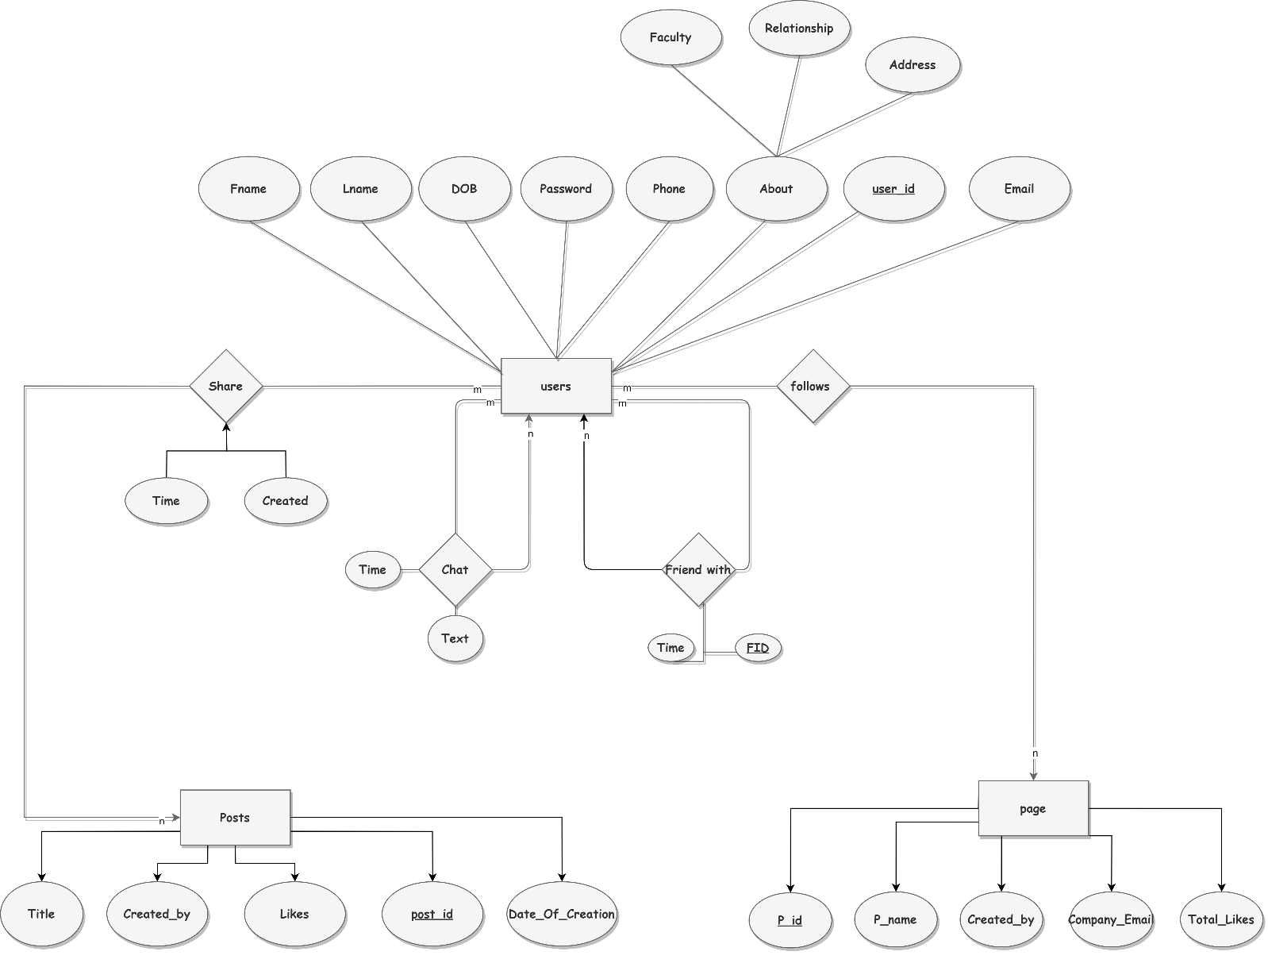

**Schema :-**

**1-Entities**

**Users(user_id,Fname,Lname,Date_of_Birth,Password,Phone,Faculty,Relationship,Address)**

**Posts(post_id,likes,date_of_creation,created_by,title)**

**Page(p_id,Page_date_of_creation,p_name,total_likes)**

**2-Relations**

**Chat (chat_id, user1_id, user2_id, text,time)**

**There is a "many-to-many" relationship within the user entity itself, where both user1_id and user2_id are linked to the user_id in the User entity using foreign keys, and the chat_id serves as the primary key.**

**Friend_with(Friend_id,user1_id,user2_id,date)**

**There exists a "many-to-many" relationship within the user entity itself, where user1_id and user2_id are connected to the user_id in the User entity through foreign keys.**

**Share(user_id,post_id,time,Created)**

**There is a "many-to-many" relationship between the User entity and the Posts entity, where the composite primary keys user_id and post_id are connected to the User and Posts entities respectively using foreign keys**

**follows(user_id,p_id)**

**There is a "many-to-many" relationship between the User entity and the Page entity, where the composite primary keys user_id and p_id are connected to the User and Page entities respectively using foreign keys.**

**What about Login and register?**

**Based on the interface will be made, user will put its inputs, so will take these inputs and store it in User entity, then when log-in user will check if this data as same as input, then will log in if the data is as same as input of user.**

**Normalization**

**Based on All entites :**

**Users(user_id,Fname,Lname,Date_of_Birth,Password,Phone,Faculty,Relationship,Address) Achieving First-Second-Third NF**

**Posts(post_id,likes,date_of_creation,created_by,title) Achieving First-Second-Third NF**

**Page(p_id,Page_date_of_creation,p_name,total_likes) Achieving First-Second-Third NF**

**Chat (chat_id, user1_id(fk), user2_id(fk), text,time) Achieving First-Second-Third NF**

**Friend_with(Friend_id,user1_id(fk),user2_id(fk),date) Achieving First-Second-Third NF**

**Share(user_id,post_id,time,Created) Achieving First-Second-Third NF**

**follows(user_id,p_id) Achieving First-Second-Third NF**

**_________________________________________________________________________**

**Code has been done in phpMyAdmin, the next step is to set up this data into interface to do.**