1. Matrix keypads consist of a grid of buttons with corresponding wires that may be read and interpreted by a microcontroller.
2. 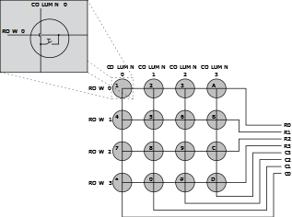
3. 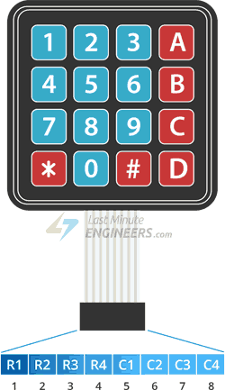To detect which button has been pressed, the keypad controller scans the rows and columns in a sequential manner. It applies a voltage to one row at a time, and reads the voltage on each column. If a button is pressed, it will create a connection between the row and column, and the voltage at the corresponding column will change. By scanning through all the rows and columns, the controller can determine which button has been pressed.
4. 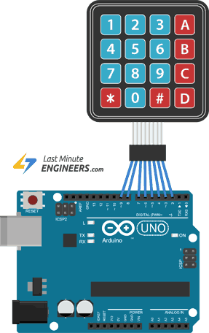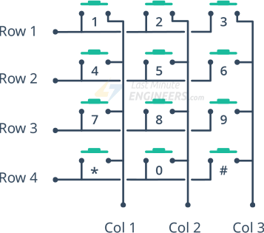
5. 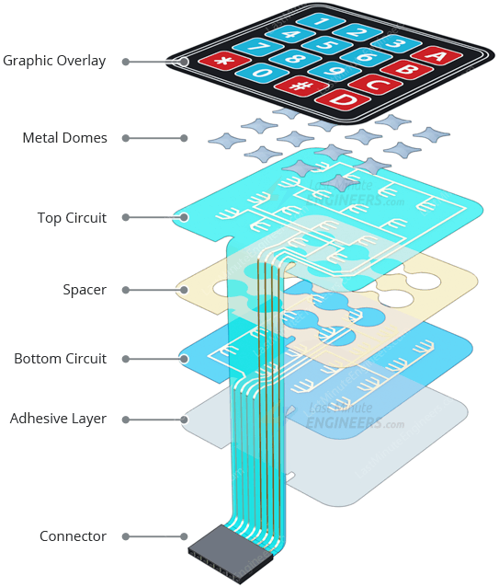

What about how to connect them and interface in ESP32?   
Only need is about 8 pins, from 1 to 4 “Rows” and 5 to 8 columns

Configure the GPIO pins as input pins in the ESP32 code.

Scan the matrix keypad by iterating through each row and setting the corresponding row pin to high, then reading the state of each column pin to determine which button has been pressed.

Then after connection them all printing your own results on Serial monitor or try print it

Using LCD if connected.

byte rowPins[ROWS] = {R1, R2, R3, R4}; /* connect to the row pinouts of the keypad */

byte colPins[COLS] = {C1, C2, C3, C4}; /* connect to the column pinouts of the keypad */

[Esp32 Keypad Interfacing With Esp32 | Esp32 (electronicwings.com)](https://www.electronicwings.com/esp32/keypad-interfacing-with-esp32)

[In-Depth: Interface 4x3 & 4x4 Membrane Keypad with Arduino (lastminuteengineers.com)](https://lastminuteengineers.com/arduino-keypad-tutorial/)