What is OSI Model?

The OSI Model is a logical and conceptual model that defines network communication used by systems open to interconnection and communication with other systems

What is TCP/IP Model?

TCP/IP helps you to determine how a specific computer should be connected to the internet and how you can transmit data between them. It helps you to create a virtual network when multiple computer networks are connected.

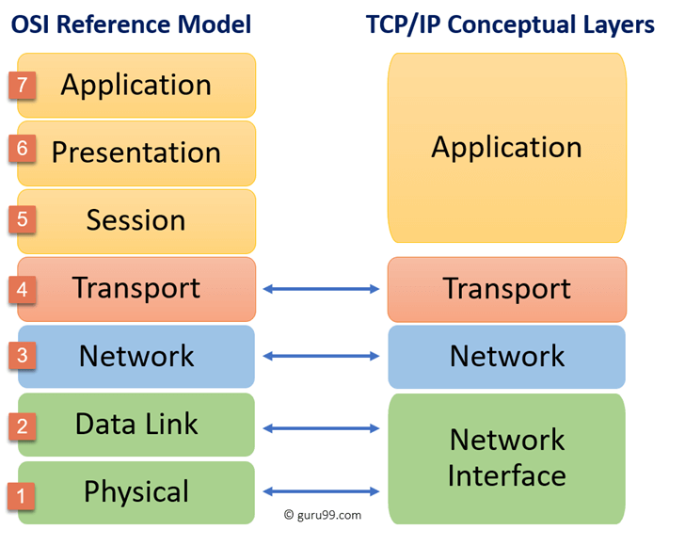

|  |  |
| --- | --- |
| OSI Model | TCP/IP Model |
| It is developed by ISO (International Standard Organization) | It is developed by ARPANET (Advanced Research Project Agency Network). |
| OSI model provides a clear distinction between interfaces, services, and protocols. | TCP/IP doesn’t have any clear distinguishing points between services, interfaces, and protocols. |
| OSI refers to Open Systems Interconnection. | TCP refers to Transmission Control Protocol. |
| OSI uses the network layer to define routing standards and protocols. | TCP/IP uses only the Internet layer. |
| OSI layers have seven layers. | TCP/IP has four layers. |
| In the OSI model, the transport layer is only connection-oriented. | A layer of the TCP/IP model is both connection-oriented and connectionless. |
| In the OSI model, the data link layer and physical are separate layers. | In TCP, physical and data link are both combined as a single host-to-network layer. |

***Http AND Version***

**HTTP** **(Hypertext Transfer Protocol) is the fundamental protocol of the World Wide Web, created by Tim Berners-Lee and his team in the late 1980s to early 1990s. Since its inception, HTTP has undergone significant changes to maintain its simplicity and adapt to the evolving web landscape. Originally designed for file exchange in a controlled environment, it has evolved into a versatile protocol capable of transmitting high-resolution images, videos, and even 3D content over the internet.**

HTTP/0.9 and HTTP/1.0, which were designed for basic file exchange, to the more advanced HTTP/1.1 and HTTP/2, which introduced features like persistent connections and multiplexing

And HTTP 3 QUIC is a protocol designed to significantly reduce latency in HTTP connections. Unlike HTTP/2, which runs over a single TCP connection, QUIC operates over UDP and supports multiple streams. This allows packet loss detection and retransmission to be handled independently for each stream, preventing the blocking of all streams in case of errors. By implementing these mechanisms, QUIC aims to improve the efficiency and responsiveness of HTTP connections, leading to a faster and more reliable web browsing experience.