1-Using shell expansion characters only, We need to create parent directory mfs. mfs contains 3 directories admin1,admin2,admin3. Each admin directory contains 5 directies (day1,day2,day3,day4,day5). Each day contains 5 labs files (lab1,lab2,lab3,lab4,lab5).txt

mkdir -p mfs/admin{1..3}/day{1..5}

touch mfs/admin{1..3}/day{1..5}/lab{1..5}

cd

ls -lR

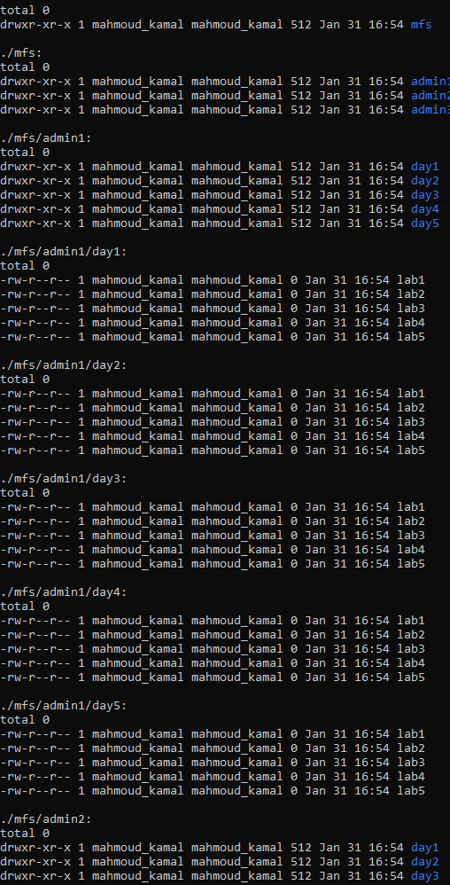

2-Chanege shell prompt to permanent:

LoginNAME@HOSTNAME-MM-DD-Current Directory$

PS1="\[\e]0;\u@\h: \w\a\]${debian_chroot:+($debian_chroot)}\[\033[01;32m\]\u@\h\[\033[00m\]-\D{%m-%d}:\[\033[01;34m\]\w\[\033[00m\]\$"

Or PS1="\e[0;36m\u@\h-\D{%m-%d}-\w$ \e[m"

[nano ¬/.bashrc and chance PS1 to change for ever]

3-Any user has W on a directory can remove any file under this directory even if he/she has no write perm on this file and not owner ?? What is the solution.

Create new user:

sudo useradd -c "MK" -m -s /bin/bash mk

sudo su – mk

mkdir Directory

touch Directory/file

$ chmod 1777 Directory/ or $ chmod +t Directory/

[If you set the sticky bit to a directory, other users cannot delete or rename the files (or subdirectories) within that directory.

When the sticky bit is set on a directory, only the owner and the root user can delete / rename the files or directories within that directory.]

4-How normal user change is password while has has no W on /etc/shadow? How? how to do it?



The ‘s’ in the 4th position indicates that the setuid flag is set. This allows any user to run the executable as the files owner (root) without having to actually be root (and with no need to use sudo either)