1-Validate an email,print 1 if email is valid, 0 if not valid

[ <https://unix.stackexchange.com/questions/194912/what-is-the-email-matching-regex-in-basic-regex-for-grep> ]

echo "mahmoudfierr@gmail.com" | grep -c -E "^[a-zA-Z0-9]+@[a-zA-Z0-9]+\.[a-z]{2,}"

OR

echo "mahmoudfierr@gmail.com" | grep -c '^[a-zA-Z0-9]\+@[a-zA-Z0-9]\+\.[a-z]\{2,\}'

2-Validate a floating point number (negative and poisitive)

echo "-12.1" | grep -c -E '^[+-]?[0-9]*\.?[0-9]+$'

3-Backup your home directory in compressed archive in a directory /backup every day The archive name must be home-backup-<day>-<year>.tar.gz

touch home_backup.sh

nano home_backup.sh

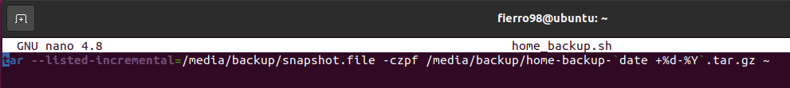tar --listed-incremental=/media/backup/snapshot.file -czpf /media/backup/home-backup-`date +%d-%Y`.tar.gz ~

chmod +754 home_backup.sh

sudo crontab -u $USER -e

0 3 * * * /home/$USER/home_backup.sh

4-Save the system load, and memory used in log file (syslog) every min

while true; do (echo "%CPU %MEM ARGS $(date)" && ps -e -o pcpu,pmem,args --sort=pcpu | cut -d" " -f1-5) >> syslog.log; sleep 60; done