1-Using Virtual machine

1-Add two disks

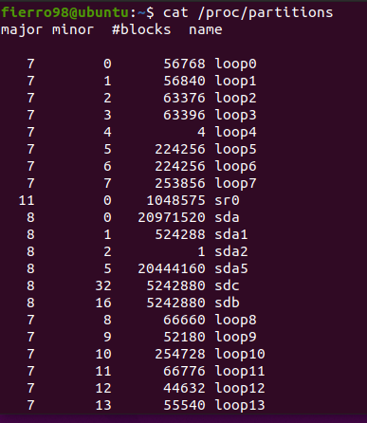

$ cat /proc/partitions

2-COnfigure Volume group of the 2 disks

1-CSreate physical volume

$ sudo apt install lvm2

$ sudo pvcreate /dev/sdb /dev/sdc

2-Display pv info

$ sudo pvdisplay /dev/sdb /dev/sdc

3-Create volume group

$ sudo vgcreate itivg /dev/sdb /dev/sdc



4-Display vg info

$ sudo vgdisplay itivg

3-Create two logical volume

1-lv1 : 20% of total VG

2-lv2 : 80% rest of VG

5-Create logical volume

$ sudo lvcreate -l 20%FREE-n lv1 itivg

$ sudo lvcreate -l 100%FREE -n lv2 itivg

6-Display info about logical volume

$ sudo lvdisplay /dev/itivg/lv1

$ sudo lvdisplay /dev/itivg/lv2

7- Create a file system on the partition(Formatting) & Mount the partition under mount point

$ sudo apt-get install xfsprogs

$ sudo mkfs.xfs /dev/itivg/lv1

$ sudo mkdir /MyApp

$ sudo mount /dev/itivg/lv1 /MyApp

$ sudo mkfs.xfs /dev/itivg/lv2

$ sudo mkdir /MyLogs

$ sudo mount /dev/itivg/lv2 /MyLogs

2-Configure a web application on apache web on this VM

$ sudo gedit /MyApp/index.html

1-Document root will use the lv1

1- Create virtual host

Create a file /etc/apache2/sites-available/itivg.com.conf

$ sudo gedit /etc/apache2/sites-available/itivg.com.conf

<VirtualHost \*:80>

ServerName itivg.com

ServerAlias www.itivg.com

DocumentRoot /MyApp

</VirtualHost>

<Directory /MyApp >

AllowOverride all

Require all granted

</Directory>

2- Enable site then reload apache2

$ sudo a2ensite itivg.com

$ sudo service apache2 reload

Open notepad on Windows as administrator

Open Hosts files 🡪 C:\Windows\System32\drivers\etc\hosts



192.168.187.130 itivg.com

$ sudo gedit /etc/hosts

2-Apache (Access log, and error log) will use the lv2

$ sudo gedit /etc/apache2/sites-available/itivg.com.conf

<VirtualHost \*:80>

ServerName itivg.com

ServerAlias www.itivg.com

DocumentRoot /MyApp

ErrorLog /MyLogs/error.log

CustomLog /MyLogs/access.log combined

<Directory /MyApp >

AllowOverride all

Require all granted

</Directory>

</VirtualHost>

$ sudo service apache2 reload