Company Database Schema

Here is the schema of a company database, please implement it on any RDBMS you like and then try to create the following requests (queries): "create only the dependent table with all data and relations"

Employee:
Fname | Lname | SSN | BDATE | Addresss | Sex | Salary | Superssn | Dno
Ahmed | Ali | 112233 | 1/1/1965 | 15 Ali fahmy St.Giza | M | 1300 | 223344 | 10
Kamel | Mohamed | 223344 | 15/10/1970 | 38 Mohy el dien abo el Ezz St.Cairo | M | 1800 | 321654 | 10
Hanaa | Sobhy | 123456 | 18/3/1973 | 38 Abdel Khalik Tharwat St. Downtown.Cairo | F | 800 | 223344 | 10
Amr | Omran | 321654 | 14/9/1963 | 44 Hilopolis.Cairo | M | 2500 | null | null
Noha | Mohamed | 968574 | 1/2/1975 | 55 Orabi St. El Mohandiseen .Cairo | F | 1600 | 321654 | 20
Edward | Hanna | 512463 | 19/8/1972 | 18 Abaas El 3akaad St. Nasr City.Cairo | M | 1500 | 321654 | 30
Mariam | Adel | 669955 | 12/6/1982 | 269 El-Haram st. Giza | F | 750 | 512463 | 20
Maged | Raoof | 521634 | 6/4/1980 | 18 Kholosi st.Shobra.Cairo | M | 1000 | 968574 | 30

Department
Dname | DNum | MGRSSN | MGRStart date
DP1 | 10 | 223344 | 1/1/2005
DP2 | 20 | 968574 | 1/3/2006
DP3 | 30 | 512463 | 1/6/2006

Works for
ESSN | Pno | Hours
223344 | 100 | 10
223344 | 200 | 10
223344 | 300 | 10
112233 | 100 | 40
968574 | 400 | 15
968574 | 700 | 15
968574 | 300 | 10
669955 | 400 | 20
223344 | 500 | 10
669955 | 700 | 7
669955 | 300 | 10
512463 | 500 | 10
512463 | 600 | 25
521634 | 500 | 10
521634 | 600 | 20
521634 | 300 | 6
521634 | 400 | 4

Project
Pname | Pnumber | Plocation | City | Dnum
AL Solimaniah | 100 | Cairo_Alex Road | Alex | 10
Al Rabwah | 200 | 6th of October City | Giza | 10
Al Rawdah | 300 | Zaied City | Giza | 10
Al Rowad | 400 | Cairo_Faiyom Road | Giza | 20
Al Rehab | 500 | Nasr City | Cairo | 30
Pitcho american | 600 | Maady | Cairo | 30
Ebad El Rahman | 700 | Ring Road | Cairo | 20

Dependent
ESSN | Dependent_name | Sex | Bdate
112233 | Hala Saied Ali | F | 18/10/1970
223344 | Ahmed Kamel Shawki | M | 27/3/1998
223344 | Mona Adel Mohamed | F | 25/4/1975
321654 | Ramy Amr Omran | M | 26/1/1990
321654 | Omar Amr Omran | M | 30/3/1993
321654 | Sanaa Gawish | F | 16/5/1973
512463 | Sara Edward | F | 15/9/2001
512463 | Nora Ghaly | F | 22/6/1976

* Try to create the following Queries:

- Display the Department id, name and id and the name of its manager.

SELECT Dnum, Dname, SSN, Fname+' '+Lname as Name
FROM Departments d, Employee e
WHERE d.MGRSSN = e.SSN;
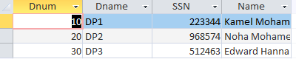

- Display the name of the departments and the name of the projects under its control.

SELECT Dname, Pname
FROM Departments d, Project p
WHERE d.Dnum = p.Dnum;
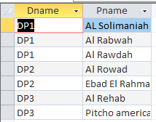

- Display the full data about all the dependence associated with the name of the employee they depend on him/her.

SELECT ESSN, Dependent_name, d.gender, d.Bdate, Fname+' '+Lname as Name
FROM Dependent d, Employee e
WHERE d.ESSN = E.SSN;
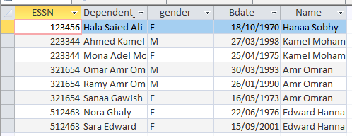

- Display (Using Union Function)
  - The name and the gender of the dependence that's gender is Female and depending on Female Employee.
  - And the male dependence that depends on Male Employee.

SELECT Dependent_name, d.gender, e.gender
FROM Dependent d, Employee e
WHERE d.ESSN = E.SSN
AND e.gender = d.gender;
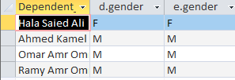

Using Union Function:
SELECT Dependent_name
from Dependent d,Employee e
where d.gender=F and e.gender=F
UNION
SELECT Dependent_name
from Dependent d,Employee e
where d.gender=M and e.gender=M;

- Display the Id, name and location of the projects in Cairo or Alex city.

SELECT Pnumber, Pname, Plocation
FROM Project
WHERE City in('Alex', 'Cairo');
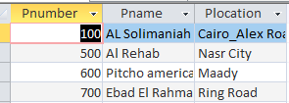

- Display the Projects full data of the projects with a name starts with "a" letter.

SELECT *
FROM Project
WHERE Pname like'a*';
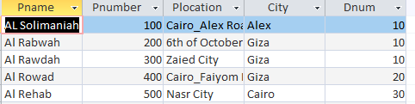

- display all the employees in department 30 whose salary from 1000 to 2000 LE monthly

SELECT Fname+' '+Lname as [Full Name], Dno, Salary
FROM Employee
WHERE Dno = 30
AND Salary between 1000 and 2000 ;
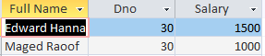
- Retrieve the names of all employees in department 10 who works more than or equal10 hours per week on "AL Rabwah" project.

SELECT e.Fname+' '+e.Lname as Full_Name, e.Dno
FROM Employee e, Works_for w
where w.ESSn = e.SSN
AND e.Dno = 10
AND w.Hours >= 10
AND w.Pno = 100;
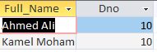

- Find the names of the employees who directly supervised with Kamel Mohamed.

SELECT e.Fname+' '+e.Lname as [Full Name], s.Fname+' '+s.Lname as SV
FROM Employee e, Employee s
WHERE e.Superssn = s.SSN
AND E.Superssn = 223344;
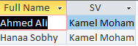

- For each project, list the project name and the total hours per week (for all employees) spent on that project.

SELECT p.Pname,sum(w.Hours) as [Total Hours]
FROM Project p, Works_for w
where p.Pnumber = w.Pno
group by p.Pname;
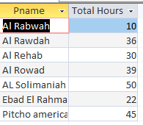

- Retrieve the names of all employees and the names of the projects they are working on, sorted by the project name.

SELECT e.Fname+' '+Lname as Full_Name, p.Pname
FROM Project p, Employee e, Works_for w
where e.SSN = w.ESSn
AND w.Pno = p.Pnumber
order by p.Pname;
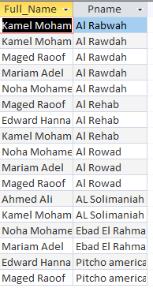

- Display the data of the department which has the smallest employee ID over all employees' ID.

SELECT *
FROM Departments
WHERE Dnum = (Select Dno from Employee where SSN = (SELECT min(SSN) From Employee));
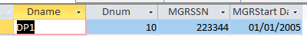

- For each department, retrieve the department name and the maximum, minimum and average salary of its employees.

SELECT d.Dname, max(e.Salary) as max, min(e.Salary) as min, avg(e.Salary) as avg
FROM Employee e, Departments d
where e.Dno = d.Dnum
group by d.Dname;
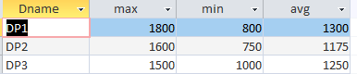

- List the last name of all managers who have no dependents.

SELECT Lname
FROM Employee
where SSN in (SELECT Superssn from Employee) and SSN not in (SELECT ESSN from Dependent);
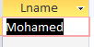

- For each department-- if its average salary is less than the average salary of all employees-- display its number, name and number of its employees.

SELECT d.Dnum,d.Dname, count(e.SSN) as count
FROM Employee e, Departments d
where d.Dnum = e.Dno
group by d.Dnum, d.Dname
HAVING (SELECT avg(e.Salary)from Employee e, Departments d where e.Dno = d.Dnum) < (SELECT avg(Salary)from Employee);
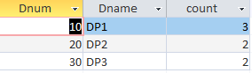

- Retrieve a list of employees and the projects they are working on ordered by department and within each department, ordered alphabetically by last name, first name.

SELECT d.Dnum, e.Fname, e.Lname, p.Pname
FROM Employee e, Project p, Departments d, Works_for w
where w.ESSn = e.SSN
AND p.Pnumber = W.Pno
order by d.Dnum, e.Lname, e.Fname;
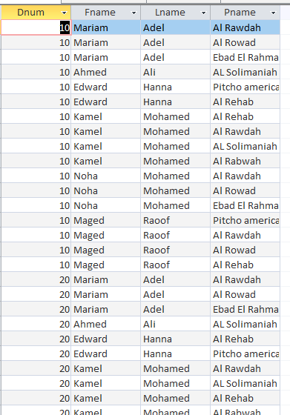

- For each project located in Cairo City , find the project number, the controlling department name ,the department manager last name ,address and birthdate.

SELECT p.Pnumber, p.Dnum, d.Dname, e.Lname, e.Address, e.Bdate
FROM Employee e, Project p, Departments d
where p.City = 'Cairo'
AND p.Dnum = d.Dnum
AND d.MGRSSN = E.SSN;
