MongoDB Lab2
1 - Download the following json file and import it into a collection named “zips” into “iti” database
$ sudo apt install mongo-tools
$ sudo mongoimport --db iti --collection umongo --file /home/fierro98/Desktop/zips.json
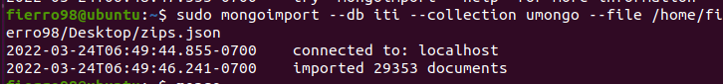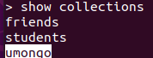
2 – find all documents which contains data related to “NY” state
> db.umongo.find({state: "NY"})
(or)
> db. umongo.aggregate([{$match:{ "state": "NY"}])
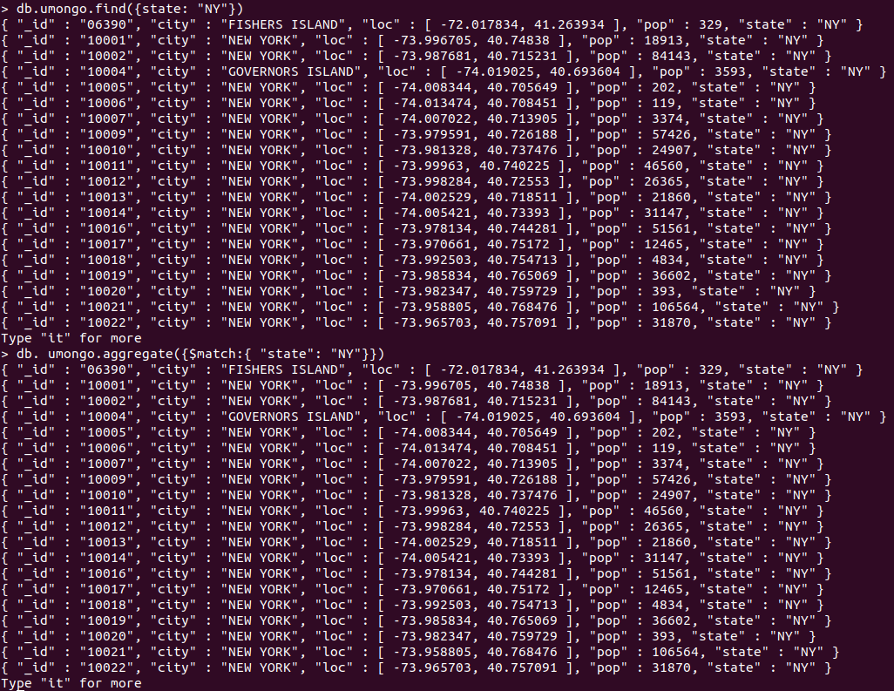
3 – find all zip codes whose population is greater than or equal to 1000
> db.umongo.find({$or:[{pop: 1000}, {pop: {$gt:1000}}]}, {_id:1})
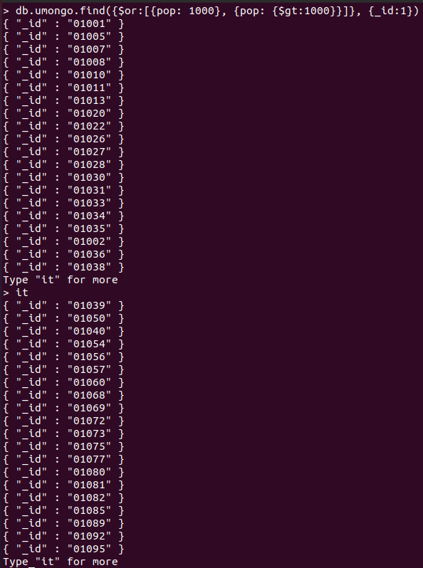

4 – add a new boolean field called “check” and set its value to true for “PA” and “VA” state
> db.umongo.updateMany({$or:[{state: "PA"}, {state: "VA"}]}, {$set: {"check": true}})
(or)
> db.umongo.aggregate( [
{
$match: {$or:[{state: "PA"}, {state: "VA"}]}
},
{
$addFields: {"check": true}
}
] )

5 – using zip codes find all cities whose latitude is between 55 and 65 and show the population only.
> db.umongo.find({"loc.1":{$gt:55}, "loc.1":{$lt:65}}, {_id:0, pop:1})
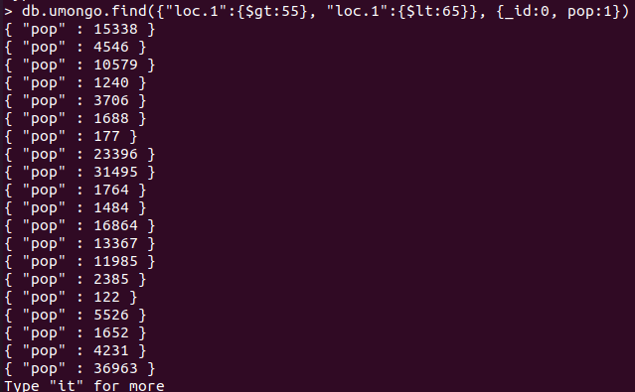
6 – create index for states to be able to select it quickly and check any query explain using the index only.
> db.umongo.createIndex({state:1})
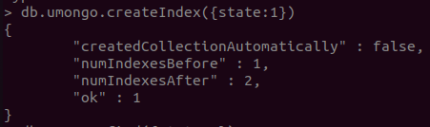
7 – increase the population by 0.2 for all cities which doesn't located in “AK” nor “NY”
> db.umongo.updateMany({state:{$nin:[ "AK", "NY"]}}, { $mul: { pop: 1.2}})
8 – update only one city whose longitude is lower than -71 and is not located in “MA” state, set its population to 0 if zipcode population less than 200.
> db.umongo.update({"loc.0":{$lt:-71}, state:{$nin:["MA"]}, pop:{$lt:200}}, { $set: { pop: 0}})

9 – update all documents whose city field is a string, rename its city field to be country and if there isn't any, add new document the same as the first document in the database but change the _id to avoid duplications.
Hint: use Variables
*****************************************************************
part2

- Get sum of population that state in PA, KA
> db.umongo.aggregate({$match:{state: {$in: ['PA', 'KA']}}},{$group:{_id:"$state",sum:{$sum:"$pop"}}})
- Get only 5 documents that state not equal to PA, KA
> db.umongo.aggregate([ { $match: { state: {$nin:["PA", "KA"]} }} , { $limit: 5}])
(or)
> db.umongo.find({state:{$ne:["PA", "KA"]}}).limit(5)
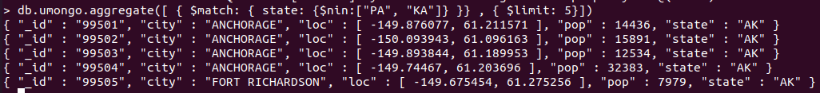
- Get sum of population that state equal to AK and their latitude between 55, 65
> db.umongo.aggregate([ {$match: { state: "AK", "loc.1":{$lte:65}, "loc.1":{$gte:55}}}, {$group: {_id: "$state", sum: {$sum: "$pop"}}}])
- Sort Population of document that state in AK, PA and skip first 7 documents
> db.umongo.aggregate([{$match: {$or:[{state: "PA"}, { state: "AK"}]}}, {$sort:{pop: 1}}, {$skip: 7}])
(or)
> db.umongo.find({state:{$in:["AK", "PA"]}}).skip(7).sort({pop:1})
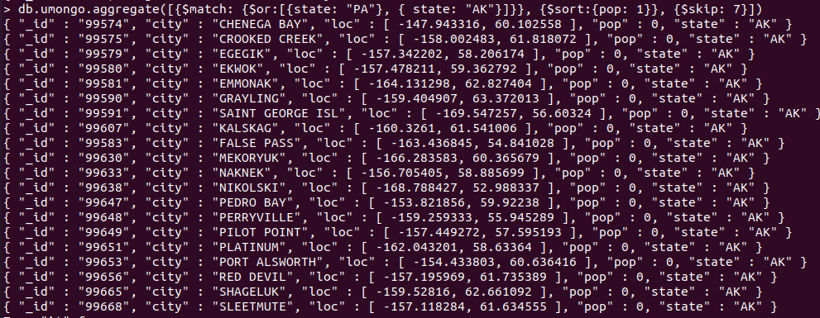
- Get smallest population and greatest population of each state and save the result in collection named "mypop" on your machine colleague
> db.umongo.aggregate({$group: {_id: "$state", max: {$max: "$pop"}, min: {$min: "$pop"}}},{$out: {db: "iti", coll: "mypop"}})

- Write an aggregation expression to calculate the average population of a zip code (postal code) by state
> db.umongo.aggregate({$group: {_id: "$state", avg: {$avg: "$pop"}}})
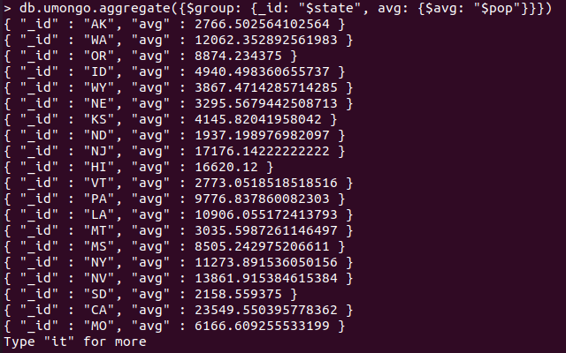

- Write an aggregation query with just a sort stage to sort by (state, city), both ascending
> db.umongo.aggregate([{$sort: {state:1, city:1}}])
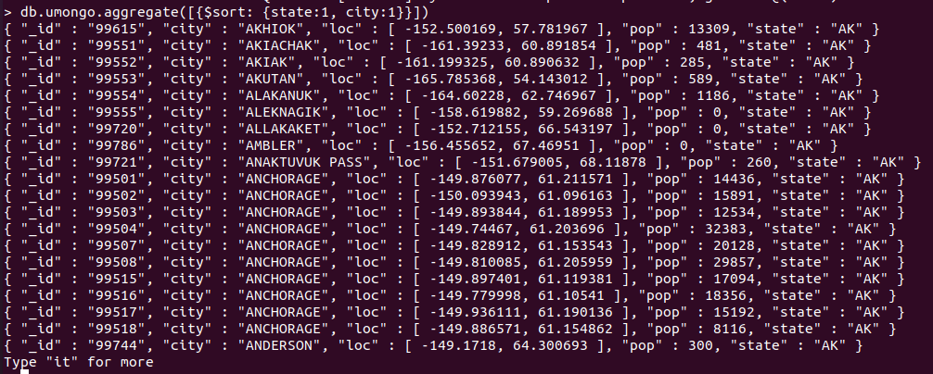
- Write an aggregation query with just a sort stage to sort by (state, city), both descending
> db.umongo.aggregate([{$sort: {state:-1, city:-1}}])
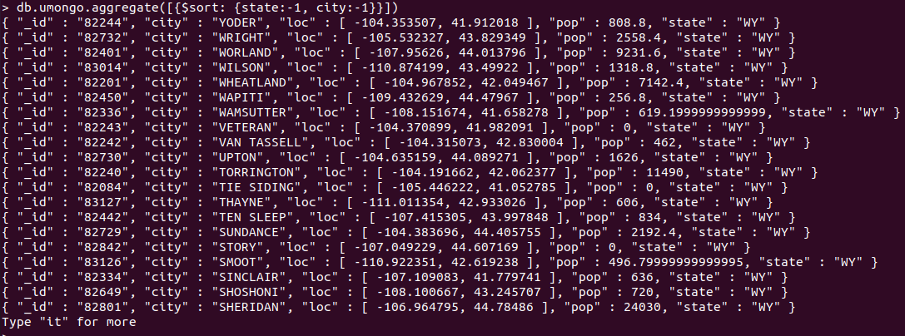
- Calculate the average population of cities in California (abbreviation CA) and New York (NY) (taken together) with populations over 25,000
> db.umongo.aggregate({$match: {state: {$in: ['CA', 'NY']}, pop: {$gt: 25000}}},{$group: {_id: "$state", avg: {$avg: "$pop"}}})
- Return the average populations for cities in each state
> db.umongo.aggregate({$group: {_id: "$city", avg: {$avg: "$pop"}}})
