CS251: Software Engineering I

**Software Design**

**Specification**

**For**

**Bingo**

**Prepared by**

**Team Name: A2M2**

**Versions History**

|  |  |  |  |
| --- | --- | --- | --- |
| **Date** | **Version** | **Description** | **Author(s)** |
| **15/11/2014** | **1.0** | **Initial version** | **A2M2** |

**Approved by:**

**Eng. Mohammed Arnaoty**

Contents

Team 4

Document Purpose and Audience 4

System Models 5

System Decomposition 5

Class diagrams 6

Sequence diagrams 8

Class - Sequence Usage 9

User Interface Design 10

Screen 1 – Main Interface 10

Screen 2 – Play Interface 11

Screen 3 – Score Interface 12

Ownership Report 12

# Team

|  |  |  |  |
| --- | --- | --- | --- |
| **ID** | **Name** | **Email** | **Mobile** |
| 20120363 | Mahmoud Mohamed Gamal | [mandolove200@gmail.com](mailto:mandolove200@gmail.com) | 01100841259 |
| 20120256 | Amr Abo El-Aila | [aboelala.amr@gmail.com](mailto:aboelala.amr@gmail.com) | 01117908593 |
| 20120352 | Mahmoud Hamdy Sayed | [ma7moud_7amdy18m@yahoo.com](mailto:ma7moud_7amdy18m@yahoo.com) | 01114044592 |
| 20120260 | Amr Sameh Raafat | [amr4159@gmail.com](mailto:amr4159@gmail.com) | 01113288609 |

# Document Purpose and Audience

* **This document is the Software Requirements Specification (SRS) for Bingo Game. SDD usually accompanies an architecture diagram with pointers to detailed feature specifications of smaller pieces of the design. It is designed and written for stakeholders: professors and project developers.**

# System Models

## System Decomposition

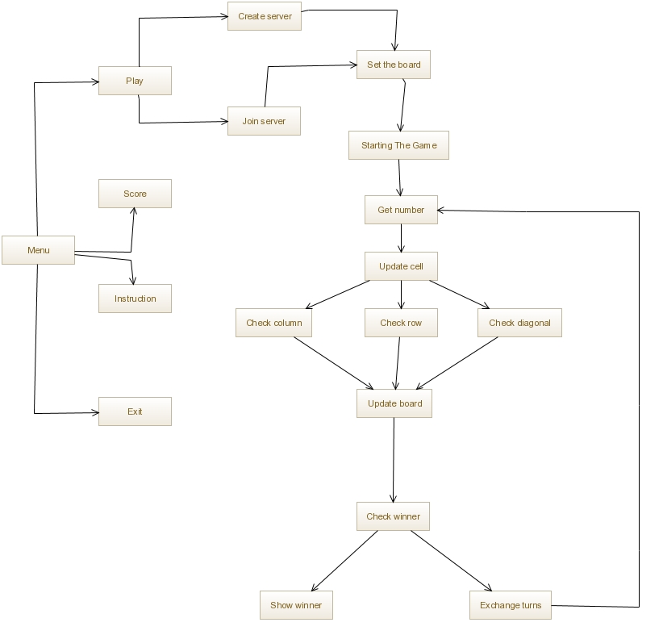

## Class diagram

*Note: System can’t be divided into sub systems because the server is taken place on one of user’s device.

| **Class ID** | **Class Name** | **Description** |
| --- | --- | --- |
| 1 | Bingo | Each game has array of numbers , array of chosen numbers , array of players , counter and connection to start game  Methods like Start , get number from player , update cell , check if one of the players won the game and if no body win exchange turn and at the end show winner |
| 2 | Player | Each Player has name and score  The player can set his name and get his name and score |
| 3 | Server | Each server has name and players can create one or join existing one |
| 4 | Board | Once all players joined the server the game board will be set and after every turn the board will be updated and check the row , column and diagonal |
| 5 | Host | The player who created the server and choose the number of players |

## Sequence diagrams

### Class - Sequence Usage

| **Class Name** | **Sequence Diagrams** | **Overall used methods** |
| --- | --- | --- |
| Server | 1.1 , 1.2 | Create_Server , Join_Server |
| Board | 1.1.1 , 1.2.1 , 3.1.1 , 3.1.2 , 3.1.3 , 3.1.1.1 , 3.1.2.1 , 3.1.3.1 | Set_Board , Update_Board , Check_Row , Check_Column , Check_Diagonal |
| Bingo | 2 , 2.1 , 3 , 3.1 , 4 , 4.1 , 4.2 , 4.2.1= , 5 | Starting_The_Game , Get_Number , Update_Cell , Check_Winner , Exchange_Turns , Show_Winner |

## User Interface Design

### Screen 1 – Main Interface

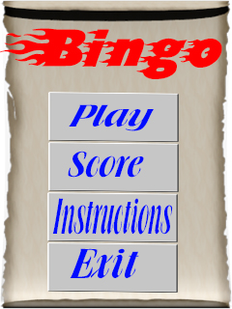

### Screen 2 – Play Interface

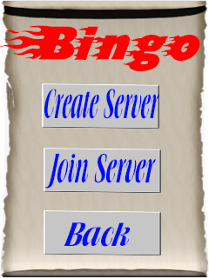

### Screen 3 – Score Interface

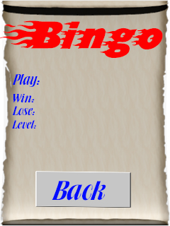

# Ownership Report

|  |  |
| --- | --- |
| **Item** | **Owners** |
| Document purpose and Audience , Sequence Diagrams , User Interface Design | *Mahmoud Mohamed Gamal , Amr Sameh Rafaat* |
| System Decomposition , Class Diagrams | *Mahmoyd Hamdy Sayed , Amr Abo El-Aila* |