Most common CLI Commands

Ls: list the contents of the current directory
pwd: print working directory
clear: to clear your terminal
ls –help: to get help
man ls : to read manual
ls -f : full details of this place
ls -S : will sort the files and directories by size,
ls-s: will sort the files and directories by names,
cd: change directory
~ character at the start of a path to mean “the current user’s home directory”.
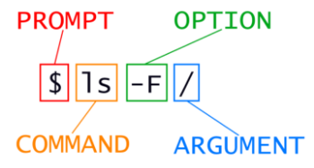
Mkdir means ‘make directory’
mkdir -p ../project1 ../project2 => to create a directory with nested sub-directories in a single operation
ls -fr => list directories with sub-directories with full extension
touch file.txt => to create text file
ls -i => list and inspect the size
mv file1 file2 => overrite file1 on file2 and delete file1
mv file1 directory => move file1 to directory
mv file1 file2 directory => move file1 and file2 to directory

Recall that .. refers to the parent directory (i.e. one above the current directory) and that . refers to the current directory.
Cp file/directory file/directory => copy -r for recursive copy for all contents
mv filename newfilename => renaming
rm -i file = > remove file
rm -r -i directory => to remove directory
* is a wildcard => match 0 or more of characters
? = > match only 0 or one character
wc file=> word counts lines words characters in file -l (lines) -m(chars) -w(words)

wc -l *.pdb > lengths.txt => > redirect the output from screen to file (lengths.txt)
cat lengths => screen whole content of lengths
less lengths => screen first page of lengths and space for next page and b for previous page and q for quit
sort -n file => sort numerical content of file
head -n 1 file = > first 1 line of file
tail -n 1 file = > last 1 line of file
echo hello > textfile.txt = > override hello in file
echo hello >> textfile = > append hello to the content of file
| between the two commands is called a pipe. It tells the shell that we want to use the output of the command on the left as the input to the command on the right.
sort -n lengths.txt | head -n 1 => sort and take the first line of the result of sort

