**RTOS-Simulation**

**1-Offline:**

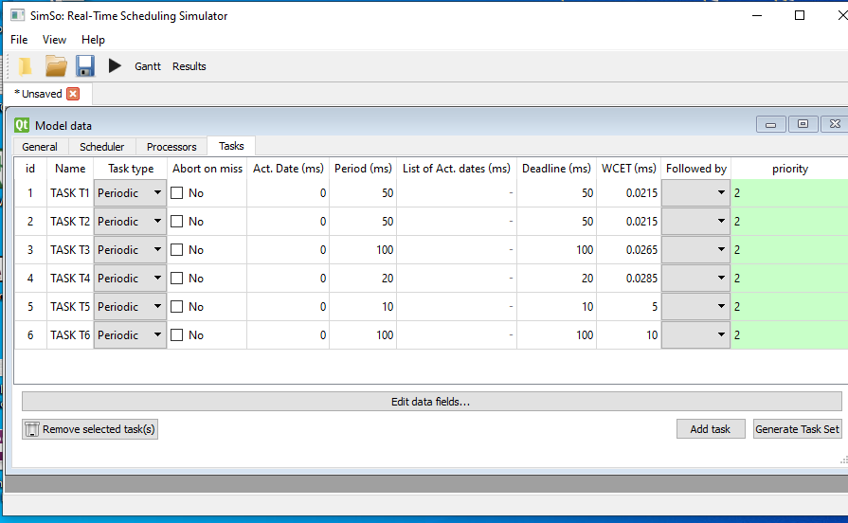

**Comment: Inputs.**

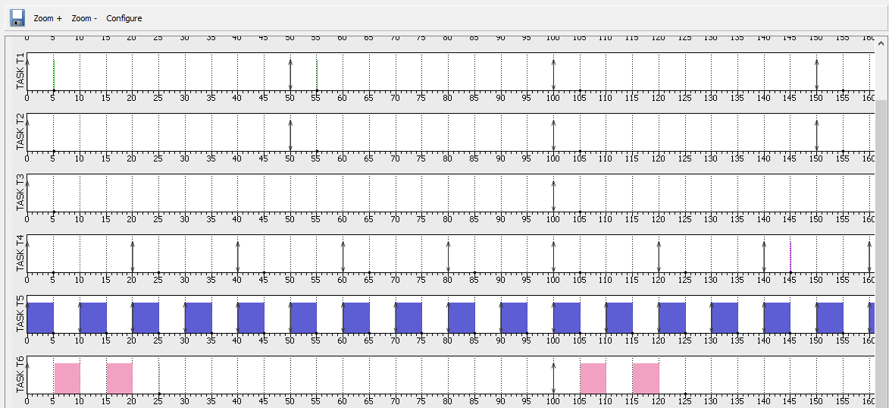

**Comment: Outputs. “Note that the 1st four tasks execution time is in uS so it doesn’t appear it will appear at next Screen at zooming."**

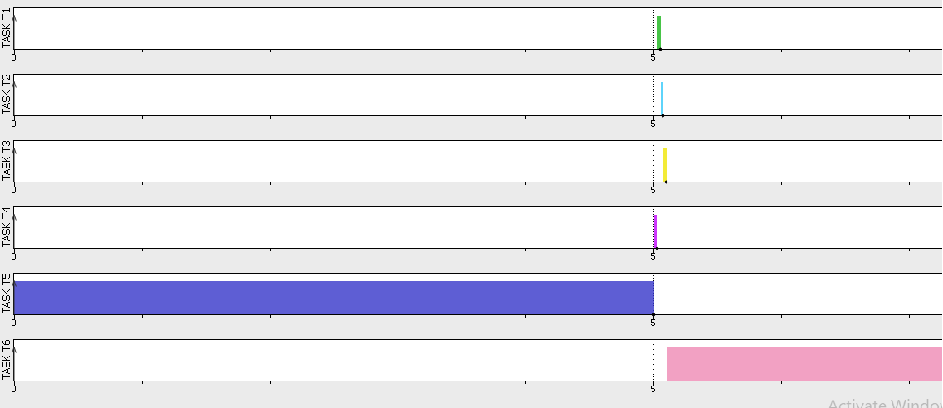**Comment: ”zooming on 1st four Tasks at time slot 5ms.”**

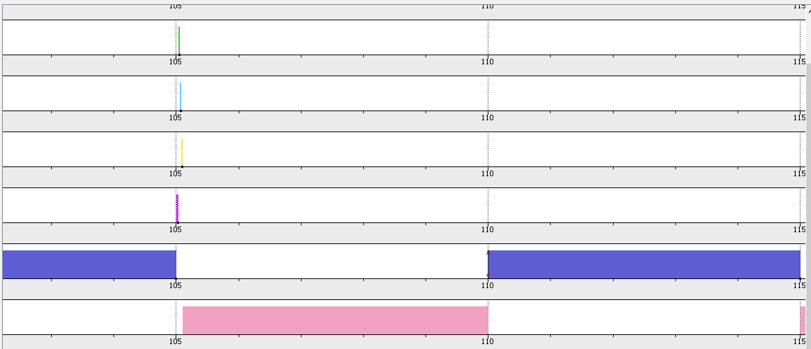**Comment: ”zooming on 1st four Tasks at time slot 105ms.”**

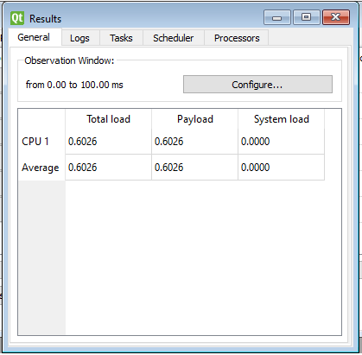

**Comment: CPU-Load equal 60% “which is acceptable for reaching Schedulability”**

**Online Using Logical-Analyzer:**

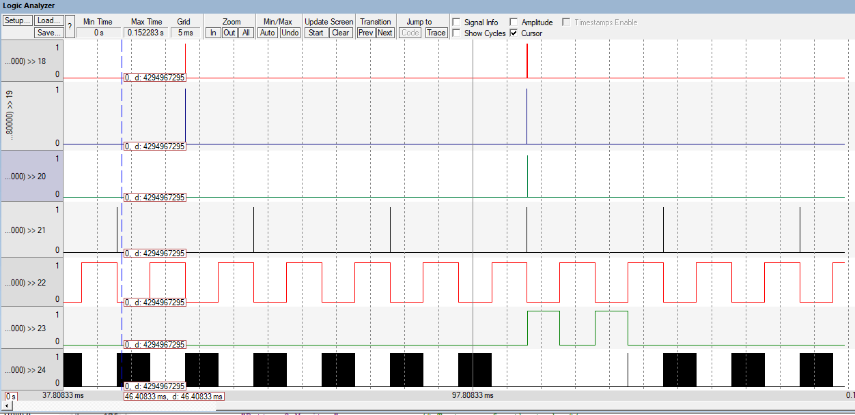

**Comment: “Tasks Running at Time Slot 100ms , Tasks arrangement from One to six Plus Idle Task at the end”**

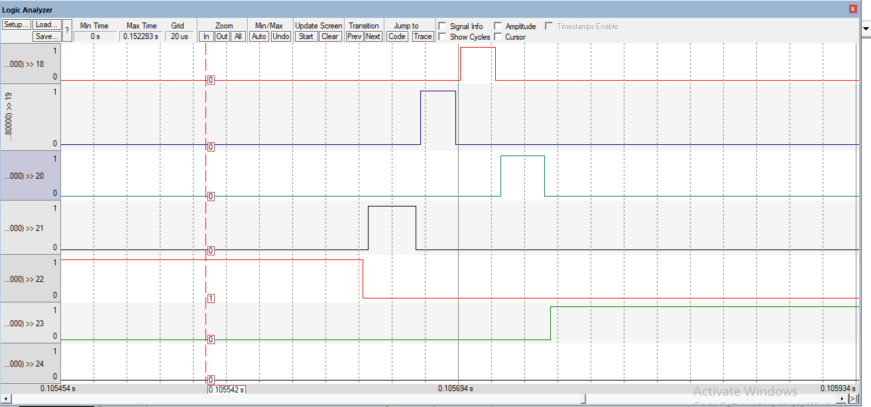

**Comment: “Zooming on at Time 105ms to see first four Tasks Simulation as they execute at us.”**

**3-Calculation:**

**a-** **Hyperperiod (LCM(Pi))= 100ms.**

**b- Cpu-Load= total execution time of all Tasks / Hyperperiod**

**= [ (10 * 5ms) + (5 * 0.285ms) + (2 * 0.215ms) + (2 * 0.215ms)+**

**(1 * 0.265ms)+(1 * 10ms) ] /100 = 0.6 (60%)**

**Comment: acceptable Cpu-Load which is in range (60~80 %).**

**c- Schedulability:**

**I) Rate Monotonic Utilization bound Method:**

**U (Task-1) = [21.5 * 10^(-3) ] / 50 = 4.3 * 10 ^ (-4).**

**U (Task-2) = [21.5 * 10^(-3) ] / 50 = 4.3 * 10 ^ (-4).**

**U (Task-3) = [26.5 * 10^(-3) ] / 100 = 2.65 * 10 ^ (-4).**

**U (Task-4) = [28.5 * 10^(-3) ] / 20 = 1.425 * 10 ^ (-3).**

**U(Task-5) = [5 ] / 10 = 0.5.**

**U(Task-6) = [10 ] / 100 = 0.1.**

**by adding Results: U (total) = 0.60255.**

**URM = 6 *[ 2^(1/6) - 1] = 0.735**

**so U<URM “System** **Guaranteed** **Schedulable Under Certain**   **Condition”**

**II) Time demand analysis Method:**

**Task-5:**

**W(5) = 5+0= 5ms** **“less than Deadline which is 10ms”**

**Task-4:**

**W(20) = 28.5*(10^-3)+(20/10)*5= 10.0285ms**

**“less than Deadline which is 20ms”**

**Task-1:**

**W(50) = [21.5*(10^-3)] + [(50/10)*5 ] + [(50/20)* (28.5*10 ^(-3))]**

**= 25.107**  **“less than Deadline which is 50ms”**

**Task-2:**

**W(50) = [21.5*(10^-3)] + [(50/10)*5 ] + [(50/20)* (28.5*10^(-3))]**

**+ [(50/50)21.5*(10^-3)] = 25.1285**

**“less than Deadline which is 50ms”**

**Task-3:**

**W(100) = [26.5*(10^-3) ]+ [(100/10)*5 ] +**

**[(100/20)* (28.5*10^(-3))] + [(100/50)*(21.5*(10^-3))]**

**+ [(100/50)*(21.5*(10^-3))] = 50.255**

**“less than Deadline which is 100ms”**

**Task-6:**

**W(100) = 10 + [(100/10)*5 ] +**

**[(100/20)* (28.5*10^(-3))] + [(100/50)*(21.5*(10^-3))]**

**+ [(100/50)*(21.5*(10^-3))]+ [(100/100)26.5*(10^-3) ] = 60.255**

**“less than Deadline which is 100ms”**

**SO there’s no task meet it’s deadline.**

**Therefore System is** **Schedulable.**