

**Faculty of Engineering & Technology Electrical & Computer Engineering Department**

**- ENCS4370 ArchProject**

**Mips**

**Prepared by:** Razi Atyani **ID:** 1200028

**Partners:**

**Name:**Mahmoud Khatib **ID:** 1200275

**Instructor**: Dr. Aziz Qarouch

**Section:** 2

**Date:** 8.12.2023

Calender.txt

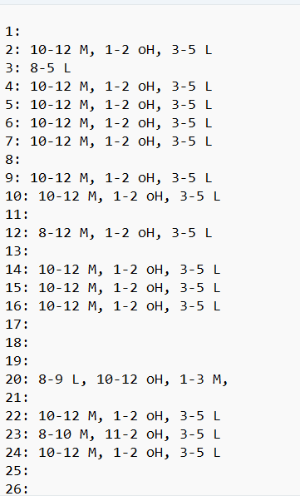

View calender 1:

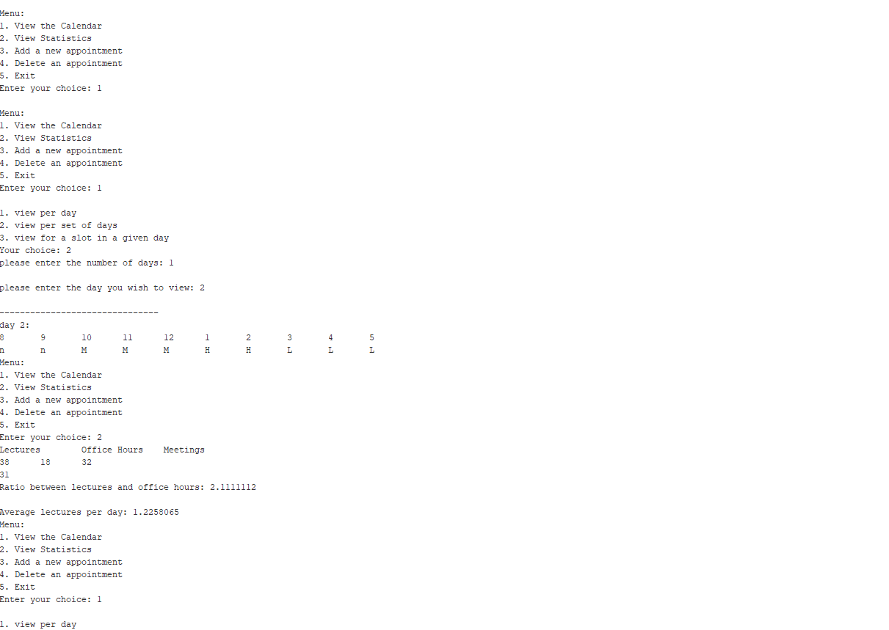

Stastistics:

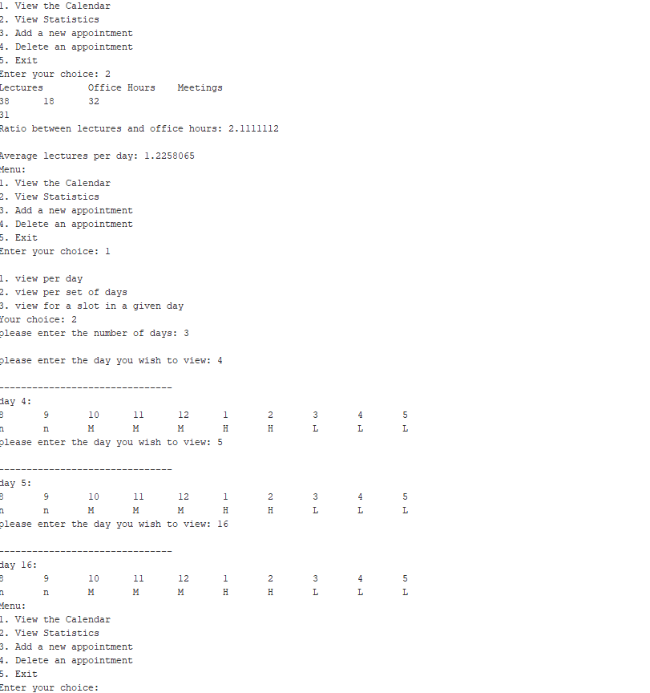

View calender2,3:

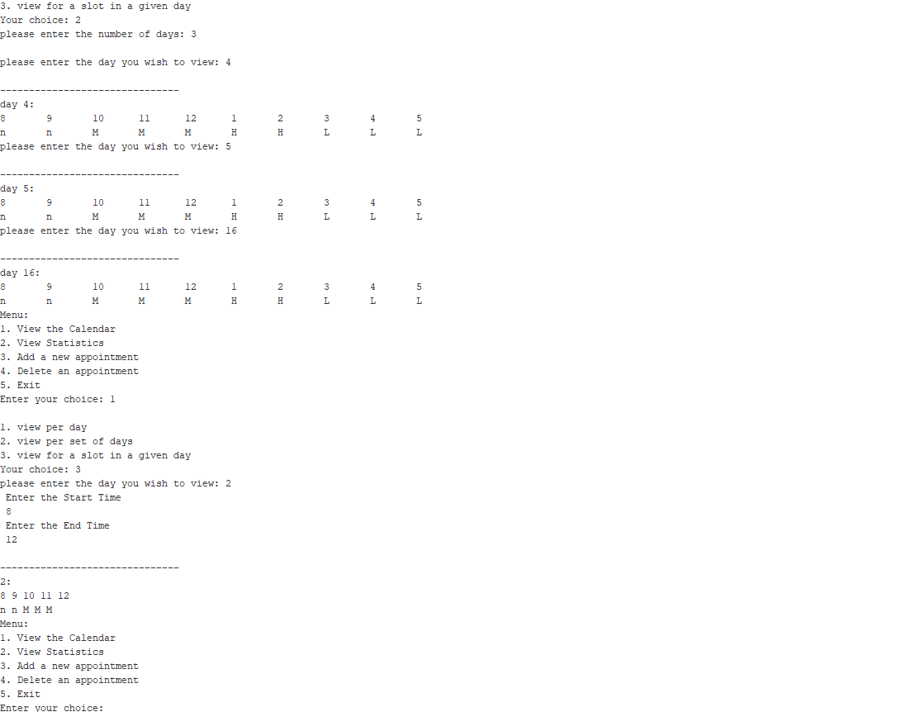

ADD:

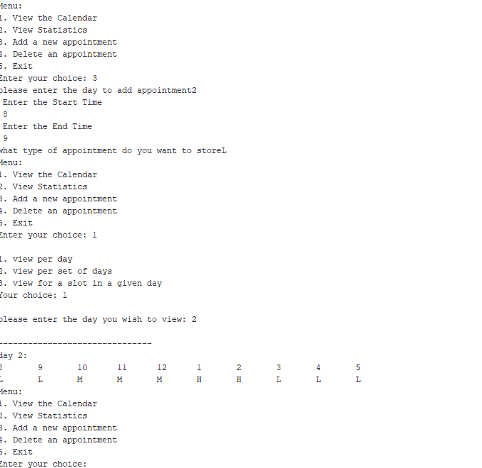

Delete:

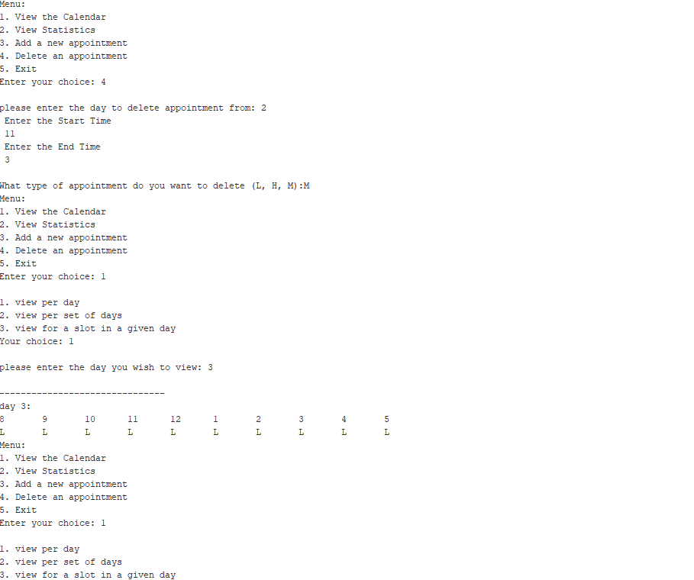

Delete :

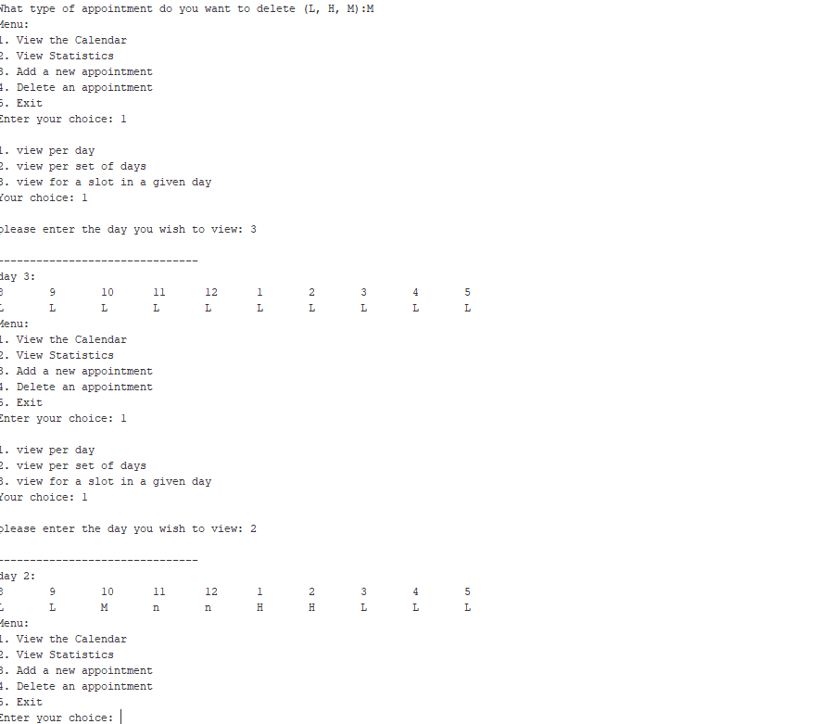

Output file:

