# **iti bootstrap**

# Created on September 04 2021

# **Table of Contents**

1.0. Page 1

2.0. Page 2

3.0. Page 3

# **1.0. Page 1**

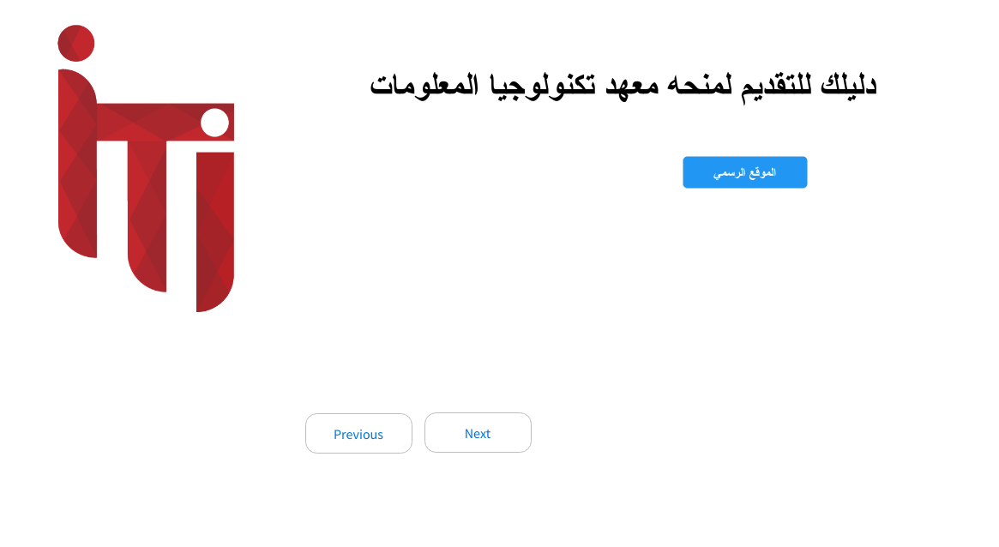

# **2.0. Page 2**

0 Imagen

# **3.0. Page 3**

0 Imagen