**الاسم / محمود خالد عمر عبدالعزيز**

**سكشن / 4**

**Dsp – lapالمادة /**

Assignment

1. Plot frequency response , impulse response for each n = 4,21

(band pass fc1 = 200, fc2 = 2000)

On octaive program or matlab we will write this code on editor:-

% Infinite impluse filter (IIR) => order =4

Fs = 10000;

n = 4;

[b ,a] = butter(n ,[200 2000]/ (Fs/2) ,'bandpass');

figure; impz( b ,a ,20 );grid;

f = (0 : 0.001 :1)* Fs/2;

H = freqz (b,a,f,Fs);

figure;plot(f , abs(H) );

xlabel('Frequency (Hz)')

ylabel('Amplitude')

title('Frequency Respone')

grid

The signal is stable because the function isstable(b,a) output is 1

And this is the result is

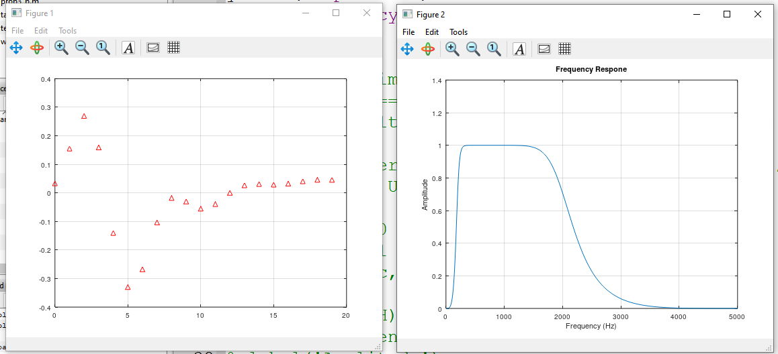

And for n = 21

% Infinite impluse filter (IIR) => order = 21

Fs = 10000;

n = 21;

[d ,c] = butter(n ,[200 2000]/ (Fs/2) ,'bandpass');

figure; impz( d ,c ,20 );grid;

f = (0 : 0.001 :1)* Fs/2;

H = freqz (d,c,f,Fs);

figure;plot(f , abs(H) );

xlabel('Frequency (Hz)')

ylabel('Amplitude')

title('Frequency Respone')

grid

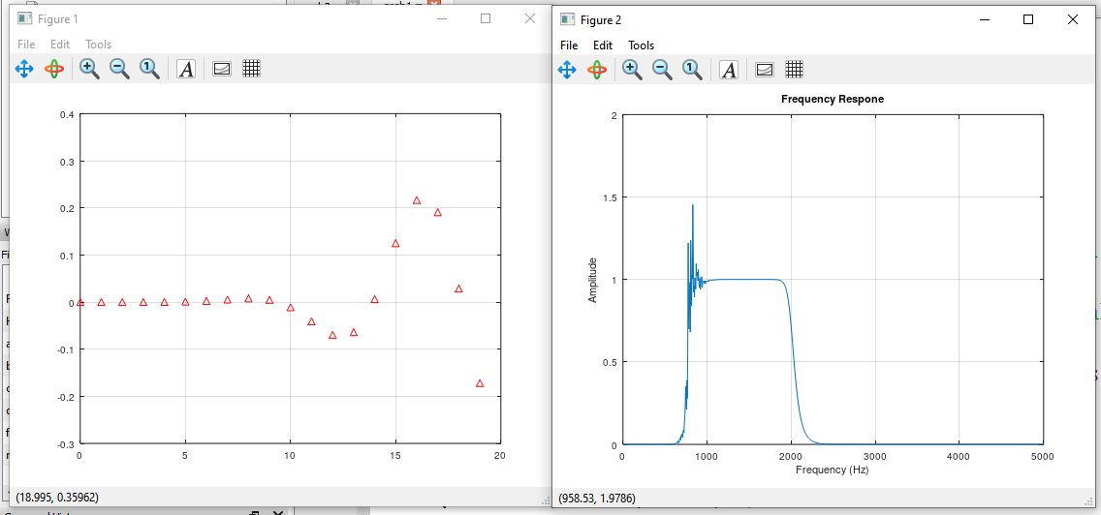

The signal is unstable

Problem – 2

**1ـــ Reading the file called ‘whistle.wav’ into octave and specifying samples and time in sec**

The code is

clc;clear;close all;

% To read the file

[x,Fs] = audioread('whistle.wav');

%% No of Samples

N = length(x);

fprintf('No of samples: %i\n', N);

%% time in sec

time = N / Fs;

fprintf('time in sec: %.3f\n', time);

%% Energy of the signal before wistle rejection

energy1 = sum(x.^2);

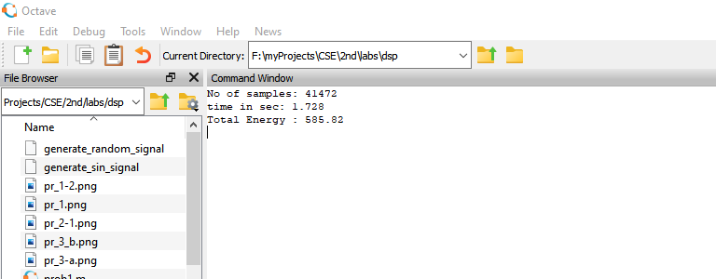fprintf('Total Energy : %.2f\n',energy1)

%% time domain representation

t = linspace(0 , time ,N);

2ـــ Plot the frequency spectrum of signal x, do you notice th peaks?

X_k = abs(fft(x)); %calc abs of fast fourier transform

f = linspace(0,Fs,N); %discretize freq

figure(2);plot(f,X_k);

title('Amplitude spectrum of x(t)');

xlabel('Frequency (Hz)');

ylabel('|X(f)|');

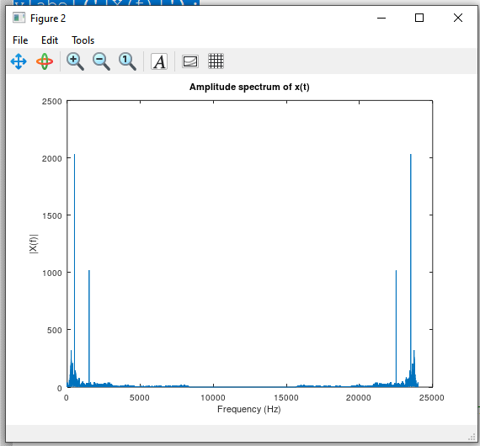

**3- Design a filter reject the sinusoidal signals from signal x**

**4- Plot freq response, impulse response, is filtered stable**

% Design a Butterworth bandstop filter

n = 4; % Filter order

fstop = [475 525]; % Stopband frequency range

[b, a] = butter(n, fstop/(Fs/2), 'stop');

% Check if the filter is stable

if all(abs(roots(a)) < 1)

disp('Filter is stable');

else

disp('Filter is unstable');

end

% Apply the filter to the audio signal

y = filter(b, a, x);

% Play the filtered audio signal

sound(y, Fs);

pause(time);

%% Energy of the signal after y bandstop

energy2 = sum(y.^2);

fprintf('Total Energy of filtered signal : %.2f\n',energy2);

%% Impulse Response

figure(4);

impz(b , a),grid;

%% Freq response

f=(0:0.001:1)*Fs/2;

H= freqz(b,a,f,Fs);

figure(5);plot(f,abs(H)),grid;

title('frequency response');

xlabel('Physical frequency f(HZ)');

ylabel('frequency response');

%% plot y in time domain

figure(6);plot(t,y),grid;

xlabel('Time (sec)');

ylabel('Amplitude');

title('Time domain representation of y(t)');

%% Plot y in freq domain

Y_k = abs( fft(y) ); %calc abs of fast fourier transform

f = linspace(0 , Fs, N); %discretize freq

figure(7);

plot(f ,Y_k);grid;

xlabel('Frequency (Hz)');

ylabel('Amplitude');

title('Amp spectrum of y(t) filtered signal')

%% Bandstop filter design

n=4;

[b , a] = butter(n ,[1475 1525] / (Fs/2), 'stop');

if all(abs(roots(a)) < 1)

n=n-1;

[b , a] = butter(n ,[1475 1525] / (Fs/2), 'stop');

disp('Filter is stable');

else

disp('Filter is unstable');

end

S =filter (b , a , y);

sound(S, Fs, 16);

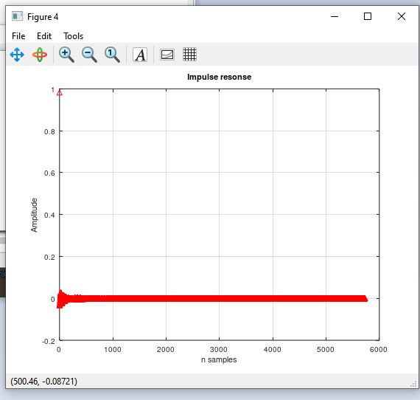

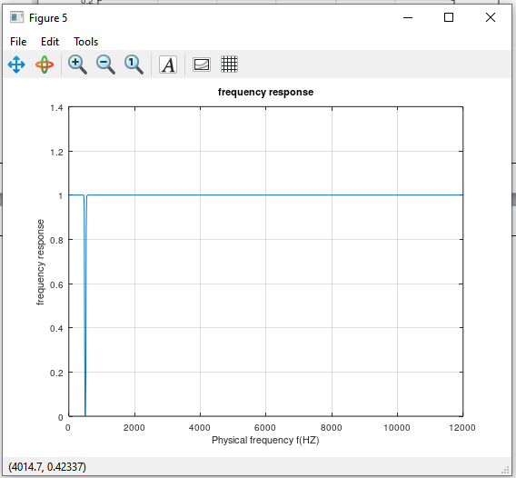

Filter is stable

**5 ـــ Plot the frequency spectrum of signal y**

%% plot S in time domain

figure(8);

plot(t,S);

xlabel('Time (sec)');

ylabel('Amplitude');

title('Time domain representation of S(t)');

%% Plot S in freq domain

S_k = abs( fft(S) ); %calc abs of fast fourier transform

f = linspace(0 , Fs, N); %discretize freq

figure(9);

plot(f ,S_k);

grid on ;

xlabel('Frequency (Hz)');

ylabel('Amplitude');

title('Amp spectrum of S(t)');

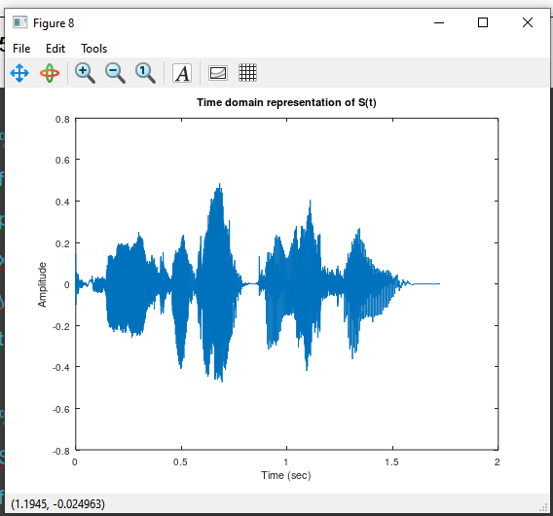

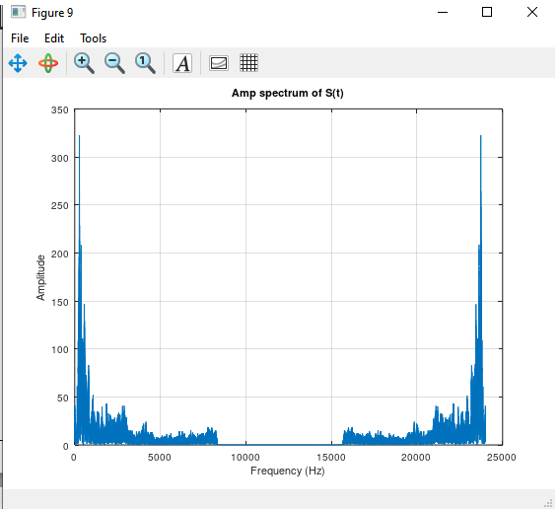

There is no whistel the voice is clear

薂ࠀTotal Energy : 311.91

Problem 3

For each of the following plot frequency response,impulse response:

a.

Code

% A)finite low pass filter

a =1;

b =0.125*[1,1,1,1,1,1,1,1];

Fs=8000;

%impulse responce

figure;impz(b,a,10),grid;

title('impulse responce');

xlabel('n(Samples)');

ylabel('impulse responce');

%freqancy responce

f=(0:.001:1)*Fs/2;

H= freqz(b,a,f,Fs);

figure;plot(f,abs(H)),grid;

title('freqancy responce');

xlabel('f(HZ)');

ylabel('freqancy responce');

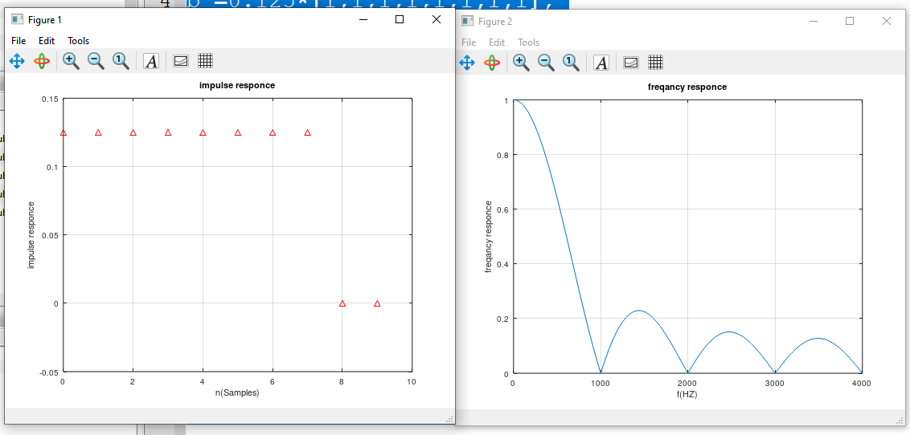

b.

% b)infinite low pass filter

a =[1 -1];

b =0.125*[1,0,0,0,0,0,0,0,-1];

Fs=8000;

%impulse responce

figure;impz(b,a,10),grid;

title('impulse responce');

xlabel('n(Samples)');

ylabel('impulse responce');

%freqancy responce

f=(0:.001:1)*Fs/2;

H= freqz(b,a,f,Fs);

figure;plot(f,abs(H)),grid;

title('freqancy responce');

xlabel('f(HZ)');

ylabel('freqancy responce');

