# 1.1 Motivation

Smart phones became most used devices in our daily life and it is easily used so our product will be mobile app.

# 1.2 App Overview

App consist of screens that enable user for reading Quran, Tafseer, searching for ayahs and listen to Quran these are basic features, the core is Quran Recitation Test by allowing user to record his sound and our ML will process it and return a Text that will be compared with Quran and results been displayed on screen.

# 1.3 Process

User selects ayahs to test then record his sound and upload it to our API then results been displayed on screen.

# 1.4 Screenshots

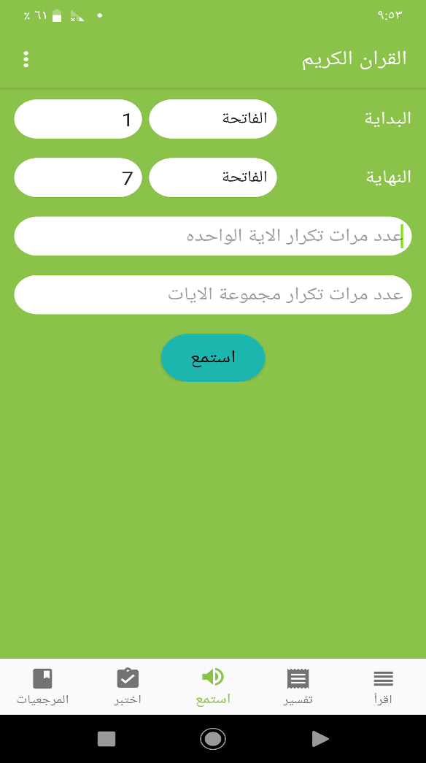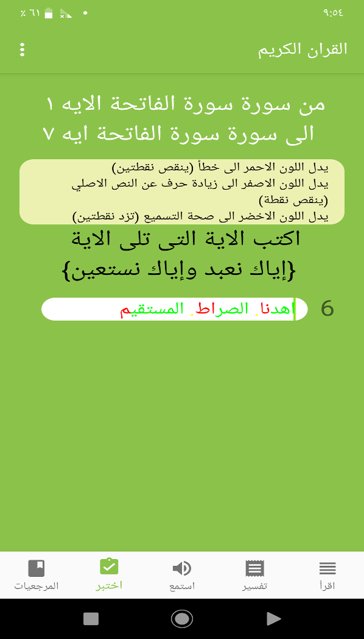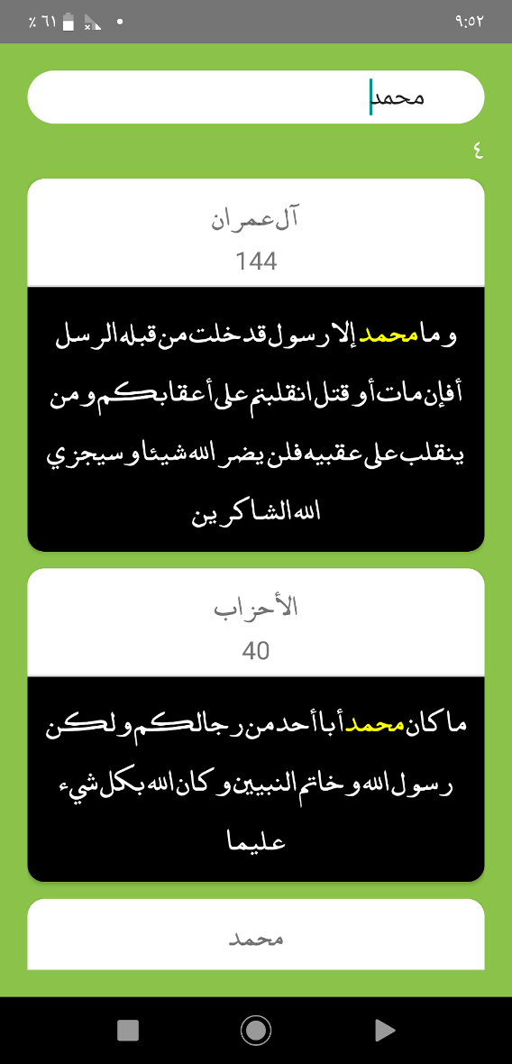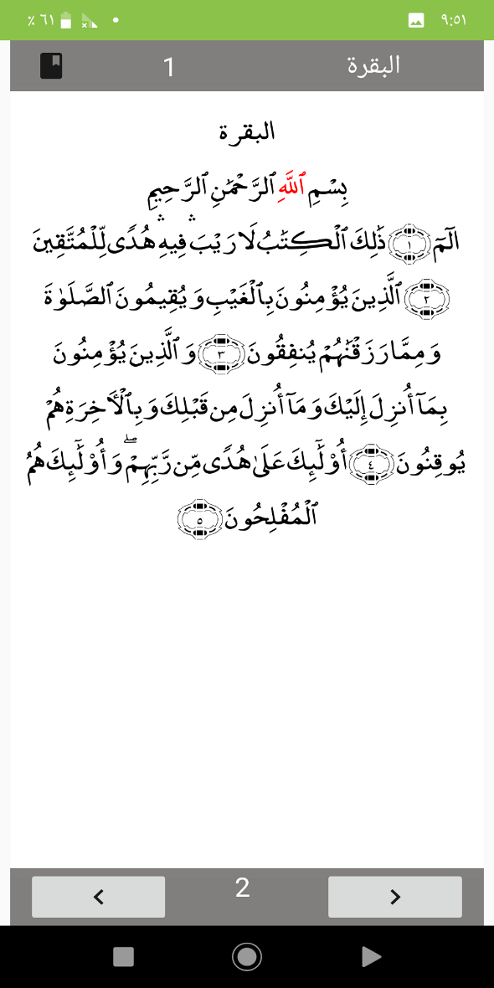

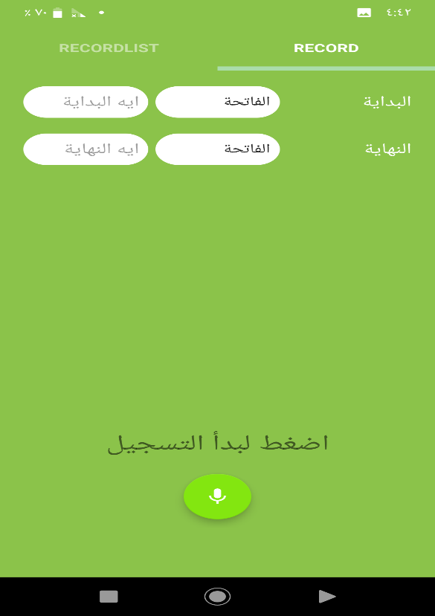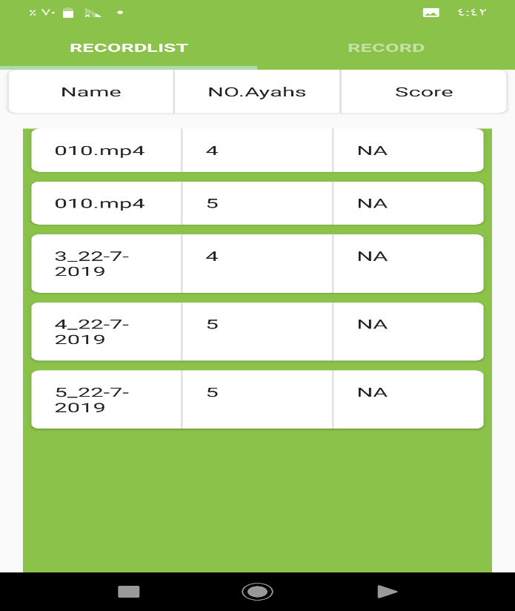

# 1.5 API

Ml model is hosted on server and there are API developed using flask

**Flask** is most used **framework** for making **API** for machine learning and deep learning applications.

To create API we need two parts

1. **Wrap the model**: code that deal with model and return response.
2. **Building the app**: This is where we communicate with the client and build an actual API with Flask.

To deploy API to be accessed using end users we use Heroku that need:-

* **Procfile**: - configuration file.
* **Main**: - code of API, define routes and its functions.
* **requirements.txt**:- contains list of packages needed in code.
* **model.pkl**:- serialized pre-trained model.

## Flask code:-

from flask import Flask , request , jsonify

from sklearn.externals import joblib

app = Flask(__name__)

# main path (root )

@app.route("/")

def hello():

return "Hello Every One To Qurany App"

@app.route('/uploadfile',methods=['GET','POST'])

def uploadfile():

// do logic here, load model, predict values.

return "Result"

if __name__ == '__main__':

app.run(debug = True , port= 5874)

# 1.6 Statistics

1. Code base is about 10k line of code.
2. App downloads is 100-500 on Google play store.

# 1.7 Awards

App have got 1st place at Al Azhar Exhibition(Azex) at Android Track(Class A).