Make & Trade

SRS

Introduced by G18

|  |  |  |  |  |
| --- | --- | --- | --- | --- |
| Version | Written By | Reviewed By | Approved By | Date |
| 0.1 | Haitham Mustafa & Youssef Zaki | Hesham Samir & Amr Essam | Youssef Abo El Maaty & Moatassem Adel | 25-10-18 |
| 0.2 | Amr Essam & Hesham Samir | Mostafa Abd El Megeed | Ali Taalab & Mahmoud Magdy | 2-12-18 |

# Introduction

# This section gives a scope description and overview of everything included in this SRS document. Also, the purpose for this document is described and a list of abbreviations and definitions is provided.

# Executive Summary

Make & Trade is an e-shop for handmade crafts. In Make & Trade users can sell their handmade products, share their experience by uploading tutorials for other users to see or even buy material needed to make their products.

# Document overview

The Document will introduce detailed system description including

Its Users and modules, in System users it will explain in detail the

role of each user that will use website, in System modules the

document will use block diagrams to explain the modules.

The document will provide details about system functional and

Non-functional requirements describing the Modules of each one,

It will also include the domain requirements. The document will

include the system models and system interfaces.

# Abbreviations and Terminologies

|  |  |
| --- | --- |
| Abbreviations | Meaning |
| HTML | Hyper Text Markup Language |
|  |  |
|  |  |

# References

[1] IEEE Software Engineering Standards Committee, “IEEE Std 830-1998, IEEE Recommended Practice for Software Requirements Specifications”, October 20, 1998.

# System description

# Introduction

Facility is number one in our site. Customers are going to search about anything related to handcraft products easily, and put whatever they want to buy in a checkout list. They will find materials, tools, tutorials, and videos provided by the suppliers and providers who have necessary roles, as suppliers will offer the required materials and tools for sale on the website, and the providers are going to upload videos and tutorials that would help many users to make such products.

Customers' feedbacks and reviews are valuable, so we care about them as they are sent to the Administrator and in return categories are organized and the system is updated usually.

Payment methods are also easy as we are going to deal using PayPal. As it will check the details of the credit card and will send a validation in return.

**System Context Diagram (SCD):**

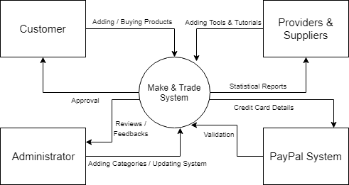

# Users

# Admin user

# They have specific permission for managing the system and its users.

# General user

# They are the users who will interact with the website.

# Supplier user

# This user is the one who adds tools, materials & tutorials.

# Modules

# Suppliers Area:

# Area for all suppliers' functions.

# Seller Area:

# Area for all sellers' functions.

# Category Browsing:

# Viewing all categories.

# Product Browsing:

# Viewing products by category.

# Checkout List:

# Customer's buying list.

# Shipping Order:

# Module related to delivery.

# Payment Method:

# Module affords easy payment way.

# System Admin Area:

# Module related to administrator user.

# Analytics and Reporting Area:

# Module related to reviewing materials, tools and products.

# System users

# Admin user

# The administrators only interact with the web portal. They are managing the overall system so there is no incorrect information within it. The administrator can manage the information for each user as well as the options for both the products, tutorials and materials.

# General user

# This user has access to registration module, he has to be authenticated to have access creation area, he will be able to add or sell products, he will view or upload tutorials and be able to buy materials.

# Supplier user

# This user will be able to provide materials, tools, videos and tutorials. He sells tools and materials on the website. He receives statistical reports based on customers' feedbacks and reviews. He also has general user's features.

# System Modules

**Suppliers Area:**

# Part of website accessed by all suppliers in which supplier can add material, add tools, add price, view statistical reports.

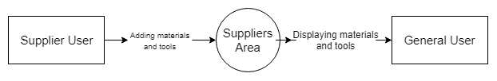

**Seller Area:**

# Part of website accessed by all users in which they can put their own product and its price.

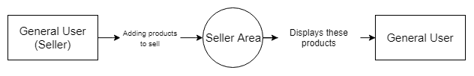

**Category Browsing:**

# This module shows all Categories in our website, user can search by certain Category.

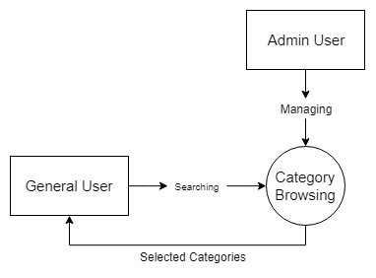

**Product Browsing:**

This module shows all products that belong to certain Category, user can search by certain product, filter by price and view reviews for products.

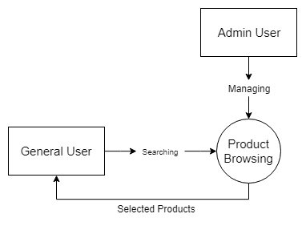

**Checkout List:**

A list that contains all product that user wants to buy.

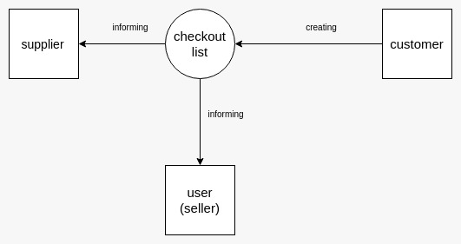

**Shipping Order:**

A Module that enable suppliers to deliver materials and tools to users.

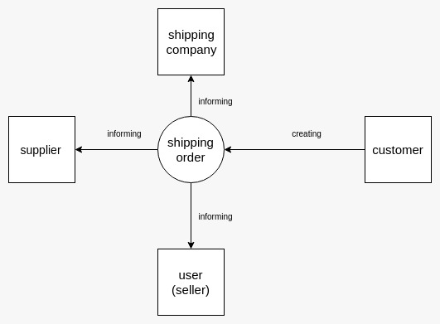

**Payment Method:**

# This module aims to transfer money between user and suppliers using PayPal.

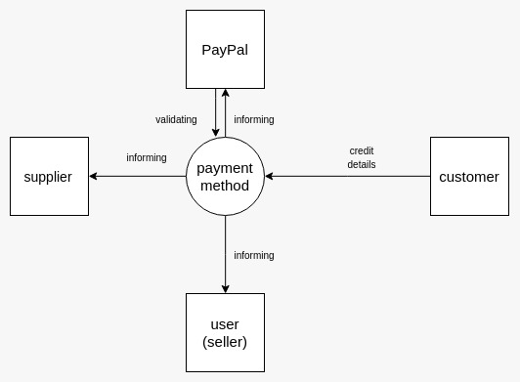

**System Admin Area:**

# Part of website accessed by administrator only to view all reviews and approve any product, materials and tools.

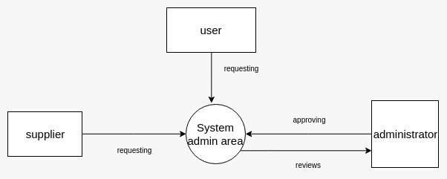

**Analytics and Reporting Area:**

# This module integrates customers' feedbacks and reviews on tools and materials, in order to grant statistical reports to the supplier user.

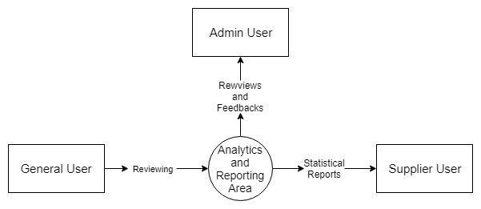

# System Functions

# Suppliers Area Module Functions

# Add Material Module Function

# Description: used by supplier user to add materials.

# Inputs: name, type, price, stock number, photo and description.

# Outputs: saving material in database.

# Pre-conditions: Supplier is approved by administrator and has an ID.

# Post-conditions: All inputs are valid.

# Add Tool Module Function

# Description: used by supplier user to add tools.

# Inputs: name, type, price, stock number, photo and description.

# Outputs: saving tool in database.

# Pre-conditions: Supplier is approved by administrator and has an ID.

# Post-conditions: All inputs are valid.

# Add Tutorial Module Function

# Description: used by supplier user to add tutorials.

# Inputs: name, type, price, stock number, photo and description.

# Outputs: saving tutorial in database.

# Pre-conditions: Supplier is approved by administrator and has an ID.

# Post-conditions: All inputs are valid.

# View Report Module Function

# Description: used by supplier user to view statistical reports.

# Inputs: name.

# Outputs: statistical reports.

# Pre-conditions: Supplier is approved by administrator, has an ID.

# Post-conditions: name is valid.

# Seller Area Module Functions

# Add Product Module Function

# Description: used by general user (seller) to add products.

# Inputs: name, type, price, stock number, photo and description.

# Outputs: saving product in database.

# Pre-conditions: user is approved by administrator and has an ID.

# Post-conditions: All inputs are valid.

# Category Browsing Module Functions

# View Category Module Function

# Description: used by general user to view products in a category.

# Inputs: name.

# Outputs: displaying products of the category.

# Pre-conditions: user is approved by administrator and has an ID.

# Post-conditions: name is valid.

# Add Category Module Function

# Description: used by admin user to add products.

# Inputs: name, type, photo, products names, and description.

# Outputs: saving category in database.

# Pre-conditions: logged in as admin.

# Post-conditions: All inputs are valid.

# Product Browsing Module Functions

# View product Module Function

# Description: used by general user to view product..

# Inputs: name, category

# Outputs: displaying product

# Pre-conditions: user is approved by administrator and has an ID.

# Post-conditions: name or category is valid.

# Buy product Module Function

# Description: used by general user to view product.

# Inputs: product

# Outputs: displaying product in checklist

# Pre-conditions: user is approved by administrator and has an ID.

# Post-conditions: product is valid.

# Checklist Module Functions

# View checklist Module Function

# Description: used by general user to view product he decided to buy.

# Inputs: name

# Outputs: displaying products in shipping area

# Pre-conditions: user is approved by administrator and has an ID.

# Post-conditions: products are available.

# Shipping method Module Functions

# Determine shipping method Module Function

# Description: used by general user to determine the shipping method he wants

# Inputs: name

# Outputs: producing into payment area

# Pre-conditions: user is approved by administrator and has an ID.

# Post-conditions: products are available.

# Payment method Module Functions

# Determine payment method Module Function

# Description: used by general user to determine the shipping method he wants

# Inputs: name

# Outputs: saving order into database.

# Pre-conditions: user is approved by administrator and has an ID.

# Post-conditions: products are available.

# System Admin area Module Functions

# Description: used by admin user only to manage website

# Inputs: report,materials,products

# Outputs: saving changes into database.

# Pre-conditions: user must be an administrator.

# Post-conditions: no changes in user profiles.

# 

# Non-Functional Requirements

# Security Requirements

# Passwords should be to standard of Django forms

# Usability Requirements

# The site does not target any specific group and its usage does not require any specific set of skills.

# Performance Requirements

# The required response time of site has not been determined

# Technology Requirements

# The website is compatible with laptop and mobile system

# Development Requirements

# The website is developed by bootstrap and django

# Delivery Requirements

# The website should be ready before 10 February 2019

# Operation Requirements

# Domain Requirements

# The website need no domain requirements.