**Project chess**

First student’s name: Mahmoud Ebrahim Elsayed

First student’s ID: 62

Second student’s name: Andrew Adel

Second student’s ID: 16

**Features:**

1. We use ASCII code for make board :

We use the alphabet : White pieces are represented by "p", "r", "n", "b", "q", "k" for pawns, rooks, knights, bishops, queen and king respectively.

And black pieces where the same but capital.

We use “+” for white squares and “-”for black squares.

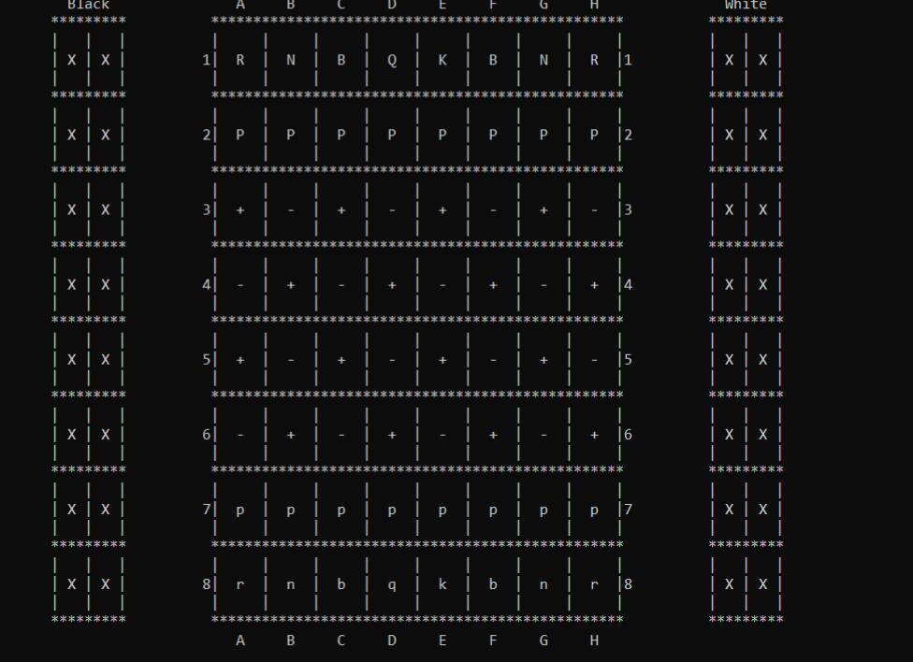As shown in figure

1. In the game you can make save at any time and you can load what you save

Only press on 's' and enter to save and if you want to load it press 'l' and enter.

1. You can make undo and redo for 500 time in the game
2. In the game start with the white pieces
3. Any player can’t move the pieces for the other player and can’t play in the round others

**Dynamic of the game**

When the game start ask you for the move for the first player for the white piece

And after the first move you can make save or undo or redo if you make undo before.

If you don’t have saved file you can’t make load for the game.

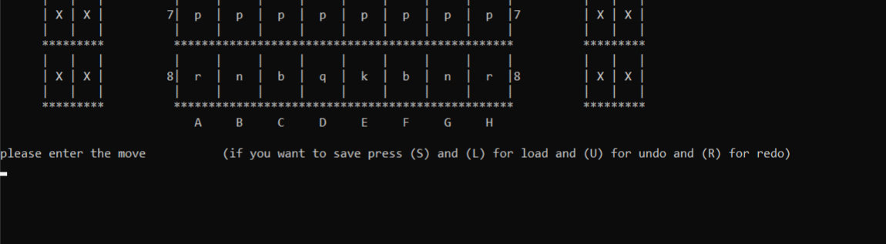

This figure to show you the available input another the move.

**The Data structures**

-We used 2D array for the board.

-And defined structure (DO) for save the moves for undo and redo which can save up to 500 moves.

-we used 'short','int' and 'char' variables.

-we separated between white and black pieces as each white piece has its own function which is different from the same piece in black.

-we used a number of functions and those are the most important :

* Void stalematewhite()
* Void stalemateblack()
* Void checkmateblack()
* Void checkmatewhite()
* Int checkTheKingBlack(int row1,int col1,int row2,int col2)
* Int checkTheKingWhite(int row1,int col1,int row2,int col2)

Print the board

If

Checkmate or stalemate

true

false

Read inputs

If the move is valid

false

true

Do the move

Notes:

* We used a counter ''number of moves'' to determine if it is the white's move or black's move.
* We tried to cover almost all the probable crashes in this application.
* All the application is a result of personal effort and we didn't rely on external sources.