Toyota Smart Gate & Queue

Technical Handover

Document type: Client technical handover Project: Tamkeen Phase 1 — Kiosk AI Agent & Queue Management Audience: Client technical team Date: August 2026 Prepared by: Mahmoud Matter

Table of contents
1. Executive summary
2. What we are building
3. What has been delivered
4. Architecture overview
5. Design patterns — adapter ports
6. Web UIs
7. Real-time communication — Socket.io
8. Kiosk conversation approach
9. Voice pipeline — STT, NLU, TTS, avatar sync
10. Queue engine
11. Integrations status
12. HTTP API reference
13. Environment variables
14. Domain events
15. How to run and demo
16. Not yet production-ready
17. Open questions for the client

1. Executive summary

The problem
At a Toyota service branch, cars queue at entry gates while staff manually verify identity. Plate recognition exists, but there is no conversational confirmation with the driver. Garage slot availability is opaque — drivers enter without knowing when a slot will free up, and no-shows waste capacity.

The solution
Two modules, one middleware brain:
Module | Role
Module 1 — Kiosk AI Agent | Voice avatar at each gate confirms identity after LPR + SAP lookup, captures a visit phone when the driver is not the account holder, opens the gate, and enqueues the visit
Module 2 — Queue Management | Single shared FIFO queue across all gates; when a garage slot frees, notify the next driver via WhatsApp (authoritative), SMS, and app push, with a 50-second claim window and growing push-back on no-shows

Phase 1 scope
- In scope: Single branch, multiple entry gates, one shared queue, entry flow only
- Out of scope: Exit flow, multi-branch scale, Arabic voice (scaffolded but disabled), production hardware integrations not yet contracted

What this delivery includes
A demo-ready NestJS middleware prototype with:
- Full kiosk session state machine (voice + touch)
- Shared queue engine with BullMQ claim timers
- Three browser UIs (kiosk, demo console, integration logs)
- ElevenLabs STT/TTS integration (live)
- Stub adapters for SAP, gate, and WhatsApp so local development proceeds before vendor API schemas arrive
- End-to-end proof script and unit tests
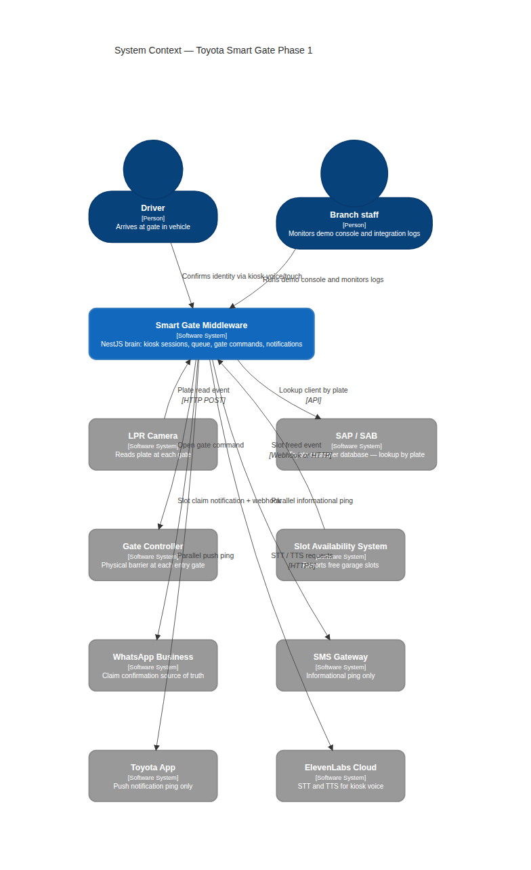

2. What we are building

System actors
Actor / system | Role
LPR camera (one per gate) | Reads plate as car approaches; sends plate to middleware
Kiosk / avatar (one per gate) | Voice-driven UI; displays client info, asks for confirmation
Gate controller | Physical barrier; opens on middleware command
Middleware | Central brain — orchestrates all gates, owns the queue, drives notifications
SAP / SAB | Toyota customer database — lookup by plate (read-only from middleware)
Slot availability system | Reports when garage slots become free
Notification service | WhatsApp (claim source of truth), SMS, Toyota app push (informational)

Business rules (resolved)
Rule | Behaviour
Plate not found in SAP | Gate stays closed — no guest flow
SAP / middleware unreachable | Gate stays closed
Driver says phone on file is wrong | Ask if owner; if yes, collect visit phone by voice; visit phone does not overwrite SAP record
WhatsApp confirm within 50s | Slot assigned; confirmation treated as guaranteed arrival
Timeout on claim | Entry pushed back N positions (N grows with consecutive misses); next FIFO head notified
Retry ceiling on queue | None — client cycles indefinitely if they keep missing notifications
Staff escalation | After 3 unclear retries in kiosk conversation
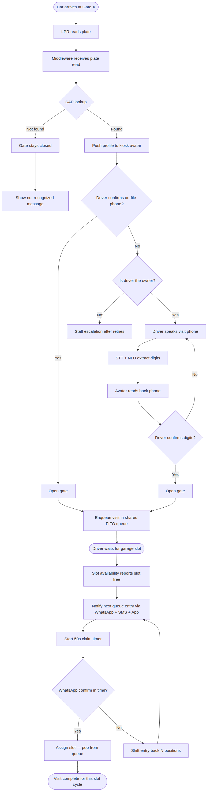

3. What has been delivered
Work completed August 9–11, 2026 (see releases.md for full changelog).

A. Middleware core
- NestJS modular monolith: LPR, SAP, Gate, Kiosk, Queue Engine, Notifications, Audit, Demo, TTS, STT, NLU, Integration Log
- Redis for live state (sessions, queue, TTS cache, audit stream, LPR dedupe)
- BullMQ delayed jobs for 50s claim timers
- Domain event bus (@nestjs/event-emitter) with typed payloads and audit trail
- Correlation IDs via x-correlation-id header

B. Kiosk session engine
- Explicit state machine — not a free-form LLM conversational agent
- States: identity confirm → owner check → phone speech → phone confirm → done / staff escalation / not recognized
- Bilingual i18n scaffolding (English active; Arabic disabled via ARABIC_ENABLED=false)
- Display text vs ElevenLabs speech strings split (prompt vs speech in session payload)
- Al-Sayer Hayyak branding in kiosk copy

C. Queue engine
- Redis FIFO list with atomic Lua scripts for enqueue, shift-back, and assign
- Growing push-back on consecutive no-shows per slot cycle
- Multi-slot parallel notify via batch free endpoint
- WhatsApp confirm HTTP endpoint (stub notification adapter for demos)

D. Voice stack (ElevenLabs)
- STT via ElevenLabs Scribe (scribe_v2)
- TTS via ElevenLabs v3 (eleven_v3) with audio tags and 3-3-4 digit read-out
- Redis TTS cache (SHA256 of voice+model+text)
- Retry with exponential backoff on ElevenLabs 429/5xx
- Stub adapters for offline demo without API key

E. NLU (transcript interpretation)
- Rules-first hybrid: yes/no and clean phone digits handled instantly
- Optional local LLM (Ollama qwen3:0.6b) for messy digit speech only
- 2s fail-fast timeout; falls back to rules
- EG/SA phone validation
- Read-back confirm step is the accuracy safety net

F. Web UIs
- Kiosk (index.html) — avatar, voice capture, touch keypad, STT/TTS sandbox
- Demo console (console.html) — full operator workflow with audit timeline
- Integration logs (logs.html) — live tail of external API calls

G. Integration logging
- Structured logging for ElevenLabs, LPR, NLU, SAP, gate, notifications, TTS, STT
- File sink (rotating logs under middleware/logs/) + live WebSocket viewer
- Redaction of API keys and long bodies

H. Tests and proof
- Unit tests: state machine, queue logic, TTS/STT/NLU specs (19+ tests)
- scripts/prove_flow.sh — curl-based end-to-end proof without browser

4. Architecture overview
The middleware is a modular monolith: one Node.js process serves REST, WebSocket, and static HTML. Modules communicate via domain events rather than direct tight coupling.
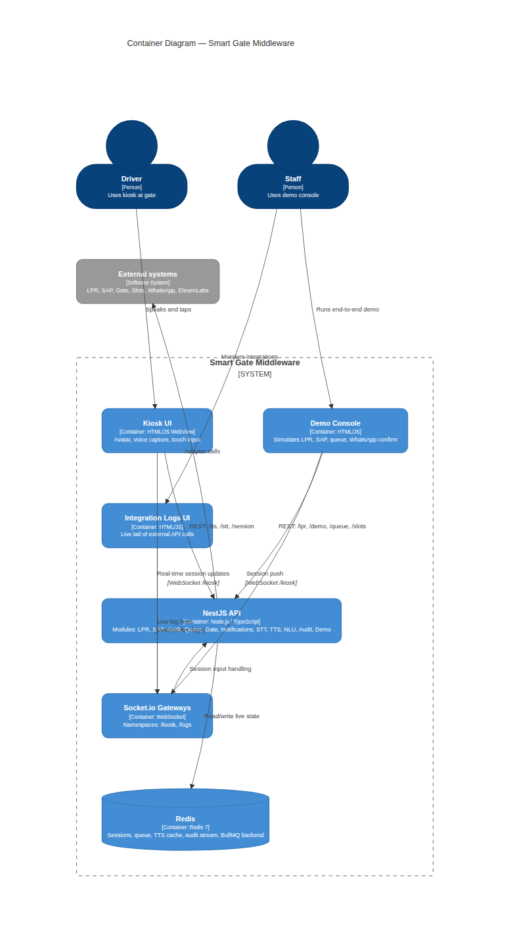

NestJS modules
Module | Responsibility
lpr | Ingest plate reads, dedupe active plates, emit lpr.plate.read
sap | Lookup client profile by plate on LPR event
kiosk | Session state machine, Redis store, Socket.io push
gate | Open gate on identity/phone confirmed
queue-engine | FIFO queue, slot notify, claim timers, shift-back
notifications | Send slot notifications; WhatsApp confirm endpoint
audit | Append all domain events to Redis stream
demo | Fake SAP overrides, full reset, config
tts / stt / nlu / speech | Voice pipeline with adapter seams
integration-log | Pretty file logs + live WebSocket viewer

Data stores
Store | Contents
Redis | Kiosk sessions, queue entries, LPR active-plate keys, TTS cache, audit stream, BullMQ backend
Postgres | Not implemented in this phase (design doc recommends it for durable audit history)

5. Design patterns — adapter ports
External integrations use the hexagonal / ports-and-adapters pattern. Each integration has a TypeScript interface (port) and one or more implementations selected by environment variable. Stub adapters exist so development and demos proceed locally until the actual vendor API schemas are delivered.
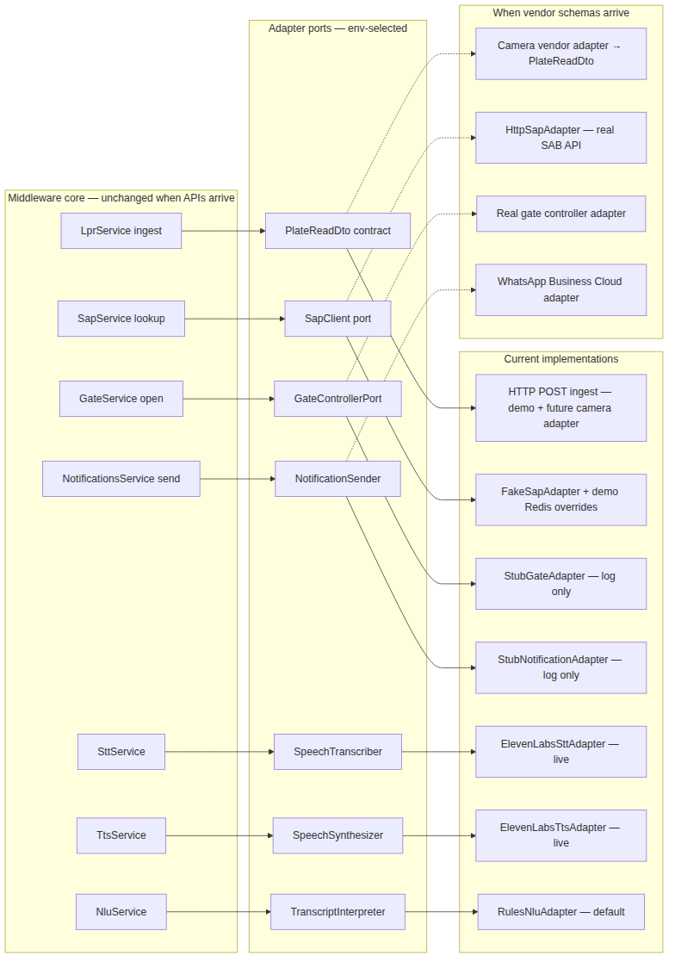

LPR — ingest contract (not a full adapter yet)
LPR uses a stable ingest DTO today. When the camera vendor API schema arrives, a thin adapter maps vendor payloads into this contract without changing kiosk or queue logic.
// POST /lpr/plate-read
{ gateId, plateNumber, timestamp?, image? }

SAP / SAB — customer lookup
Port | `SapClient.lookupByPlate(plate) → ClientProfile \ | null`
Today | FakeSapAdapter — hardcoded ABC 1234 + Redis demo overrides via POST /demo/sap-profile
Future | SAP_ADAPTER=http with real SAB API (reserved; throws at startup until implemented)

Gate controller
Port | GateControllerPort.openGate(gateId)
Today | StubGateAdapter — logs gate.open.stub, no physical action
Future | GATE_ADAPTER=real (reserved; throws at startup until implemented)

WhatsApp / notifications
Port | NotificationSender.notify({ entryId, phone, plateNumber, slotId, channels })
Today | StubNotificationAdapter — logs notification; confirm simulated via POST /notifications/whatsapp/confirm
Future | NOTIFICATION_ADAPTER=real — WhatsApp Business Cloud API + webhook (reserved)
Important: Only WhatsApp confirmation counts for queue logic. SMS and app push are parallel informational pings.

STT / TTS / NLU
Port | Live implementation | Stub
SpeechTranscriber | ElevenLabsSttAdapter | StubSttAdapter (returns "yes")
SpeechSynthesizer | ElevenLabsTtsAdapter | StubTtsAdapter (silent WAV)
TranscriptInterpreter | RulesNluAdapter (default) | LlmNluAdapter (Ollama, optional)
Env vars: STT_ADAPTER, TTS_ADAPTER, NLU_ADAPTER.

6. Web UIs
All UIs are thin HTML/JavaScript clients served from middleware/public/ via NestJS ServeStaticModule. All session logic lives on the server — the browser handles presentation, TTS playback, STT capture, and Socket.io transport only.

6.1 Regular kiosk UI
File | Role
index.html | Kiosk layout — avatar panel, session controls, STT/TTS sandboxes
app.js | Socket.io connect, session render, hold-to-speak, touch input
avatar.js | Avatar states (idle/talking/listening), canvas or Rive lip-sync from TTS audio RMS
URL: http://127.0.0.1:3000/
Features: Start manual visit, Yes/No buttons, hold-to-record voice answers, phone keypad, TTS/STT test panels.

6.2 Demo console
File | Role
console.html | Operator layout — connection, SAP profile, LPR simulate, queue, slots
console.js | Demo workflow orchestration, audit timeline polling
mw-api.js | Shared HTTP + Socket.io API wrapper with localStorage config
URL: http://127.0.0.1:3000/console.html
Operator workflow: Connect → Save SAP profile → Send LPR plate → interact with avatar → Free slot → WhatsApp confirm → watch audit timeline.

6.3 Integration logs UI
File | Role
logs.html | Filterable live log viewer
logs.js | Socket.io /logs subscribe, append lines
URL: http://127.0.0.1:3000/logs.html
Tracks: elevenlabs, lpr, nlu, sap, gate, notifications, tts, stt.

UI design approach
- Server-driven prompts: Each session.update carries prompt (screen text) and speech (ElevenLabs-optimized text with audio tags and spelled digits)
- Avatar sync: Server sets avatar_state; client drives lip-sync during TTS playback via Web Audio API amplitude analysis
- Degraded fallback: Touch keypad and Yes/No buttons work when STT fails or ElevenLabs is unavailable (with stub adapters)

7. Real-time communication — Socket.io
HTML clients connect to the same origin as the NestJS API (port 3000). Two WebSocket namespaces are used.
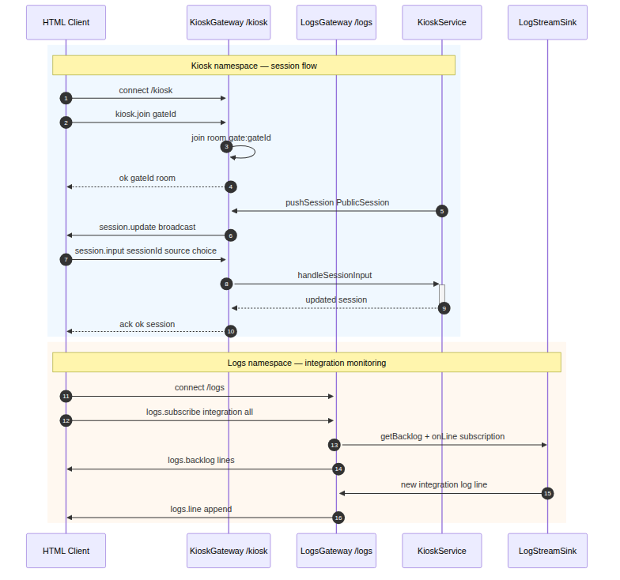

Namespace /kiosk — session flow
Direction | Event | Payload | Notes
Client → Server | kiosk.join | { gateId } | Joins room gate:{gateId}
Server → Client | session.update | PublicSession | Broadcast to gate room
Client → Server | session.input | { sessionId, source, choice?, text?, phone_digits? } | Ack returns { ok, session }
REST fallback: POST /session/:sessionId/input when socket is disconnected.

Namespace /logs — integration monitoring
Direction | Event | Payload
Client → Server | logs.subscribe | `{ integration: 'all' \ | 'elevenlabs' \ | ... }`
Server → Client | logs.backlog | Initial buffered lines
Server → Client | logs.line | New log line (live tail)

PublicSession payload (key fields)
Field | Description
session_id, gate_id, state, lang | Session identity
profile.name, profile.phone_display | Masked phone (e.g. 050-XXX-4567)
prompt, speech | Display vs TTS text
avatar_state | idle / talking / listening
retries, max_retries | Retry counter (max 3)
gate_open_stub | Whether gate stub fired

8. Kiosk conversation approach
The kiosk uses an explicit server-side state machine — not a free-form LLM agent. NLU only extracts yes/no and phone digits from STT transcripts; the state machine decides what to ask next.
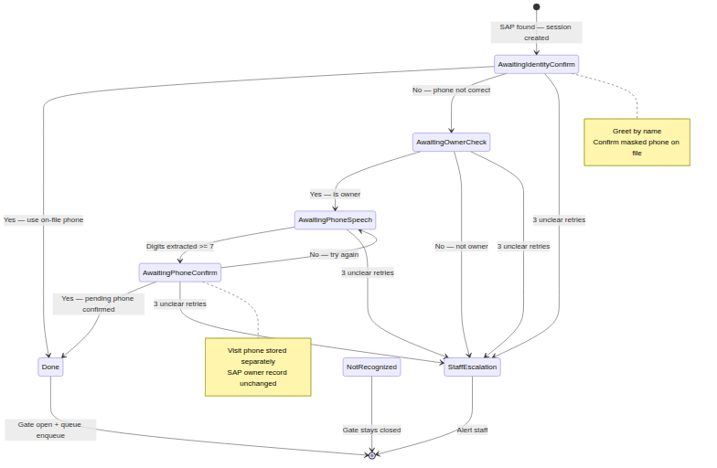

States
State | Meaning
awaiting_identity_confirm | Greet by name; confirm masked phone on file
awaiting_owner_check | Driver said phone wrong — are you the owner?
awaiting_phone_speech | Owner speaks alternate visit phone
awaiting_phone_confirm | Read back heard digits; confirm
done | Visit complete — gate open + enqueue
staff_escalation | Max retries or not owner
not_recognized | SAP lookup failed — gate stays closed

Known customer — happy path
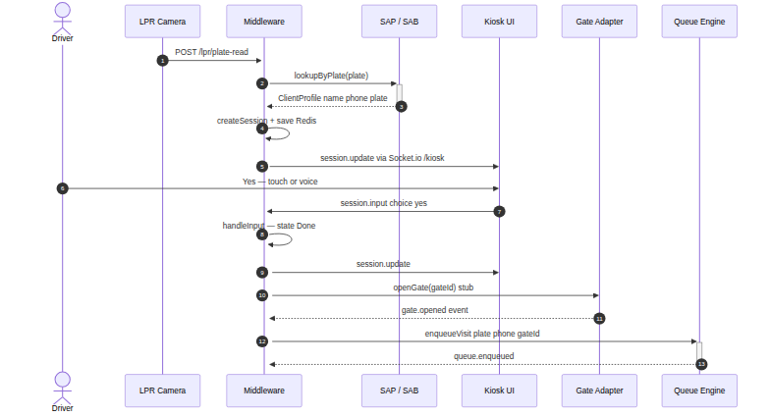
1. LPR sends plate → SAP returns profile
2. Middleware creates session → pushes to kiosk via Socket.io
3. Avatar greets and asks to confirm phone
4. Driver says Yes (voice or touch)
5. Gate stub opens → visit enqueued with on-file phone

Driver not owner — visit phone capture
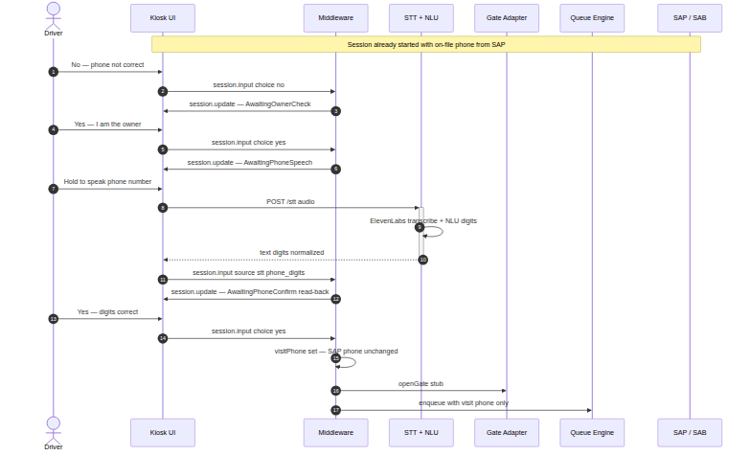
1. Driver says phone on file is wrong
2. Avatar asks: are you the owner?
3. If yes → driver speaks visit phone → STT + NLU extract digits
4. Avatar reads back digits → driver confirms
5. Gate opens → enqueued with visit phone only — SAP owner record unchanged

i18n and branding
- Copy uses Al-Sayer Hayyak brand voice
- display strings are clean screen text; speech strings include ElevenLabs v3 audio tags ([warmly], pauses) and spelled-out phone digits (3-3-4 pattern)
- Arabic translations exist in code but are disabled (ARABIC_ENABLED=false); language picker hidden in UI

9. Voice pipeline — STT, NLU, TTS, avatar sync
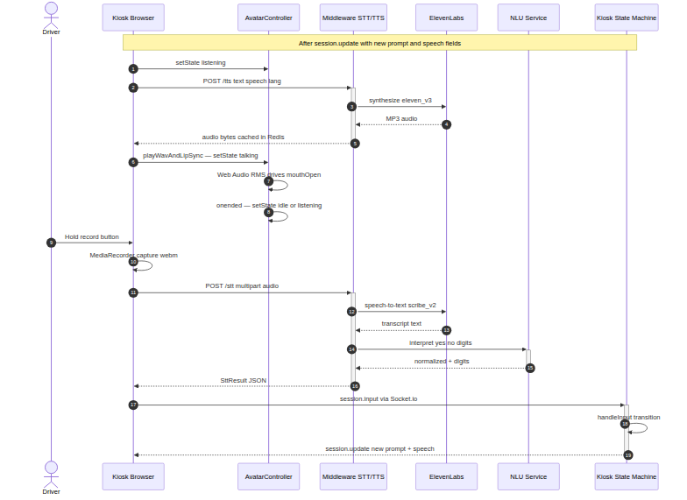

Flow (one voice answer turn)
1. Server pushes session.update with speech field
2. Client calls POST /tts with { text: speech, lang } → ElevenLabs returns MP3 (cached in Redis)
3. AvatarController.playWavAndLipSync() — Web Audio RMS drives mouth openness
4. Driver holds record button → MediaRecorder captures audio
5. Client calls POST /stt (multipart audio + lang)
6. Middleware: ElevenLabs transcribe → NluService.interpret() → { text, normalized, digits }
7. Client sends session.input via Socket.io
8. State machine transitions → new session.update → repeat from step 1

ElevenLabs configuration
Setting | Default | Purpose
ELEVENLABS_STT_MODEL_ID | scribe_v2 | Speech-to-text
ELEVENLABS_TTS_MODEL_ID | eleven_v3 | Text-to-speech (required for audio tags)
ELEVENLABS_TTS_VOICE_ID | — | Voice selection (required for live TTS)
ELEVENLABS_TTS_OUTPUT_FORMAT | mp3_44100_128 | Audio format
TTS_CACHE_TTL_SECONDS | 86400 | Redis cache TTL
Note: Live ElevenLabs requires outbound internet from the kiosk/middleware host. Use TTS_ADAPTER=stub / STT_ADAPTER=stub for air-gapped demos; touch input remains available.

NLU strategy (latency-first)
1. Rules normalize yes/no and extract digits instantly
2. Pure yes/no (no long digit run) → return immediately — no LLM call
3. Clean valid EG/SA phone from rules → skip LLM
4. If NLU_ADAPTER=llm and speech is ambiguous → call Ollama with 2s timeout
5. LLM timeout or error → fall back to rules
6. Phone confirm read-back catches extraction errors

Avatar rendering
- Default: Procedural canvas face; mouth driven by mouthOpen 0..1 from audio amplitude
- Optional: Rive animation (avatar.riv) if present — state machine inputs idle/talking/listening

10. Queue engine
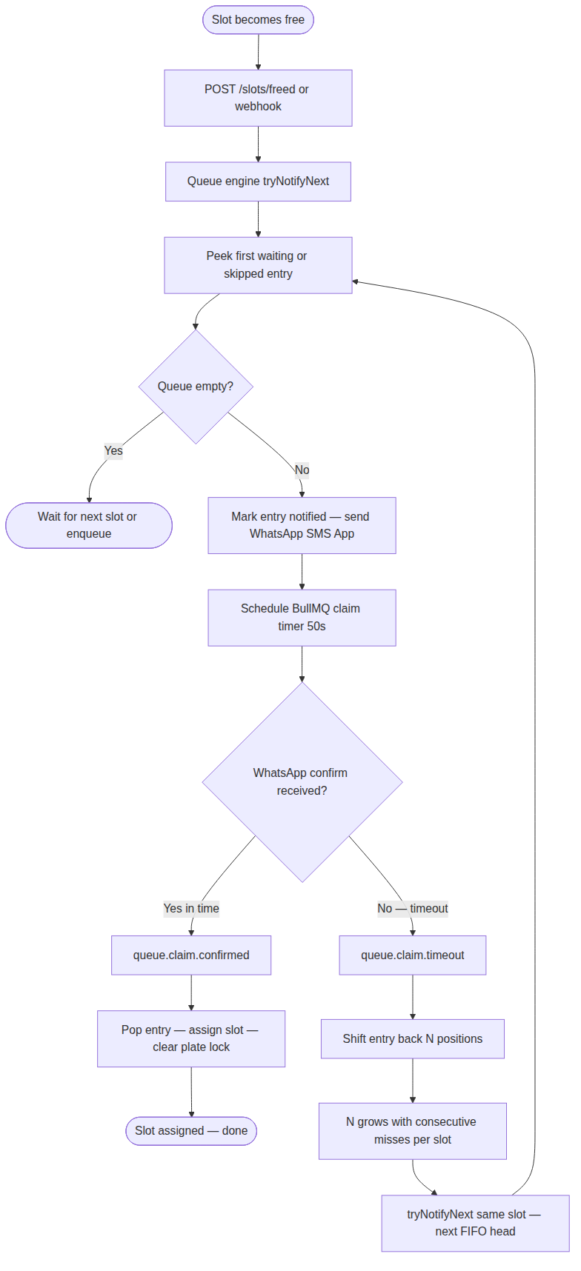

Data model (Redis)
Key | Purpose
qms:queue | Ordered list of entry IDs (FIFO)
qms:entry:{id} | Entry JSON (plate, phone, status, gate, timestamps)
qms:plate:{PLATE} | Idempotency — one active entry per plate
qms:claim:{slotId} | Active claim for a slot
slots:available | Count of free slots awaiting batch notify

Entry statuses
waiting → notified → confirmed → assigned On timeout: skipped (re-eligible at next peek)

Push-back algorithm
When a driver does not confirm within 50 seconds (CLAIM_TIMEOUT_MS):
- 1st consecutive miss → shift back 1 position
- 2nd consecutive miss → shift back 2 positions
- Nth miss → shift back N positions
- Counter resets when someone confirms
Example: Queue [1, 2, 3, 4] → 1 times out → [2, 1, 3, 4] → 2 times out → [3, 1, 2, 4] → 3 confirms → slot assigned to 3.

Multi-slot
When N slots free simultaneously, up to N queue heads are notified in parallel, each with its own 50s timer and slot reservation.

Triggering slot free (today)
Production: slot availability system webhook or poll (contract TBD). Demo: POST /slots/freed or POST /slots/freed-batch from console.

11. Integrations status
Integration | Status | Implementation | Notes
ElevenLabs STT | Live | ElevenLabsSttAdapter | Requires API key + outbound HTTPS
ElevenLabs TTS | Live | ElevenLabsTtsAdapter | Requires API key + voice ID
NLU rules | Live | RulesNluAdapter | Default; no external dependency
NLU LLM | Optional | LlmNluAdapter | Ollama at NLU_BASE_URL; not required for demo
SAP / SAB | Stub | FakeSapAdapter + demo Redis overrides | Real HTTP adapter reserved
Gate controller | Stub | StubGateAdapter | Logs open command only
WhatsApp / SMS / App | Stub | StubNotificationAdapter | Confirm via HTTP simulate endpoint
LPR camera | Ingest only | POST /lpr/plate-read | Vendor adapter maps to DTO when schema arrives
Slot availability | Manual trigger | POST /slots/freed | Webhook/poll adapter when contract known

12. HTTP API reference
Method | Path | Purpose
GET | /health | Health check; reports active TTS/STT adapters
POST | /lpr/plate-read | Camera plate ingest
POST | /session/start | Manual kiosk session (test without LPR)
GET | /session/:id | Session snapshot
POST | /session/:id/input | Touch/STT input (REST fallback)
POST | /tts | Text-to-speech { text, lang } → audio bytes
POST | /stt | Speech-to-text multipart audio → { text, normalized, digits }
GET | /queue | Live queue entries
GET | /slots/available | Available free slots + active claims
PUT | /slots/available | Set available slot count { available }
POST | /slots/freed | Single slot free → notify next
POST | /slots/freed-batch | Free N slots → notify up to N waiting
POST | /notifications/whatsapp/confirm | WhatsApp claim confirm
GET | /audit/events?limit=N | Recent domain-event audit trail
GET | /demo/config | Demo config (claimTimeoutMs)
POST | /demo/sap-profile | Register fake-SAP override for a plate
POST | /demo/reset | Clear queue, sessions, LPR, TTS cache, demo, audit

WebSocket namespaces
Namespace | Events
/kiosk | kiosk.join, session.input, push session.update
/logs | logs.subscribe, push logs.backlog / logs.line

13. Environment variables
Validated in middleware/src/config/env.validation.ts. Copy middleware/.env.example to .env.
Variable | Default | Purpose
PORT | 3000 | HTTP server port
NODE_ENV | development | Environment
LOG_LEVEL | info | Pino log level
REDIS_HOST | 127.0.0.1 | Redis host
REDIS_PORT | 6379 | Redis port
REDIS_PASSWORD | "" | Redis password
REDIS_DB | 0 | Redis database index
CLAIM_TIMEOUT_MS | 50000 | Queue claim window (ms)
SESSION_TTL_SECONDS | 1800 | Kiosk session TTL in Redis
SAP_ADAPTER | fake | fake \ | http (http not implemented)
SAP_BASE_URL | "" | Reserved for HTTP SAP adapter
GATE_ADAPTER | stub | stub \ | real (real not implemented)
NOTIFICATION_ADAPTER | stub | stub \ | real (real not implemented)
TTS_ADAPTER | elevenlabs | elevenlabs \ | stub
STT_ADAPTER | elevenlabs | elevenlabs \ | stub
ELEVENLABS_API_KEY | "" | Required for live ElevenLabs
ELEVENLABS_TTS_VOICE_ID | "" | ElevenLabs voice ID
ELEVENLABS_TTS_MODEL_ID | eleven_v3 | TTS model
ELEVENLABS_TTS_OUTPUT_FORMAT | mp3_44100_128 | Audio output format
ELEVENLABS_STT_MODEL_ID | scribe_v2 | STT model
TTS_CACHE_TTL_SECONDS | 86400 | Redis TTS cache TTL
CORS_ORIGINS | localhost URLs | Comma-separated CORS origins
NLU_ADAPTER | rules | rules \ | llm
NLU_BASE_URL | http://127.0.0.1:11434/v1 | LLM server (Ollama)
NLU_MODEL | qwen3:0.6b | LLM model name
NLU_TIMEOUT_MS | 2000 | LLM timeout; fallback to rules
PHONE_REGIONS | EG,SA | Accepted phone regions
INTEGRATION_LOG_ENABLED | true | Enable integration logging
INTEGRATION_LOG_DIR | logs | Log file directory
INTEGRATION_LOG_MAX_BODY_CHARS | 2000 | Max chars per logged body
INTEGRATION_LOG_MAX_FILE_MB | 10 | Log rotation size
INTEGRATION_LOG_ROTATE_KEEP | 3 | Rotated files to keep

14. Domain events
All events are typed in middleware/src/events/domain-events.ts and appended to the audit Redis stream.
Event | Emitter | Typical listeners
lpr.plate.read | LPR | SAP
sap.lookup.found | SAP | Kiosk
sap.lookup.not_found | SAP | Kiosk
kiosk.session.started | Kiosk | Audit
kiosk.identity.confirmed | Kiosk | Gate, Queue
kiosk.phone.captured | Kiosk | Gate, Queue
kiosk.staff.escalation | Kiosk | Audit
gate.open.commanded | Gate | Audit
gate.opened | Gate | Audit
queue.enqueued | Queue | Audit
slot.freed | Queue | Audit
queue.notified | Queue | Notifications
queue.claim.confirmed | Notifications | Queue
queue.claim.timeout | Queue (BullMQ) | Audit
queue.shifted | Queue | Audit
queue.assigned | Queue | Audit

15. How to run and demo

Prerequisites
- Node.js 20+
- Docker (Redis 7)
- ElevenLabs API key (optional — use stub adapters without)

Start
cd middleware
cp .env.example .env
npm install
docker compose up -d
npm run start:dev

Demo console walkthrough
1. Open http://127.0.0.1:3000/console.html
2. Connect to middleware URL
3. Save SAP profile — plate ABC 1234, name, phone
4. Send LPR plate read — same plate
5. Avatar greets on kiosk panel → click Yes or hold-to-speak
6. Set available slots → Free batch
7. WhatsApp confirm for the notified entry
8. Watch audit timeline and open logs.html for integration trace

Automated proof
cd middleware
npm test
bash scripts/prove_flow.sh http://127.0.0.1:3000

16. Not yet production-ready
The following items are designed (see solution design and presentation) but not implemented in this repository delivery:
Item | Design intent | Current state
Real SAP/SAB HTTP API | Production customer lookup | Fake adapter + demo overrides
Real gate controller | MQTT or device API | Stub logs only
WhatsApp Business Cloud | Authoritative claim webhook | Stub + HTTP simulate confirm
Slot availability webhook | Automatic slot-free events | Manual POST /slots/freed
LPR vendor adapter | Camera-specific protocol | HTTP ingest DTO only
Android kiosk shell | Kiosk-mode lockdown + WebView | Browser UI only
PostgreSQL audit | Durable history | Redis stream only
On-prem voice (Vosk/Piper) | Air-gapped branch option | ElevenLabs cloud (Option B shipped)
Arabic voice UI | Phase 2 bilingual avatar | Scaffolded, disabled
On-site pilot | Week 6 one-gate deployment | Demo/prove scripts only

17. Open questions for the client
These decisions from the executive presentation remain open and block production integration:
1. Kiosk platform — Windows, Ubuntu, Android kiosk shell, or TBD?
2. AI voice strategy — Hosted APIs (current ElevenLabs path) vs full on-prem STT/TTS vs hybrid?
3. Slot availability contract — Webhook push vs polling from the slot system owner?
4. LPR read failure — Treat as "not a client" (gate closed) vs retry vs route to staff?

Blockers to start production integrations
- SAP API credentials and contract
- LPR and gate controller hardware access
- Slot system owner and API shape
- WhatsApp Business Cloud account and webhook URL
- On-prem server provisioning and pilot gate selection

Appendix — diagram sources
All diagrams are version-controlled as Mermaid (.mmd) under docs/client/diagrams/ and exported as PNG for this document. Edit the .mmd file and re-export with:
cd docs/client/diagrams
npx -y @mermaid-js/mermaid-cli -i <file>.mmd -o <file>.png -b white -p puppeteer-config.json

File | Description
01-system-context.mmd | C4 system context
02-containers.mmd | C4 container diagram
03-end-to-end-flow.mmd | Full visit and queue flow
04-kiosk-conversation.mmd | Kiosk state machine
05-known-customer-sequence.mmd | Happy path sequence
06-driver-not-owner-sequence.mmd | Visit phone capture sequence
07-voice-avatar-pipeline.mmd | STT/TTS/avatar sequence
08-socket-html-backend.mmd | Socket.io namespaces
09-queue-claim-flow.mmd | Queue notify and claim
  10-adapter-seams.mmd | Adapter port diagram

