محمود مصطفي الشحات

سكشن 4

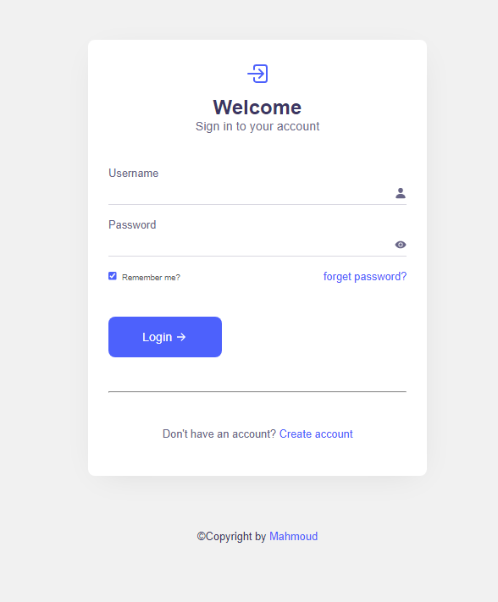

<https://login-mahmoud.netlify.app>

<https://github.com/MahmoudMostafa11199/login-project>

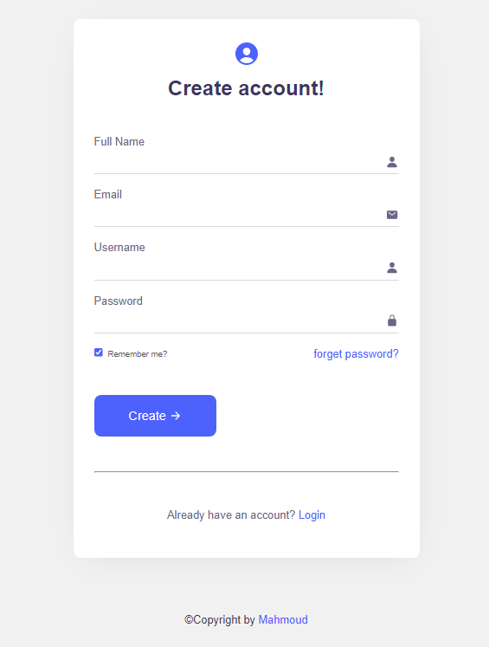

<https://login-mahmoud.netlify.app>

<https://github.com/MahmoudMostafa11199/login-project>



