MACHINE LEARNING FULL PIPELINE
AML Detection — Splitting, Feature Engineering & Modeling
  - Comprehensive documentation of the final experimental pipeline and results.
Date: 19 August 2026
Executive Summary
The pipeline is designed to detect money-laundering transactions while respecting the information that would realistically be available at the time a transaction is monitored. It is organized into three major stages: data splitting, feature engineering, and modeling.
The final experiment contains 5,078,345 transactions and 5,177 laundering transactions. It uses 139 model features and two complementary detectors: Model A, a general AML detector, and Model B, a specialist detector trained to distinguish TRUE unpatterned laundering from normal behavior.
The central result is that recognizable, structured laundering is detected very well, while unpatterned laundering remains substantially harder. On the untouched test set, patterned-laundering recall is 92.18% for Model A and 94.54% for Model B, whereas unpatterned-laundering recall is 37.25% and 18.95%, respectively.

Final Dataset and Experiment at a Glance
Item | Final result
Total transactions | 5,078,345
Total laundering | 5,177
Training | 3,046,810
Validation | 1,015,701
Test | 1,015,834
Patterned laundering | 3,209
Unpatterned laundering | 1,968
Model features | 139

PART I — DATA SPLITTING

Step 1 — Parse the annotation file into attempts. The dataset ships a separate text file listing laundering attempts (fan-in, fan-out, cycle, scatter-gather, stack, bipartite, gather-scatter, random-hop). Parsing this file produced 370 individual laundering attempts.

Step 2 — Match each attempt’s transaction rows back to the main transaction table. Each row inside an attempt block is a transaction record, but it isn’t tagged with a transaction ID — it has to be matched to the main 5M-row table by its actual attributes (timestamp, sender, receiver, amount, currency, payment format). (A number of pattern rows — about 3,087 (of 5,177 positive)

Step 3 — Detect attempts that share a transaction, and merge them into components. A single transaction can appear inside more than one laundering attempt (for example, one account gets reused across two separate scheme write-ups). If attempt A and attempt B share even one transaction, they cannot be placed in different splits — doing so would still leak information indirectly through that shared transaction. So any attempts connected this way are merged into a single group. This uses the classic “union-find” (disjoint-set) technique: every attempt starts in its own group; whenever two attempts are found to share a transaction, their groups are unioned into one.
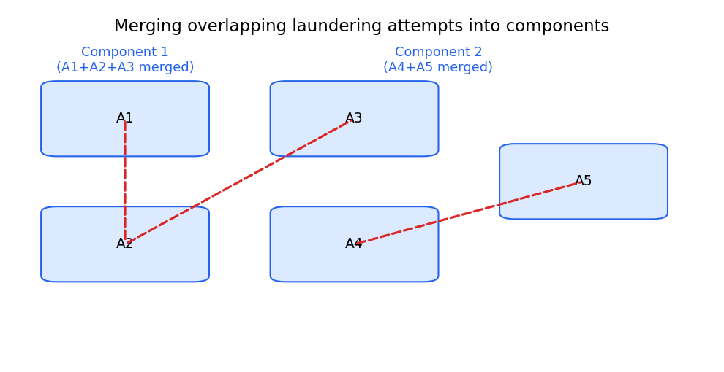
Component merging
Running this over all 370 attempts collapsed them into 86 independent “pattern components.” Each component is the smallest unit that can safely be assigned to a single split without any risk of leakage.

Step 4 — Assign whole components to train / validation / test. Now the actual splitting decision only has to be made 86 times (once per component), not 370 or 5 million times. The assignment used a greedy, size-aware algorithm:
- Sort all 86 components largest-first (by number of transactions they contain).
- Walk down that sorted list. For each component, assign it to whichever split (train / val / test) is currently furthest below its target share of total transaction volume.
- Update that split’s running total and move to the next component.
Placing the largest components first matters: if small components were placed first, a handful of very large components arriving late could badly overshoot one split’s target. Handling the big ones first keeps the final proportions much closer to the intended target.
Step 5 — Handle everything not covered by an annotation. The annotation file explicitly does not cover all laundering activity — IBM’s own dataset documentation states the 8 known patterns are a subset, not the full picture. So most of the 5.08M transactions (including the vast majority of the 5,177 labeled-laundering transactions) have no pattern annotation at all. For these, component-based splitting isn’t possible, so a second rule takes over: strict time-based ordering. Transactions are sorted by timestamp; the earliest ~60% go to train, the next ~20% to validation, the final ~20% to test. This guarantees that even for unannotated data, nothing in training happened after anything it will later be evaluated against.

2. Train, validation and test populations
Training is used to learn behavioral relationships. Validation is used to select the operating threshold under a 15% precision-floor objective. Test is kept untouched until final evaluation.
Population | Rows | Purpose
TRAIN | 3,046,810 | Learn laundering-related behavior
VALIDATION | 1,015,701 | Select operating thresholds
TEST | 1,015,834 | Final independent evaluation

3. Two laundering populations
The final experiment separates TRUE patterned laundering (3,209 transactions) from TRUE unpatterned laundering (1,968 transactions). This distinction is central because recognizable laundering structures and subtle unpatterned laundering represent different learning problems.

4. Model-specific populations
Model A is the general detector and is trained on normal plus laundering behavior, with patterned laundering serving as its positive target. Model B is deliberately narrower: patterned laundering is excluded from its training and validation populations so that it can focus on TRUE unpatterned laundering versus normal behavior.

PART II — FEATURE ENGINEERING

5. Feature engineering objective
The purpose of feature engineering is to transform raw transactions into behavioral evidence. The pipeline does not rely only on the transaction amount or other isolated properties. It asks how the current transaction compares with historical behavior and how it fits into the surrounding transaction network.

6. Historical and causal behavioral features
Historical features describe previous activity such as transaction counts, historical amounts, transaction frequency, and sender/receiver relationships. These features are constructed causally so that information from future transactions is not used to explain the current transaction.
The approach uses multiple historical horizons. Shorter histories help identify sudden changes, while longer histories establish a more stable behavioral baseline. This allows the model to distinguish normal variation from meaningful behavioral deviation.

7. Behavioral deviation
A transaction should not be interpreted in isolation. A given amount can be ordinary for one account and highly unusual for another. Features that compare current behavior with historical behavior therefore provide context that raw transaction values cannot provide.

8. Counterparty and relationship behavior
The pipeline captures whether relationships are familiar or novel and how sender-receiver pairs have behaved historically. This helps identify changes such as sudden interaction with new counterparties or unusual activity within an established relationship.

9. Network and structural behavior
Money laundering can be a network phenomenon. The feature set therefore includes structural scores describing patterns such as fan-in, fan-out, cycles, stacks, bipartite relationships, scatter-gather, and gather-scatter behavior.

PART III — MODELING

11. Modeling approach
The final modeling strategy uses two complementary detectors. Model A is designed for broad AML detection. Model B is a specialist designed specifically around the difficult unpatterned-laundering population.
Model | Learning population | Main purpose
Model A — General AML | all laundering | Broad laundering detection
Model B — Unpatterned Specialist | unpatterned laundering | Focus on laundering without the known patterned component

12. Validation operating point
Thresholds were selected independently using a 15% precision floor. Model A selected 0.27131698, producing 15.0000% validation precision and 71.4017% validation recall. Model B selected 0.02541507, producing 15.0012% validation precision and 96.4392% validation recall. The numerical scores are not directly comparable because the models solve different learning problems.

13A. Focused evaluation by laundering type
The overall test metrics can hide important differences between laundering types. The following tables isolate the requested subgroups. Where subgroup-specific precision is not reported in the experiment, it is marked as not reported rather than estimated.

13A.1 Model A — Unpatterned laundering only
Model A detects 37.2549% of the 459 unpatterned laundering transactions and generates 171 alerts in this subgroup.
Model | Population | Laundering rows | Recall | Precision | Alerts
Model A | Unpatterned only | 459 | 37.2549% | 15% | 171

13A.2 Model B — Patterned laundering only
Model B detects 94.5409% of the 806 patterned laundering transactions and generates 762 alerts in this subgroup.
Model | Population | Laundering rows | Recall | Precision | Alerts
Model B | Patterned only | 806 | 96.4392% | 15% | 762

13A.3 Combined evaluation view
This combined view places the requested subgroup evaluations beside the overall test results. It is a comparison table, not a combined model score; the experiment explicitly used no combined max(A,B) score or threshold.
Model | Evaluation population | Recall | Precision
Model A | Unpatterned only | 37.2549% | 15%
Model B | Patterned only | 96.4392% | 15%
Model A | Overall test | 72.2530% | 14.3937%
Model B | Overall test | 67.1146% | 10.4428%
Important: overall precision must not be presented as subgroup precision. The source results report overall precision, but do not provide exact subgroup-specific precision for these two requested slices.

13. Complete TEST results
Model | AP | ROC-AUC | Precision | Recall | F1 | Alerts
Model A | 0.522837 | 0.980053 | 14.3937% | 72.2530% | 0.240053 | 6,350
Model B | 0.532733 | 0.915247 | 10.4428% | 67.1146% | 0.180734 | 8,130

15. Detailed interpretation of Model A
Model A achieves ROC-AUC 0.980053 and test recall 72.2530%. Its main strength is broad detection of recognizable laundering behavior. However, its recall on unpatterned laundering falls to 37.2549%, showing that the general detector has substantially more difficulty when the known structural evidence is weak or absent.

16. Detailed interpretation of Model B
Model B achieves AP 0.532733, slightly above Model A's 0.522837, but its ROC-AUC, precision and overall recall are lower. On patterned laundering it nevertheless reaches 96.5409% recall. On unpatterned laundering it reaches 18.9542% recall at the selected operating point. This shows that creating a specialist learning problem is conceptually useful, but the current features and model do not yet provide a strong enough signal for the hardest unpatterned cases.

17. Alert burden and operational meaning
The test population contains 1,014,569 normal transactions. Model A produces 5,436 alerts on normal transactions, while Model B produces 7,281. Thus, the system must balance detection against investigation workload. In AML, maximizing recall alone is not sufficient: a useful operating point must recover meaningful suspicious activity without overwhelming investigators with false positives.

18. What the results prove
- Structured laundering behavior is highly detectable in this dataset.
- The structural feature families provide useful evidence, especially FAN-IN and FAN-OUT-related behavior.
- The general detector is strong for broad laundering detection.
- Unpatterned laundering is the dominant remaining detection challenge.
.

20. Final conclusion
The final pipeline establishes a realistic AML machine-learning framework built around sequential data splitting, causal behavioral feature engineering, structural transaction analysis, and complementary model objectives. The strongest result is the clear separation between structured and unpatterned laundering: patterned laundering is detected at roughly 92–95% recall, while unpatterned laundering remains much harder.
Therefore, the next major improvement should focus on richer behavioral representation of unpatterned laundering rather than simply adding more known-pattern rules. The current pipeline provides a strong foundation for recognizable AML structures and clearly identifies where the remaining modeling challenge lies.

21. Evaluation matrix for presentation
This matrix gives a compact presentation-ready comparison of overall and subgroup recall, precision, and alert volume.
Model | Population | Recall | Precision | Alerts
Model A | Overall | 72.2530% | 14.3937% | 6,350
Model A | Unpatterned only | 37.2549% | Not reported | 171
Model B | Overall | 67.1146% | 10.4428% | 8,130
Model B | Patterned only | 94.5409% | Not reported | 762

21. Overall evaluation

System | Recall (overall) | Precision
Model A | 72.2530% | 14.3937%
Model B | 67.1146% | 10.44%
A + B combined | 81.1146%

