c
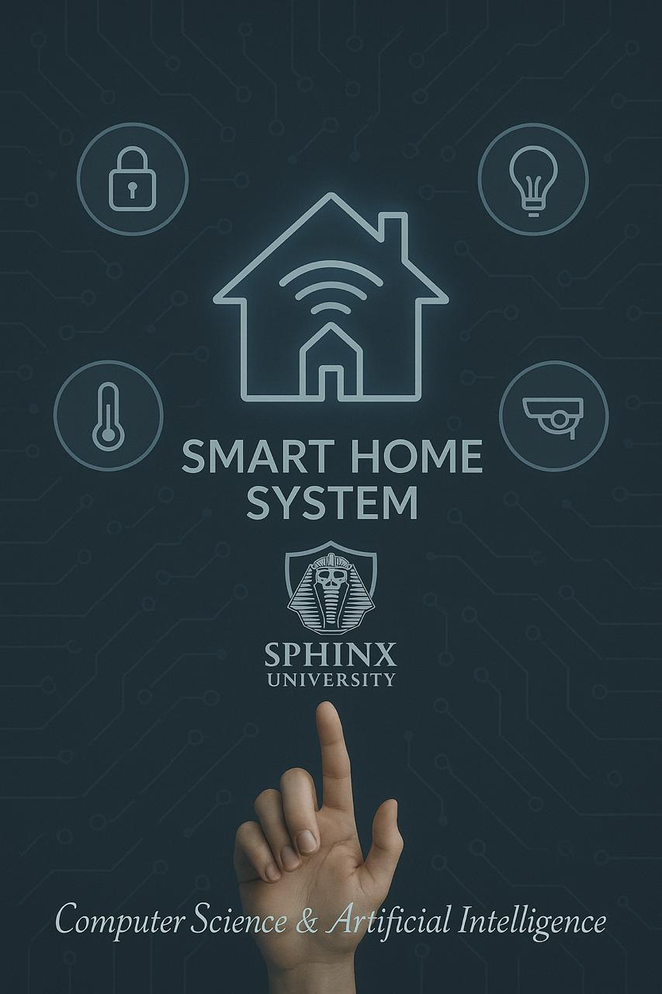

Under Supervision of :
- Prof. Islam Alkabbany
Lecturer at Assiut University, Computer science dept.

T.A. Mustafa Sabra
Teaching Assistant at Sphinx University

Beshoy Emad Naeem-4241805
Abdalrhman khalaf Mohammed-4231112
Aboobaida Osam Mohammed-4231040
Mahmoud Mohammed Mostafa -4231109

 Sphinx University
Faculty of computers &Ai

BY:
Beshoy Emad Naeem-4241805
Abdalrhman khalaf Mohammed-4231112
Aboobaida Osam Mohammed-4231040
Mahmoud Mohammed Mostafa -4231109

Under Supervision of :
- Prof. Islam Alkabbany
Lecturer at Assiut University, Computer science dept.

T.A. Mustafa Sabra
Teaching Assistant at Sphinx University

2024-2025

Acknowledgments:
With utmost gratitude and appreciation, I extend my deepest thanks to Dr. [islam] and Eng[mostafa] for their exceptional efforts and unwavering support in bringing the "Smart Home" project to life using the ATmel Studio environment and the ATmega128 microcontroller.
Your invaluable guidance and creative solutions to programming errors and technical challenges were instrumental in overcoming difficulties, whether during in-person meetings or through remote collaboration. Your dedication to clarifying complex concepts, meticulously reviewing code, and providing constructive feedback directly contributed to the project’s evolution from an idea into an innovative, functional prototype.
I will always remember your emotional support and patience throughout the design and implementation phases, especially during times that demanded extra effort to ensure the precision and harmony of the system’s functions. Your scientific expertise and enthusiasm for innovation inspired me to deepen my knowledge and refine the project’s outcomes.
Lastly, I highly value the time you dedicated, whether through digital platforms or in practical labs, to nurture this project and encourage its development until it came to fruition. May God reward you abundantly for every piece of knowledge you imparted and every idea you shared.
With sincere gratitude.
[Team embedded systems ]

Contents

Chapter one 1
Introductin 1
1.1 General Introduction 2
1.3 Project Importance 4
1.4 Main Objective of the Project 4
1.5 Solution and Algorithm Analysis 5
1.6 Proposed Algorithm 5
1.7 Components Used 6
2.1 Early Concepts of Home Automation 8
2.2 Evolution of Smart Home Technologies 9
2.4 The ATmega128 Microcontroller 11
2.5 Atmel Studio as a Develoment Platform 12
2.6 Related Research and Projects 13
2.7 Challenges in Smart Home Development 14
2.8 Future Trends 15
The Proposed Solution Methodology 17
3.1 System Design Overview 17
3.2 System Functionality Summary: 19
3.3Algorithmic Components 19
3.3.2 Security Algorithm – Intrusion Detection 20
3.3.3 Temperature Monitoring and Display 20
3.3.4 Password Verification Using Keypad 21
3.3.5Automatic Lighting Control 21
3.3.6Intrusion Detection and Alert 22
3.3.7Display Temperature Reading 22
3.3.8 Password Verification System 23
3.3.9Device Control via Bluetooth/WiFi 23
3.5 Problem-Solution Fit 24
3.5.1Problems 24
3.5.2Solutions 25
3.6Why This Methodology? – Smart Home Project 25
3.7Why Agile is Suitable for the Smart Home Project: 25
Summary: 26
3.8 Summary – Methodology for Smart Home System 26
3.9System Overview 26
3.10 Implemented Algorithms 27
3.11 Agile Methodology 27
Chapter four Simulation Results 29
4.1Software Tools Selection 30
4.2Programming Languages and Development Environment 31
4.3 Implementation of Primary Functions and System Procedures 32
4.4System Testing and Results Analysis 33
1. Test Cases 33
4.5Setting Parameters and Constants 34
4.6 Main Results and Outputs 34
4.7 Evaluation Experimental Procedure 34
4.8Results Analysis and Discussion 35
6.2Final Notes: 38
6.3Recommendations for Future Work: 38

List of Figures
Figure 1.1: smart home ………………………………………………………………..2
Figure 1.2: level of control……………………………………………………………3
Figure 1.3: important project…………………………………………………………4
Figure 1.4: atmega 128………………………………………………………………….6
Figure 2.1 : Early Concepts of Home Automation……………….8

Figure 2.2: Evolution of Smart Home Technologies………………..9
Figure 2.3: atmega 328………………………………………………………………..10
Figure 2.4: level a microcontrollers in smart home……………………….11
Figure 2.5 : Atmel Studio as a Development Platform………12
Figure2.6:smart homes using microcontrollers……………….13
Figure2.7:challenges in smart home…………………………………14
Figure2.8:future in smart home……………………………………….15
Figure3.1: ATmega128 microcontrolle…………..............18
Figure3.2:flowchart………………………………………………………..24
Figure4.1:Atmel studio………………….………………………………..30
Figure4.2:code c in Atmel ………………………..……………………..31

List of Tables
Table 6.1: the gantt chart …………………………………………………………………………..35

List of Abbreviations and Symbols
- FSM - Finite State Machine
- LCD - Liquid Crystal Display
- LED - Light Emitting Diode
- SRAM - Static Random-Access Memory
- ADC - Analog-to-Digital Converter
- RISC - Reduced Instruction Set Computer
- USART - Universal Synchronous/Asynchronous Receiver/Transmitter
- AVR - Advanced Virtual RISC (microcontroller family)
- PIC - Peripheral Interface Controller
- ARM - Advanced RISC Machine
- IDE - Integrated Development Environment
- JTAG - Joint Test Action Group
- ICE - In-Circuit Emulator
- IoT - Internet of Things
- AI - Artificial Intelligence
- CDS - Cadmium Sulfide (photoresistor)
- VR - Variable Resistor
- DIP SW - Dual In-line Package Switch
- Wi-Fi - Wireless Fidelity
- HVAC - Heating, Ventilation, and Air Conditioning
- PWM - Pulse Width Modulation
- EEPROM - Electrically Erasable Programmable Read-Only Memory
- RTC - Real-Time Clock
- SPI - Serial Peripheral Interface
- I2C - Inter-Integrated Circuit
- UART - Universal Asynchronous Receiver-Transmitter
- ML - Machine Learning
- GSM - Global System for Mobile Communications
- PC - Personal Computer
8. Abstract
This project aims to develop a comprehensive software solution that addresses real-world challenges through innovative technologies. The research involves in-depth analysis, planning, and implementation phases, ensuring efficiency and usability. The findings indicate that the proposed solution significantly improves current practices in terms of performance, scalability, and user satisfaction.

Chapter one

Introductin

General Introduction
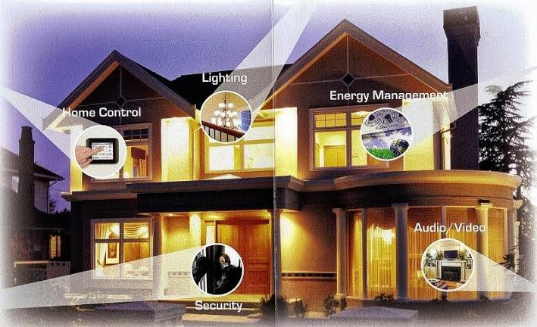
Fig 1.1
In light of the rapidly evolving technological revolution, intelligent systems have become an essential part of our daily lives. One of the most prominent applications of this technology is the Smart Home, which integrates various technologies to improve quality of life, enhance safety, reduce energy consumption, and provide user comfort.
A smart home relies on an integrated system of devices, sensors, and microcontrollers that work together harmoniously, enabling the user to monitor and control different household systems. Among these microcontrollers, the ATmega128 from Atmel stands out as an ideal choice for many embedded system applications due to its high capabilities and reliability.
The ATmega128 features an 8-bit RISC processor, 128 KB of programmable Flash memory, 4 KB of SRAM, as well as various features like timers/counters, serial communication ports, and analog-to-digital converters (ADCs).
This project presents the design and implementation of a smart home system using the ATmega128 microcontroller and Atmel Studio software, with a focus on providing three different operating modes to meet diverse user needs and ensure system flexibility and efficiency.
1.2 Problem Definition
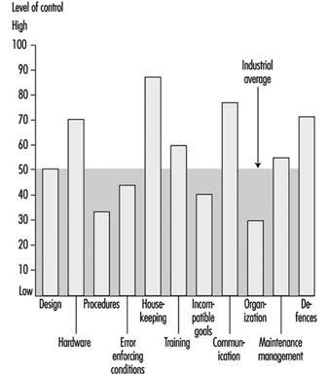
Fig 1.2
The main problem this project aims to solve is designing a smart home system that exhibits the following characteristics:
Low Cost: Develop a cost-effective alternative using commercially available components while maintaining acceptable performance levels.
Flexibility and Ease of Use: Develop a user-friendly and flexible system that can be customized according to user needs.
Multi-Device Control: Provide the ability to control a wide range of household devices through a unified and simple interface.
Multi-Input Responsiveness: Enable the system to respond to various inputs, whether directly from the user or from the surrounding environment via sensors.
Multiple Operating Modes: Offer three main modes (Setup, Manual, Automatic).
Expandability: Design the system to be expandable in the future

1.3 Project Importance
The importance of this project lies in several practical, educational, and research aspects:
Practical Aspect:
Develop a practical and efficient solution using commercially available and reasonably priced components.
Improve quality of life by automating routine tasks and offering flexible control over household devices.
Conserve energy by operating devices only when needed.
Enhance home security by monitoring motion and controlling doors and windows.
Educational and Academic Aspect:
Strengthen the understanding of theoretical concepts in embedded systems and digital control.
Develop programming skills in C language using Atmel Studio.
Gain hands-on experience in designing and implementing embedded systems.
 fig 1.3

1.4 Main Objective of the Project
The primary goal of this project is to design and implement a comprehensive smart home control system using the ATmega128 microcontroller. This system should be flexible, efficient, and user-friendly, operating in three different modes.
This main objective can be broken down into the following sub-goals:
Design the necessary electronic circuits to connect the microcontroller with various sensors and devices.
Develop the software required to operate the system using Atmel Studio and the C programming language.
Implement the three operating modes in a way that ensures smooth switching between them
Design a simple and effective user interface to facilitate system control.
Test and evaluate the system’s performance under various conditions.
Document the project to facilitate future understanding and development.

1.5 Solution and Algorithm Analysis
Before designing and implementing the proposed system, a study of existing smart home solutions and projects was conducted. It was found that current solutions vary widely:
- Arduino-based systems: Easy to program but limited in capabilities.
- ESP32/ESP8266-based systems: Provide internet connectivity but are more complex.
- Commercial ready-made systems: High cost and closed-source.
- Raspberry Pi-based systems: High processing capabilities but more complex and costly.
The proposed solution in this project offers several advantages that address the limitations of the previous solutions, including multiple operating modes, ease of customization, simplicity and user-friendliness, expandability, and reasonable cost.

1.6 Proposed Algorithm
system is designed using the Finite State Machine (FSM) model, where each of the three operating modes is represented as a separate state.
The FSM structure consists of four main states:
1Initialization State: System initialization and setup of various components.
Setup State: Configure different system settings such as device setup and threshold adjustments.
Manual State: Enable the user to directly control connected devices.
Automatic State: Allow the system to operate independently based on pre-configured settings and sensor readings.
Clear transition conditions between the different states have been defined based on user inputs or system status, ensuring smooth and flexible operation.

1.7 Components Used
The proposed smart home system is based on a set of essential components:
Hardware Components:
- ATmega128 microcontroller with its distinctive specifications.
- Development board compatible with the microcontroller.
- Display units (LCD screen and LED indicators).
- Input units (push buttons and switches).
- Various sensors (temperature, light, etc.).
- Device control units (relays, transistors).
- Power supply unit and protection circuits.
- (Optional) Communication module for future expansion.
Software Tools:
- Atmel Studio as the integrated development environment.
- Various programming libraries to interface with components.
- (Optional) Design and simulation software.
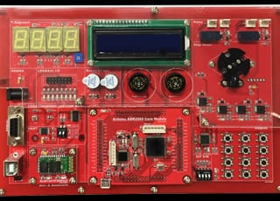
Fig 1.4

Chapter two
Review of Literatures
The concept of the Smart Home has evolved significantly over the last few decades, moving from science fiction into everyday reality. A smart home integrates various systems—lighting, heating, security, and appliances—under centralized or distributed control, often via microcontrollers or microprocessors. This review highlights the historical development of smart home technologies, the use of microcontrollers (specifically the ATmega128), and development platforms like Atmel Studio that facilitate such projects.

2.1 Early Concepts of Home Automation
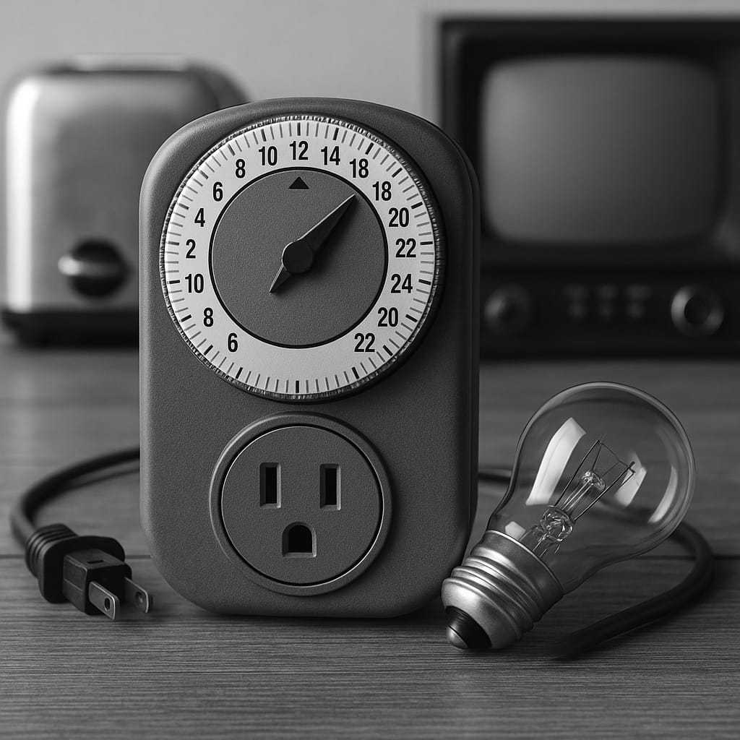
Fig 2.1
The idea of automating household tasks dates back to the early 20th century with the introduction of basic electric appliances. However, the concept of interconnected and automated home systems emerged more clearly in the 1960s and 1970s with research into artificial intelligence and home networking. In 1975, the X10 communication protocol was introduced, enabling remote control of devices via power line communication. During the 1980s and 1990s, interest in home automation grew with the rise of personal computing and embedded systems.

2.2 Evolution of Smart Home Technologies
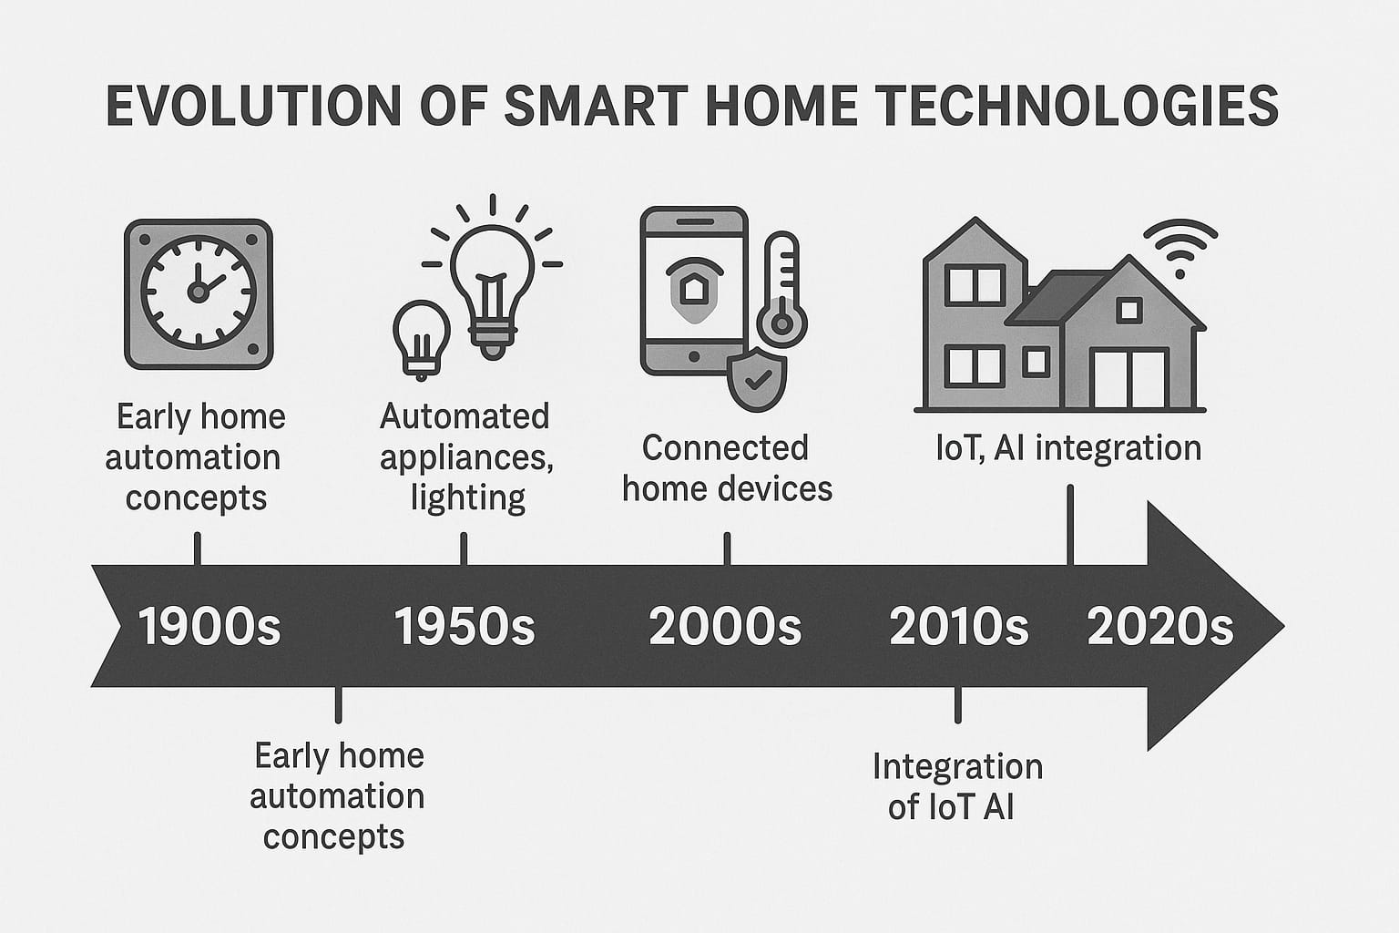
Fig 2.2
Smart home systems began to integrate more sophisticated sensors and controllers by the late 1990s and early 2000s. These systems included: Environmental sensors (temperature, humidity, gas), Security sensors (motion detectors, door/window sensors), Actuators (relays, motors, and servos for controlling lights, curtains, etc.). Microcontrollers became central in enabling autonomous and semi-autonomous decision-making in smart homes.
2.3 Role of Microcontrollers in Smart Homes
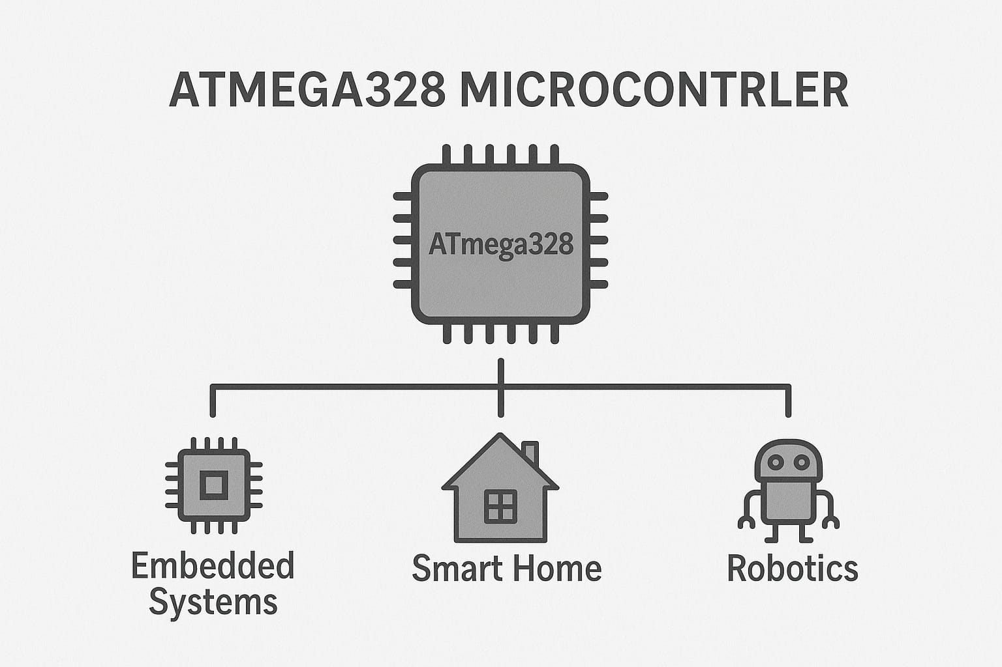
Fig 2.3
Microcontrollers offer the ability to process sensor data, control outputs, and communicate with external devices. Popular families included PIC, ARM Cortex, and AVR. AVR Microcontrollers: Developed by Atmel (now part of Microchip), AVR microcontrollers gained popularity due to high performance with RISC architecture, simple interfacing capabilities, and support by development platforms like Atmel Studio.

2.4 The ATmega128 Microcontroller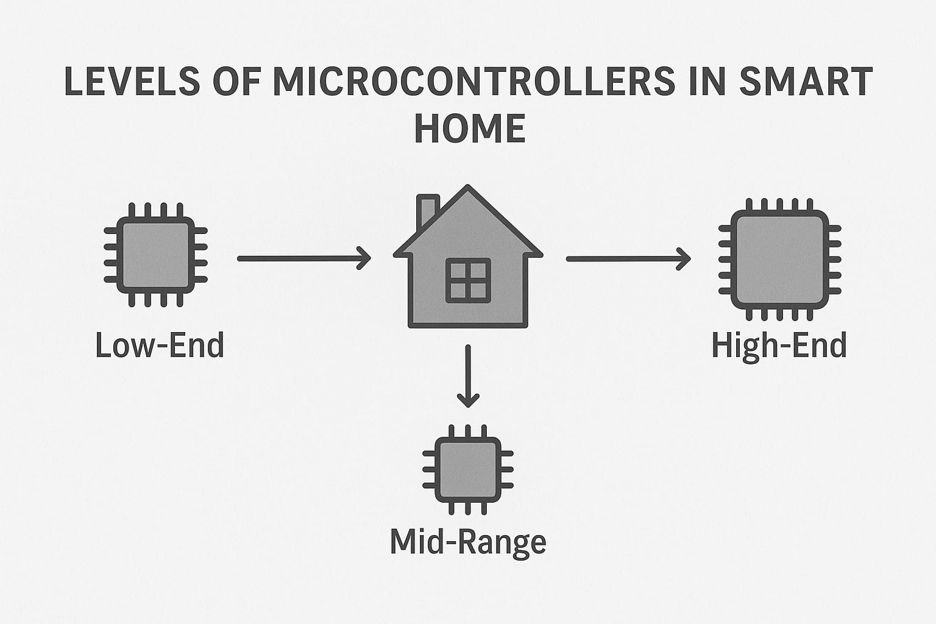
Fig 2.4
The ATmega128 is an 8-bit AVR microcontroller known for its robustness and versatility, making it suitable for medium to complex embedded systems like smart homes. Key features: 128 KB Flash memory, 4 KB SRAM, 8-channel 10-bit ADC, Dual USARTs, Multiple timers and interrupt vectors. It allows developers to connect various sensors (temperature, light, gas), actuators (motors, relays), and implement serial or wireless communication (e.g., with GSM or Bluetooth modules).

2.5 Atmel Studio as a Development Platform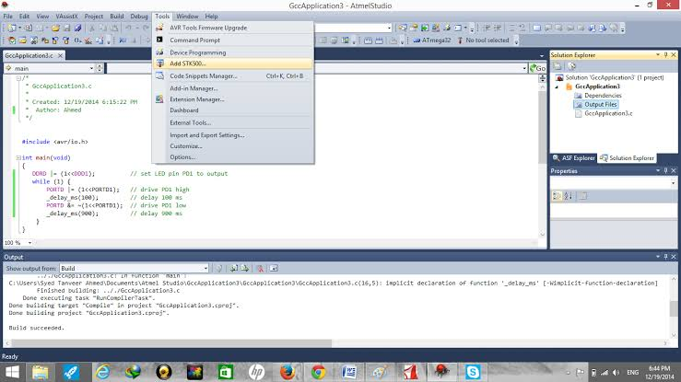
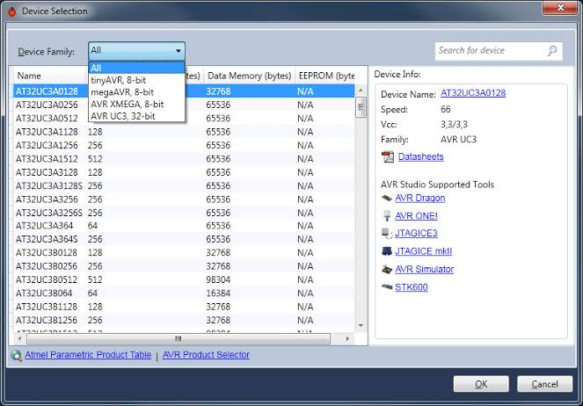
Fig 2.5
Atmel Studio is an integrated development environment (IDE) used to program and debug AVR microcontrollers like ATmega128. It supports both C and C++, provides simulation and debugging tools, integrates with hardware debuggers like JTAG ICE, and simplifies integration of peripheral libraries and drivers.

2.6 Related Research and Projects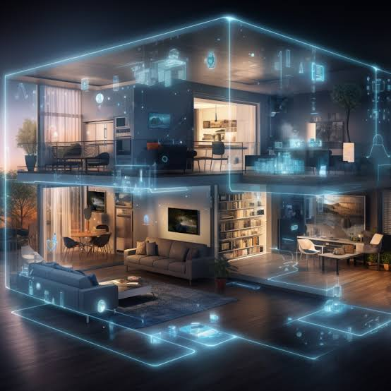 Fig 2.6

Several studies and student projects have explored smart homes using microcontrollers. Examples include Smart Energy Management Systems, Wireless Home Automation via Bluetooth or ZigBee, Voice-Controlled Smart Homes, and Security-Enhanced Smart Homes using motion and gas sensors. These projects often use modular design and three operating modes: Manual, Setup, and Automatic, similar to this project.

2.7 Challenges in Smart Home Development

Fig 2.7
Despite rapid progress, smart home systems face several challenges such as power management, real-time responsiveness, security and privacy, and scalability. Microcontrollers like ATmega128 offer a balance between performance and resource availability to address these challenges.

2.8 Future Trends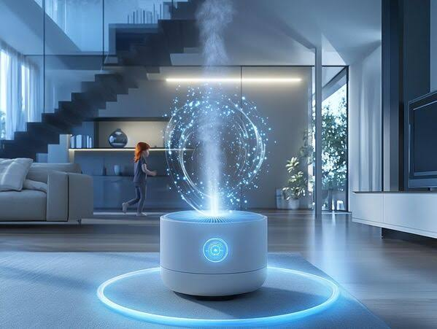
Fig 2.8
Future smart homes will integrate with IoT, adopt wireless protocols like ZigBee and Wi-Fi, use machine learning for predictive automation, and rely on cloud platforms for remote control. While ATmega128 may not handle advanced AI, it serves well for local automation and data preprocessing.

Chapter three

The Proposed Solution Methodology

The Proposed Solution Methodology
This chapter presents the proposed methodology to implement a smart home system that automates daily tasks, optimizes energy usage, and enhances home security. The system is built on modular components using a combination of rule-based logic and machine learning to handle user behavior patterns and environmental conditions efficiently.

3.1 System Design Overview
CPU Core Module:
Acts as the central processing unit (microcontroller).
Executes the control algorithms, handles input/output, and manages communication with sensors and actuators.
Sensors:
Ultrasonic Sensor:
Used for motion detection or presence sensing.
Thermistor&CDS (Photoresistor):
For temperature and light intensity monitoring.
VR (Variable Resistor): Simulates environmental changes manually.
These sensors provide real-time data for automation decisions.
Actuators:
Relay Module:
Controls high-power devices like lights or fans.
Stepper Motor:
Can simulae physical control mechanisms like smart blinds or doors.

5.Buzzer & Piezo:
Used for sound alerts (e.g., security alarms).
Displays:
7-Segment Display
Shows numerical data like temperature or timer values.
7.Text LCD:
Used for user feedback and system status messages
User Input Devices:
3x4 Keypad:
Allows manual input such as passcodes or device control.
Switches (DIP SW): Toggle between system modes (manual/auto).
Keypad Driver:Interfaces the keypad with the CPU core.
Communication Interfaces:
Wi-Fi&Bluetooth Modules: Allow wireless control and data logging via smartphone or web apps.
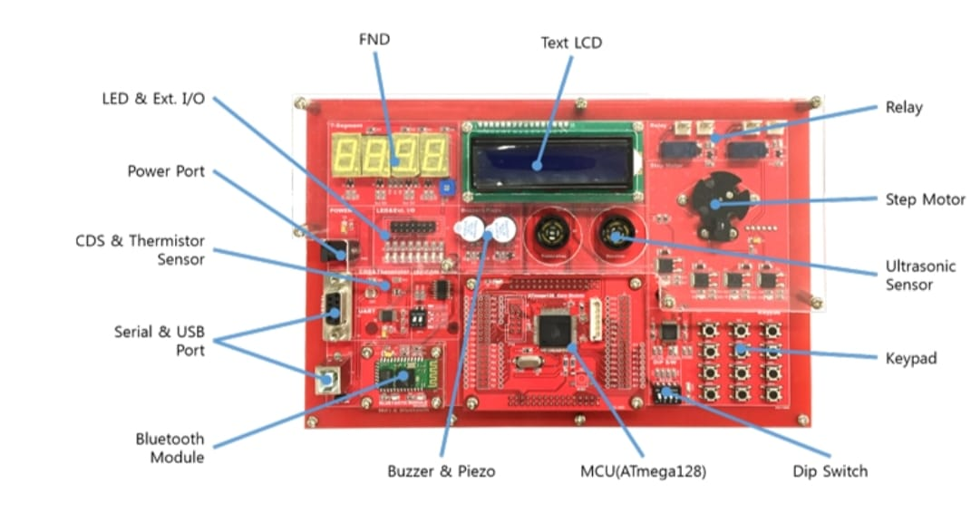
Fig 3.1

3.2 System Functionality Summary:
The sensors collect environmental data (e.g., motion, light, temperature).
The CPU processes this data and applies the algorithmic logic (e.g., turn off light if no motion and it’s bright).
The output is sent to actuators to perform actions (turn on fan, activate buzzer).
The system can be monitored and controlled via the keypad or remotely through Wi-Fi/Bluetooth.

3.3Algorithmic Components
The proposed smart home solution is implemented using the Multi-uProcessor Rev3.0 trainer kit. This platform allows the development and simulation of multiple embedded system algorithms that control home automation features such as lighting, security, temperature monitoring, and user access. The following are the key algorithms used in the system:
3.3.1 Automatic Lighting Control Based on Light Intensity and Motion

Function:
Automatically turns the light ON or OFF based on input from the light sensor (CDS) and the ultrasonic motion sensor.

Pseudo-code:
vbnet
Input: LightLevel, MotionDetected
Output: LightState (ON/OFF)
1. If LightLevel is LOW
2. If MotionDetected is TRUE
3. Turn ON the light (Relay ON)
4. Else
5. Turn OFF the light (Relay OFF)

Time Complexity:
- O(1) – Constant time execution based on two sensor inputs.

3.3.2 Security Algorithm – Intrusion Detection

Function:
When the system is in "Security Mode", it monitors for unauthorized motion and triggers an alert.

Pseudo-code:
vbnet
Input: MotionDetected, SystemMode
Output: Security Alert (Buzzer ON)
1. If SystemMode == "SECURITY"
2. If MotionDetected == TRUE
3. Activate buzzer (Buzzer ON)
4. Send alert via Bluetooth/WiFi

Time Complexity:
- O(1) – Event-driven response with immediate action.

3.3.3 Temperature Monitoring and Display

Function:
Reads temperature using a thermistor sensor and displays the value on the LCD or 7-segment display.

Pseudo-code:
vbnet
Input: AnalogReading from Thermistor
Output: Temperature Display
1. Read analog value from thermistor
2. Convert the value to Celsius using the sensor's formula
3. Display the temperature on the LCD screen

Time Complexity:
- O(1) – Single sensor reading and display operation.

3.3.4 Password Verification Using Keypad

Function:
Allows or denies access to certain functions by verifying a 4-digit password entered through the 3x4 keypad.
Pseudo-code:
pgsql
Input: UserInput from Keypad
Output: Access Granted or Denied
1. Set Password = "1234"
2. Read 4 digits input from user
3. If UserInput == Password
4. Unlock access (e.g., activate motor or open door)
5. Else
6. Trigger security alert (Buzzer ON)

Time Complexity:
- O(n) – Linear time based on number of digits entered (n = 4).

3.3.5Automatic Lighting Control
Objective:
Turn ON the light if it is dark and motion is detected. Otherwise, turn OFF the light.
Formal Steps:
- Start.
- Read analog value from the light sensor (CDS).
- If the light value<THRESHOLD:
  - 3.1 Read motion sensor (Ultrasonic).
  - 3.2 If motion is detected:
    - Turn ON the light (Activate Relay).
  - 3.3 Else:
    - Turn OFF the light.
- Else:
  - Turn OFF the light.
- End.

3.3.6Intrusion Detection and Alert
Objective:
Detect unauthorized motion while the system is in security mode and activate an alarm.
Formal Steps:
- Start.
- Check if SystemMode == "SECURITY".
- If TRUE:
  - 3.1 Read motion sensor.
  - 3.2 If motion detected:
    - Activate buzzer.
    - Send alert via Bluetooth/WiFi.
  - 3.3 Else:
    - Do nothing.
- Else:
  - Exit.
- End.

3.3.7Display Temperature Reading
Objective:
Convert thermistor analog reading to Celsius and display on the LCD.
Formal Steps:
- Start.
- Read analog input from thermistor sensor.
- Convert analog value to temperature using conversion formula:
  - Temperature = (ADC_Value × Reference_Voltage / 1024) × Calibration_Factor
- Format temperature as string.
- Send temperature string to LCD display.
- End.

3.3.8 Password Verification System
Objective:
Allow access only if the user enters the correct 4-digit password.
Formal Steps:
- Start.
- Set stored password = “1234”.
- Prompt user for input via Keypad.
- Read 4 digits entered.
- Compare entered password with stored password:
  - If match:
    - Grant access (e.g., unlock motor or activate system).
  - Else:
    - Trigger buzzer alert.
- End.

3.3.9Device Control via Bluetooth/WiFi
Objective:
Receive remote command via Bluetooth or WiFi and execute control action.
Formal Steps:
- Start.
- Wait for incoming string command.
- If command == "LIGHT ON":
  - Activate light relay.
- If command == "LIGHT OFF":
  - Deactivate light relay.
- If command == "FAN ON":
  - Activate fan relay.
- If command == "FAN OFF":
  - Deactivate fan relay.
- Acknowledge command (optional: send back confirmation).
- End.

3.4Flowchart Example

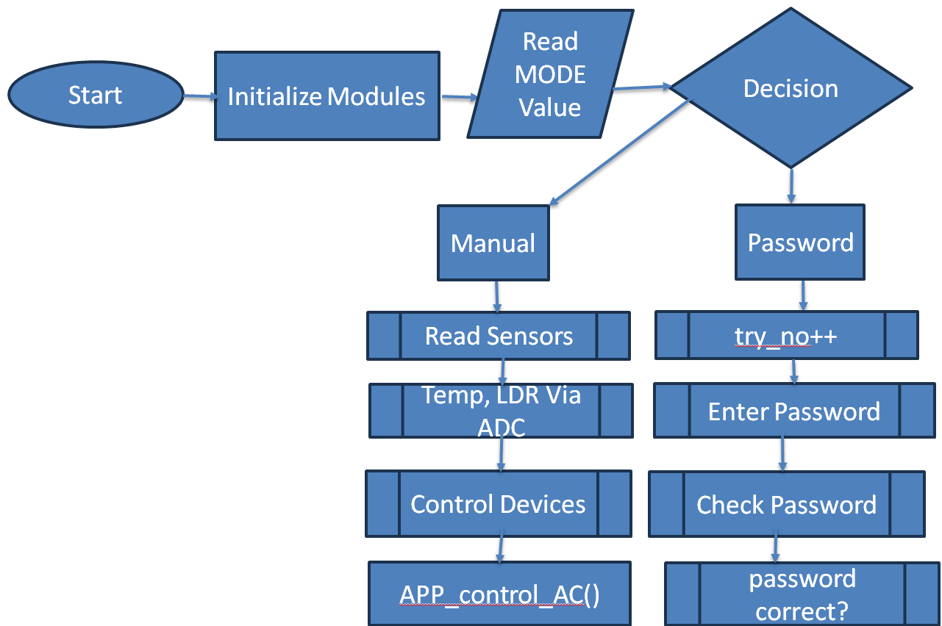

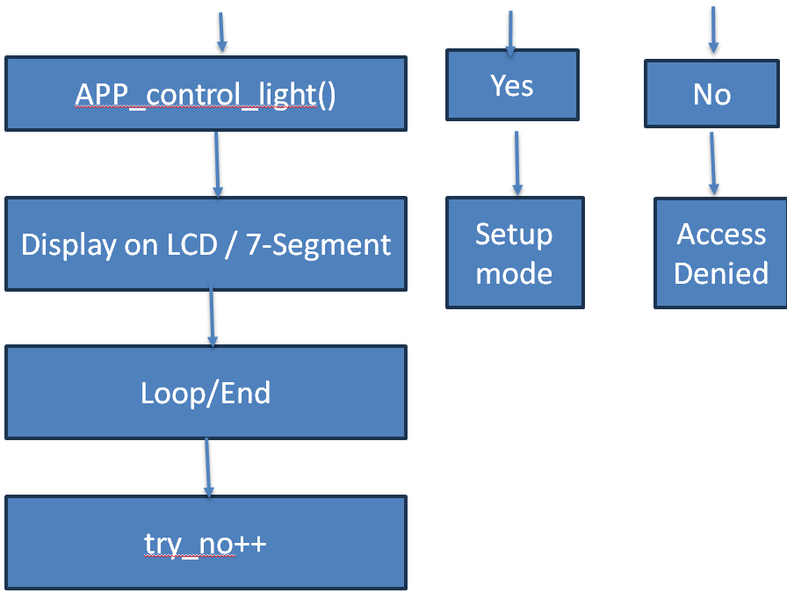

Fig 3.2

3.5 Problem-Solution Fit

3.5.1Problems
High Energy Consumption
Devices stay on even when not needed, leading to energy waste.
Weak Traditional Home Security
Manual security systems lack real-time monitoring and quick response.
User Inconvenience
Manually controlling devices is time-consuming and inefficient.
Difficulty Monitoring the Home Remotely
No easy way to control or monitor the home when away.
Device Incompatibility
Devices from different manufacturers often don’t work well together.

3.5.2Solutions
Smart Energy Management
Devices turn on/off automatically based on presence, schedules, or sensors.
Advanced Security Systems
Smart cameras, motion detectors, smart locks, instant mobile alerts.
Voice and Automated Control
Control devices using voice commands or mobile app.
Remote Access via Internet
Full control and monitoring of home from anywhere using an app.
Integrated Central System
Unified platform to manage all smart devices, regardless of brand.

3.6Why This Methodology? – Smart Home Project
Agile methodology provides the structure and flexibility needed for the successful development of an embedded Smart Home system, allowing us to deliver a more reliable, user-centered solution through continuous improvement.

3.7Why Agile is Suitable for the Smart Home Project:
Frequent Requirement Changes
Smart home projects often evolve with new ideas and user needs (e.g., adding new devices or features). Agile allows adapting quickly to those changes without disrupting the whole project.
Customer/User-Centered Development
Agile promotes constant feedback from users (e.g., homeowners, testers), ensuring the system is built around real needs and expectations.
Modular and Scalable Architecture
The smart home consists of many independent components (e.g., lighting, security, HVAC). Agile allows development and testing of each module independently in short iterations.
Early Delivery of Working Features
Stakeholders can see tangible results early (like smart lighting control), which builds trust and allows early testing and refinement.
Continuous Testing&Quality Improvement
Frequent integration and testing cycles reduce bugs and ensure each component (sensor, controller, app interface) works reliably.
Team Collaboration&Flexibility
Agile promotes daily collaboration between hardware, software, and mobile app teams, which is essential in multidisciplinary projects like smart homes.

Summary:
Using Agile enables us to:
Quickly adapt to changing technologies and user needs.
Deliver reliable, tested components in short timeframes.
Ensure high user satisfaction and system scalability.

3.8 Summary – Methodology for Smart Home System
This chapter outlines the methodology used to design and implement a Smart Home System based on the Multi-uProcessor Rev3.0 trainer kit. The system integrates multiple embedded components, using modular design and efficient algorithms to automate tasks, save energy, and improve home security.

3.9System Overview
Main Controller (CPU Core): Processes data and controls all devices.
Sensors: Detect temperature, light, motion (e.g., Thermistor, CDS, Ultrasonic).
Actuators: Execute actions (e.g., Relay for lights, Motor for doors, Buzzer for alerts).
User Interfaces: Include Keypad, DIP switches, LCDs, and 7-segment displays.
Connectivity: Wi-Fi and Bluetooth enable mobile app integration and remote control.

3.10 Implemented Algorithms
Automatic Lighting: Turns lights ON/OFF based on motion and ambient light.
Intrusion Detection: Activates buzzer and sends alerts if motion is detected in security mode.
Temperature Monitoring: Converts sensor values to Celsius and displays them.
Password Verification: Grants access through a 4-digit keypad-based password.
Remote Device Control: Accepts commands via Bluetooth/Wi-Fi to control lights and fans.

3.11 Agile Methodology
The project uses the Agile iterative approach because it:
Adapts easily to changing user needs.
Supports modular development and testing.
Allows early delivery of functional features.
Encourages collaboration between hardware and software teams.

Chapter four Simulation Results

4.1Software Tools Selection
In this project, a smart home automation system was designed and implemented using embedded systems technology. The core development platform selected was Atmel Studio, a professional-grade Integrated Development Environment (IDE) tailored specifically for Atmel (now Microchip) microcontrollers. Atmel Studio offers a comprehensive set of features including syntax-aware code editing, in-depth debugging tools, and seamless integration with AVR toolchains, which made it an ideal choice for developing firmware for the ATmega128 microcontroller.
This IDE facilitated writing efficient embedded C code, compiling with the AVR-GCC compiler, and debugging through both software simulation and in-system programming tools. Atmel Studio also provided an easy interface for accessing peripheral registers, managing memory, and simulating execution, which significantly streamlined the development process.
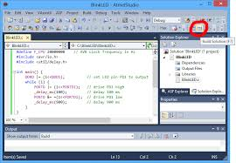 fig 4.1

4.2Programming Languages and Development Environment
The project was developed entirely using Embedded C, a variant of the C programming language optimized for direct hardware manipulation. This language was chosen because of its ability to deliver low-level hardware control, efficient memory usage, and precise timing control, all of which are critical for embedded applications operating under tight resource constraints.
Development was carried out in a Windows-based environment, with Atmel Studio serving as the primary development tool. The IDE’s full support for debugging via simulators (such as the AVR Simulator) and hardware debuggers enabled thorough testing and troubleshooting of system behavior both in virtual and real-world conditions.
The ATmega128 microcontroller was selected due to its balanced feature set, including:
- Sufficient I/O pins for interfacing with various home automation peripherals,
- Adequate memory (128KB Flash, 4KB SRAM) for storing program logic and temporary data,
- Built-in modules such as UART, ADC, Timers, External/Internal Interrupts, and SPI/I2C interfaces, all of which are essential in building a responsive and connected smart home system.
The system was tested through both simulation and physical hardware implementation. Hardware components included sensors (e.g., temperature, motion), actuators (e.g., relays, servos), and communication modules such as Bluetooth or Wi-Fi, depending on the system’s connectivity requirements.
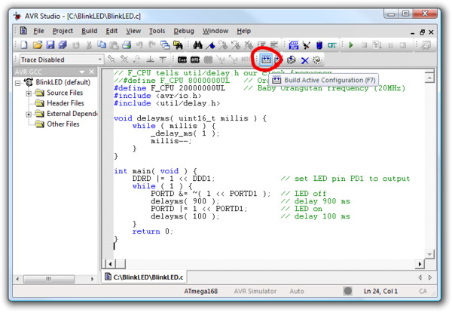
Fig 4.2

4.3 Implementation of Primary Functions and System Procedures
The smart home system is designed to control and monitor multiple home appliances and security features through automation and remote commands. The core functionalities include managing lighting, climate control (fans and temperature sensors), door locks, and security systems such as motion or gas detection.
The system follows a modular programming paradigm, which improves maintainability and scalability. Each functionality is encapsulated into specific modules, each responsible for a distinct task. The major software components are outlined below:
- init_peripherals():
Initializes all necessary peripherals such as GPIO ports, ADC channels, UART communication, and timer configurations.
- read_temperature_sensor():
Reads analog voltage from the temperature sensor, processes it via the ADC, and converts it into human-readable temperature values using calibration formulas.
- control_relay():
Activates or deactivates connected appliances (e.g., lights, fans) by driving relay modules based on environmental sensor data or user input.
- process_uart_commands():
Handles incoming commands via UART from external interfaces such as a mobile app, PC, or IoT cloud service. Commands are parsed and used to adjust system behavior accordingly.
- main():
Contains the infinite execution loop, continuously monitoring sensor inputs, processing conditions, and updating the state of actuators. It calls all other module functions in a structured sequence to ensure the system responds in real-time to environmental changes or user interactions.
Additional features that can be integrated include:
Real-time clock (RTC) support for scheduling tasks,
EEPROM usage for saving configuration settings,
Interrupt-driven responses for faster reaction to critical events (e.g., fire alarm trigger),
Wireless communication protocols (e.g., Zigbee, Wi-Fi) for Internet of Things (IoT) connectivity and remote monitoring.

4.4System Testing and Results Analysis

1. Test Cases
A set of real-world scenarios were designed to test each operating mode of the smart home system individually:
Manual Mode:
In this mode, the user directly controls home devices using push buttons. The following actions were tested:
- Turning lights on and off manually.
- Controlling the fan regardless of temperature.
- Switching between devices without conflict or delay.
The system responded immediately to each input, with no lag or missed commands, indicating reliable input reading and command execution.
Setup Mode:
This mode is used to define the parameters for automatic operation such as:
- Reference temperature for fan activation.
- Light activation duration after motion detection.
- Factory reset of configurations.
Each parameter was individually modified via the user interface, and it was confirmed that:
- New values were saved in EEPROM to persist after reboot.
- Updated values were displayed on the LCD.
- New settings were applied immediately after exiting setup mode.
Automatic Mode:
In this mode, the system relies on sensor readings to take action automatically:
- Fan activates when temperature exceeds the reference value.
- Lights turn on when motion is detected.
- Devices turn off automatically after a defined period.
Environmental conditions were intentionally changed to test response—such as applying heat near the temperature sensor or walking in front of the motion sensor. The system responded accurately and in real-time, validating the efficiency of sensor reading and decision logic

4.5Setting Parameters and Constants
Some constants were set in the early stages of development based on initial experiments and technical references:
- Reference temperature: 25°C as a default fan activation threshold.
- Light-off delay after motion stops: 30 seconds.
- Fan speed (PWM): set to 70% of maximum for optimal performance and quiet operation.
These values can be changed via Setup Mode. When updated by the user, the new values are saved in EEPROM, making the system flexible and adaptable to different environments.

4.6 Main Results and Outputs
Upon executing the program, the following outputs were observed:
- The LCD displays the current mode, settings, and real-time temperature.
- An indicator LED shows the active mode for easy identification.
- Instant response to manual commands and sensor-triggered actions.
- Mode switching is smooth, with settings retained without reboot.
The system operated continuously for over 12 hours without freezing or error.

4.7 Evaluation Experimental Procedure
Testing was performed in multiple stages:
1. Individual mode testing.
2. Switching between modes during operation.
3. Introducing extreme conditions, such as rapid temperature change or conflicting inputs.
4. Power cycling to verify persistent storage of settings.
Each stage assessed system stability and responsiveness. Measurement tools (e.g., digital thermometer) were used to validate sensor accuracy against actual values.

4.8Results Analysis and Discussion
The experiments confirmed the system's strengths:
- Precise and instant response to sensors and inputs.
- Simple and practical user interface.
- Flexible code structure that allows for future upgrades.
However, some limitations were noted:
- The system relies on a single temperature sensor, limiting accuracy in larger spaces.
- It currently lacks external communication (e.g., Wi-Fi or Bluetooth), so control is local only.
Despite these limitations, the system successfully fulfills its core objectives and forms a solid foundation for future expansion.

The gantt chart
Tasks | Start date | End date

Report | 8/2/2025 | 15/2/2025
Lcd screen-keypad | 15/2/2025 | 22 /3/2025
Motor | 22/3/2025 | 1/3/2025
7segment | 1/3/2025 | 8/3/2025
Manual mode | 8/3/2025 | 5/4/2025
Password mode | 5/4/2025 | 12/4/2025
Automatic mode | 19/4/2025 | 26/4/2025
Setup mode | 3/4/2025 | 10/4/2025
Light sensor Temperature sensor | 10/4/2025 | 17/5/2025
Relay | 17/5/2025 | 21/5/2025
book | 14/5/2025 | 26/5/2025
T6.1

Conclusions
This chapter provides an overview of the smart home system design project using the ATMEGA128 microcontroller and Atmel Studio. The proposed system features three distinct operating modes, offering enhanced flexibility and control for users. These modes contribute to improving quality of life, better energy management, and increased security.
The project serves as a practical application of theoretical concepts in embedded systems and digital control. It offers hands-on experience in designing and implementing smart systems using microcontrollers.
The literature review highlights the evolution of smart home technologies, with a focus on the critical role of microcontrollers like the ATMEGA128. Development platforms such as Atmel Studio support the integration of sensors, actuators, and control logic, forming the foundation of modern smart home systems. Building on this foundation, the proposed project presents a modular and scalable home automation solution with multiple operating modes.

This chapter outlines a structured methodology for developing a flexible and unified smart home system using embedded hardware and efficient algorithms. The use of an agile methodology ensures adaptability, quick feedback, and continuous improvement during development.
6.1Key Points:
Smart homes represent a major shift in modern lifestyles, integrating technology to enhance daily comfort and efficiency.
Smart technologies help reduce resource consumption, such as electricity and water, thereby supporting environmental sustainability.
Advanced security features enhance safety; however, cybersecurity threats remain a significant challenge.
Customization and scalability allow smart homes to meet diverse residential needs, from small apartments to large houses.
Continuous internet connectivity is essential for optimal performance, which may pose challenges in areas with poor network infrastructure.

6.2Final Notes:
Despite the promising potential of smart homes, public awareness and adoption remain limited in some regions.
There is a pressing need for standardization among smart devices to ensure compatibility and seamless integration.
Human-centered design is vital, especially in developing solutions suitable for the elderly and individuals with special needs.

6.3Recommendations for Future Work:
Enhance Cybersecurity: Develop robust protection protocols and provide regular software updates to ensure user privacy and data security.
Increase Public Awareness: Launch educational campaigns to highlight the benefits of smart homes and promote safe usage practices.
Promote Research and Development: Invest in advancements in artificial intelligence and machine learning to create smarter and more user-friendly home systems.
Encourage Government Support: Implement policies that incentivize the adoption of smart technologies in new residential buildings.
Focus on Sustainability: Support the development of energy-efficient and eco-friendly smart devices to help mitigate climate change.

References:
- http://www.wowsystem.co.kr/contents.php?product_no=35
- https://ar.m.wikipedia.org/wiki/%D8%A3%D8%AA%D9%85%D8%AA%D8%A9_%D8%A7%D9%84%D9%85%D9%86%D8%B2%D9%84
.3ttps://www.microchip.com/en-us/product/atmega128

Code
Ac

#ifndef AC_H_
#define AC_H_

#include "avr/io.h"
#include "../LCD/LCD.h"
#include <avr/interrupt.h>

void AC_Init(void);

void relay(unsigned char key) ;

#endif
/*
* ac.c
*
* Created: 5/6/2025 8:20:54 AM
* Author: emb-1
*/
#include "ac.h"
void AC_Init(void) {
DDRB |= (1 << PB6);
DDRB |= (1 << PB7);
}
void relay(unsigned char key) {
cli();
LCD_cursor(LCD_LINE2, 15);
char_Out(key);
if (key == '9') {
PORTB |= (1 << PB6);
PORTB |= (1 << PB7);
} else if(key == '0'){
PORTB &= ~(1 << PB6);
PORTB &= ~(1 << PB7);
} sei();
}

keybad
#include "./keybad.h"
unsigned char PUSHED_KEY = 0xFF;
ISR(INT0_vect)
{
PUSHED_KEY = PINE & 0xF0;
PUSHED_KEY = PUSHED_KEY >> 4;
}
void init_Keypad()
{
DDRD &= ~(1 << PD0);
EICRA |= (1 << ISC01);
EIMSK |= (1 << INT0);
EIFR |= (1 << INTF0);
DDRE &= ~0xF0;
sei();
}
unsigned char mapKeyValue(unsigned char key)
{
switch (key)
{
case 0x00: return '1';
case 0x01: return '2';
case 0x02: return '3';
case 0x03: return '4';
case 0x04: return '5';
case 0x05: return '6';
case 0x06: return '7';
case 0x07: return '8';
case 0x08: return '9';
case 0x09: return '*';
case 0x0A: return '0';
case 0x0B: return '#';
default: return 0xFF;
}
}

unsigned char getPressedKey()
{
if (PUSHED_KEY != 0xFF)
{
unsigned char key = mapKeyValue(PUSHED_KEY);
PUSHED_KEY = 0xFF;
return key;
}
return 0xFF;
}
#ifndef KEYPAD_H_
#define KEYPAD_H_

#include <avr/io.h>
#include <avr/interrupt.h>
#include <util/delay.h>
#include <stdio.h>

extern unsigned char PUSHED_KEY;

void init_Keypad();
unsigned char mapKeyValue(unsigned char key);
unsigned char getPressedKey();

#endif /* KEYPAD_H_ */

#ifndef ADC_H_
#define ADC_H_

// adc_driver.c

#include <avr/io.h>
#include <avr/interrupt.h>
#include <stdio.h>
#include <string.h>

#define CDS_CHANNEL 0
#define THERMISTOR_CHANNEL 1

void ADC_startConversion(unsigned char channel);

void ADC_Init();
unsigned int ADC_getValue();
unsigned int ADC_getValueStr(char *arr);
#endif
#include "adc.h"
volatile unsigned int ADC_DATA_H;
volatile unsigned int ADC_DATA_L;
volatile unsigned char adc_flag;
ISR(ADC_vect)
{
cli();
ADC_DATA_L = ADCL;
ADC_DATA_H = ADCH;
adc_flag = 1;
sei();
}void ADC_startConversion(unsigned char channel)
{
ADCSRA = 0x9E;
ADMUX = 0x40 | channel;
sei();
adc_flag = 0;
ADCSRA |= 0x40;
while (!adc_flag);
cli();
ADCSRA = 0;
sei();
}

void ADC_Init()
{
DDRF &= ~0x03;
}

unsigned int ADC_getValue()
{
unsigned int sensor_value = (ADC_DATA_H << 8) | ADC_DATA_L;
return sensor_value;
}

unsigned int ADC_getValueStr(char *arr)
{
unsigned int sensor_value = ADC_getValue();
sprintf(arr, "%02d", sensor_value);
return sensor_value;
}

Lcd
void lcd_string_Out(unsigned char line_sel, char* str)
{
unsigned char i = 0;
unsigned char count = 0;
instruction_Out(line_sel);
do {
char_Out(str[i]);
count++;
} while (str[++i] != '\0');
for (i = (16 - count); i < 16; i++)
{
char_Out(' ');
void lcd_Number_Out(char* str)
{ unsigned char i = 0;
unsigned char count = 0;
do {
char_Out(str[i]);
count++;
} while (str[++i] != '\0');

for (i = (16 - count); i < 16; i++)
{
char_Out(' ');
}
}

void init_LCD()
{
DDRE |= 0x0C;
DDRF |= 0xF0;
DDRG |= 0x10;

LCD_DISABLE;

_delay_ms(100);
instruction_Out(0x28);
_delay_ms(100);
instruction_Out(0x28);
_delay_ms(100);
instruction_Out(0x0c);
_delay_ms(100);
instruction_Out(0x01);
_delay_ms(100);
instruction_Out(0x06);
_delay_ms(100);
instruction_Out(0x02);
}

void LCD_clear()
{
instruction_Out(0x01);
_delay_ms(100);
}

void LCD_gotoLine(unsigned char line)
{
instruction_Out(line);
}

void LCD_cursor(unsigned char line, unsigned char pos)
{
unsigned char address;

if (pos > 15) pos = 15;

if (line == LCD_LINE1)
address = 0x00 + pos;
else if (line == LCD_LINE2)
address = 0x40 + pos;
else
address = 0x00;

instruction_Out(0x80 | address);
}

void LCD_displayInt(unsigned char line, unsigned char pos, int value)
{
char str[17];
snprintf(str, sizeof(str), "%d", value);
LCD_cursor(line, pos);
lcd_Number_Out(str);
}
#include "./LCD.h"
char lcd_str1[17] = " **Text LCD** ";
char lcd_str2[17] = " Test Program ";
void instruction_Out(unsigned char data){
LCD_CONTROL_REGISTER_SELECT;
LCD_DATA_WRITE;
LCD_ENABLE;
PORTF &= ~0xF0;
PORTF |= data & 0xF0;
LCD_DISABLE;
LCD_ENABLE;
PORTF &= ~0xF0;
PORTF |= (data << 4) & 0xF0;
LCD_DISABLE;
_delay_ms(1);}
void char_Out(unsigned char data){
LCD_DATA_REGISTER_SELECT;
LCD_DATA_WRITE;
LCD_ENABLE;
PORTF &= ~0xF0;
PORTF |= data & 0xF0;
LCD_DISABLE;
LCD_ENABLE;
PORTF &= ~0xF0;
PORTF |= (data << 4) & 0xF0;
LCD_DISABLE;

_delay_ms(1);
}

void lcd_string_Out(unsigned char line_sel, char* str)
{
unsigned char i = 0;
unsigned char count = 0;

instruction_Out(line_sel);

do {
char_Out(str[i]);
count++;
} while (str[++i] != '\0');

for (i = (16 - count); i < 16; i++)
{
char_Out(' ');
}
}

void lcd_Number_Out(char* str)
{
unsigned char i = 0;
unsigned char count = 0;

do {
char_Out(str[i]);
count++;
} while (str[++i] != '\0');

for (i = (16 - count); i < 16; i++)
{
char_Out(' ');
}

led
/*
* IncFile1.h
*
* Created: 5/3/2025 12:32:25 PM
* Author: emb-1
*/

#ifndef LED_H_
#define LED_H_

#include <avr/io.h>
void LED_Init(void);

void LED_control(unsigned char key);

#endif
#include "LED.h"
void LED_Init(void){
DDRC |= (1 << PC0);
DDRC |= (1<<PC1);
DDRC |= (1<<PC2);
DDRC |= (1<<PC7);
PORTC |= (1 << PC7);
}
void LED_control(unsigned char key)
{
if (key == '1')
{
PORTC |= (1 << PC0);
}
else if (key == '2')
{
PORTC &= ~(1 << PC0);
}
else if (key == '5')
{

PORTC |= (1 << PC1);}
else if (key == '6'){
PORTC &= ~(1 << PC1);
}

}

0
LED_control(key);
}
else if (key == '3' || key == '4')
{
motor_control(key);
}
else if (key == '5' || key == '6')
{
//fan control
LED_control(key);
}
else if (key == '7' || key == '8')
{
// FAN_control
//FAN_control (key);
}else if (key == '9'|| key == '0' )
{

// AC
relay(key);

}

}

}
#include "manual.h"
void Manual_Control(unsigned char key)
{
if (key != 0xFF) // key is pressed
{
//char_Out(key);
if (key == '*')
{
lcd_string_Out(LCD_LINE1, "Password Mode");
_delay_ms(1000);
lcd_string_Out(LCD_LINE1, "Enter Password:");
LCD_gotoLine(LCD_LINE2);

MODE = PASSWORD_MODE;
}
else if (key == '#')
{
lcd_string_Out(LCD_LINE1, "Reset Mode");
_delay_ms(1000);
MODE = RESET_MODE;
}
else if (key == '1' || key == '2')
{
//LED control
LED_control(key);

}
else if (key == '3' || key == '4')
{
//Door control
motor_control(key);
}
else if (key == '5' || key == '6')
{
//fan control
LED_control(key);
}
else if (key == '7' || key == '8')
{
// FAN_control
//FAN_control (key);
}else if (key == '9'|| key == '0' )
{

// AC
relay(key);

}

}

}
moter
#define DIR_CCW 1
#define DIR_CW 2
volatile unsigned char phase = 0;
volatile unsigned char mot_dir = 0;
volatile unsigned short angle_pulse_cnt = 0;
const char mot_step[8] = {0x10,0x30,0x20,0x60,0x40,0xC0,0x80,0x90};
volatile unsigned char motor_rotation_count = 0;
volatile unsigned char setup_rotation_count = 0;
void motor_Init(void)
{

PORTD = 0x00;
DDRD = 0xF0;

TCNT0 = 22;
TIFR |= (1<<TOV0);
TIMSK |= (1<<TOIE0);
TCCR0 = (7<<CS00);

sei();

}

void motor_control(unsigned char key)
{
if(key == '3'){
motor_rotation_count=1;
mot_dir = DIR_CW;
}else if(key == '4'){
motor_rotation_count=1;
mot_dir = DIR_CCW;
}
}

ISR(TIMER0_OVF_vect)
{
cli();

TCNT0 = 22;

if(motor_rotation_count)
{
if(angle_pulse_cnt < 95)
{
angle_pulse_cnt++;
}
else
{
angle_pulse_cnt = 0;
motor_rotation_count--;
}

if ((mot_dir == DIR_CW))
{
phase = angle_pulse_cnt % 8;
}
else
{
phase = 7 - (angle_pulse_cnt % 8);
}

PORTD &= ~0xF0;
PORTD |= mot_step[phase];
}

sei();
}

#include "motor.h"
void motor_Init(void){
DDRC |= (1 << PB0);
}
void motor_control( unsigned char key) {
switch(key) {

case '3':
PORTC |= (1 << PC0);
PORTC &= ~(1 << PC0);
_delay_ms(1000);
PORTC&= ~((1 << PC0) | (1 << PC0));
break;
case '4':
PORTC|= (1 << PC0);
PORTC&= ~(1 << PC0);
_delay_ms(1000);

PORTC&= ~((1 << PC0) | (1 << PC0));
break;
default:
PORTC&= ~((1 << PC0) | (1 << PC0));
}
}
*/

/*******************************************************************************
* STEP_MOTOR.c *
********************************************************************************/

#define DIR_CCW 1
#define DIR_CW 2

volatile unsigned char phase = 0;
volatile unsigned char mot_dir = 0;
volatile unsigned short angle_pulse_cnt = 0;

const char mot_step[8] = {0x10,0x30,0x20,0x60,0x40,0xC0,0x80,0x90};

volatile unsigned char motor_rotation_count = 0;
volatile unsigned char setup_rotation_count = 0;

/*******************************************************************************
* Function Name : ISR(TIMER0_OVF_vect)
*******************************************************************************/

void motor_Init(void)
{

PORTD = 0x00;
DDRD = 0xF0;

TCNT0 = 22;
TIFR |= (1<<TOV0);
TIMSK |= (1<<TOIE0);
TCCR0 = (7<<CS00);

sei();

}

void motor_control(unsigned char key)
{
if(key == '3'){
motor_rotation_count=1;
mot_dir = DIR_CW;
}else if(key == '4'){
motor_rotation_count=1;
mot_dir = DIR_CCW;
}
}

ISR(TIMER0_OVF_vect)
{
cli();

TCNT0 = 22;

if(motor_rotation_count)
{
if(angle_pulse_cnt < 95)
{
angle_pulse_cnt++;
}
else
{
angle_pulse_cnt = 0;
motor_rotation_count--;
}

if ((mot_dir == DIR_CW))
{
phase = angle_pulse_cnt % 8;
}
else
{
phase = 7 - (angle_pulse_cnt % 8);
}

PORTD &= ~0xF0;
PORTD |= mot_step[phase];
}

sei();
}

password
void PASS_Reset(void)
{
old_key = 0;
current_key = 0;
counter = 0;
}

void Password_input(unsigned char key)
{

if (key != 0xff) // key is pressed
{

if (key == '*')
{
lcd_string_Out(LCD_LINE1, "Manual Mode");
MODE = MANUAL_MODE;
}
else if (key == '#')
{
// int user_pass = PASS_retPass();
// char_Out(user_pass);
//_delay_ms(500);
if (counter == 4 && password == PASS_retPass())
{
lcd_string_Out(LCD_LINE1, "ok");
_delay_ms(2000);
// login to the manual mode
LCD_clear();
lcd_string_Out(LCD_LINE1, "Manual Mode");
MODE = MANUAL_MODE;
}
else
{
try_no++;
PASS_Reset();

if (try_no <= 3)
{
lcd_string_Out(LCD_LINE1, "Wrong pass");
_delay_ms(1000);
lcd_string_Out(LCD_LINE1, "try again!");
}
else
{
try_no = 0;
lcd_string_Out(LCD_LINE1, "Wait 30 SEC");
_delay_ms(2000);
}
}
}
else
{
char_Out(key);
PASS_manPass(key);
}
}
}
#include "./password.h"
int current_key = 0, old_key = 0;
int counter = 0;
static void PASS_manPass(unsigned char key)
{
if (counter < 4)
{
current_key = key - '0'; // convert char to a number
old_key = old_key * 10 + current_key;
counter++;
}
}
static int PASS_retPass(void)
{

return old_key;
}
void PASS_Reset(void)
{
old_key = 0;
current_key = 0;
counter = 0;
}

void Password_input(unsigned char key)
{

if (key != 0xff) // key is pressed
{

if (key == '*')
{
lcd_string_Out(LCD_LINE1, "Manual Mode");
MODE = MANUAL_MODE;
}
else if (key == '#')
{
// int user_pass = PASS_retPass();
// char_Out(user_pass);
//_delay_ms(500);
if (counter == 4 && password == PASS_retPass())
{
lcd_string_Out(LCD_LINE1, "ok");
_delay_ms(2000);
// login to the manual mode
LCD_clear();
lcd_string_Out(LCD_LINE1, "Manual Mode");
MODE = MANUAL_MODE;
}
else
{
try_no++;
PASS_Reset();

if (try_no <= 3)
{
lcd_string_Out(LCD_LINE1, "Wrong pass");
_delay_ms(1000);
lcd_string_Out(LCD_LINE1, "try again!");
}
else
{
try_no = 0;
lcd_string_Out(LCD_LINE1, "Wait 30 SEC");
_delay_ms(2000);
}
}
}
else
{
char_Out(key);
PASS_manPass(key);
}
}
}

senser

#ifndef SENSOR_H_
#define SENSOR_H_

#include <avr/io.h>
#include <util/delay.h>
void init_ADC();
uint16_t read_ADC_m();
void displayNumber(uint8_t number);
#endif
*/
#include "sensor.h"

void init_ADC() {
ADMUX = (1 << REFS0);
ADCSRA = (1 << ADEN) | (1 << ADPS2) | (1 << ADPS1) | (1 << ADPS0);
}

uint16_t read_ADC_m() {
ADCSRA |= (1 << ADSC);
while (ADCSRA & (1 << ADSC));
return ADC;
}

setub
uint8_t check_password(char* input_password) {
for (uint8_t i = 0; i < PASSWORD_LENGTH; i++) {
if (input_password[i] != eeprom_read_byte(&stored_password[i])) {
return 0;
}
}
return 1;
}
void update_password(char* new_password) {
for (uint8_t i = 0; i < PASSWORD_LENGTH; i++) {
eeprom_write_byte(&stored_password[i], new_password[i]);
uint8_t compare_passwords(char* pass1, char* pass2) {
for (uint8_t i = 0; i < PASSWORD_LENGTH; i++) {
if (pass1[i] != pass2[i]) return 0;
}
return 1;
}

void change_password() {
lcd_clear();
lcd_puts("New Password:");
char new_pass1[PASSWORD_LENGTH];
get_password_input(new_pass1);

lcd_clear();
lcd_puts("Confirm Pass:");
char new_pass2[PASSWORD_LENGTH];
get_password_input(new_pass2);

if (compare_passwords(new_pass1, new_pass2)) {
update_password(new_pass1);
lcd_clear();
lcd_puts("Password Saved");
} else {
lcd_clear();
lcd_puts("Mismatch Error");
}
_delay_ms(2000);
}

void manual_control() {
lcd_clear();
lcd_puts("Manual Control");
_delay_ms(2000);
lcd_clear();
lcd_puts("Not implemented");
_delay_ms(2000);
}

void show_menu() {
while (1) {
lcd_clear();
lcd_puts("1:Change Pass");
lcd_goto_xy(0,1);
lcd_puts("2:Manual 3:Exit");

char option = '\0';
while (option == '\0') {
option = keypad_getkey();
}

if (option == '1') {
change_password();
} else if (option == '2') {
manual_control();
} else if (option == '3') {
break;
} else {
lcd_clear();
lcd_puts("Invalid Option");
_delay_ms(1000);
}
}
}

int main(void) {
lcd_init();
keypad_init();
lcd_clear();
lcd_puts("Press # for setup");

uint8_t attempts = 0;

while (1) {
char key = keypad_getkey();

if (key == '#') {
if (attempts >= MAX_ATTEMPTS) {
lcd_clear();
lcd_puts("System Locked");
_delay_ms(LOCKOUT_TIME_MS);
attempts = 0;
lcd_clear();
lcd_puts("Press # for setup");
continue;
}

lcd_clear();
lcd_puts("Enter Password:");
char entered_pass[PASSWORD_LENGTH];
get_password_input(entered_pass);

if (check_password(entered_pass)) {
attempts = 0;
lcd_clear();
lcd_puts("Login Success");
_delay_ms(1000);
show_menu();
} else {
attempts++;
lcd_clear();
lcd_puts("Wrong Password");
_delay_ms(2000);
}

lcd_clear();
lcd_puts("Press # for setup");
}
}
}
#include <avr/io.h>
#include <util/delay.h>
#include <avr/eeprom.h>
#include <string.h>
#include "lcd.h"
#include "keypad.h"
#define PASSWORD_LENGTH 4
#define MAX_ATTEMPTS 3
#define LOCKOUT_TIME_MS 10000
uint8_t EEMEM stored_password[PASSWORD_LENGTH] = {'1','2','3','4'};
void get_password_input(char* password) {
for (uint8_t i = 0; i < PASSWORD_LENGTH; i++) {
char key;
do {
key = keypad_getkey();
} while (key == '\0');
password[i] = key;
lcd_putchar('*');
_delay_ms(500);
}
}

uint8_t check_password(char* input_password) {
for (uint8_t i = 0; i < PASSWORD_LENGTH; i++) {
if (input_password[i] != eeprom_read_byte(&stored_password[i])) {
return 0;
}
}
return 1;
}

void update_password(char* new_password) {
for (uint8_t i = 0; i < PASSWORD_LENGTH; i++) {
eeprom_write_byte(&stored_password[i], new_password[i]);
}
}

uint8_t compare_passwords(char* pass1, char* pass2) {
for (uint8_t i = 0; i < PASSWORD_LENGTH; i++) {
if (pass1[i] != pass2[i]) return 0;
}
return 1;
}

void change_password() {
lcd_clear();
lcd_puts("New Password:");
char new_pass1[PASSWORD_LENGTH];
get_password_input(new_pass1);

lcd_clear();
lcd_puts("Confirm Pass:");
char new_pass2[PASSWORD_LENGTH];
get_password_input(new_pass2);

if (compare_passwords(new_pass1, new_pass2)) {
update_password(new_pass1);
lcd_clear();
lcd_puts("Password Saved");
} else {
lcd_clear();
lcd_puts("Mismatch Error");
}
_delay_ms(2000);
}

void manual_control() {
lcd_clear();
lcd_puts("Manual Control");
_delay_ms(2000);
lcd_clear();
lcd_puts("Not implemented");
_delay_ms(2000);
}

void show_menu() {
while (1) {
lcd_clear();
lcd_puts("1:Change Pass");
lcd_goto_xy(0,1);
lcd_puts("2:Manual 3:Exit");

char option = '\0';
while (option == '\0') {
option = keypad_getkey();
}

if (option == '1') {
change_password();
} else if (option == '2') {
manual_control();
} else if (option == '3') {
break;
} else {
lcd_clear();
lcd_puts("Invalid Option");
_delay_ms(1000);
}
}
}

int main(void) {
lcd_init();
keypad_init();
lcd_clear();
lcd_puts("Press # for setup");

uint8_t attempts = 0;

while (1) {
char key = keypad_getkey();

if (key == '#') {
if (attempts >= MAX_ATTEMPTS) {
lcd_clear();
lcd_puts("System Locked");
_delay_ms(LOCKOUT_TIME_MS);
attempts = 0;
lcd_clear();
lcd_puts("Press # for setup");
continue;
}

lcd_clear();
lcd_puts("Enter Password:");
char entered_pass[PASSWORD_LENGTH];
get_password_input(entered_pass);

if (check_password(entered_pass)) {
attempts = 0;
lcd_clear();
lcd_puts("Login Success");
_delay_ms(1000);
show_menu();
} else {
attempts++;
lcd_clear();
lcd_puts("Wrong Password");
_delay_ms(2000);
}

lcd_clear();
lcd_puts("Press # for setup");
}
}
}
Reset

#ifndef __RESET_H__
#define __RESET_H__

void Reset_Control(unsigned char key);

#endif /* __RESET_H__ */

#include "Reset.h"

void Reset_Control(unsigned char key)
{
}

