Pattern Recognition

Team Members

. Mohamed Adly Mohamed Ali (2301000)
. Yassen Omar Sayed Farrag (2301784)
. Mahmoud Osama Salah Taha (2302601)
. Ali Osama Ali Meselhy (2302942)
. Ahmed Nasser Ahmed Abdel Hamid (2302978)

. Idea: News Popularity Prediction in Social Media
. Dataset Link:
https://www.kaggle.com/datasets/georgesaavedra/news-popularity-in-social-media-platforms

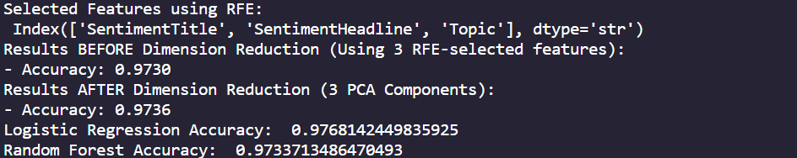

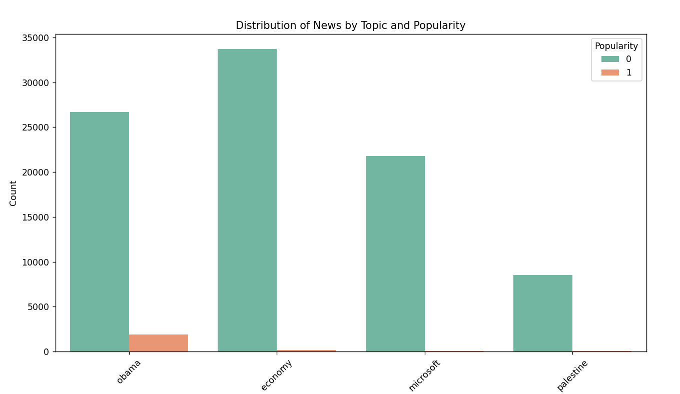
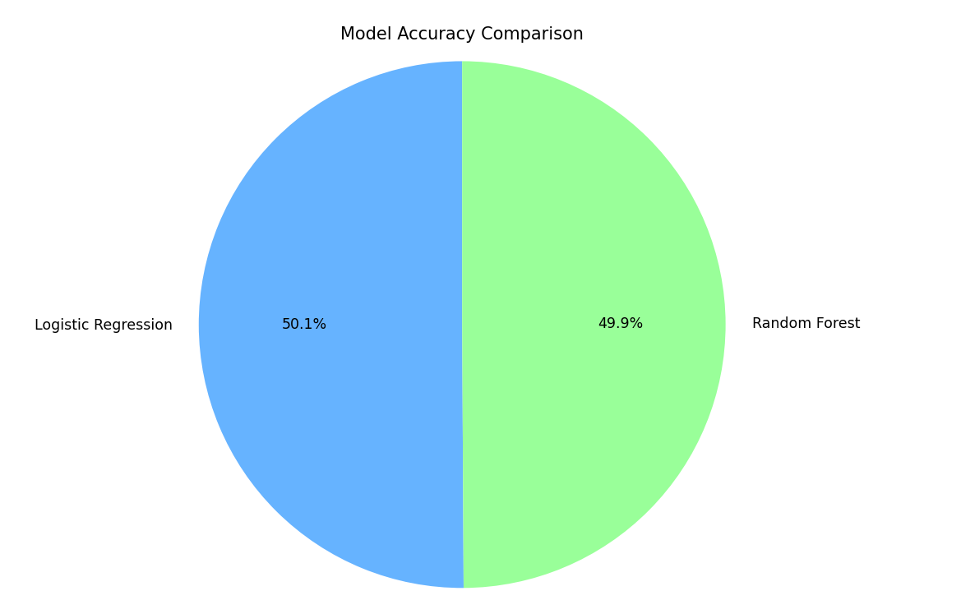

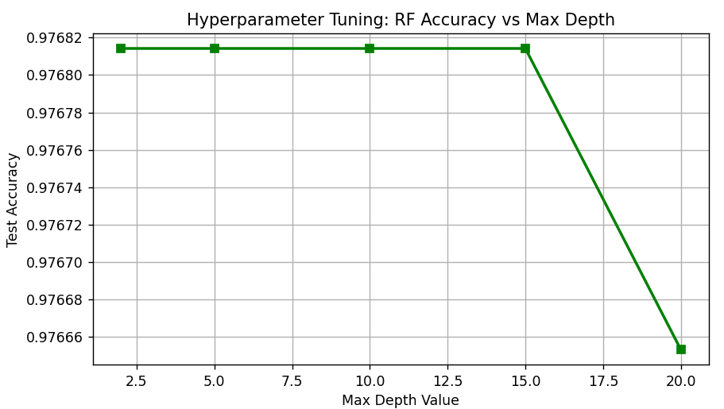
1. Importing Libraries

import warnings
warnings.filterwarnings('ignore')
import pandas as pd
import numpy as np
import matplotlib.pyplot as plt
import seaborn as sns
import kagglehub
import os
from sklearn.preprocessing import LabelEncoder
from sklearn.model_selection import train_test_split
from sklearn.linear_model import LogisticRegression
from sklearn.metrics import accuracy_score
from sklearn.ensemble import RandomForestClassifier
from sklearn.decomposition import PCA
from sklearn.feature_selection import RFE

Explanation: In this step, we import all the necessary libraries required for our project.
We use: Pandas and NumPy for data manipulation and numerical operations.
Matplotlib and Seaborn for data visualization.
KaggleHub to download the dataset.
Scikit-learn (sklearn) for building and evaluating machine learning models.
We also disable warnings to keep the output clean.

2. Loading the Dataset
path = kagglehub.dataset_download("georgesaavedra/news-popularity-in-social-media-platforms")
file_path = os.path.join(path, "News_Final.csv")
df = pd.read_csv(file_path)

Explanation: Here, we download the dataset from Kaggle using KaggleHub.
Then, we construct the file path and load the dataset into a Pandas DataFrame for further processing.

3. Data Cleaning

df = df.dropna()
df = df.drop_duplicates()

Explanation: In this step, we clean the dataset by:
Removing rows with missing values (NaN).
Removing duplicate rows.
This ensures that our data is accurate and reliable before training the model.

4. Feature Engineering (Date Processing)

df['PublishDate'] = pd.to_datetime(df['PublishDate'])
df['Year'] = df['PublishDate'].dt.year
df['Month'] = df['PublishDate'].dt.month
df['Hour'] = df['PublishDate'].dt.hour

Explanation: We convert the PublishDate column into a datetime format.
Then, we extract useful features: Year , Month , Hour
These features may help the model understand when news becomes popular.

5. Creating the Target Variable

df['Popularity'] = (df['Facebook'] > 1000).astype(int)

Explanation:We create a new column called Popularity, which represents our target variable.
If the number of Facebook shares is greater than 1000 → we label it as 1 (Popular)
Otherwise → 0 (Not Popular)
This converts the problem into a binary classification problem.

6. Defining Features and Target
X = df[['SentimentTitle', 'SentimentHeadline', 'Topic', 'Source',
'GooglePlus', 'LinkedIn', 'Month', 'Hour']].copy()
y = df['Popularity']

Explanation: We define: X → the input features used to train the model
y → the target variable (Popularity)
These features include sentiment, topic, source, and engagement metrics.

7. Encoding Categorical Data
le = LabelEncoder()
for col in X.select_dtypes(include=['object']).columns:
X[col] = le.fit_transform(X[col])
Explanation: Some features (such as Topic and Source) are categorical.
Machine learning models cannot work with text, so we convert them into numerical values using Label Encoding.

8. Feature Selection using RFE

model_rfe = LogisticRegression(max_iter=1000)
rfe = RFE(model_rfe, n_features_to_select=3)
X_rfe = rfe.fit_transform(X, y)
selected_features_rfe = X.columns[rfe.support_]
print("Selected Features using RFE:\n", selected_features_rfe)

Explanation:
We apply Recursive Feature Elimination (RFE) to select the most important features.
We use Logistic Regression as the base model.
RFE removes less important features iteratively.
Finally, we keep only the top 3 most relevant features.
This helps reduce complexity and improve model performance.

9. Splitting the Dataset
X_train_base, X_test_base, y_train, y_test = train_test_split(
X_rfe, y, test_size=0.2, random_state=42)

Explanation:
We split the dataset into:
Training set (80%) → used to train the model
Testing set (20%) → used to evaluate performance
We use a fixed random state for reproducibility.

10. Random Forest (Before PCA)

rf_full = RandomForestClassifier(n_estimators=50, random_state=42)
rf_full.fit(X_train_base, y_train)
acc_before = accuracy_score(y_test, rf_full.predict(X_test_base))

Explanation: We train a Random Forest model using the selected features.
Then, we evaluate its accuracy on the test data.
This gives us a baseline performance before applying dimensionality reduction.

11. Applying PCA (Dimensionality Reduction)

pca = PCA(n_components=3)
X_train_pca = pca.fit_transform(X_train_base)
X_test_pca = pca.transform(X_test_base)

Explanation: We apply Principal Component Analysis (PCA) to reduce dimensionality.
The data is transformed into 3 principal components.
This helps reduce noise and improve computational efficiency.

12. Random Forest (After PCA)

rf_pca = RandomForestClassifier(n_estimators=50, random_state=42)
rf_pca.fit(X_train_pca, y_train)
acc_after = accuracy_score(y_test, rf_pca.predict(X_test_pca))

Explanation: We train the Random Forest model again after applying PCA.
Then, we compare the accuracy before and after dimensionality reduction.

13. Logistic Regression Model

log_model = LogisticRegression(max_iter=1000)
log_model.fit(X_train_base, y_train)
y_pred_log = log_model.predict(X_test_base)
log_accuracy = accuracy_score(y_test, y_pred_log)

Explanation: We train a Logistic Regression model as a baseline model.
Then, we evaluate its performance using accuracy.

14. Random Forest Model

rf_model = RandomForestClassifier()
rf_model.fit(X_train_base, y_train)
y_pred_rf = rf_model.predict(X_test_base)
rf_accuracy = accuracy_score(y_test, y_pred_rf)

Explanation: We train another Random Forest model and compare its performance with Logistic Regression.
Random Forest typically provides better results due to its ensemble natur
15. Data Visualization
plt.figure(figsize=(10, 6))
sns.countplot(x='Topic', hue='Popularity', data=df, palette='Set2')
plt.show()

Explanation: We visualize how different news topics relate to popularity.
This helps us understand patterns in the dataset.

Model Comparison

labels = ['Logistic Regression', 'Random Forest']
accuracy_scores = [log_accuracy, rf_accuracy]
plt.pie(accuracy_scores, labels=labels, autopct='%1.1f%%')
plt.show()

Explanation: We compare the performance of both models using a pie chart. Hyperparameter Tuning

depths = [2, 5, 10, 15, 20]
rf_accs = []
for d in depths:
m = RandomForestClassifier(max_depth=d, n_estimators=50, random_state=42)
m.fit(X_train_base, y_train)
rf_accs.append(accuracy_score(y_test, m.predict(X_test_base)))
plt.plot(depths, rf_accs, marker='s')
plt.show()
Explanation: We test different values of max_depth in Random Forest.
This helps us identify the best parameter for improving accuracy.

