**At First I Hope you are well..**

**User**

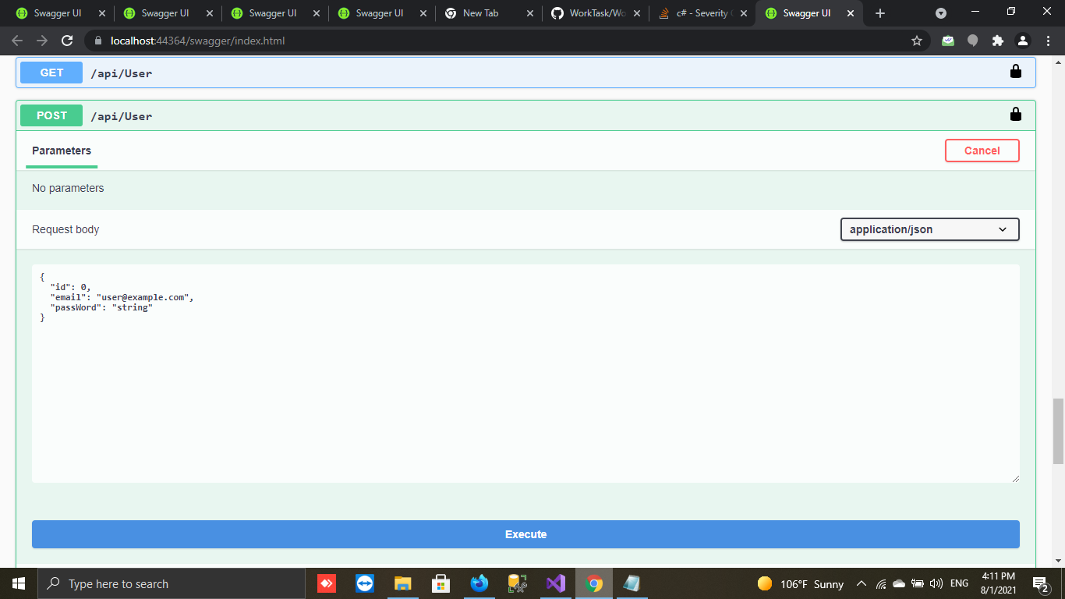

* **You should add User At First**

**With UserEmail Ex :Mahmoud@gmail.com**

**And PassWord**

* **Get all User api/User**
* 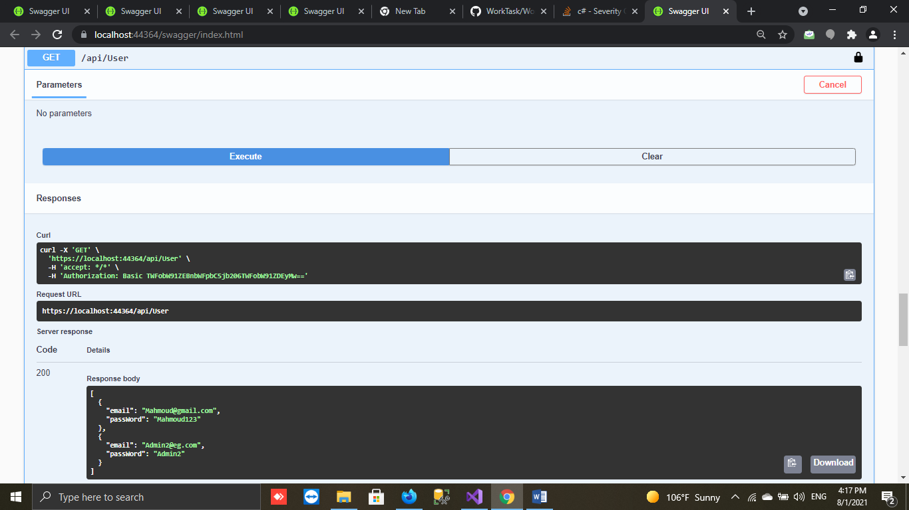
* **And Can Get User By Id**
* **And Modify User**
* **And Delete User**

**Reservation**

You Should Login To Get Information about Trip or Reservation

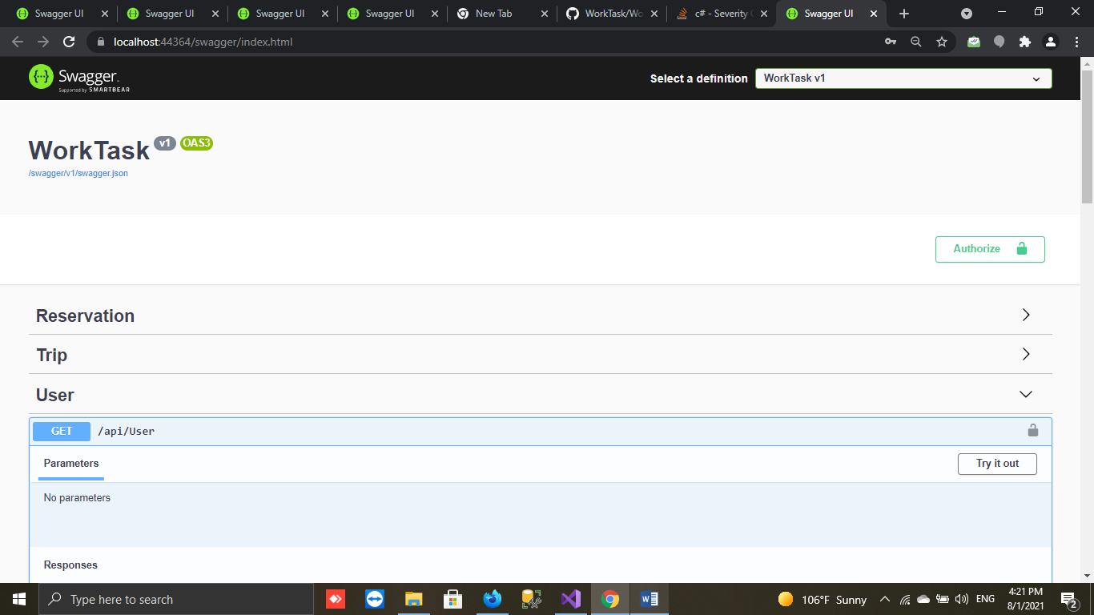

By Click On Authorize 🡺 then Write Email And Password You Add In User

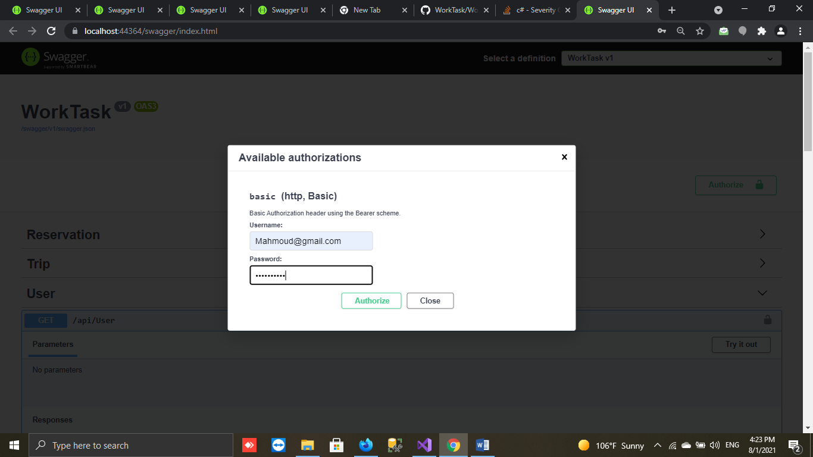

-Use Page number and Page size to get all reservation

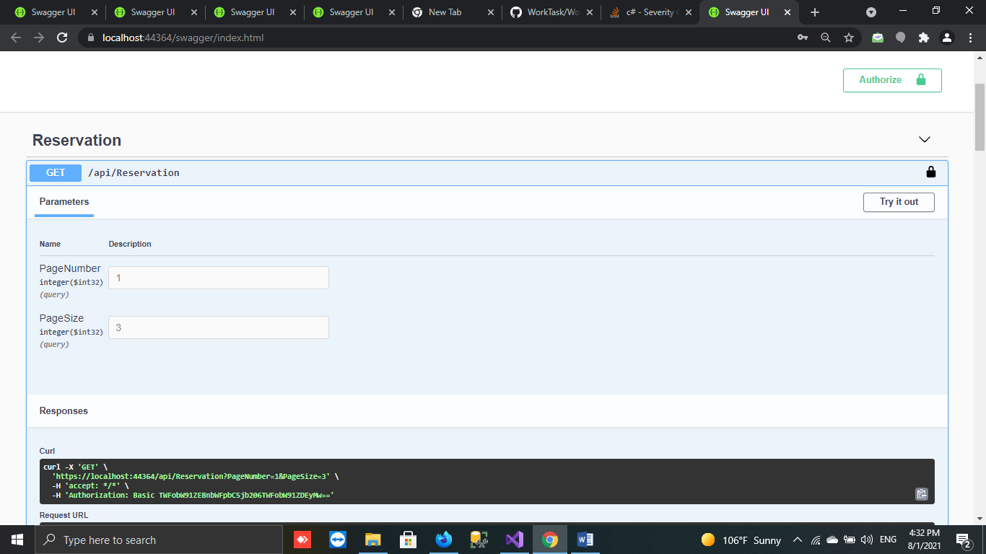

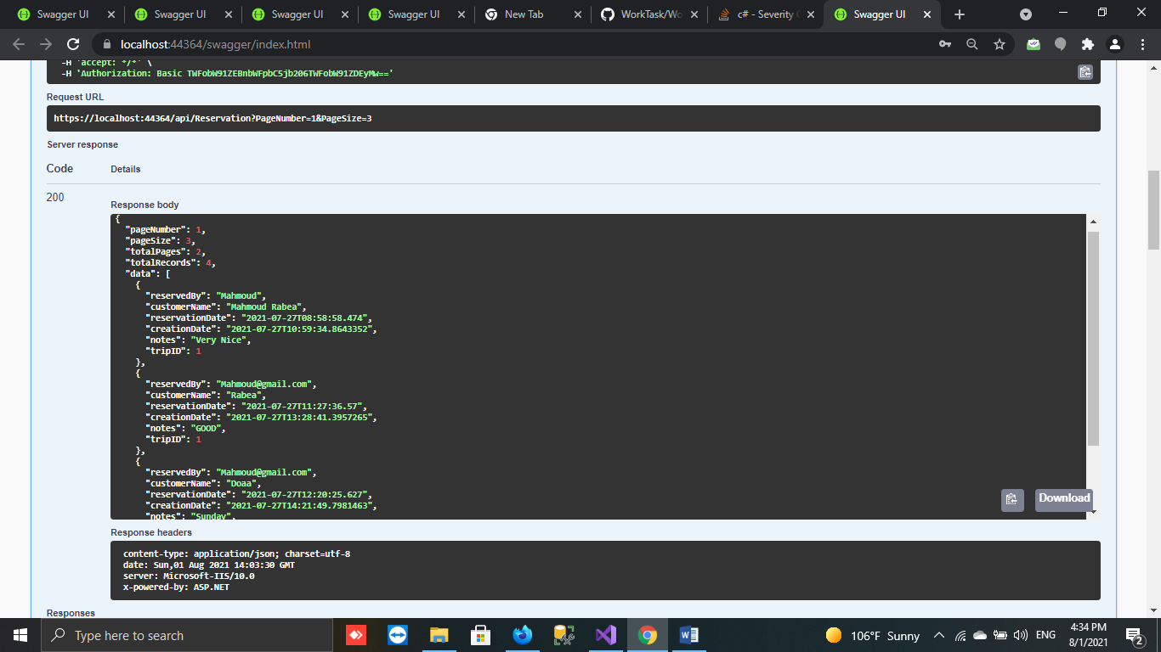

-Get Reservation By Id (reservation With Trip details)

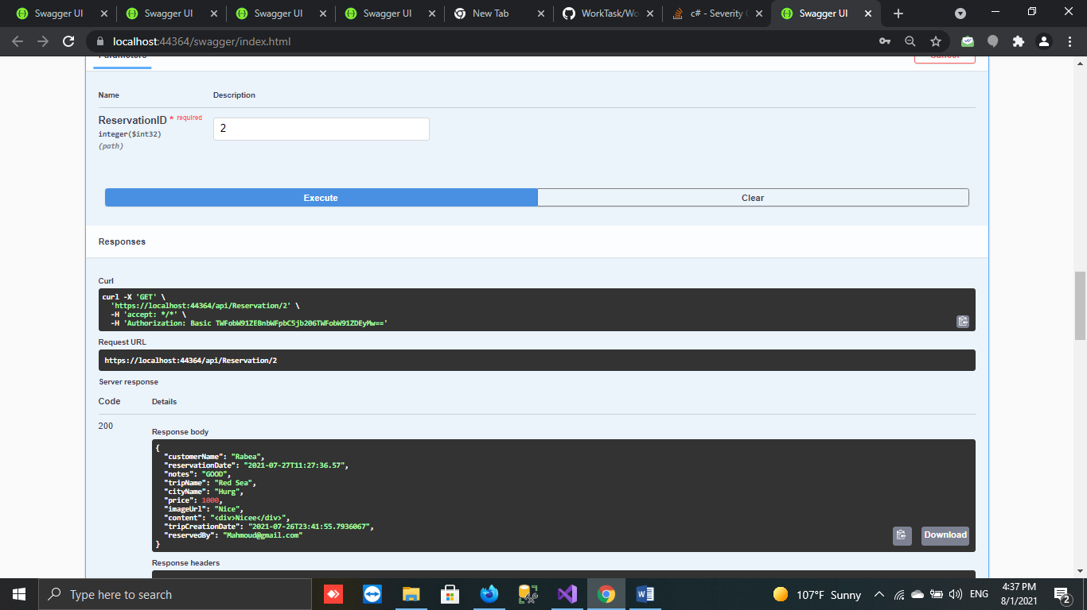

**reservationDate = DateTime.now 🡺 time When Reserve**

**reservedBy 🡺 User Login Name**

* - You Can (Add Reservation ,Modify and Delete Reservation)

**Trip**

Now You Can User Trip Controller

* Get All Trip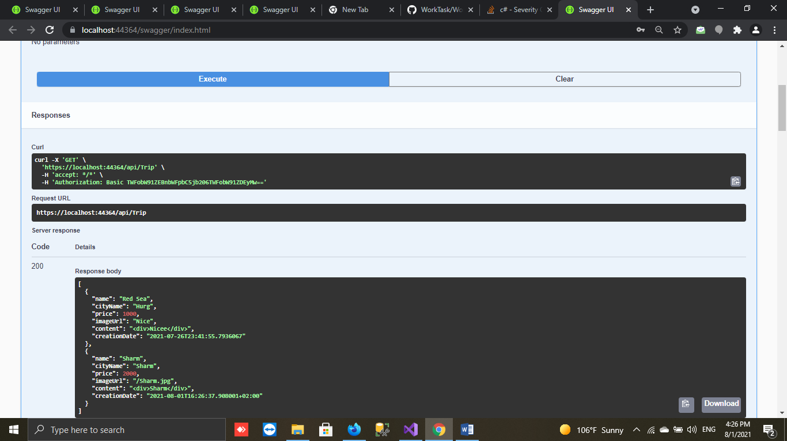
* You Can ( Get Trip By Id, Add Trip ,Modify and Delete Trip)