Benha University

Benha Faculty of Engineering

Dept. of Electrical Engineering

Subject Name :

**Communication system project**

Submitted By :

**Name : Mahmoud Saad Mostafa**

Supervised By :

**DR. Ayman Mostafa**

Dept. of Electrical Engineering

Benha Faculty of Engineering

Benha University

* Introduction

In the realm of modern communication systems, the efficient transmission of information is of paramount importance. Modulation techniques have emerged as indispensable tools for encoding and decoding signals, enabling reliable and high-quality communication in various domains.

The purpose of this report is to explore the fundamental principles of modulation, examining how it allows for the efficient transmission of data by imposing information on carrier signals. Furthermore, we will analyze the various modulation schemes employed in different communication systems, considering their strengths, limitations, and trade-offs.

1. **Part 1**

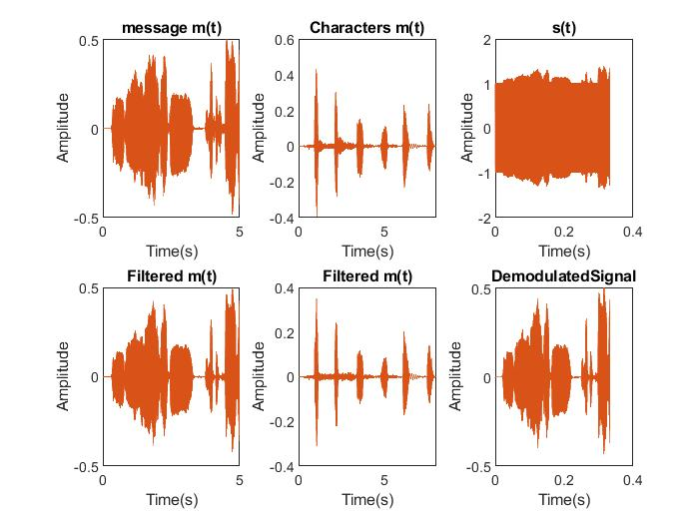**Signals plot in time domain**

Signals plot in frequency domain

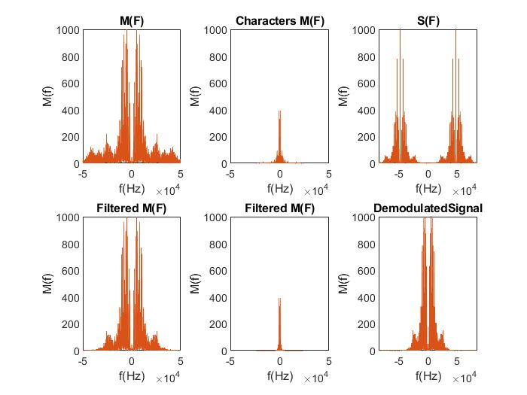

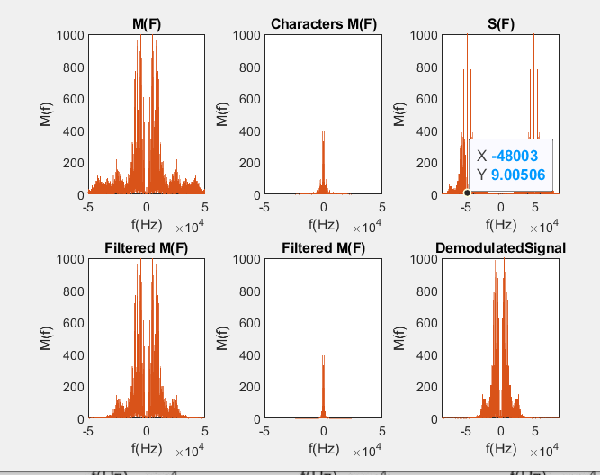

Cut off frequency after which the signal message becomes unintelligible is under **800Hz.**

Cut off frequency after which the characters signal becomes unintelligible is under **1500Hz**.

1. **Part 2**

When I added several values of frequency offset to LO in both DSB-SC and SSB-SC the signal got distorted.

In DSB-SC there is time varying phase.

In SSB-SC there is a phase shift for all frequencies.

Signals plot in time domain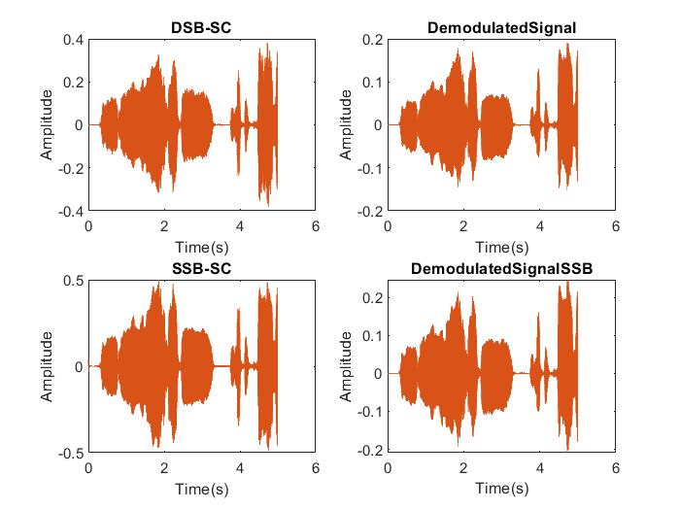 :

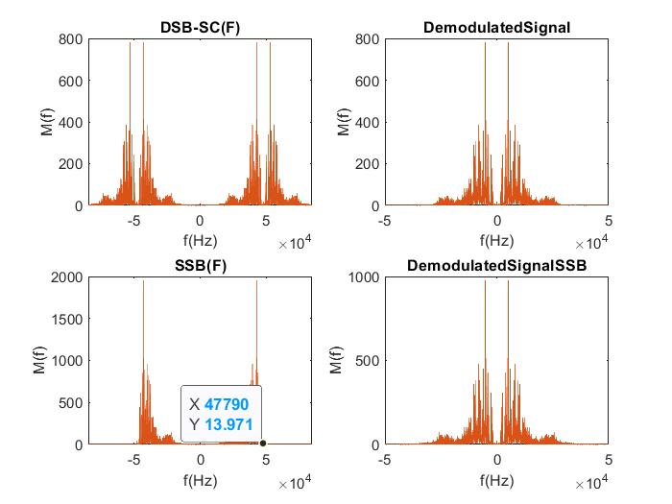**Signals plot in frequency domain:**