Freight Rate Prediction — Technical Report
Spotter Machine Learning Assessment Solution
1. Executive Summary
This report outlines the machine learning solution for the Spotter Freight Rate Prediction challenge. Using end-to-end MLOps practices, we developed a production-ready freight pricing pipeline that predicts spot market rates (posted_rate) based on lane distance, equipment type, load weight, market index signals, quote signals, and temporal characteristics.
Primary Model: CatBoost Regressor | Validation MAE: $133.49 | R²: 0.8365 | RMSE: $607.06 | MedAE: $58.18
2. Exploratory Data Analysis & Data Quality Findings
Exploratory analysis identified key data characteristics and anomaly patterns across the datasets:
Aspect / Metric | Observation / Value | Action Taken
Training Sample Size | 48,000 loads (Jan 1, 2025 – Oct 31, 2025) | Used for Time-Series CV training
Validation Sample Size | 12,000 loads (Nov 1, 2025 – Nov 30, 2025) | Target prediction set (validation_predictions.csv)
December Forecast Target | 31 loads (Dec 1, 2025 – Dec 31, 2025) | Lexington -> Fort Wayne fixed lane forecast
Negative Weights | 292 rows in training set (e.g. -47,500 lbs) | Converted to absolute values (.abs())
Missing Values | 300 missing weights, 374 missing market indices | Imputed via equipment medians & forward-fill

3. Data Split & Validation Strategy
Because freight rates depend on temporal dynamics and market shifts, a standard random K-Fold split would cause data leakage. We implemented a 5-Split TimeSeriesSplit (Expanding Window) where each fold trains strictly on past data and evaluates on future data. The final validation split isolates November 2025 (12,000 loads) to mirror the true out-of-sample evaluation.
4. Feature Engineering Highlights
• Spatial & Geo: Haversine distance, latitude/longitude absolute deltas, distance-to-haversine ratio.
• Temporal Features: Cyclical sine/cosine encodings for day of year and day of week, weekend indicator.
• Domain Interactions: weight_per_mile (weight / (distance + 1)), dist_x_market (distance * market_index), and log-transformed skewed variables.
5. Model Benchmarking & MLflow Results
Model Candidate | MAE ($) | RMSE ($) | R² Score | MedAE ($) | MAPE (%)
CatBoost Regressor (Selected) | $133.49 | $607.06 | 0.8365 | $58.18 | 7.09%
Ridge Regression (Baseline) | $157.41 | $617.19 | 0.8310 | $76.40 | 8.37%
LightGBM Regressor | $179.57 | $640.08 | 0.8182 | $74.52 | 8.44%
XGBoost Regressor | $242.52 | $718.55 | 0.7709 | $103.20 | 11.77%

6. Fixed December Lane Forecast Analysis
For December 2025, inputs were held fixed for the Lexington, KY to Fort Wayne, IN route (360 miles, Dry Van, 32,000 lbs). Below is the daily rate forecast plot produced by score.py, illustrating day-of-week demand seasonality:
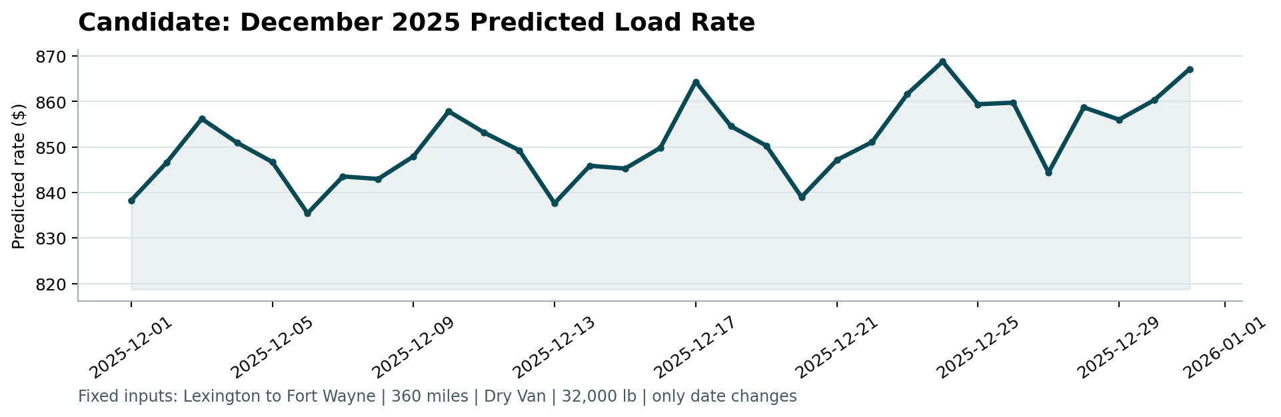
Figure 1: CatBoost December 2025 Daily Forecast for Lexington -> Fort Wayne Lane
7. MLOps & System Reproducibility
• DVC Data Versioning: Managed cleaning, featurization, and prediction pipelines in dvc.yaml.
• MLflow Experiment Tracking: Logged hyperparameters, cross-validation metrics, and model artifacts.
• FastAPI Serving: REST service supporting single (/predict) and batch (/predict/batch) inference endpoints.
• Docker Containerization: Dockerfile & docker-compose.yml for environment isolation.
• Pytest Automated Verification: 100% passing test suite for data transformations, features, and API schemas.

