Cairo University  
Faculty of Computers and Artificial Intelligent

**CS251**

**Software Engineering I**

Parking Garage Application

Software Design Specification

Ziad Ibrahim, Hamza Abdul-Hameed, Mahmoud Yassin, Omar Abdel-Aziz

5 / 2022

Contents

Team 3

Document Purpose and Audience 3

Purpose 3

Audience 3

System Models 4

I. Class diagrams 4

Important Algorithm 5

II. Sequence diagrams 5

sequence diagram 1 5

sequence diagram 2 6

sequence diagram 3 7

sequence diagram 4 8

sequence diagram 5 8

sequence diagram 6 9

Class - Sequence Usage Table 9

Ownership Report 10

Policy Regarding Plagiarism: 10

# Team

|  |  |  |  |
| --- | --- | --- | --- |
| **ID** | **Name** | **Email** | **Mobile** |
| 20200193 | Ziad Ibrahim Galal | Ziad.ebrahim00@gmail.com | 01127381814 |
| 20200162 | Hamza Abdul-Hameed Ali | hamzaemad598@gmail.com | 01122090518 |
| 20200506 | Mahmoud Yassin Mahmoud | yassinmahmoudyassin@gmail.com | 01145826595 |
| 20200831 | Omar Abdel-Aziz El-Sayed | [Omarcyclist7@gmail.com](mailto:Omarcyclist7@gmail.com) | 01099611380 |

# Document Purpose and Audience

## Purpose

The purpose of this Software Design Specification document is to define the design views of the project that will satisfy the functional and non-functional requirements stated in the Software Requirement Specification Document for the garage parking system. Another purpose is to serve as a guideline throughout development phase of the project. Also serves as a tool for validation for the final project

## Audience

The intended audience for this document includes the developers of the project and vehicle drivers. Developers should use this document in the development phase to structure the design of each part.

# System Models

## I. Class diagrams

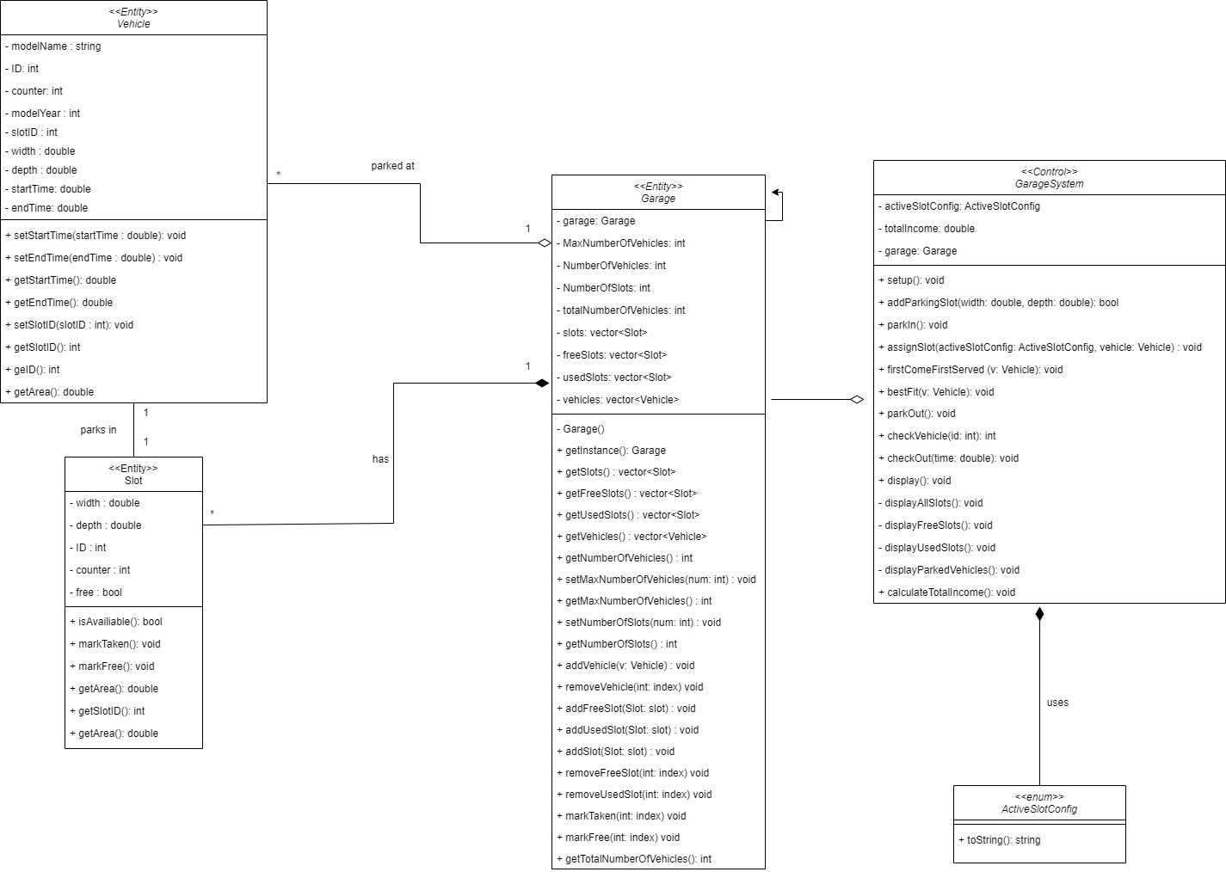

| **Class ID** | **Class Name** | **Description & Responsibility** |
| --- | --- | --- |
| 1 | Garage | Entity class send garage info to GarageSystem . |
| 2 | Vehicle | Entity class to represent each driver’s vehicle. It includes some info about the vehicle like model year and save the time and sends it to GarageSystem. |
| 3 | Slot | Entity class to represent each slot in the garage and sends it to GarageSystem |
| 4 | GarageSystem | Control class to control the whole garage system and assign slot for the user and return it to the screen |
| 5 | ActiveSlotConfig | An enum class to represent active slot config approach |

### Important Algorithm

## II. Sequence diagrams

### sequence diagram 1

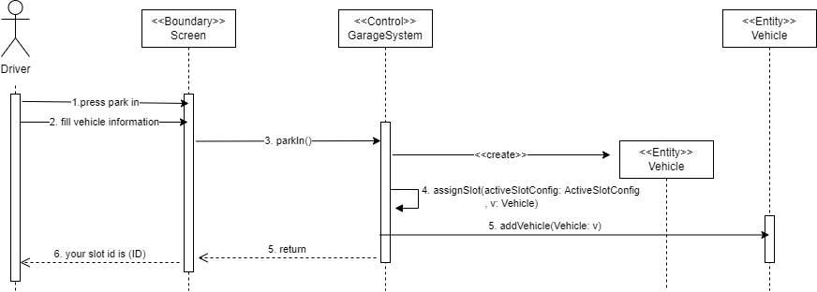

### sequence diagram 2

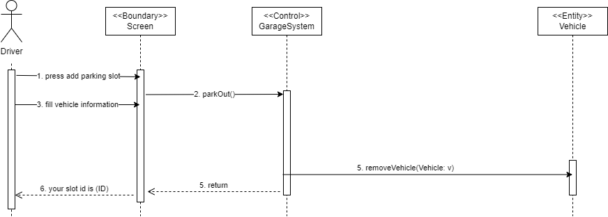

### sequence diagram 3

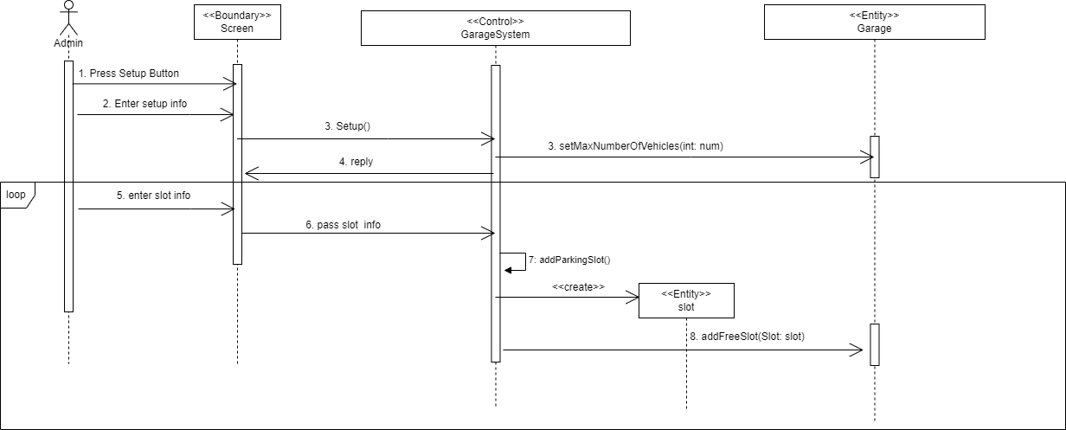

### sequence diagram 4

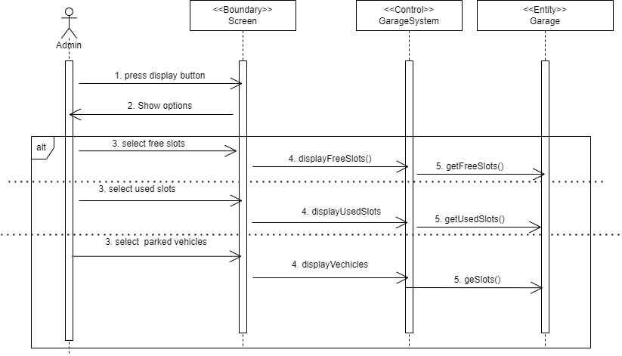

### sequence diagram 5

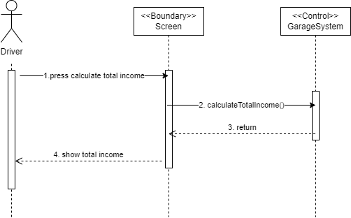

### 

### sequence diagram 6

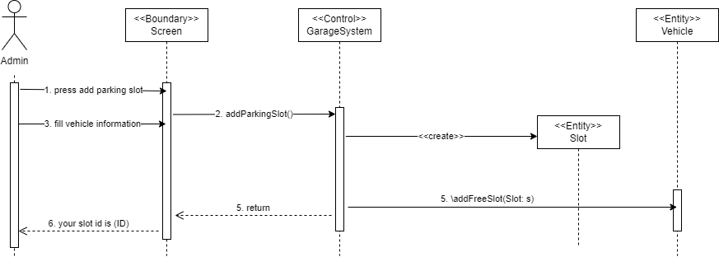

### Class - Sequence Usage Table

| **Class Name** | **Sequence Diagrams** | **Overall used methods** |
| --- | --- | --- |
| GarageSystem | 1, 2, 3, 4, 5, 6 | parkIn, assignSlot, parkOut, checkSlot, checkOut, setup, pass slot info, addParkingSlot,, displayFreeSlots, displayUsedSlots, displayVehicles, |
| Screen | 1, 2, 3, 4, 5, 6 | Press park in, fill vehicle information,your slot id is ,press parkout , enterslotID, press setup button ,Enter setup info, enter slot info,press display button , show options,select free slots ,select used slots , select parked vehicles, press calculate total income, show total income, press addparkingslot , fillNewSlot |
| Slot | 3, 6 |  |
| Vehicle | 1, 2, 6 |  |
| Garage | 3, 4 | setMaxNumberOfVehicles, addFreeSlots, getFreeSlots, getUsedSlots, getSlots. |

# Ownership Report

|  |  |
| --- | --- |
| **Item** | **Owners** |
| Document purpose and audience | *Ziad Ibrahim* |
| Class Diagram | *Ziad Ibrahim, Hamza Abdul Hameed, Mahmoud Yassin, Omar Abdel-Aziz* |
| Sequence Diagram 1 | *Hamza Abdul Hameed, Mahmoud Yassin* |
| Sequence Diagram 2 | *Hamza Abdul Hameed, Omar Abdel-Aziz* |
| Sequence Diagram 3 | *Hamza Abdul Hameed, Mahmoud Yassin* |
| Sequence Diagram 4 | *Ziad Ibrahim, Omar Abdel-Aziz* |
| Sequence Diagram 5 | *Mahmoud Yassin, Omar Abdel-Aziz* |
| Sequence Diagram 6 | *Ziad Ibrahim* |
| Source Code | *Hamza Abdul-Hameed, Ziad Ibrahim* |