**Determining the Optimal quantities of protein, carbohydrates, and fats for astronaut’s consumption.**

**Prepared By:**

**Mahmoud Zain Sabto 180501448.**

**Oubai Nasrallah 170501633.**

**Salem Zeidan 190501142.**

**Razan Abusabrah 190501492.**

**Mohammed Saber 170501596.**

**Content:**

**executive summary Page: 3**

**Introduction Page: 3**

**space food Packaging: Page: 3**

**Space food history: Page: 4**

**real-life example Page: 5-9**

**discussions Page: 10**

**Resources:**

[www.wikipedia.org](http://www.wikipedia.org)

[www.nasa.gov](http://www.nasa.gov)

[www.open.edu](http://www.open.edu)

[www.braeunig.us](http://www.braeunig.us)

**executive summary:**

This report gives exclusive insights into the solution of a real-life problem on determining the optimal quantities of calories obtained from proteins, carbohydrates, and fats that astronauts eat on the international space station, because astronauts can pick and choose between 220 different meals and treats that they want to eat on the ISS, NASA has to run a linear program of each astronaut's choices, it is important to keep the meals balanced and similar to what they would eat on earth.in this report, we will be minimizing the cost of manufacturing space meals, considering the number of required fats, proteins, and carbohydrates that a certain astronaut should consume per day.

**Introduction:**

Space food is a type of food product created and processed for consumption by astronauts during missions to outer space. The food has specific requirements of providing balanced nutrition for individuals working in space while being easy and safe to store, prepare, and consume in the machinery-filled weightless environments of crewed spacecraft, In recent years, space food has been used by various nations engaging on space programs as a way to share and show off their cultural identity and facilitate intercultural communication. Although astronauts consume a wide variety of foods and beverages in space, the initial idea from The Man in Space Committee of the Space Science Board in 1963 was to supply astronauts with a formula diet that would supply all the needed vitamins and nutrients, Designing food for consumption in space is an often difficult process. Foods must meet a number of criteria to be considered fit for space. Firstly, the food must be physiologically appropriate. Specifically, it must be nutritious, easily digestible, and palatable. Secondly, the food must be engineered for consumption in a zero-gravity environment. As such, the food must be light, well packaged, fast to serve, and require minimal cleaning up. Finally, foods require a minimum of energy expenditure throughout their use; they must store well, open easily, and leave little waste behind (foods that tend to leave crumbs, for example, are ill-suited for space).

**space food Packaging:**

The primary purpose of packaging space food is preserving and containing the food. However, the packaging must also be light-weight, easy to dispose of and useful in the preparation of the food for consumption. The packaging also includes a bar-coded label, which allows for the tracking of an astronaut's diet. The labels also specify the food's preparation instructions in both English and Russian, NASA space foods are packaged in retort pouches or employ freeze-drying. They are also packaged in sealed containers which fit into trays to keep them in place. The trays include straps on the underside, allowing astronauts to attach the tray to an anchor point such as their legs or a wall surface and include clips for retaining a beverage pouch or utensils in the microgravity environment.

**Space food history:**

Early space food was primarily composed of bite-sized cubes, freeze-dried powders, and thick liquids stuffed in aluminum tubes. Eventually, the tubes were discontinued, the powders made it easier to re-freeze, and the cubes were coated in gelatin to prevent crumbling on the equipment. With the introduction of the "spoon bowl," astronauts were able to open the contents of the package and eat the simple meal with a spoon.

**Project Gemini and Apollo (1965–1975):**Several of the food issues from the Mercury missions were addressed for the later Gemini missions (1965–1966). Tubes (often heavier than the foods they contained) were abandoned, gelatin coatings helped to prevent bite-sized cubes from crumbling, and simpler rehydration methods were developed. The menus were also expanded to include items such as shrimp cocktail, chicken and vegetables, toast squares, butterscotch pudding, and apple juice, The crew of Gemini 3 snuck a corned beef sandwich on their spaceflight. Mission Commander Gus Grissom loved corned beef sandwiches, so Pilot John Young brought one along, having been encouraged by fellow astronaut Walter Schirra. However, Young was supposed to eat only approved food, and Grissom was not supposed to eat anything. Floating pieces of bread posed a potential problem, causing Grissom to put the sandwich away (although he did enjoy it) and the astronauts were mildly rebuked by NASA for the act. A congressional hearing was called, forcing NASA deputy administrator George Mueller to promise no repeats. NASA employed renewed vigilance regarding what astronauts brought along on future missions.

**Skylab (1973–1974):**Larger living areas on the Skylab space station (1973–1974) allowed for an on-board refrigerator and freezer. This allowed perishable and frozen items to be stored, making microgravity the primary obstacle of future missions. When Skylab's solar panels were damaged during its launch and the station had to rely on minimal power from the Apollo Telescope Mount until Skylab 2 crewmembers performed repairs, the refrigerator and freezer were among the systems that Mission Control kept operational, Menus included 72 items; for the first time about 15% was frozen. Shrimp cocktail and butter cookies were consistent favorites; Lobster Newberg, fresh bread, processed meat products, and ice cream were among other choices. A dining room table and chairs, fastened to the floor and fitted with foot and thigh restraints, allowed for a more normal eating experience. The trays used could warm the food, and had magnets to hold eating utensils and scissors used for opening food containers. The food was similar to that used for Apollo, but canned for preservation. The crew found it to be better than that of Apollo but still unsatisfying, partially due to food tasting different in space than on Earth. The frozen foods were the most popular, and they enjoyed spicy foods due to sinus congestion from weightlessness dulling their senses of taste and smell, Weightlessness also complicated both eating and cleaning up; crews spent up to 90 minutes a day on housekeeping.

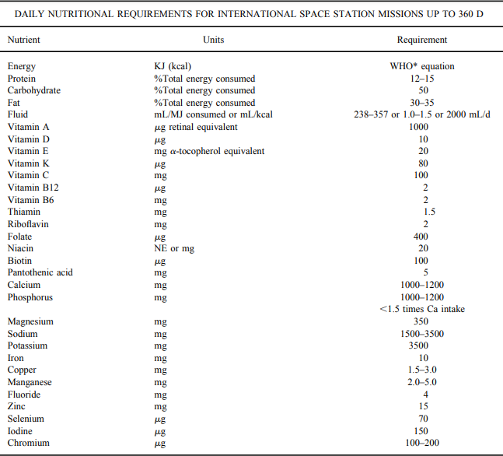**real-life example:-**for manufacturing space meals, NASA had to take into consideration the amount of nutrition that astronauts must eat per day (as shown in the table below, the table is taken from the report: "History of Nutrition in Space Flight: Overview"), **most of the minerals and vitamins can be supplemented with pills and oils, but some sorts of base nutrition can only be taken from a certain food or drink and must be taken in large quantities (a pill is not enough), (like proteins, carbohydrates, and fats).**  
**according to the table: 15% of the calories must be protein and 50% of the calories must be carbohydrates and 35% of the calories must be fats,** the total number of calories is different for each astronaut (different age, gender, body mass, etc...), NASA has to calculate how much calories each astronaut should eat per day, **but we will calculate only for one astronaut** **that requires 3000 calories a day, that means 450 calories from proteins, 1500 calories from carbohydrates, and 1050 calories from fats, keep in mind that astronauts eat 3 meal a day**, astronauts have the ability to choose from 220 different types of meals (the meals quantities are not always the same, because there are (220*219*218=105003240) possible outcomes of what the astronauts can select, so NASA has to do this linear programming each time they send food).  
let's assume that the astronaut selected (ham and cheese sandwiches), (Chicken and rice), and (brownies for dessert), **A SIDE NOTE:** for the meals to be appetizing (more like earth’s food), the ratio of protein to carb (or sugar to butter in the brownies, (sugar is considered as carbs and butter is fat)) is kind of standard, so it would be better if NASA can make the meals more like normal food, and not like one meal is full of rice and barely any chicken just to reach the required amount of carbs, but it is okay if the ratios change a bit.   
the specific information (from google research) about the meals is listed in the table below:

|  |  |  |  |
| --- | --- | --- | --- |
| Meals | Proteins calories | Carbohydrates calories | Fats calories |
| 1 ham and cheese sandwich | 84 | 132 | 135 |
| Chicken and rice meal | 250 | 344 | 110 |
| 1 Brownie | 6 | 48 | 63 |

**our goal is to minimize the cost of manufacturing these meals and satisfy the required amount of calories from proteins, carbohydrates, and fats,** (the cost of making these meals might change from time to time, and there is the cost of preparation (either dehydration or packaging, and there is not enough information on that), so, the costs are estimates).  
**the cost of 1 Ham and cheese sandwich: $13  
the cost of Chicken and rice: $34   
the cost of 1 Brownie: $5**

**Answer:-**

**first**, we need to determine the decision variables:  
X1 is the variable of Ham and cheese sandwiches that should be eaten per day  
X2 is the variable of Chicken and rice meals that should be eaten per day  
X3 is the variable of Brownies that should be eaten per day

**second**, we need to write the objective function:  
min w = 13X1 + 34X2 +5X3

**third**, we need to write the constraints:  
84X1 + 250X2 + 6X3 <= 450 **calories from proteins.**  
132X1 + 344X2 + 48X3 <= 1500 **calories from carbohydrates.**  
135X1 + 110X2 + 63X3 <= 1050 **calories from fats.**X1 <= 1 **sign restrictions (we used 1 because there must be 3 meals a day).**  
X2 <= 1 **sign restrictions (we used 1 because there must be 3 meals a day).**  
X3 <= 1 **sign restrictions (we used 1 because there must be 3 meals a day).**

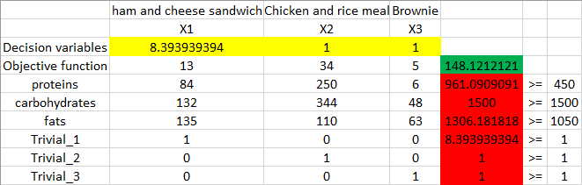**fourth,** after we run the linear program with these constraints, the results are **not satisfying**:  
  
we can see that the programs suggests making 8.4 Ham and cheese sandwiches! and only 1 meal of Chicken and rice and 1 Brownie, and there is a huge excess amount of proteins and fats!, we can also observe that the program did that just to satisfy the carbohydrates constraint.

The first thing we should do is increasing the carbohydrates in each meal :  
the required amount: 1500 – 132 – 344 – 48 = 976 (we should distribute a big piece of that 976 calories worth of carbohydrates into the meals while keeping into consideration, not to overfill one type of meal with carbohydrates only), (Of course, the cost of the meals will increase if we increase the amount of carbohydrates in it, but ever so slightly, because most of the cost is in manufacturing and packaging), (and as we mentioned before the cost might vary from one place to another and from time to time and there isn't enough information online on the cost of manufacturing, so the costs are just estimates).

**the new table of information:**

|  |  |  |  |
| --- | --- | --- | --- |
| Meals | Proteins calories | Carbohydrates calories | Fats calories |
| 1 ham and cheese sandwich | 84 | 175 | 135 |
| Chicken and rice meal | 250 | 577 | 110 |
| 1 Brownie | 6 | 50 | 63 |

now we just have to run the linear program again with these constraints:

**first**, we need to determine the decision variables:  
X1 is the variable of Ham and cheese sandwiches that should be eaten per day  
X2 is the variable of Chicken and rice meals that should be eaten per day  
X3 is the variable of Brownies that should be eaten per day

**second**, we need to write the objective function:  
min w = 13X1 + 34X2 +5X3

**third**, we need to write the constraints:  
84X1 + 250X2 + 6X3 <= 450 **calories from proteins.**  
175X1 + 577X2 + 50X3 <= 1500 **calories from carbohydrates.**  
135X1 + 110X2 + 63X3 <= 1050 **calories from fats.**X1 <= 1 **sign restrictions (we used 1 because there must be 3 meals a day).**  
X2 <= 1 **sign restrictions (we used 1 because there must be 3 meals a day).**  
X3 <= 1 **sign restrictions (we used 1 because there must be 3 meals a day).**

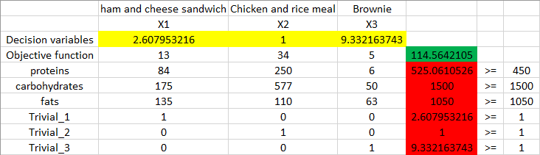**fourth,** after we run the linear program with these constraints, the results are **more sensible**:

the program suggests making 2.6 units of Ham and cheese sandwiches, 1 meal of Chicken and rice, and 9.3 units of Brownies, but we also observed that there are 75 extra calories of the required protein, 75 calories is not a lot we can just subtract them from each meal, and they shouldn't affect the original outcome too much.

**the new table of information:**

|  |  |  |  |
| --- | --- | --- | --- |
| Meals | Proteins calories | Carbohydrates calories | Fats calories |
| 1 ham and cheese sandwich | 74 | 175 | 135 |
| Chicken and rice meal | 201 | 577 | 110 |
| 1 Brownie | 6 | 50 | 63 |

now we just have to run the linear program again with these constraints:

**first**, we need to determine the decision variables:  
X1 is the variable of Ham and cheese sandwiches that should be eaten per day  
X2 is the variable of Chicken and rice meals that should be eaten per day  
X3 is the variable of Brownies that should be eaten per day

**second**, we need to write the objective function:  
min w = 13X1 + 34X2 +5X3

**third**, we need to write the constraints:  
74X1 + 201X2 + 6X3 <= 450 **calories from proteins.**  
175X1 + 577X2 + 50X3 <= 1500 **calories from carbohydrates.**  
135X1 + 110X2 + 63X3 <= 1050 **calories from fats.**X1 <= 1 **sign restrictions (we used 1 because there must be 3 meals a day).**  
X2 <= 1 **sign restrictions (we used 1 because there must be 3 meals a day).**  
X3 <= 1 **sign restrictions (we used 1 because there must be 3 meals a day).**

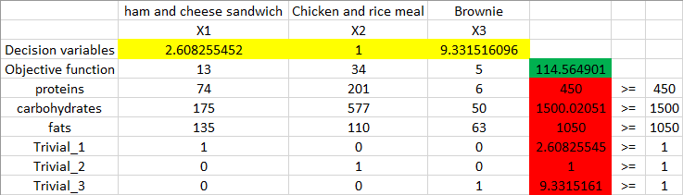**fourth,** after we run the linear program with these constraints, the results are **perfect**:

the program suggests making 2.6 units of Ham and cheese sandwiches, 1 meal of Chicken and rice, and 9.3 units of Brownies.

the optimal solution for this problem is:   
**2.6X1 + 1X2 + 9.3X3 = $114.56**

**Sensitivity Analysis:**

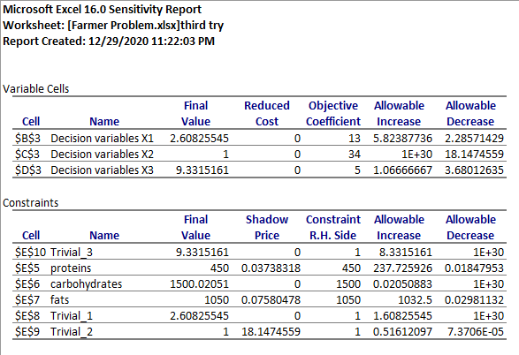

**Discussions:**

**wouldn't be better if there are 3 different menus to choose from, 1 for breakfast and another for lunch and another for diner?**yes, usually astronauts choose more than 3 meals, and the meals are separated into categories of breakfast, lunch, and dinner. All meals from the same category have the same nutrition value, so astronauts can choose what they want to eat and combine it with different meals throughout the day, but the same analysis that we did before must be done to all meals, they also get to choose snacks like M&Ms and nuts and drinks.

**what about the rest of the nutrition?**most vitamins lack benefit after a certain amount of time, and the conditions in space are much harder than earth (radiation), so some vitamins have a short lifetime, the solution to that problem is that NASA sends food supplements for the astronauts (food supplements are artificially made, they are not extracted from the actual source, so they have different combinations and different characteristics, and can withstand different environments).

**why is it so important to do all this, and why not send an excess amount of food?**as an astronaut, your time is really valuable, so, wasting time trying to cook something or deciding what you want to do with the ingredients and measuring how much you should eat is a waste of time, so all of this work is left for people on earth to do it (NASA workers), and it is an extra advantage to have the food pre-made from earth so that the astronauts can be sure of its quality, the last thing that an astronaut wants to worry about is having a stomach ache and being put out of commission to recover and waste time.astronauts already have an extra amount of food and water and supplies that are stored in case of emergencies, and it is not a wise decision to send extra food, because every kilogram costs approximately $20062 to send to space, the extra capacity of the space shuttle can be used to send other important things like machines and electronics.

**why not grow food in space?**to grow food in space you need a lot of resources, light, water, soil, time, ETC, and in the end, all of what the plants are doing is extracting nutrition and vitamins from the soil, so, essentially what you are doing is just sending inedible vitamins to space (soil).although it is worth mentioning that soil is sent to space to research plant growth in space, and there are some attempts to produce food in space but it is challenging and it is not efficient enough.

**isn't 9 Brownies a lot for one person to eat?**the Brownies in our example are not that heavy (full of fat and sugar like the typical ones we get in supermarkets), they are only 119 calories each, and the person that we are trying to fulfill his-her calorie requirements, requires 3000 calories a day, the normal person only requires around 2200 calories a day, but it is only an example.