Cairo University  
Faculty of Computers and Artificial Intelligent

**CS251**

**Software Engineering, I**

Project Name: Parking system

Software Design

**Team Names:**

**Mahmoud Adel Mamdouh**

**Mahmoud Alaa-ElDeen Fathy**

**Mohammed Gabr Ahmed**

Month & Year

Contents

Instructions [To be removed] 3

Team 3

Document Purpose and Audience 3

System Models 3

I. Class diagrams 3

Important Algorithm 4

II. Sequence diagrams 5

Class - Sequence Usage Table 6

Ownership Report 6

Policy Regarding Plagiarism: 7

# Team

|  |  |  |  |
| --- | --- | --- | --- |
| **ID** | **Name** | **Email** | **Mobile** |
| 20200500 | Mahmoud Adel Mamdouh | [Mahmoudadel5556@gmail.com](mailto:Mahmoudadel5556@gmail.com) | 01226427763 |
| 20200502 | Mahmoud Alaa Eldeen Fathy | [Malaafathy02@gmail.com](mailto:Malaafathy02@gmail.com) | 01550608047 |
| 20200765 | Mohammed Gabr Ahmed | [Mohammedgabr.ex.g7b@gmail.com](mailto:Mohammedgabr.ex.g7b@gmail.com) | 01126286046 |

# Document Purpose and Audience

This document clarifies class, sequence to the developer to minimize misleading and confusion encouraging team working.

**Target audience:**

* **Developers**
* **Project manager**

# System Models

## I. Class diagrams

| **Class ID** | **Class Name** | **Description & Responsibility** |
| --- | --- | --- |
| 1 | Screen | Responsible for displaying options to the user whoever he is to make sure that he can deal with the system |
| 2 | ParkingLot | Entity class that set the slot and get the current slot and remove the vehicle in park out |
| 3 | ParkingCtrl | Controller class that creates an object that has access to all functionalities |
| 4 | Ticket | Carries any information that modifies the experience of the customer, admin, and owner |
| 5 | Slot | Carries the details of every slot in the parking  Availability, dimensions, id, name,…etc. |
| 6 | Vehicle | Carries every vehicle specification |
| 7 | Income | Creates only one object (singleton) that has the total incomes every time payment happens |
| 8 | TotalCost | Returns the Total Cost |
| 9 | Context | maintains a reference to one of the concrete strategies and communicates with this object only via the ISelection interface. |
| 10 | ISelection | Interface means all the methods in an interface are declared with the empty body, and all the fields are public, static and final by default. A class that implements an interface must implement all the methods declared in the interface. |
| 11 | BestFit | It implements the ISelection interface and override the methods it is responsible to make the vehicle park in the most fit slot |
| 12 | FirstCome | It implements the ISelection interface and override the methods it is responsible to make the vehicle park in the first empty fit slot |

## II. Sequence diagrams

1-ParkIn Sequence

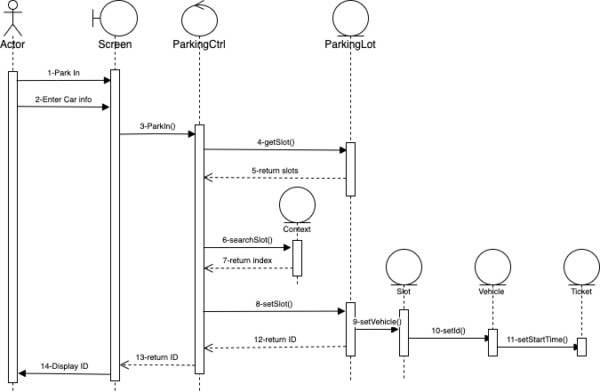

Figure :: Park in ID: 1

2-ParkOut Sequence

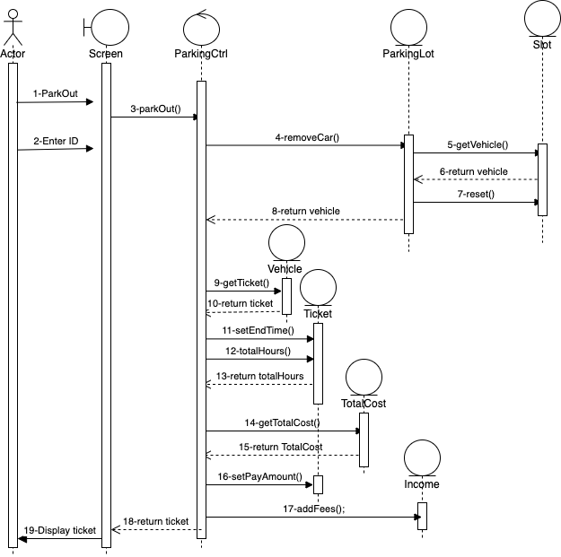

Figure 2 :: Park Out ID: 2

3-Total Income Sequence

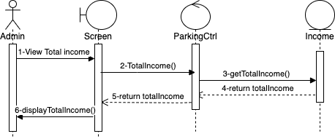

Figure 3 :: Total Income ID: 3

4-Total number of vehicles Sequence

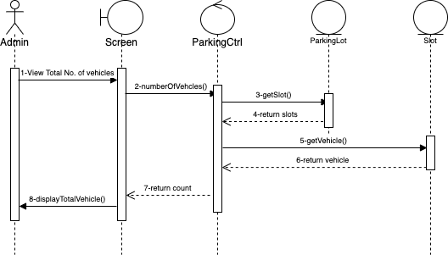

Figure 4 :: Total No. Of Vehicles ID: 4

### Class - Sequence Usage Table

| **Class Name** | **Sequence Diagrams** | **Overall used methods** |
| --- | --- | --- |
| Screen | Seq IDs (1,2,3,4) | TotalVehicle() ,TotalIncome() |
| ParkingCtrl | Seq IDs (1,2,3,4) | Parkin(),ParkOut(),  numberOfVehicles(),TotalIncome() |
| ParkingLot | Seq IDs (1,2,4) | getSlot(),removeCar(),setSlot() |
| Ticket | Seq IDs (1,2) | setEndTime, totalHours(),  setStartTime() |
| Slot | Seq IDs (1,2,4) | getVehicle(),reset(),setVehicle() |
| Vehicle | Seq IDs (1,2) | getTicket(),setId() |
| Income | Seq IDs (2,3) | getTotalIncome(),addFees() |
| TotalCost | Seq IDs (2) | getTotalCost() |
| Context | Seq IDs (1) | searchSlot() |

# 

# Ownership Report

|  |  |
| --- | --- |
| **Item** | **Owners** |
| **Code implementation** | Mahmoud Adel Mamdouh |
| **Design pattern Code implementation, sequence diagrams** | *Muhammed Gabr and Mahmoud Adel Mamdouh* |
| **Class, sequence diagrams** | *Mahmoud Alaa Eldeen Fathy and Muhammed Gabr* |
| **Use case, requirements ,descriptions** | *Mahmoud Alaa Eldeen Fathy* |