***Groups***

***Definition:*** two or more individuals interacting and interdependent who have come together to achieve particular objective.

***There are two types of groups:-***

* Formal Groups.
* Informal Groups.

***Classifications of groups:-***

***Formal Groups:***

1. Command Group.
2. Task Group.

***Informal Groups:***

1. Friendship Group.
2. Interest Group.

***Why People join groups?***

1. Security
2. Self-Esteem
3. Status
4. Power
5. Affiliation
6. Goal Achievement.

***Five stage of group Development models:***

1. Forming.
2. Storming
3. Norming.
4. Performing
5. Adjourning.

***Group Properties:-***

***Role:***

***Definition:*** A set of expected behavior patterns attributed to someone occupying a given position in a social unit.

***List of Roles:***

1. Role Perception.
2. Role Expectation.
3. Role Conflict.

***What is norms?***

Norms is an acceptable standard of behaviors within a group that are shared by the group member’s.

***Classes of norms:***

1. Performance norms.
2. Appearance norms
3. Social Arrangements.

***What is status?***

Status is a socially defined position or rank given by group members by others.

***Status is drived from one of sources:***

1. Power person have on others.
2. Ability to contribute to group goals.
3. Personal Characterstics.

***Size:-***

***Group size affects behavior:***

| *Attributes* | *Small* | *Large* |
| --- | --- | --- |
| *Speed* | **✔️** |  |
| *Individual Performance* | ✔️ |  |
| *Problem Solving* |  | ✔️ |
| *Fact finding goals* |  | ✔️ |
| *Overall performance* | ✔️ |  |

***What is Social Loafing?***

Social loafing is the tendency for individuals to expend less effort when working collectively than when working individually.

***How to prevent Social Loafing?***

1. Setting Group Goals.
2. Increase intergroup competition.
3. Use peer evaluation.
4. Distribute group rewards based on individual effort.

***What is cohesiveness?***

Cohesiveness is the degree to which group members are attracted to each other and are motivated to stay in the group.

***How to increase cohesiveness?***

1. Make the group smaller.
2. Encourage agreements with group goals.
3. Increase the time that members spend together.
4. Stimulate competition with other groups.
5. Physically isolate the group.
6. Give rewards to the group, Not individuals

***Teams***

***Why teams became so popular?***

***Comparing work teams &groups:***

| *Work groups* |  | *Team groups* |
| --- | --- | --- |
| Shared info | *Goal* | Collective Performance |
| Neutral | *Synergy* | Positive |
| Individual | *Accountability* | Individual and mutual |
| Random and Varied | *Skills* | Complementary |

***There are three types of teams:***

1. Problem solving teams.
2. Cross-functional teams.
3. Virtual teams.

***Virtual teams characterstics:***

* Limited Socialization.
* The ability to overcome time and space constraints.

***Key components of effective teams:***

1. Context.
2. Composition.
3. Work Design.
4. Process variables.

***1-Context:***

1. Adequate resources.
2. Effective leadership.
3. Climate of trust.
4. Performance evaluation and reward system that reflect teams contributions.

***2-Composition:***

1. Ability of members.
2. Personality of members.
3. Allocating roles.
4. Size of team.
5. Member’s preference for team work.

***3-Work Design***

***4-Process Variables:***

1. Commitment to a common purpose.
2. Establishment of specific team goals.
3. Mental Map.
4. A managed level of conflict.
5. Minimized Social-loafing.

***Turning individuals into team players:***

* Selection.
* Training.
* Rewards.

***Leadership***

***What is leadership?***

Leadership is the ability to influence a group toward achieving a goal.

***Difference between theories of leadership:***

1. ***Trait Theory:*** Leadership is inherited, so we must identify the leaders based on his/her traits.
2. ***Behavioral Theory:*** Leadership is a skill set and can be taught to everyone, so we must identify the proper behaviors to teach potential leaders.

***Behavioral Theory of leadership:***

* ***Ohio state university:***

***Found two key Dimensions:***

* + Initiating structure – Define structure of roles.
  + Consideration
  + Both are important
* ***University of Michigan:***

***Found two key Dimensions:***

* + Production-Oriented – emphasize the technical aspects of the job.
  + Employee-Oriented – emphasize the interpersonal relationships and is the most powerful dimensions.

***Blake and Mouton’s Mangerial grid:***

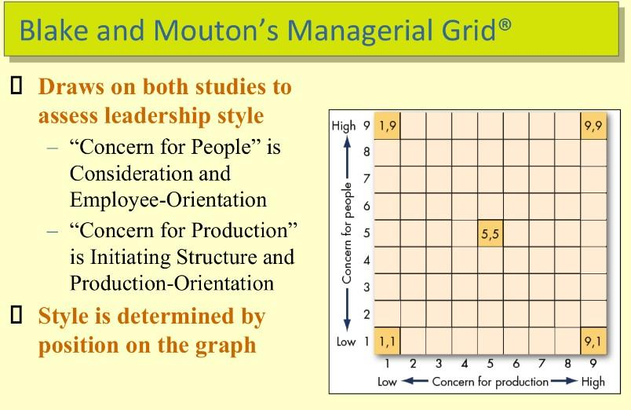

***Inspirational approaches to leadership:-***

***Charismatic leadership characteristics:***

* Have a vision.
* Are willing to take personal risks.
* Are sensitive to followers needs.
* Exhibit behaviors that are out of the ordinary.

***How charismatic leaders influence the followers:***

1. Attractive vision.
2. Communicate high performance expectations and confidence.
3. Conveys a new set of values.

***Conflict***

***What is Conflict?***

Conflict is a process that begins when one party perceives that another party has negatively affected something the first party cares about.

***Transitions in conflict thougths:***

1. ***Tradition view of conflict:***

* Conflict is harmful and Must be avoided.
* Time period (1930s-1940s).

1. ***Human Relations view of conflict:***

* Conflict is natural and inevitable.
* Time period (1940s-1970s).

1. ***Interactionist view of conflict:***

* Conflict is not only positive but also necessary.
* This is the current view.

***Types of interactionist conflict:***

1. Relationship conflict. (Dysfunctional)
2. Task Conflict. (Functional)
3. Process Conflict. (Functional)

***Conflict Process:-***

***Stage 1: Potential opposition or incompatibility:***

* Communication.
* Structure.
* Personal Variables.

***Stage 2: Cognition and Personalized:***

* Perceived Conflict
* Felt Conflict

***Stage 3: Intentions:***

* ***Dimensions:***

1. Competing.
2. Collaborating.
3. Compromising.
4. Avoiding.
5. Accommodating.

***Stage 4: Behavior:***

* Party’s behavior.
* Other’s behavior.

***Stage 5: Outcomes:***

* Increased group performance.
* Decreased group performance.

***Work Stress***

***What is work stress?***

Work stress is the harmful physical and emotional response that occur when the requirements of the job do not match the capabilities, resources, or needs of a worker.

***Types of stress:***

* Challenge Stressors.
* Hindrance Stressors.

***Potential sources of stress:***

1. ***Environmental factors:***

* Economical.
* Political.
* Technological.

1. ***Organizational factors:***

* Task Demands.
* Role Demands.
* Interpersonal Demands.

1. ***Personal factors:***

* Family and Personal.
* Economic Problems.
* Personality Problems.

***Individual Difference: (Sharpen/soften)***

* Job experience.
* Perception.
* Social support.

***Consequences of stress:***

1. ***Physiological:***

* Blood Pressure.
* Headaches.

1. ***Psychological:***

* Dissatisfaction.
* Anxiety.
* Depression.

1. ***Behavioral:***

* Smoking
* Sleeping Disorders.

***Managing Stress:***

1. ***Individual Approaches:***

* Time management.
* Physical exercise.
* Relaxation Training.
* Social Support.

1. ***Organizational Approaches:***

* Training.
* Increase employee involvement.
* Job Placement.

***Communication***

***What is communication?***

Communication is the transference and understanding of meaning.

***Functions of communication:***

* Control member.
* Foster motivation.
* Release for emotions.
* Provide info.

***Communication process:***

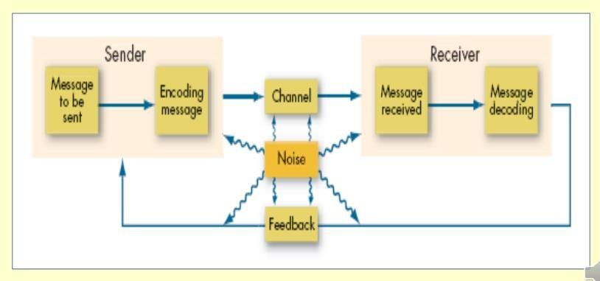

***What is channel?***

Channel is considered the medium that the message travel through.

***Channel types:***

* Formal Channels.
* Informal Channels.

***Directions of communication:***

* Downwards communication.
* Upwards communication.
* Horizontal communication.

***Interpersonal communication:***

* Oral communication.
* Written Communication.
* Non-Verbal Communication.

***Types of Non-Verbal Communication:***

* Body Movement.
* Intonations and Voice Emphasis.
* Facial expressions.
* Physical Distance between sender and receiver.

***Three common formal small-groups:***

* Chain
* Wheel
* All Channel

***Types of networks:***

| **Criteria** | **Chain** | **Wheel** | **All Channel** |
| --- | --- | --- | --- |
| **Speed** | Moderate | Fast | Fast |
| **Accuracy** | High | High | Moderate |
| **Emergence of a leader** | Moderate | High | None |
| **Member satisfaction** | Moderate | Low | High |

***Informal communication (The grapevine);***

1. ***Reducing rumors:***

* Announce time tables.
* Explain decisions.
* Emphasize the downside.
* Openly discuss.

1. ***Barriers for effective communication:***

* Filtering.
* Selective perception.
* Gender differences.
* Emotions.
* Language.
* Information overload.

***Culture***

***What is organizational culture?***

It is a common perception held by organization’s members.

* Dominant.
* Strong culture.
* Subcultures.

***Culture functions:***

1. Define the boundary between one organization and another
2. Convey sense of identity for its members.
3. Facilitates the generations of commitment.
4. Serves as control mechanism.

***How culture begins:***

1. Hiring.
2. Socializing.
3. Role model.

***How to keep culture alive:***

* Selection.
* Socialization.
* Top Management.

***Change Management***

***What is change management?***

Change management is a collective term for all approaches to prepare, support, and help individuals, teams, organization in making organized changes.

***Forces for change:***

1. Nature of the work force.
2. Technology.
3. Economic shocks.
4. Competition.
5. Social trends.
6. World Politics.

***What is planned change?***

Change is making things different and changing employee behavior.

***What are change agents?***

Person who acts as a catalyst and assume the responsibility for managing change activities.

***Forms of resistance to change:***

* Overt and immediate.
* Implicit and Deferred.

***Sources of resistace to change:***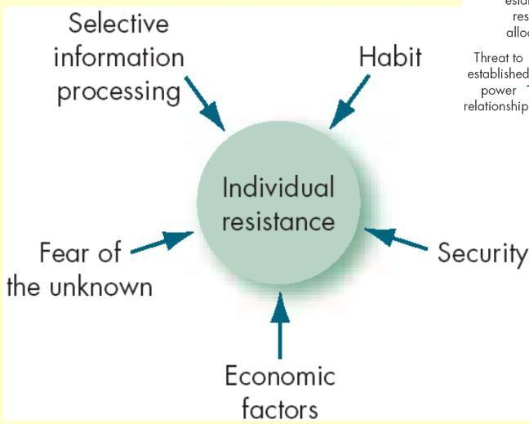

***Tactics for overcoming resistance to change:***

1. Education and communication.
2. Participation.
3. Building support and commitment.
4. Implementing change fairly.
5. Selecting people who accept change.
6. Coercion.