Mastering Embedded System Online Diploma

[www.learn-in-depth.com](http://www.learn-in-depth.com)

First Term (Final Project 2)

Student Management System

Eng. Mahmoud Ashraf

# Main Menu:

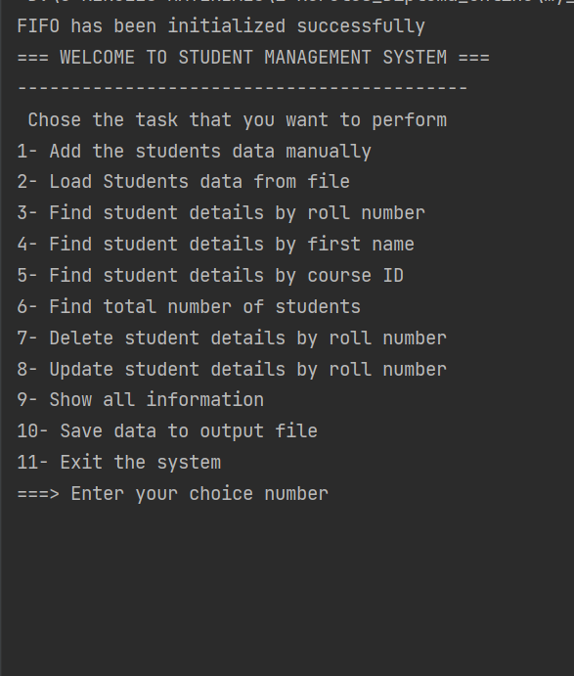

# Data File:

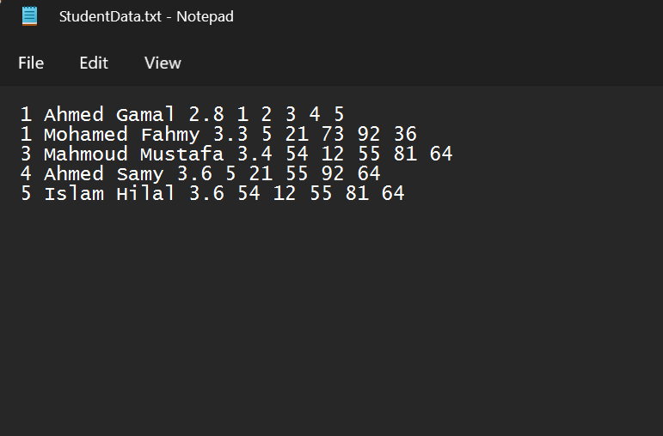

# Load Data File:

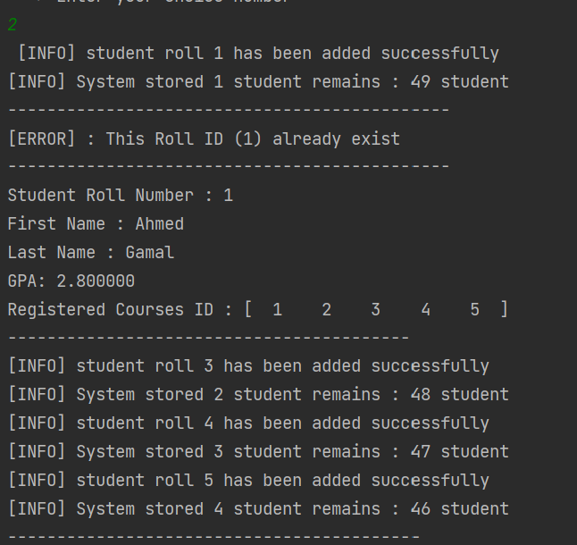

# Add Duplicated Roll ID:

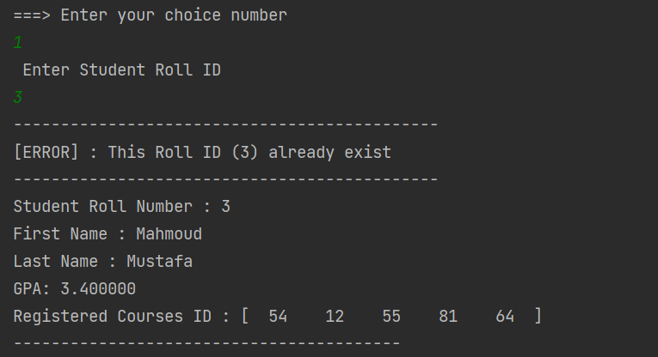

# Add Student Manually:

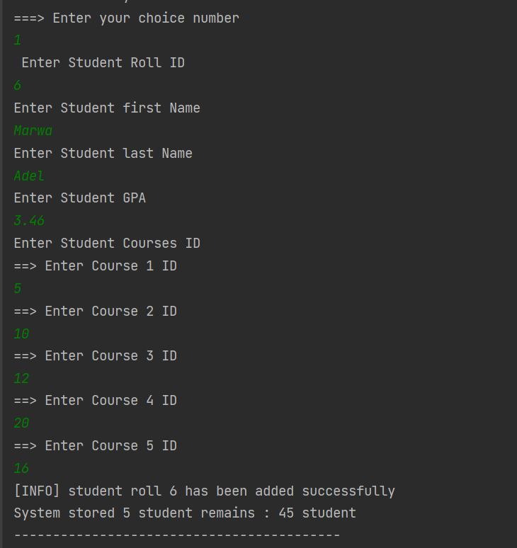

# Find Student by Roll ID:

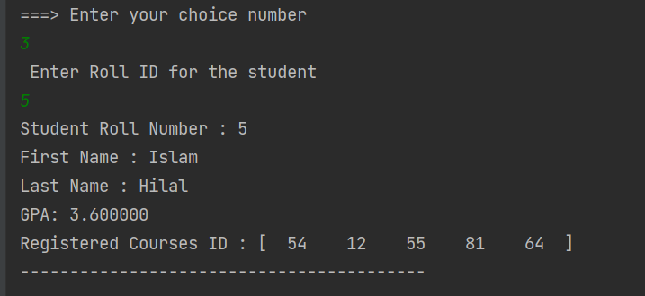

# Find Student by Name:

# Find Students Registered Course ID:

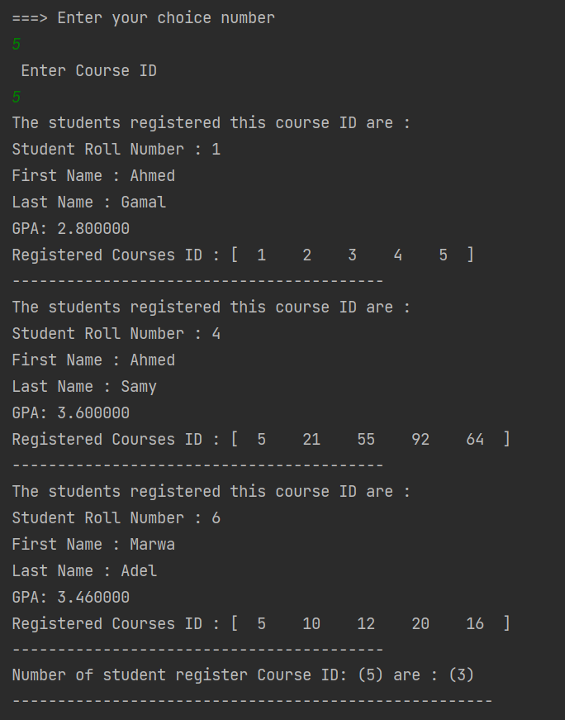

# Total Students Statistics:

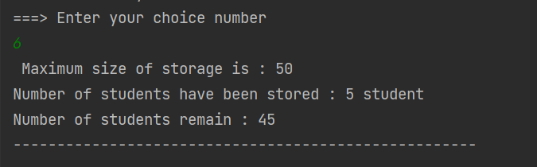

# Delete Student:

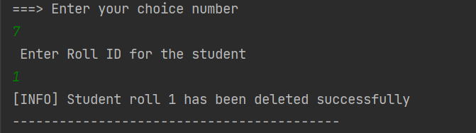

# Total Students After Deleting:

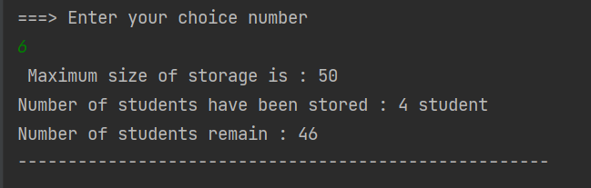

# Show All Students:

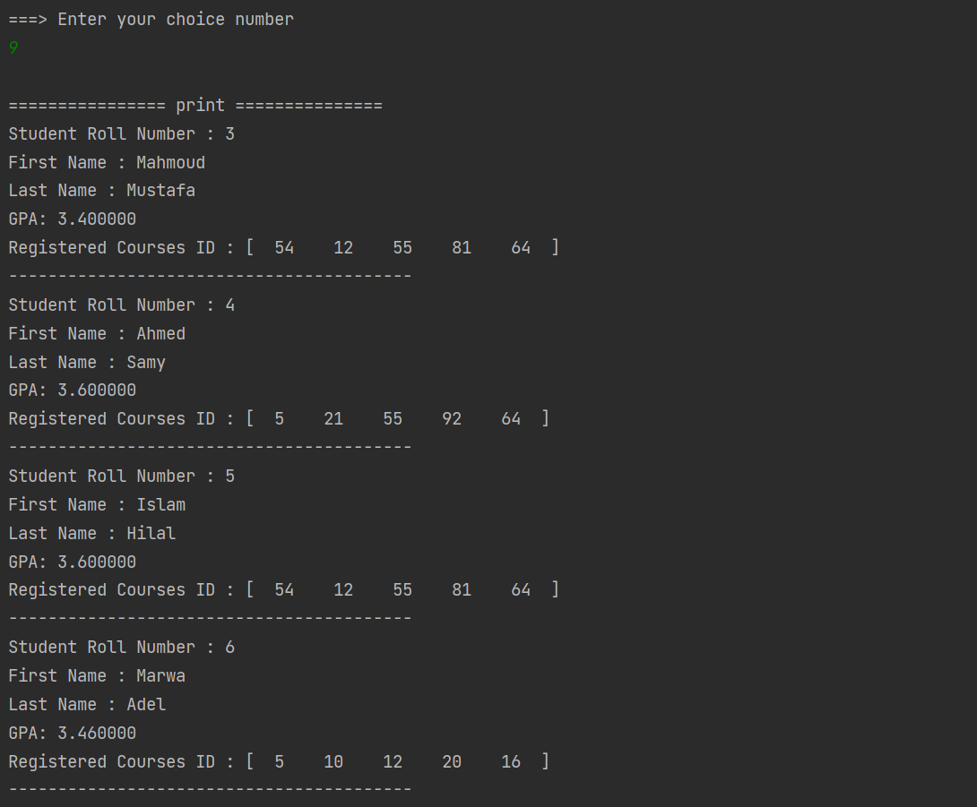

# Update Wrong ID:

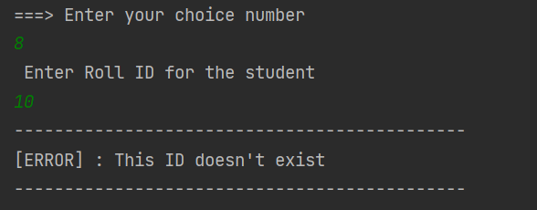

# Update Student:

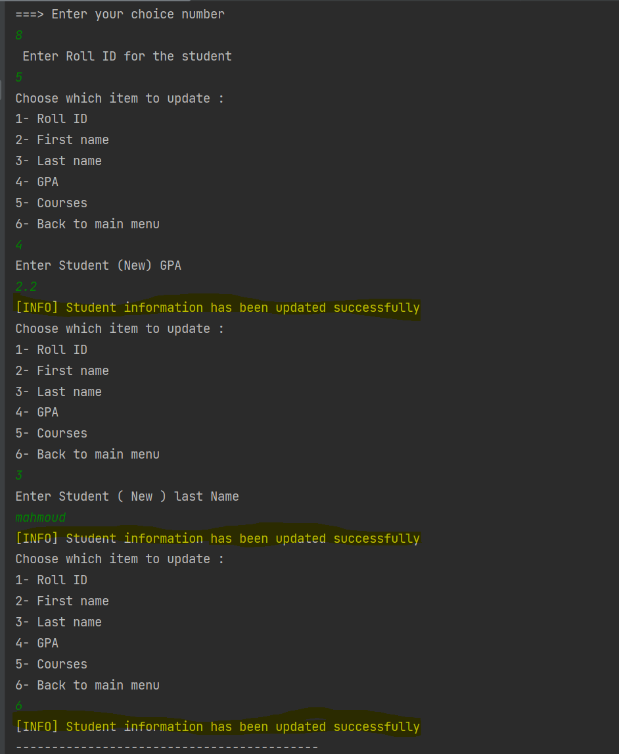

# Print Student After Updating:

# Save Changes to File:

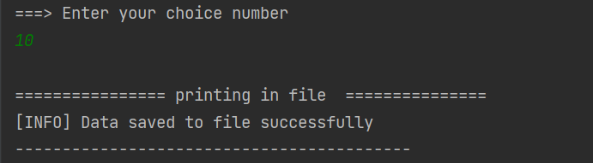

# Output File:

