Mastering Embedded System Online Diploma

[www.learn-in-depth.com](http://www.learn-in-depth.com)

First Term (Final Project 1)

Eng. Mahmoud Ashraf

# Case Study:

* The monitoring way to detect the pressure will be alarm with LEDs.
* Pressure limit is 20 bar. if exceed the limits alarm goes on while 60 second.

# Assumption:

• Controller set up and shutdown procedures are not modeled  
• Controller maintenance is not modeled   
• Pressure sensor used never fails   
• Alarm never fails   
• No power cut

# System Requirement Diagram:

# Space Exploration:

This project needs one ECU, which will be STM32.

# System Analysis:

**Main controller algorithm:** compare the value of sensor with threshold (20 bar) and take the action.

**Pressure sensor:** get reading of the sensor.

**Alarm controller:** control the alarm for 60 second when high pressure detected.

# Activity Diagram:

# Sequence Diagram:

# System Design:

## Block Diagram:

## State Machine Pressure Sensor:

## State Machine Main Controller:

## State Machine Alarm Controller:

Simulation:

# System Implementation:

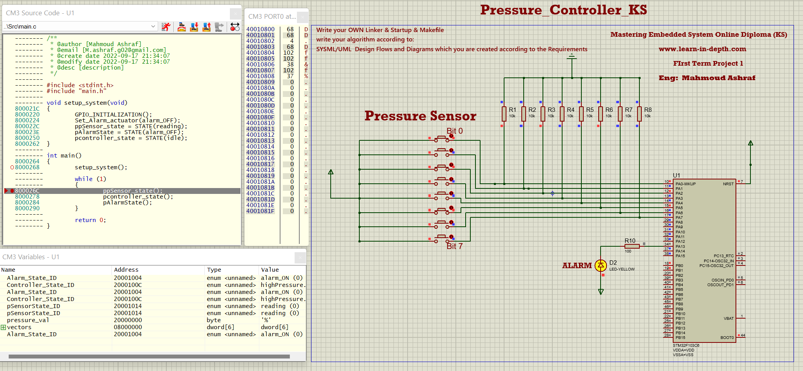

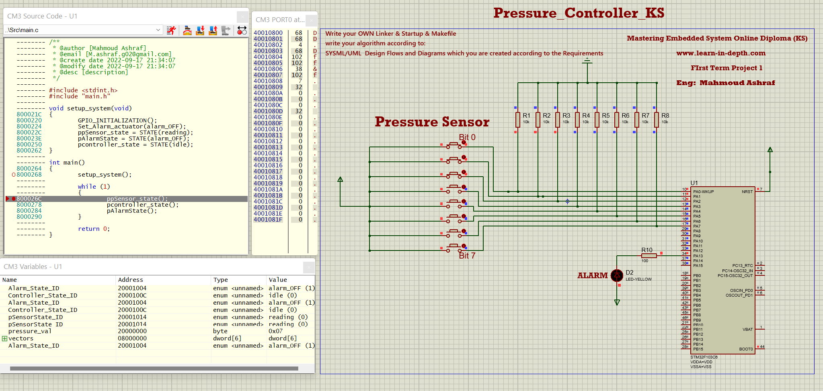

## Symbols:

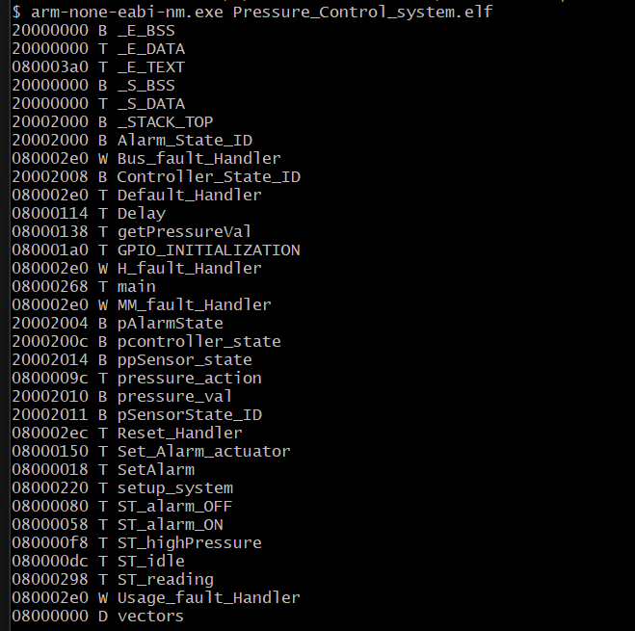

## Obj Dump:

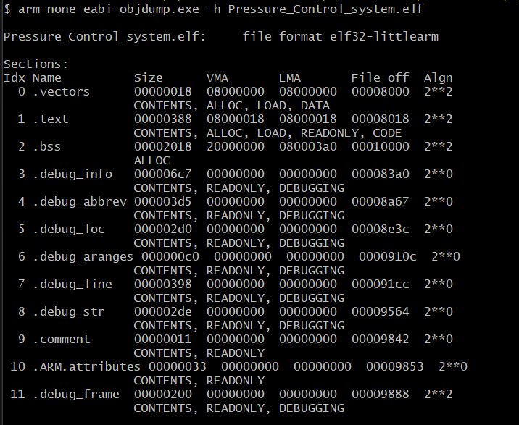

# Source Code:

* Main.c /Main.h
* Alarm.c/Alarm.h
* Sensor.c/Sensor.h
* Make File
* Startup.c
* LinkerScript.ld
* Map File

Uploaded to GitHub Repo :