# الاسم : محمود أحمد مرزوق

# رقم الجلوس: 845

# سكشن: 38

# Link for html-code: <https://github.com/Mahmoudmarzouk/HTML-PROJECT>

# Computer Architecture

**computer architecture** is a set of rules and methods that describe the functionality, organization, and implementation of [computer](https://en.wikipedia.org/wiki/Computer) systems.

Some definitions of architecture define it as describing the capabilities and programming model of a computer but not a particular implementation.[[1]](https://en.wikipedia.org/wiki/Computer_architecture#cite_note-1) In other definitions computer architecture involves [instruction set architecture](https://en.wikipedia.org/wiki/Instruction_set_architecture) design, [microarchitecture](https://en.wikipedia.org/wiki/Microarchitecture) design, [logic design](https://en.wikipedia.org/wiki/Logic_design), and [implementation](https://en.wikipedia.org/wiki/Implementation)

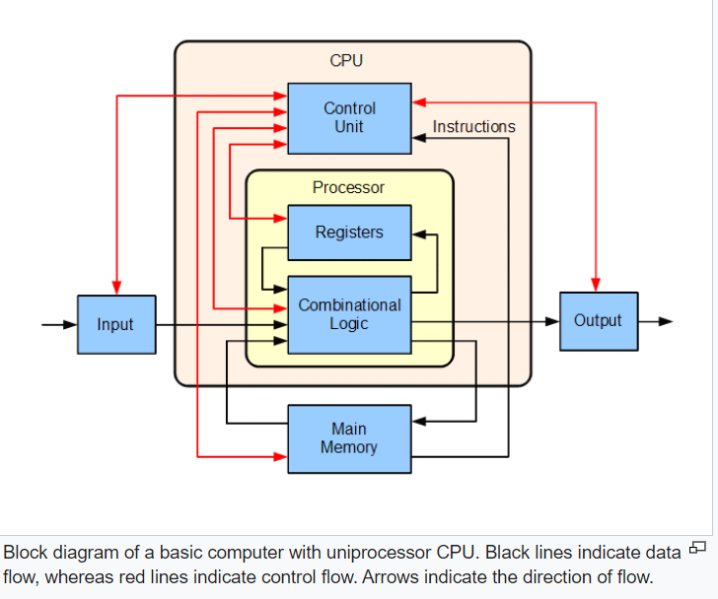

* [**Instruction set architecture**](https://en.wikipedia.org/wiki/Instruction_set_architecture) (ISA): defines the [machine code](https://en.wikipedia.org/wiki/Machine_code) that a [processor](https://en.wikipedia.org/wiki/Computer_processor) reads and acts upon as well as the [word size](https://en.wikipedia.org/wiki/Word_size), [memory address modes](https://en.wikipedia.org/wiki/Addressing_mode), [processor registers](https://en.wikipedia.org/wiki/Processor_register), and [data type](https://en.wikipedia.org/wiki/Data_type).
* [**Microarchitecture**](https://en.wikipedia.org/wiki/Microarchitecture): also known as "computer organization", this describes how a particular [processor](https://en.wikipedia.org/wiki/Central_processing_unit) will implement the ISA. The size of a computer's [CPU cache](https://en.wikipedia.org/wiki/CPU_cache) for instance, is an issue that generally has nothing to do with the ISA.
* [**Systems design**](https://en.wikipedia.org/wiki/Systems_design): includes all of the other hardware components within a computing system, such as data processing other than the CPU (e.g., [direct memory access](https://en.wikipedia.org/wiki/Direct_memory_access)), [virtualization](https://en.wikipedia.org/wiki/Virtualization), and [multiprocessing](https://en.wikipedia.org/wiki/Multiprocessing)

### Definition

Computer architecture is concerned with balancing the performance, efficiency, cost, and reliability of a computer system. The case of instruction set architecture can be used to illustrate the balance of these competing factors. More complex instruction sets enable programmers to write more space efficient programs, since a single instruction can encode some higher-level abstraction (such as the x86 Loop instruction).However, longer and more complex instructions take longer for the processor to decode and can be more costly to implement effectively. The increased complexity from a large instruction set also creates more room for unreliability when instructions interact in unexpected ways.

### Implementation

Once an instruction set and micro-architecture have been designed, a practical machine must be developed. This design process is called the *implementation*. Implementation is usually not considered architectural design, but rather hardware [design engineering](https://en.wikipedia.org/wiki/Engineering_design_process). Implementation can be further broken down into several steps:

* **Logic implementation** designs the circuits required at a [logic-gate](https://en.wikipedia.org/wiki/Logic_gate) level.
* **Circuit implementation** does [transistor](https://en.wikipedia.org/wiki/Transistor)-level designs of basic elements (e.g., gates, [multiplexers](https://en.wikipedia.org/wiki/Multiplexer), [latches](https://en.wikipedia.org/wiki/Flip-flop_(electronics))) as well as of some larger blocks ([ALUs](https://en.wikipedia.org/wiki/Arithmetic_logic_unit), caches etc.) that may be implemented at the logic-gate level, or even at the physical level if the design calls for it.
* **Physical implementation** draws physical circuits. The different circuit components are placed in a chip [floorplan](https://en.wikipedia.org/wiki/Floorplan_(microelectronics)" \o "Floorplan (microelectronics)) or on a board and the wires connecting them are created.
* **Design validation** tests the computer as a whole to see if it works in all situations and all timings. Once the design validation process starts, the design at the logic level are tested using logic emulators. However, this is usually too slow to run a realistic test. So, after making corrections based on the first test, prototypes are constructed using Field-Programmable Gate-Arrays ([FPGAs](https://en.wikipedia.org/wiki/FPGA)). Most hobby projects stop at this stage. The final step is to test prototype integrated circuits, which may require several redesigns.