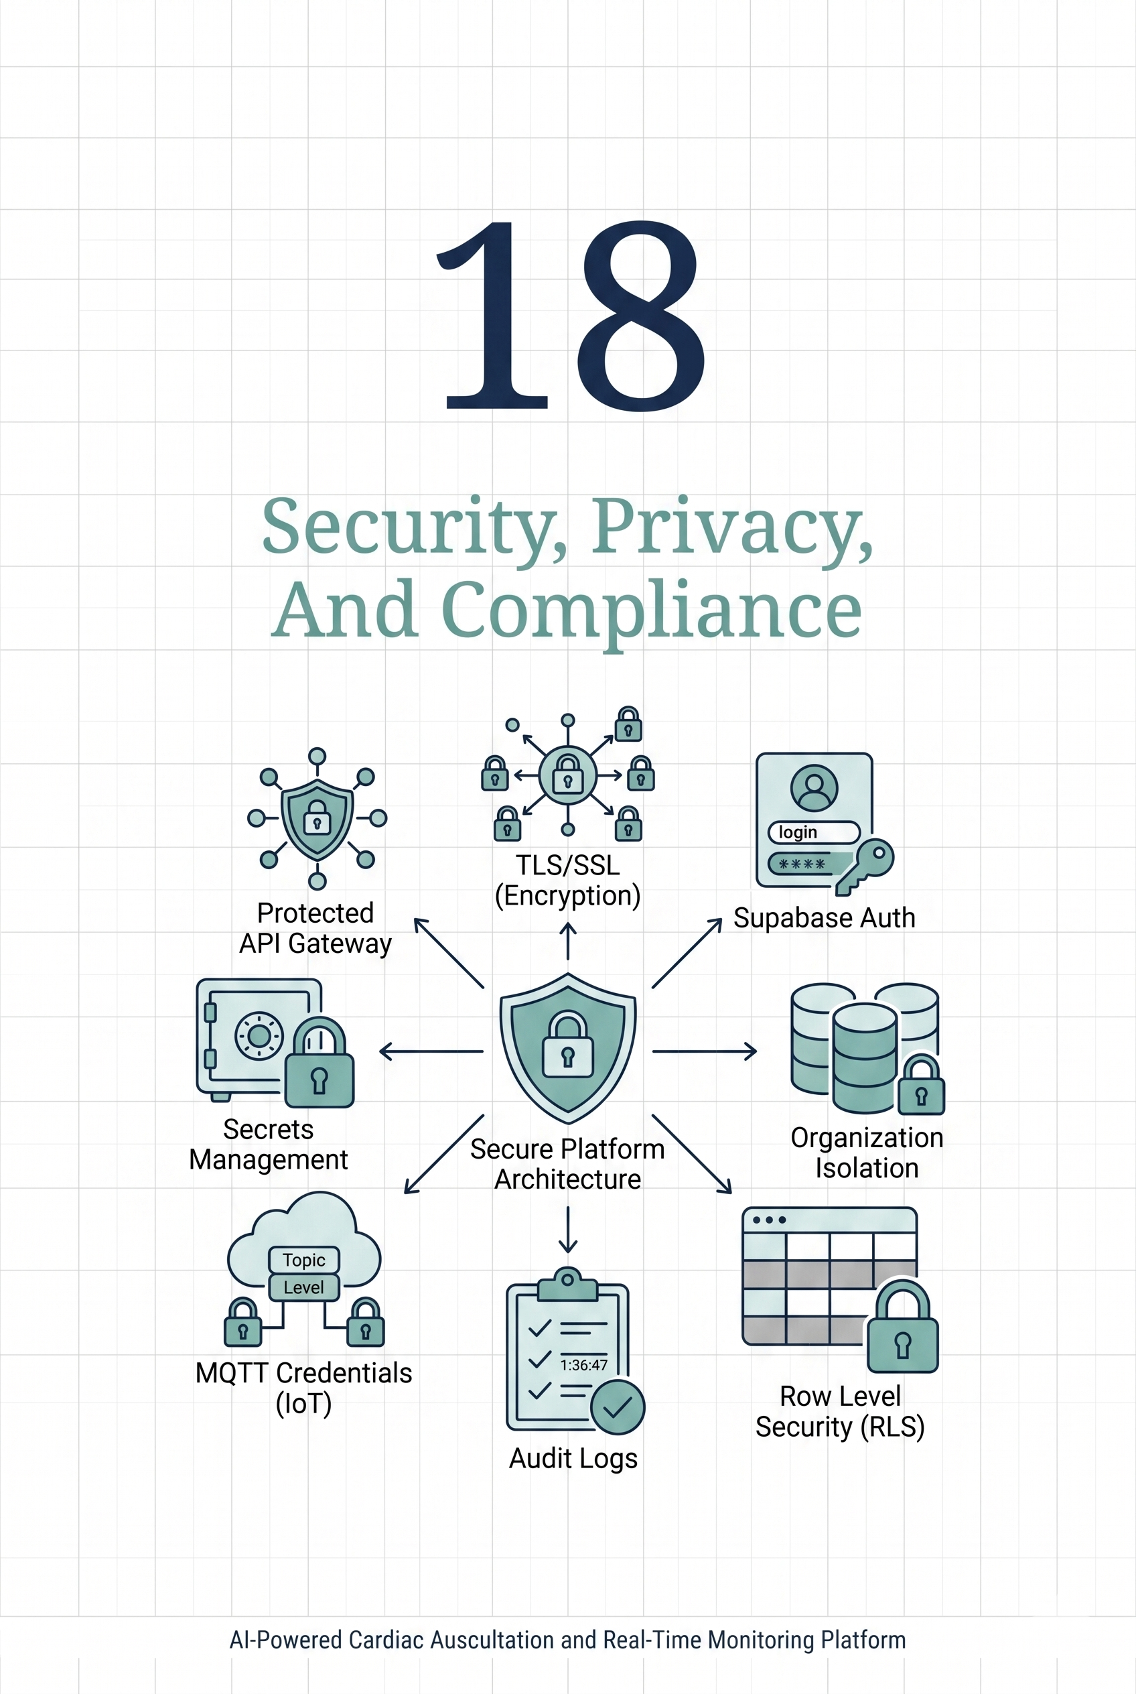

Chapter (18): Security, Privacy, And Compliance
18.1 Security Objective
The security objective of AscultiCor is: to protect patient-related data, isolate each organization, secure connected devices, protect privileged service credentials, and keep an audit trail of sensitive actions. Because the platform handles ECG recordings, PCG recordings, patient records, clinical notes, AI predictions, and generated reports, the system must be designed with privacy and operational safety from the beginning.
In this project, security is applied at several layers. Supabase Auth verifies user identity. The database schema uses organization-scoped Row Level Security to prevent one organization from accessing another organization's data. Backend services use server-side service-role credentials only where privileged access is required. Devices use a bootstrap process and MQTT credentials instead of relying only on hardcoded network settings. Cloud deployment uses NGINX, TLS, environment-based configuration, internal service tokens, and private container networking to reduce public exposure.
The platform is: a graduation project and decision-support prototype, not a certified medical product. Therefore, this chapter does not claim full medical regulatory compliance. Instead, it documents the controls implemented during the project and the additional controls required before production clinical use.
18.2 Authentication and Authorization
User authentication is handled through Supabase Auth. A user signs in through the web dashboard, and Supabase issues an authenticated session that the frontend can use when reading or writing data. The application stores additional user metadata in the profiles table, including the user's organization and role.
The platform follows an organization-based authorization model. Each user belongs to an organization, and most data records include an org_id field. This design allows the same system to support multiple clinics, labs, or project groups while keeping their data separated. The major role types used by the project are admin, clinician, operator, and readonly. Admin users can manage organization-level resources, devices, and users. Clinicians and operators can work with patients, sessions, and reports according to their permissions. Readonly users can inspect information but should not modify clinical or device records.
Route protection is handled by combining the Supabase session, frontend checks, backend API validation, and database policies. Even if a user bypasses a dashboard page, the database policies remain the final protection layer. This is important because client-side checks improve user experience, but they should not be treated as the only security boundary.
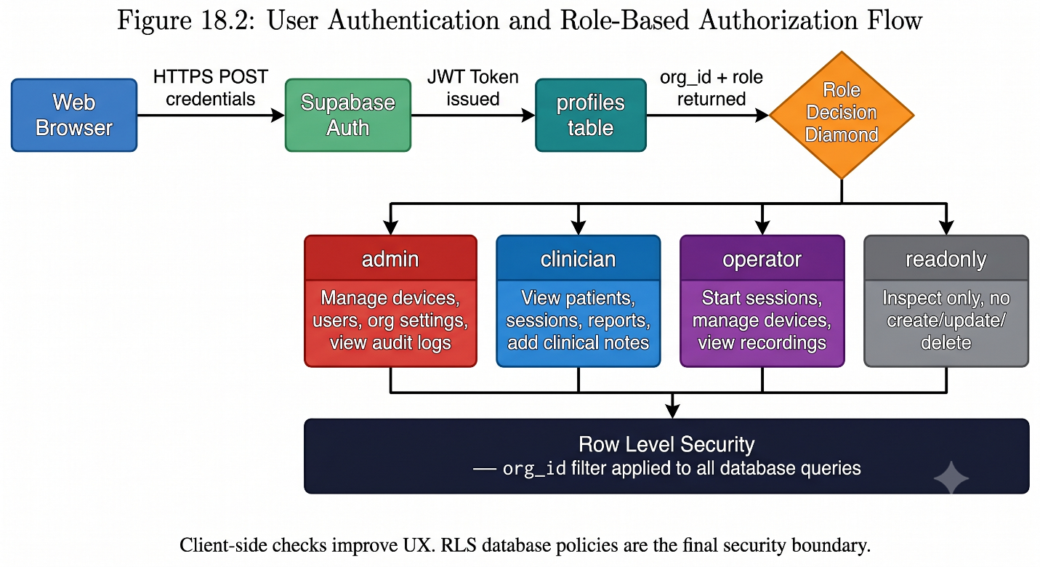

18.3 Row Level Security
Row Level Security, or RLS, is the main database isolation control in AscultiCor. The Supabase database stores shared tables such as organizations, profiles, devices, patients, sessions, recordings, predictions, live metrics, LLM reports, alerts, notes, and audit logs. Since these tables can contain records from different organizations, each query must be restricted to the current user's organization.
The database migrations enable RLS and define policies that compare the row's org_id with the organization of the authenticated user. For example, a user can view sessions, patients, devices, predictions, and reports only when those rows belong to the same organization. Admin-only policies are used for sensitive actions such as managing organization settings, deleting records, or viewing audit logs.
Some actions are performed by backend services rather than by a browser user. For example, the inference service inserts recordings, predictions, live metrics, and audit events after receiving MQTT data from a device. These operations use Supabase service-role access because they are server-side system actions. The service-role key bypasses RLS, so it must never be exposed to the browser, firmware, public repositories, screenshots, or client-side code. In the deployment, service-role credentials are stored only as server environment variables for backend containers and automation services that require them.

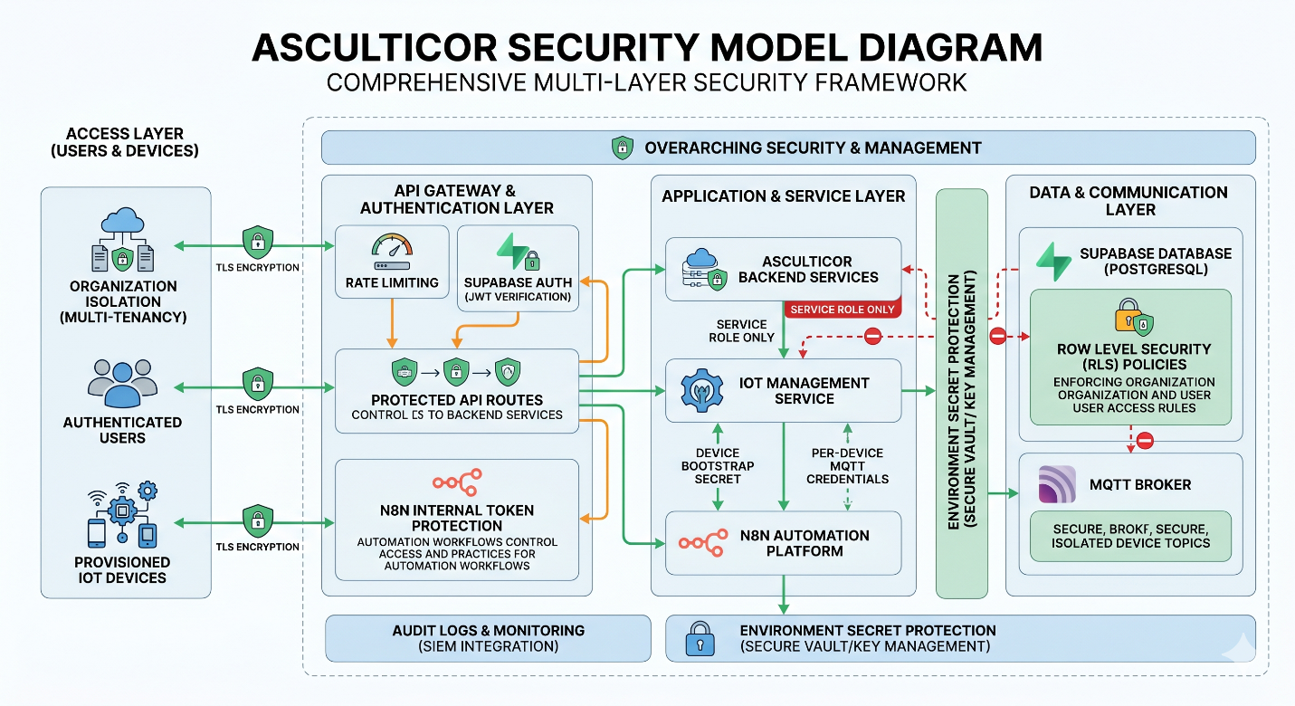
Figure 18.1 shows how Supabase Auth, user profiles, organization membership, Row Level Security, protected API routes, device bootstrap credentials, internal service tokens, TLS, and audit logs work together to protect the platform.
18.4 Device Security
- Device security is important because ESP32 devices are the entry point for physiological signals. The final device design should avoid permanent shared credentials whenever possible. AscultiCor uses a bootstrap flow in which an administrator creates a device record, assigns it to an organization, and stores a hashed device secret. The technician configures the ESP32 with the device ID, device secret, WiFi settings, and bootstrap endpoint.

- When the device calls the bootstrap API, the backend validates the provided secret against the stored hash. If the credentials are valid, the backend returns the organization ID and MQTT connection details. The implementation supports per-device MQTT credentials, which is safer than using one shared broker password for every device. The bootstrap request is also written to the audit log so that device provisioning activity can be reviewed later.
- The Mosquitto broker uses authentication and an ACL file. A runtime synchronization script reads device MQTT credentials from Supabase and regenerates the Mosquitto password and ACL configuration. The ACL design restricts each device to its own topic namespace, such as its organization and device path. This reduces the impact of a compromised device because it should not be able to publish into another device's topic path.

- For local development, MQTT may be bound to 127.0.0.1 or a trusted LAN address. For hardened cloud deployment, the broker should not be opened directly to the public internet without additional protection. Safer options include MQTT over TLS, a VPN or private tunnel, or a managed IoT broker. Device credential rotation should also be planned so that a lost or compromised device can be disabled without changing credentials for all devices.

- In Hostinger VPS deployment, this device boundary is especially important. The dashboard can be made public at https://srv1621744.hstgr.cloud, but the MQTT broker should remain private during the first rollout by keeping MQTT_WS_BIND_ADDRESS=127.0.0.1. This means the initial cloud deployment is ready for dashboard access, automation, and backend verification, while direct remote ESP32 publishing requires a later MQTT hardening step.

18.5 API And Application Security
The application security model uses several controls:
- First, public browser traffic is routed through NGINX over HTTPS. NGINX forwards requests to the frontend, MQTT WebSocket endpoint, and inference API through the internal Docker network. This keeps direct container ports away from the public internet. On the Hostinger VPS, the public hostname is srv1621744.hstgr.cloud. The intended public surface is HTTPS on port 443 for the dashboard and, if needed, HTTPS on port 8443 for n8n. The internal service ports remain bound to loopback or Docker networking. This prevents users from directly reaching the Next.js runtime port, FastAPI runtime port, MQTT broker port, or n8n runtime port.

- Second, backend services use environment variables for secrets and configuration. Important variables include the Supabase URL, Supabase anon key, service-role key, MQTT credentials, internal API token, inference internal token, allowed origins, trusted hosts, and TLS certificate paths. Real secret values must not be documented in the book, committed to source control, or shared in screenshots.

- Third, internal operational endpoints are protected with shared internal tokens. The frontend and n8n workflows use INTERNAL_API_TOKEN for protected application tasks such as report queue processing and workflow actions. The inference service uses INFERENCE_INTERNAL_TOKEN for protected operational endpoints such as configuration and metrics. This prevents casual public access to sensitive operational information.

- Fourth, the inference service includes security middleware features. It supports CORS restrictions through ALLOWED_ORIGINS, trusted host validation through TRUSTED_HOSTS, security headers when enabled, and rate limiting for API endpoints. Security headers include protections such as content type restrictions, frame denial, HSTS, referrer policy, permissions policy, and a configurable Content Security Policy.

- Finally, input validation is applied at API boundaries. Device bootstrap requires both device_id and device_secret. Session, device, report, and automation routes validate the required fields before performing database updates. This is especially important because the system connects many components: browser users, ESP32 devices, MQTT messages, automation workflows, and external LLM providers.
18.6 Privacy And Data Retention
AscultiCor stores health-related data, including patient metadata, ECG and PCG recordings, live signal metrics, AI predictions, notes, alerts, and generated reports. These records should be treated as sensitive even in a prototype environment.
The project uses several privacy controls. Supabase Storage should store recordings in a private bucket. Storage policies should allow authenticated users to view recordings only inside their organization, while uploads from backend inference services use the service role. Database RLS prevents cross-organization access to patient and session records. Audit logs record events such as device creation, device update, session start, note addition, deletion, bootstrap requests, and other sensitive operations.
For demonstrations and academic testing, de-identification should be used whenever possible. Patient names, emails, and identifiers can be replaced with synthetic values. Real clinical data should not be uploaded unless the team has explicit permission, a clear retention policy, and approval from the responsible institution. Generated reports should also be reviewed as decision-support text rather than treated as final clinical diagnosis.
Data retention should be defined before production use. The project should specify how long raw recordings, predictions, audit logs, and generated reports are kept. Shorter retention may be appropriate for test data, while longer retention may be needed for validated research records. Backups must follow the same privacy rules as the primary database, because a backup can contain the same sensitive information.
18.7 Incident Response
- Incident response defines how the team reacts when security controls fail or suspicious activity occurs. The most likely incidents for this project are leaked environment variables, exposed service-role keys, compromised device credentials, suspicious audit log events, accidental public exposure of MQTT, or accidental sharing of patient data.

- If a Supabase service-role key or internal API token is leaked, the first response should be to revoke or rotate the affected key immediately. After rotation, the .env file on the VM and any deployment secrets must be updated, containers must be restarted, and the audit logs should be reviewed for unusual access. Any screenshots, chat messages, or repository commits containing the secret should be removed or invalidated.

- If a device is compromised, the device record should be disabled or its credentials rotated. The Mosquitto credential synchronization process should then reload the broker configuration, so the compromised credentials no longer work. The team should review MQTT logs, device telemetry, session records, and audit logs to identify whether invalid data was sent.

- If patient data is exposed, the team should identify the affected records, remove public access, preserve logs for investigation, and notify the responsible supervisor or institution. For a production medical system, this process would require formal privacy and compliance workflow. For the graduation prototype, documenting these steps demonstrates that the team understands the operational responsibility of handling sensitive health information.
Table 18.1: Security Control Checklist
Area | Checklist Item | Status
TLS | Use valid TLS certificates for all public domains | Required
Public Exposure | Keep frontend, inference, MQTT, and n8n container ports private | Required
MQTT | Use MQTT over TLS, VPN, or managed broker for remote devices | Required before public IoT
Supabase | Confirm RLS is enabled on all sensitive tables | Required
Storage | Use private buckets and organization-scoped storage policies | Required
Service Role Key | Keep service-role key server-side only; rotate if exposed | Critical
Internal APIs | Protect operational endpoints with strong internal tokens | Required
n8n | Enable basic auth, strong encryption key, protect workflow credentials | Required
Environment | Store secrets outside source control; never in screenshots or commits | Critical
CORS | Restrict allowed origins to trusted domains only | Required
Trusted Hosts | Restrict accepted hostnames to production domains and local maintenance | Required
Rate Limits | Enable and tune API rate limits | Recommended
Backups | Enable database, storage, n8n, Mosquitto, and model artifact backups | Required
Restore Testing | Test at least one restore path before relying on backups | Required
Monitoring | Check health endpoints, Docker logs, workflow logs, device last-seen | Required
Incident Response | Document key rotation, device disabling, audit review procedures | Required
Clinical Safety | Keep medical disclaimer visible; require clinician review of AI outputs | Critical
Chapter (19): Deployment, Docker, NGINX, Cloud VM, And Operations
19.1 DevOps Objective
The DevOps objective is to make AscultiCor reproducible, deployable, secure, observable, and maintainable. The project contains multiple services written with different technologies: a Next.js frontend, a FastAPI inference service, a Mosquitto MQTT broker, Supabase backend services, optional n8n automation, ML model artifacts, and ESP32 firmware. Without a structured deployment layer, these components would be difficult to run consistently across team laptops, demo machines, and the cloud VM.
Docker Compose is used to package and run the local and cloud services. NGINX acts as the secure public entry point. Environment variables separate configuration from source code. Health endpoints, service logs, and operational checklists help the team verify that the system is running correctly. The final result is a deployment design that supports local development, cloud staging, and future production hardening.
19.2 Local Development Environment
The local development environment is designed to let team members run the complete platform with minimal manual setup. A developer copies the environment template, fills in the required Supabase and MQTT values, applies the database migrations, and starts the services with Docker Compose.
The core local services are the Mosquitto broker, the FastAPI inference service, the Next.js frontend, and NGINX. The frontend provides the dashboard and API routes. The inference service subscribes to MQTT topics, buffers ECG and PCG samples, runs ML inference, and writes results to Supabase. Mosquitto routes device and simulator messages. NGINX provides a reverse proxy layer and can also expose MQTT over Web Sockets for browser or device communication patterns.
Supabase remains a managed external service in the recommended setup. It provides authentication, PostgreSQL database tables, RLS policies, private storage, and edge functions. This reduces the operational burden on the team because the VM does not have to run a separate PostgreSQL database or object storage service.
Local testing should verify that containers start successfully, the Frontend can reach Supabase, the inference service can connect to MQTT , models are loaded, and test data can flow from device or simulator to dashboard. The main local command is:
docker compose up --build -d
Recommended local quality checks include frontend linting, frontend type checking, frontend production build, and Python compile checks for the inference service.
19.3 Docker Compose Architecture
Docker Compose defines the runtime architecture of the platform. The base Compose file starts the main application containers and connects them to a shared Docker bridge network named asculticor-network. Containers communicate with each other through service names such as frontend, inference, and mosquitto.
The base services are:
Service | Technology | Internal Port | Network Exposure | Persistent Volume
Frontend | Next.js 14 | 3000 | Private (NGINX proxy) | None
Inference | FastAPI/Python | 8000 | Private (NGINX proxy) | models/ (read-only)
Mosquitto | Eclipse Mosquitto MQTT | 1883, 9001 | Private (loopback or Docker) | mosquitto_data, mosquitto_logs
NGINX | NGINX 1.x | 80, 443 | Public (ports 80, 443) | nginx/certs/ (TLS certs)
n8n | n8n Workflow | 5678 | Private or port 8443 (optional) | n8n_data
Supabase | Managed Cloud | N/A | External HTTPS (managed) | Managed by Supabase

The inference container mounts the models directory read-only so that trained model artifacts can be deployed without changing application code. Mosquitto uses persistent volumes for broker data and logs. The optional n8n cloud profile uses a persistent n8n_data volume for workflow and credential storage.

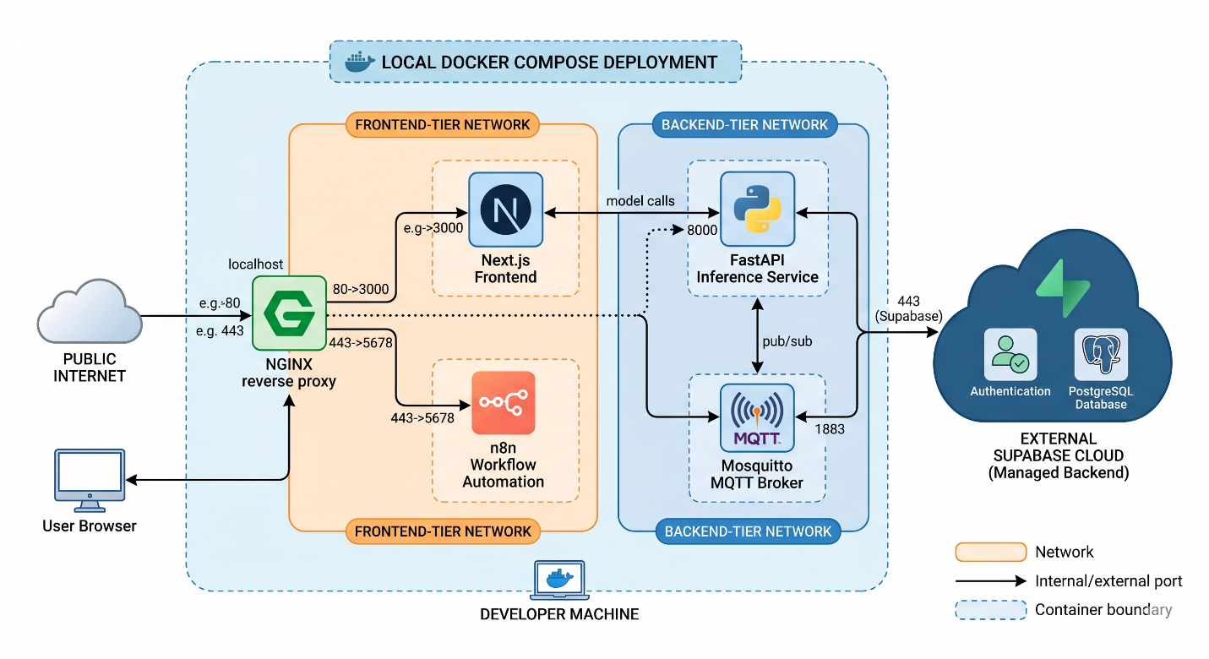
Figure 19.1 shows the local Docker Compose deployment, including the Next.js frontend, FastAPI inference service, Mosquitto MQTT broker, NGINX reverse proxy, optional n8n automation container, shared Docker network, exposed ports, persistent volumes, and managed Supabase connection.
19.4 Cloud VM Deployment
The cloud deployment uses one Hostinger VPS running Linux and Docker Compose. The selected VPS is identified by the public IP address 187.127.224.4 and the Hostinger-provided hostname srv1621744.hstgr.cloud. This hostname is important because it gives the team an immediately usable public address even before buying or configuring a custom domain.
The deployment keeps the same service architecture used in local development. The Next.js frontend, FastAPI inference service, Mosquitto broker, NGINX reverse proxy, and optional n8n automation service run as Docker containers on the VM. Supabase remains a managed cloud service outside the VM and provides authentication, PostgreSQL database tables, Row Level Security, storage, and edge functions.
Cloud architecture follows a simple security rule: NGINX is the main public entry point. Public users access the dashboard through HTTPS at https://srv1621744.hstgr.cloud. NGINX forwards web requests to the frontend container and can proxy selected internal routes to other services. The frontend container listens on port 3000 inside the deployment, the inference container listens on port 8000, Mosquitto listens on 1883 for MQTT and 9001 for MQTT over WebSockets, and n8n listens on 5678. These service ports should remain private to the VM or Docker network unless the team intentionally exposes them.
For the hostname-only Hostinger deployment, n8n has two possible access patterns. The safer option is to bind n8n to 127.0.0.1:5678 and access it through an SSH tunnel during administration. The more convenient team-demo option is to expose n8n through NGINX on the same hostname but a separate HTTPS port, https://srv1621744.hstgr.cloud:8443. In both cases, n8n requires basic authentication and an encryption key so that workflow credentials are not stored as plain text.
TLS certificates are mounted into the NGINX container from NGINX/certs. In production-like deployment, certificates should be generated through a trusted certificate authority such as Let's Encrypt. The NGINX template supports TLS for the main application domain and also supports n8n either through a separate subdomain or a separate HTTPS port when a subdomain is not available.
The cloud Compose overlay, docker-compose.cloud.yml, adds cloud-specific behavior. It mounts real certificate files, includes the n8n service, configures n8n basic authentication, sets the n8n encryption key, and connects n8n to the same Docker network as the application. From inside the network, n8n can call http://frontend:3000, http://inference:8000, and mosquitto:1883 without exposing those services publicly.

19.4.1 Hostinger VPS Target
The target Hostinger deployment values are:
Item | Value
VPS Provider | Hostinger
Public IP | 187.127.224.4
Hostname | srv1621744.hstgr.cloud
Main Application URL | https://srv1621744.hstgr.cloud
Optional n8n URL | https://srv1621744.hstgr.cloud:8443
Main Deployment Directory | /opt/asculticor
Main Compose Files | docker-compose.yml + docker-compose.cloud.yml
Public Entrypoint | NGINX (TLS termination)
Managed Backend | Supabase Cloud (Auth, DB, Storage)
Recommended OS | Ubuntu or Debian Linux

The recommended VM operating system is Ubuntu or Debian. Docker Engine, the Docker Compose plugin, Git, UFW, Certbot, and basic networking tools are installed on the VM before deployment.

19.4.2 Firewall And Public Port Plan
The firewall should expose only the ports required for administration and public access:
Port | Protocol | Purpose | Public Exposure Decision
22 | TCP | SSH administration | Open only for trusted administrators
80 | TCP | HTTP + certificate challenge | Open for NGINX and Certbot
443 | TCP | HTTPS application | Open — main dashboard public access
8443 | TCP | Optional HTTPS n8n access | Open only if n8n is intentionally public for the team
3000 | TCP | Next.js frontend container | Keep private (internal Docker only)
8000 | TCP | FastAPI inference container | Keep private (internal Docker only)
1883 | TCP | MQTT TCP broker | Keep private (VPN/TLS required for remote devices)
9001 | TCP | MQTT WebSocket listener | Keep private unless intentionally proxied
5678 | TCP | n8n container | Keep private (SSH tunnel or NGINX port 8443)

This port plan allows the team to demonstrate the cloud dashboard without exposing every internal service. It also clearly separates the current staging deployment from a fully hardened IoT production deployment.
19.4.3 Hostinger Environment Configuration
The cloud deployment uses .env.cloud.example as the template for the VM .env file. The actual .env file must stay on the server and must not be committed to Git. The following values are safe to document because they are hostnames or non-secret deployment settings:
APP_DOMAIN=srv1621744.hstgr.cloud
DEVICE_BOOTSTRAP_PUBLIC_BASE_URL=https://srv1621744.hstgr.cloud
DEVICE_BOOTSTRAP_MQTT _HOST=srv1621744.hstgr.cloud

NGINX_SERVER_NAME=srv1621744.hstgr.cloud
ALLOWED_ORIGINS=https://srv1621744.hstgr.cloud
TRUSTED_HOSTS=srv1621744.hstgr.cloud,localhost,127.0.0.1
CORS_ORIGIN=https://srv1621744.hstgr.cloud

FRONTEND_BIND_ADDRESS=127.0.0.1
INFERENCE_BIND_ADDRESS=127.0.0.1
MQTT _BIND_ADDRESS=127.0.0.1
MQTT _WS_BIND_ADDRESS=127.0.0.1

N8N_BIND_ADDRESS=127.0.0.1
N8N_DOMAIN=srv1621744.hstgr.cloud
N8N_PROTOCOL=https
N8N_EDITOR_BASE_URL=https://srv1621744.hstgr.cloud:8443
N8N_WEBHOOK_URL=https://srv1621744.hstgr.cloud:8443/
NGINX_N8N_ALT_SERVER_NAME=srv1621744.hstgr.cloud
NGINX_N8N_ALT_HTTPS_BIND_ADDRESS=0.0.0.0
NGINX_N8N_ALT_HTTPS_PORT=8443

The same file also contains secrets such as SUPABASE_SERVICE_ROLE_KEY, MQTT _PASSWORD, MQTT _DEVICE_PASSWORD_PEPPER, INTERNAL_API_TOKEN, INFERENCE_INTERNAL_TOKEN, N8N_PASSWORD, N8N_ENCRYPTION_KEY, and optional LLM provider keys. Those values must be filled on the VPS but not shown in the graduation book.

19.4.4 Rollout Procedure
The rollout procedure starts by connecting to the VPS:
ssh root@187.127.224.4

The server is updated and prepared with Docker, Git, UFW, and Certbot. The repository is then cloned under /opt:
cd /opt
git clone https://github.com/Mahmoudmetwall2y/Graduation-project.git asculticor
cd asculticor

The environment file is created from the cloud template:
cp .env.cloud.example .env
nano .env

After filling the non-secret Hostinger values and the required private secrets, TLS certificates are generated for the Hostinger hostname:
certbot certonly --standalone -d srv1621744.hstgr.cloud
mkdir -p NGINX/certs
cp /etc/letsencrypt/live/srv1621744.hstgr.cloud/fullchain.pem NGINX/certs/fullchain.pem
cp /etc/letsencrypt/live/srv1621744.hstgr.cloud/privkey.pem NGINX/certs/privkey.pem

Supabase Auth must also be configured for the cloud hostname:
Supabase Setting | Hostinger Value
Site URL | https://srv1621744.hstgr.cloud
Redirect URL | https://srv1621744.hstgr.cloud/auth/callback
Edge Function CORS Origin | https://srv1621744.hstgr.cloud

The recommended cloud deployment command is:
docker compose --env-file .env -f docker-compose.yml -f docker-compose.cloud.yml up -d --build

Before considering the deployment successful, the rendered Compose configuration should be checked:
docker compose --env-file .env -f docker-compose.yml -f docker-compose.cloud.yml config > /dev/null

19.4.5 Device Connectivity Boundary
The Hostinger deployment is suitable for remote dashboard access, teammate testing, n8n automation, report generation, and service-to-service communication on the VM. However, the safe first rollout does not treat public MQTT as production ready. With MQTT _BIND_ADDRESS=127.0.0.1, the MQTT broker is not reachable directly from remote ESP32 devices over the public internet.
If physical ESP32 devices must publish directly to the Hostinger VPS from outside the local network, the team should first add MQTT over TLS, a VPN or private tunnel, or a managed IoT broker. Only after that hardening should ports such as 1883 or 9001 be opened beyond the VM. This boundary is important because ECG and PCG streams are sensitive and because MQTT credentials should not be exposed through an unencrypted public broker.

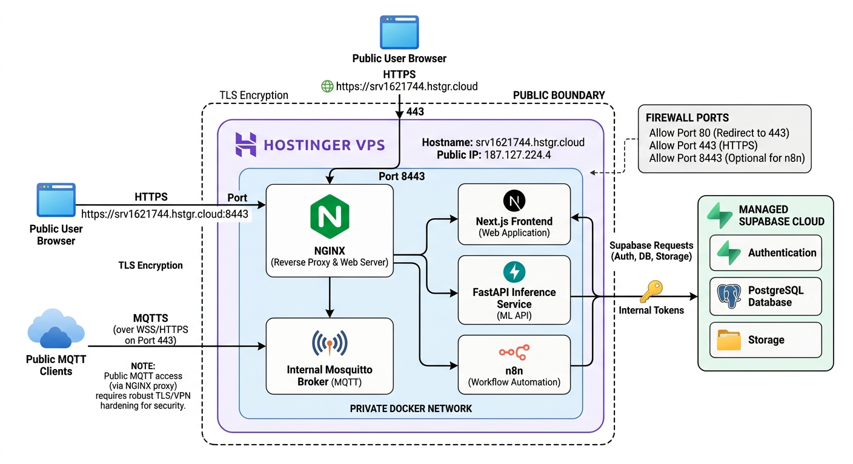
Figure 19.2 shows the cloud VM deployment, where public HTTPS traffic reaches NGINX, NGINX routes requests to private Docker services, n8n runs inside the deployment network, Mosquitto handles device communication, and Supabase provides managed authentication, database, and storage.
19.5 Environment Variables
Environment variables are used to configure the same codebase for local development, cloud staging, and future production environments. This keeps secrets out of source code and allows deployment-specific values to change without editing application files.
The book should document variable names and purposes only. It should never include real values for service-role keys, JWTs, API keys, internal tokens, MQTT passwords, n8n passwords, encryption keys, database URLs containing passwords, or production patient data.

Table 19.1: Environment Variable Reference
Variable | Purpose
APP_DOMAIN | Public domain for the application
DEVICE_BOOTSTRAP_PUBLIC_BASE_URL | Public base URL used by devices during bootstrap
SUPABASE_URL | Supabase project URL
SUPABASE_ANON_KEY | Public anon key used by browser-safe Supabase clients
SUPABASE_SERVICE_ROLE_KEY | Privileged backend key used only by server services
MQTT_USERNAME | Administrative MQTT username
MQTT_PASSWORD | Administrative MQTT password (secret)
MQTT_DEVICE_PASSWORD_PEPPER | Secret used when deriving per-device MQTT credentials
MQTT_BIND_ADDRESS | Bind address for MQTT TCP listener
MQTT_WS_BIND_ADDRESS | Bind address for MQTT WebSocket listener
DEVICE_BOOTSTRAP_MQTT_HOST | MQTT host returned to provisioned devices
DEVICE_BOOTSTRAP_MQTT_PORT | MQTT port returned to provisioned devices
DEVICE_BOOTSTRAP_MQTT_TLS | Indicates whether devices should use TLS for MQTT
FRONTEND_BIND_ADDRESS | Bind address for the Next.js service
INFERENCE_BIND_ADDRESS | Bind address for the FastAPI inference service
NGINX_SERVER_NAME | Domain served by NGINX for the main application
NGINX_SSL_CERT_PATH | Certificate path inside the NGINX container
NGINX_SSL_KEY_PATH | Private key path inside the NGINX container
INTERNAL_API_TOKEN | Shared token for protected frontend operational routes
INFERENCE_INTERNAL_TOKEN | Shared token for protected inference operational endpoints
ALLOWED_ORIGINS | Allowed browser origins for CORS
TRUSTED_HOSTS | Hostnames accepted by trusted host middleware
SECURITY_HEADERS_ENABLED | Enables security headers in the inference service
CSP_POLICY | Content Security Policy value
LLM_PROVIDER | Selects demo or external LLM provider
CLAUDE_API_KEY | Optional Anthropic Claude provider key (secret)
OPENAI_API_KEY | Optional OpenAI provider key (secret)
ASCULTICOR_ALERT_EMAIL_TO | Default alert notification recipient email
CORS_ORIGIN | Origin allowed by Supabase Edge Functions
N8N_USER | n8n basic authentication username
N8N_PASSWORD | n8n basic authentication password (secret)
N8N_ENCRYPTION_KEY | n8n credential encryption key (secret)
N8N_EDITOR_BASE_URL | Public URL for the n8n editor
N8N_WEBHOOK_URL | Public webhook base URL for n8n

Table 19.2: Hostinger VPS Environment Plan
Variable | Hostinger Deployment Value or Rule
APP_DOMAIN | srv1621744.hstgr.cloud
DEVICE_BOOTSTRAP_PUBLIC_BASE_URL | https://srv1621744.hstgr.cloud
DEVICE_BOOTSTRAP_MQTT_HOST | srv1621744.hstgr.cloud
NGINX_SERVER_NAME | srv1621744.hstgr.cloud
ALLOWED_ORIGINS | https://srv1621744.hstgr.cloud
TRUSTED_HOSTS | srv1621744.hstgr.cloud,localhost,127.0.0.1
CORS_ORIGIN | https://srv1621744.hstgr.cloud
FRONTEND_BIND_ADDRESS | 127.0.0.1
INFERENCE_BIND_ADDRESS | 127.0.0.1
MQTT_BIND_ADDRESS | 127.0.0.1 (safe first rollout)
MQTT_WS_BIND_ADDRESS | 127.0.0.1 (safe first rollout)
N8N_EDITOR_BASE_URL | https://srv1621744.hstgr.cloud:8443 (if n8n exposed)
N8N_WEBHOOK_URL | https://srv1621744.hstgr.cloud:8443/ (if n8n exposed)
NGINX_N8N_ALT_HTTPS_PORT | 8443
Secret variables | Fill on the VPS only — do not publish in the book

19.6 Monitoring And Logs
Monitoring verifies whether the deployed system is healthy and whether data is flowing across services. The project includes several operational signals that can be checked during development, demos, and cloud deployment.
The frontend exposes an application health route at /api/health. The inference service exposes /health, which reports service status, MQTT connection state, Supabase connectivity, storage connectivity, model load status, demo mode, and active sessions. The inference service also includes protected /config and /metrics endpoints that require INFERENCE_INTERNAL_TOKEN.
Docker logs are the main first-level diagnostic tool. docker compose logs can be used to inspect startup errors, MQTT connection problems, missing environment variables, model loading failures, Supabase errors, and NGINX proxy problems. Mosquitto writes broker logs to stdout and to its persistent log volume. The inference service uses structured logs, which makes it easier to search by level, service, and message.
Application-level monitoring also comes from the database. Device records store last_seen_at values and telemetry, which can be used to detect offline devices. Live metrics show signal quality and active session behavior. LLM report rows show pending, completed, or failed report states. Device alerts, workflow logs, and audit logs provide additional visibility into operational and security events.
n8n contributes workflow-level monitoring. Each workflow execution has a status, timestamp, inputs, outputs, and error information. This is useful for report processing, daily digests, clinical alerts, device health checks, and escalation workflows. In a future production version, important errors should be routed to email, chat, or incident management channels.

Recommended deployment verification commands include:
docker compose --env-file .env -f docker-compose.yml -f docker-compose.cloud.yml ps
curl -f https://srv1621744.hstgr.cloud/
curl -f https://srv1621744.hstgr.cloud/api/health
curl -vk https://srv1621744.hstgr.cloud:8443
curl -f http://127.0.0.1:3000/api/health
curl -f http://127.0.0.1:8000/health
curl -f http://127.0.0.1:8000/config -H "x-internal-token: $INFERENCE_INTERNAL_TOKEN"
curl -f http://127.0.0.1:8000/metrics -H "x-internal-token: $INFERENCE_INTERNAL_TOKEN"

For troubleshooting on the Hostinger VPS, the most useful commands are:
docker compose --env-file .env -f docker-compose.yml -f docker-compose.cloud.yml logs -f NGINX
docker compose --env-file .env -f docker-compose.yml -f docker-compose.cloud.yml logs -f frontend
docker compose --env-file .env -f docker-compose.yml -f docker-compose.cloud.yml logs -f inference
docker compose --env-file .env -f docker-compose.yml -f docker-compose.cloud.yml logs -f mosquitto
docker compose --env-file .env -f docker-compose.yml -f docker-compose.cloud.yml logs -f n8n
ufw status
ss -tulpn

19.7 Backup And Maintenance
Backup and maintenance are required because the system stores database records, raw recordings, generated reports, model artifacts, workflow definitions, and environment configuration. A failure in any of these areas could affect demos, testing, or future research work.
Supabase database backups should be enabled for the project database. The team should also keep migration files under source control so the schema can be recreated. Supabase Storage backups are important because recordings and uploaded artifacts may not be recoverable from database rows alone. If recordings are stored in a private bucket, backup copies must remain private as well.
The Hostinger VPS should preserve persistent Docker volumes. Mosquitto uses volumes for broker data and logs. n8n uses a volume for workflows and encrypted credentials. These volumes should be backed up before major updates. n8n workflows should also be exported as JSON files so they can be restored or reviewed independently of the running container.
Model artifacts should be versioned. Each deployed model should be tied to a preprocessing version, training run, validation result, and expected input shape. The inference service already exposes model status through health checks, but production operations should also track which model version is currently deployed and how to roll back to a previous version.
Credential rotation is part of maintenance. Service-role keys, MQTT administrative credentials, per-device credentials, n8n passwords, n8n encryption keys, and internal API tokens should be rotated if exposed or after a planned interval. After credential changes, containers must be restarted and dependent services must be tested again.
A normal maintenance update should follow a controlled sequence: pull or copy the new application version, review environment changes, render the Compose configuration, rebuild containers, restart the stack, run health checks, verify login, verify MQTT , verify inference, verify n8n workflows, and review logs for errors.
For the Hostinger deployment, a practical maintenance routine is:
cd /opt/asculticor
git pull
docker compose --env-file .env -f docker-compose.yml -f docker-compose.cloud.yml config > /dev/null
docker compose --env-file .env -f docker-compose.yml -f docker-compose.cloud.yml up -d --build
docker compose --env-file .env -f docker-compose.yml -f docker-compose.cloud.yml ps
curl -f https://srv1621744.hstgr.cloud/api/health
curl -f http://127.0.0.1:8000/health

Before large changes, the team should back up the server environment file, TLS certificates, n8n data volume, Mosquitto logs/data volume, model artifacts, and exported n8n workflows. The .env backup must be encrypted or kept in a restricted location because it contains service credentials.
19.8 Production Checklist
Before the platform is used outside a controlled academic or demo environment, the following checklist should be completed.
Area | Checklist Item
VPS Reachability | SSH connection to 187.127.224.4 confirmed and secured
HTTPS Application | Browser or curl confirms https://srv1621744.hstgr.cloud is reachable
Health Endpoint | Successful response from https://srv1621744.hstgr.cloud/api/health
Inference Health | Successful local VM response from http://127.0.0.1:8000/health
Container Status | docker compose ps shows all required services running
TLS Certificate | Certificate issued for srv1621744.hstgr.cloud (via Certbot)
Firewall | UFW status shows only required public ports (22, 80, 443, 8443)
n8n Access | n8n reachable by SSH tunnel or https://srv1621744.hstgr.cloud:8443
Supabase Settings | Auth redirect and CORS configured for the Hostinger hostname
MQTT Security | MQTT broker bound to loopback; remote devices use secured path
Environment Secrets | Secrets filled on VPS only; .env not in Git or screenshots
Backups Enabled | Supabase, volumes, n8n, and model artifact backups scheduled
Restore Tested | At least one restore path tested before relying on backups
Logs Reviewed | NGINX, frontend, inference, Mosquitto, and n8n logs reviewed after deployment
Medical Disclaimer | AI-generated report disclaimer visible to all dashboard users

