**Project Design**

1. **System Diagram**

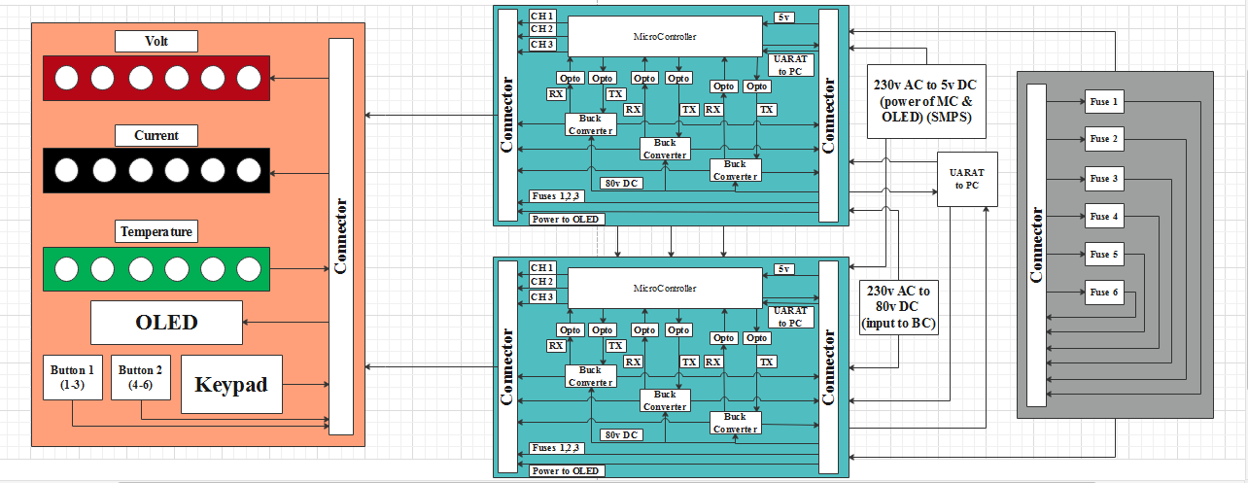

1. 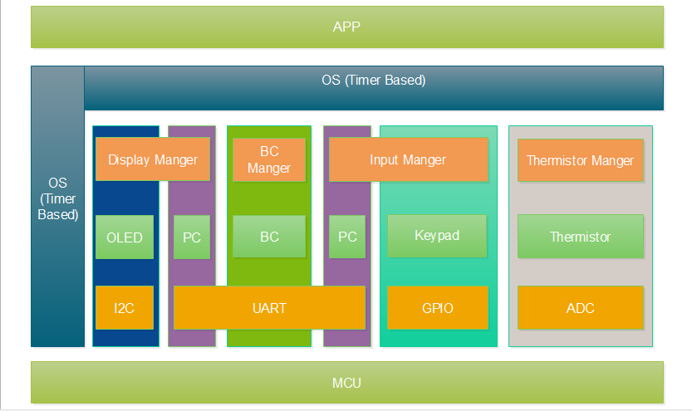**Software Layer architecture**
2. 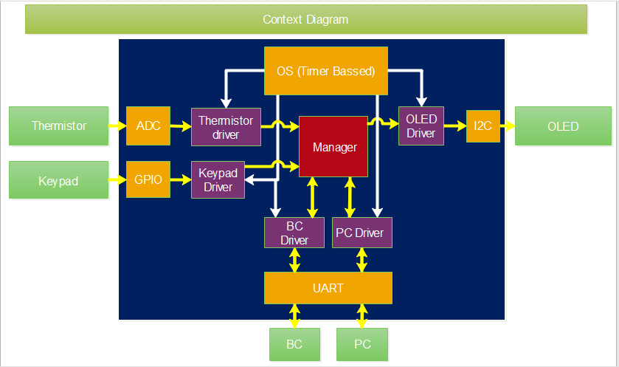**Context Diagram**
3. **Software State machine**

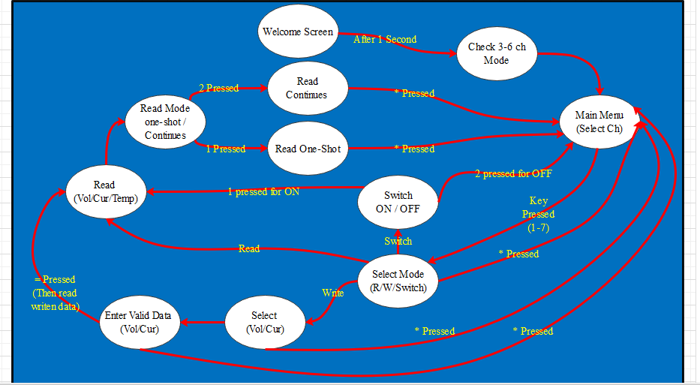

1. 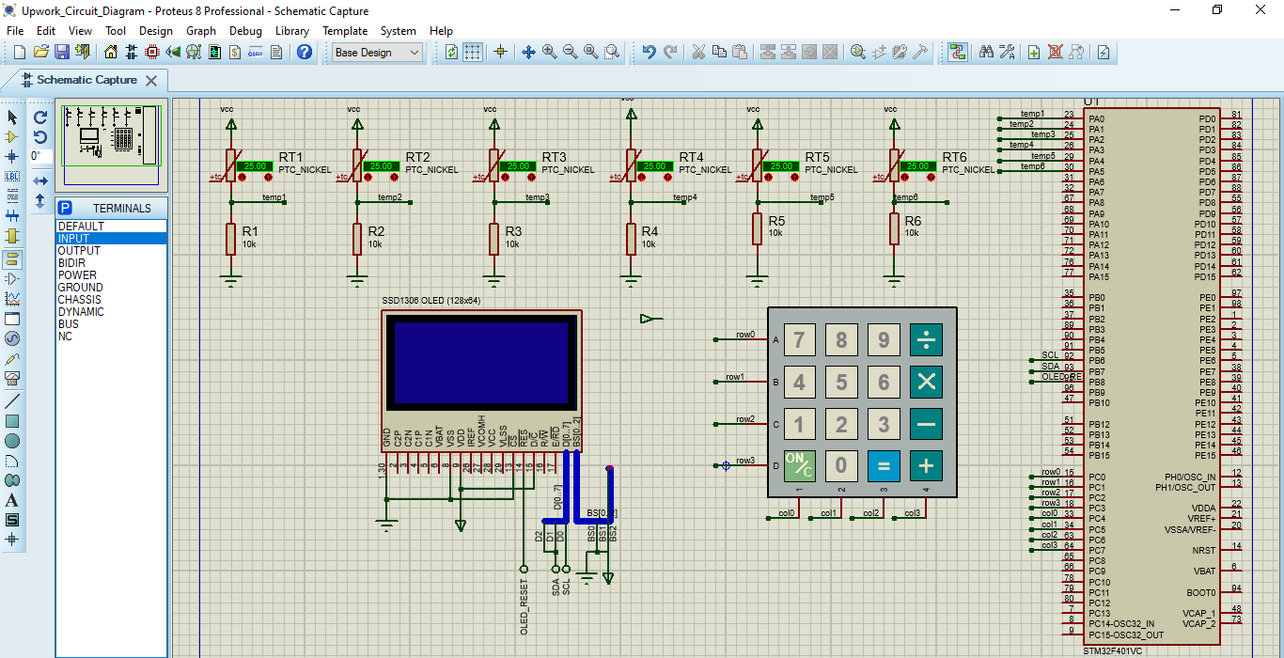**Initial Circuit Schematic**
2. **Component Selection**
3. **uC Selection**

**NUCLEO-F091RC (**STM32F091RCTx**)**

**- has** 8 USARTs

1. **Main interface (**first priority**)**

**-PC (using UART)**

1. **OLED/LCD Selection (pin connections are as same as 0.96: OLED display)**

**-SSD1306 OLED (128x64) (** [https://www.adafruit.com/product/326 but 2.4](https://www.adafruit.com/product/326%20but%202.4) inch)

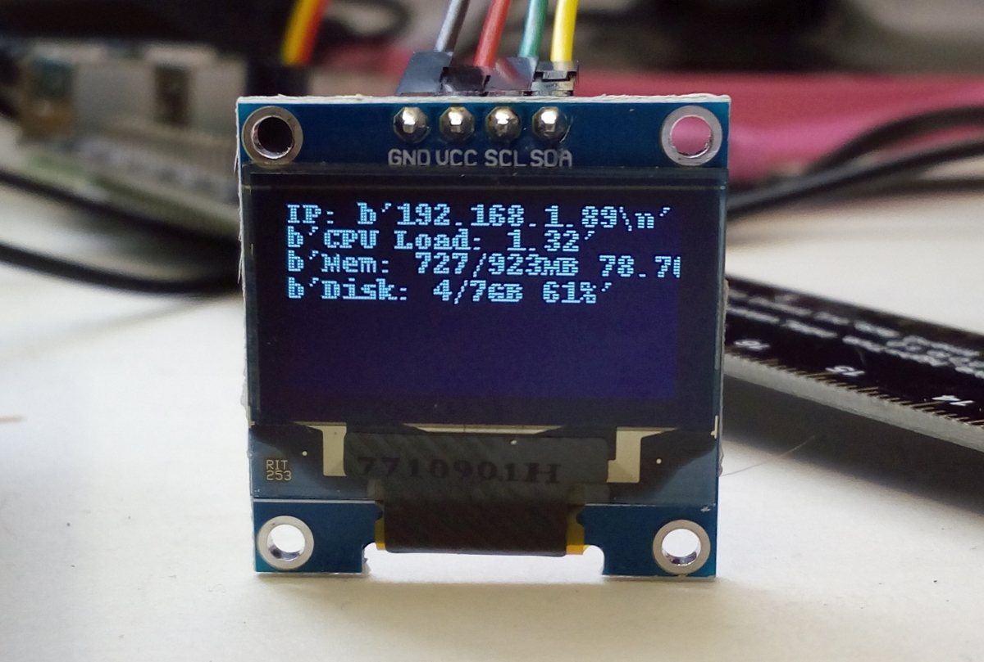

1. 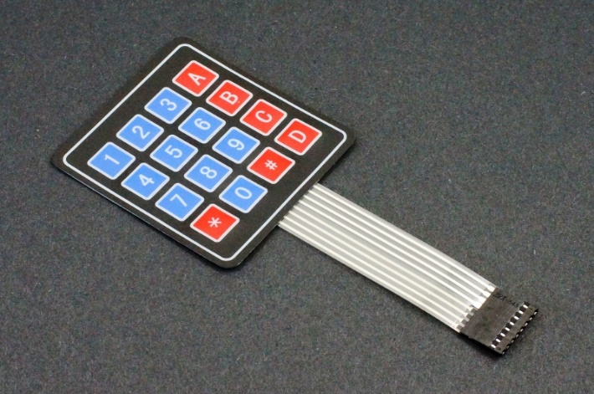**Keypad 4*4**