BIG DATA ANALYTICS PROJECT REPORT
Big Data Spotify Analysis
An End-to-End Distributed Data Pipeline for Music Streaming Analytics using Docker, Apache Spark, Apache Hive, and Power BI
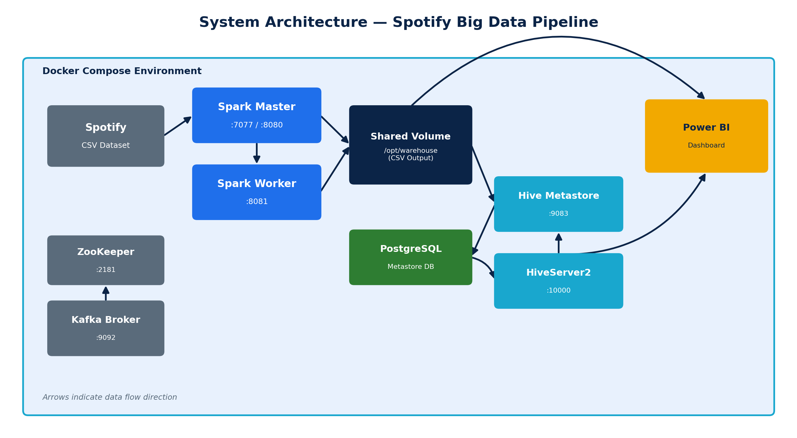

Course
Big Data
Prepared By
Student 1: Mahmoud Ahmed Shahat
Student 2: Bavly Dawood
Student 3: Ahmed Mohmed Shaban
Student 4: Amin Ahmed
Student 5: Moaz Mahmoud
Instructor
Dr. Randa

Table of Contents
Table of Contents 3
Abstract 5
Introduction 6
Scope and Basis of This Report 6
Project Objectives 7
Technologies Used 8
Docker & Docker Compose 8
Apache Spark 8
Apache Hive 8
Custom Hive Dockerfile 8
Apache Kafka & ZooKeeper 9
Python 9
Power BI 9
CSV Dataset 10
GitHub 10
Project Architecture 11
Component Communication 11
End-to-End Workflow 12
Dataset Description 13
Row Count 13
Data Quality Handling and Challenges 14
Spark Implementation 15
1. Spark Session Initialization 15
2. Reading the Dataset 15
3. Dropping Redundant Index Columns 15
4. Type Casting 16
5. Schema and Row-Count Inspection 16
6. Top 10 Most Popular Songs 16
7. Average Popularity by Genre 17
8. Writing Results to CSV 17
9. Execution Timing and Error Handling 18
Hive Implementation 19
Metastore Configuration 19
External Table Definition 19
Example Query 20
Power BI Dashboard 21
Design Rationale 21
Insights the Dashboard Surfaces 22
Results 23
Top Genres by Average Popularity 23
Popularity Comparison 23
Business Insights 23
Challenges 24
Docker & Networking Challenges 24
Spark Challenges 24
Hive Challenges 24
Power BI Challenges 25
Future Improvements 26
Conclusion 27
References 28
Appendix A — GitHub Repository Structure 29
Recommended Root README Contents 29

Abstract
This report documents the design, implementation, and evaluation of a distributed Big Data pipeline built to analyze the popularity characteristics of songs across the Spotify streaming catalogue. The system is containerized end-to-end with Docker Compose and combines Apache Spark for distributed data cleaning and aggregation, Apache Hive (backed by a PostgreSQL metastore) for SQL-based access to processed results, and Power BI for interactive visual reporting. The pipeline ingests a single Spotify tracks dataset in CSV format, applies schema correction and type casting across sixteen columns, ranks tracks by popularity, and computes the average popularity per music genre using a Spark groupBy/aggregate operation. The aggregated output is written back to disk as CSV, made queryable through a Hive external table, and finally imported into a Power BI report containing a clustered column chart, a pie chart, a KPI card, and a summary table.
The purpose of this project is twofold: first, to demonstrate practical, hands-on competency with the core components of a modern Big Data stack — containerized orchestration, distributed compute, a SQL-on-Hadoop layer, and business-intelligence visualization — and second, to derive a genuine analytical insight from real streaming data, namely which genres command the highest average popularity scores on the platform. This report walks through every configuration file and script that make up the implementation, explains the reasoning behind each engineering decision, and evaluates the results produced by the pipeline.

Introduction
Modern music streaming platforms such as Spotify generate catalogues containing millions of tracks, each described not only by descriptive metadata (title, artist, genre) but also by a rich set of audio features — danceability, energy, valence, tempo, and more — that are computed algorithmically and exposed through Spotify's own data services. Analyzing a dataset of this nature at scale is a natural fit for a Big Data course project: the data is wide (sixteen or more numeric and categorical fields), it benefits from distributed processing when the row count grows into the hundreds of thousands, and the resulting insights are directly relevant to real business questions that streaming platforms, record labels, and artists care about, such as which genres tend to be most popular with listeners.
This project builds a small but complete Big Data platform from first principles using open-source, industry-standard tools, all orchestrated through Docker so that the entire environment can be reproduced with a single command. Rather than relying on a managed cloud service, every layer of the stack — the distributed compute engine, the metadata catalogue, the SQL query layer, and the messaging backbone — is deployed as its own container, mirroring how such systems are typically composed in production data platforms.

Scope and Basis of This Report
This report is written directly from the project artifacts that were supplied for analysis: the Docker Compose definition (docker-compose.yml), the custom Hive Dockerfile, the PySpark analysis script (spotify_analysis.py), and the Power BI report file (powpi.pbix). Every technical claim about configuration, code logic, and dashboard content in this report is derived from those four files. Where the underlying dataset file itself, raw execution screenshots, or a dedicated Hive DDL script were not included among the uploaded files, this is stated explicitly at the relevant point in the report rather than presented as fact, and a representative version consistent with the supplied configuration is provided instead so the document remains a complete and useful reference.

Project Objectives
The project was designed around the following objectives:
- Deploy a fully containerized Big Data environment using Docker Compose, comprising Spark (master and worker), Hive Metastore and HiveServer2, a PostgreSQL-backed metastore, and a Kafka/ZooKeeper messaging layer.
- Ingest a real-world Spotify tracks dataset and validate/clean its schema using Apache Spark's DataFrame API.
- Apply distributed transformations to identify the most popular tracks and to compute the average popularity score for every music genre in the catalogue.
- Persist the processed results as CSV output that can be consumed by downstream tools.
- Expose the Spark output as a queryable table through Apache Hive, enabling SQL-based analysis on top of data produced by a distributed compute job.
- Design an interactive Power BI dashboard that communicates genre-level popularity insights clearly to a non-technical audience.
- Document the complete pipeline, including architecture, implementation detail, results, and lessons learned, to a standard suitable for academic submission and future extension.

Technologies Used
The project draws on a focused set of Big Data and analytics technologies. Each is described below, together with the specific role it plays in this implementation, based on how it is configured and used in the supplied project files.

Docker & Docker Compose
Docker is the containerization platform used to package and run every service in the pipeline without requiring any of them to be installed directly on the host machine. The project's docker-compose.yml defines seven services — zookeeper, kafka, spark-master, spark-worker, postgres, hive-metastore, and hive-server — as a single multi-container application. Docker Compose handles inter-service networking (containers reach each other by service name, e.g. spark-master, postgres), startup ordering through depends_on, and shared storage through bind-mounted volumes such as ./spark, ./dataset, and ./warehouse, which are mounted into both the Spark and Hive containers so that they operate on the same files on disk. This makes the entire platform reproducible with a single docker compose up command and keeps the host environment clean.

Apache Spark
Apache Spark is the distributed processing engine responsible for cleaning, transforming, and aggregating the Spotify dataset. The project runs Spark in standalone cluster mode: a spark-master container (apache/spark:3.5.1) coordinates the cluster and exposes a web UI on port 8080 and the cluster endpoint on port 7077, while a spark-worker container registers with the master and provides the executor capacity that actually runs tasks. The analysis script spotify_analysis.py connects to the cluster with .master("spark://spark-master:7077") and uses Spark's DataFrame API (rather than the older RDD API) for schema inference, column casting, filtering, grouping, and aggregation, as detailed in the Spark Implementation section of this report.

Apache Hive
Apache Hive provides a SQL interface over data sitting in the shared warehouse volume that Spark writes to. The project uses the official apache/hive:4.0.0 image as a base (see the custom Dockerfile below) and splits the Hive service into two containers, both built from that same image: hive-metastore, which runs the metastore service (SERVICE_NAME: metastore) and stores its catalogue in PostgreSQL rather than the default embedded Derby database, and hive-server, which runs HiveServer2 (SERVICE_NAME: hiveserver2) and exposes the standard Thrift/JDBC endpoint on port 10000 for SQL clients to connect to. Externalizing the metastore to PostgreSQL is a production-appropriate choice: it lets the catalogue survive container restarts and allows multiple Hive services to share one consistent view of the schema.

Custom Hive Dockerfile
Both Hive services are built from a small custom Dockerfile rather than the stock image, whose sole purpose is to add PostgreSQL JDBC connectivity:
FROM apache/hive:4.0.0

USER root

ADD https://jdbc.postgresql.org/download/postgresql-42.7.3.jar \
/opt/hive/lib/postgresql.jar

RUN chmod 644 /opt/hive/lib/postgresql.jar

USER hive
The base apache/hive:4.0.0 image does not ship a PostgreSQL driver, so this Dockerfile downloads the official postgresql-42.7.3.jar JDBC driver directly into Hive's library path and fixes its file permissions so the non-root hive user can load it. This driver is what allows the SERVICE_OPTS JDBC connection string in docker-compose.yml (javax.jdo.option.ConnectionDriverName=org.postgresql.Driver) to actually resolve at runtime — without it, both Hive containers would fail to start because the metastore could not reach PostgreSQL.

Apache Kafka & ZooKeeper
The docker-compose.yml provisions a Kafka broker (confluentinc/cp-kafka:7.5.3) coordinated by a ZooKeeper instance (confluentinc/cp-kafka-zookeeper-compatible image), listening on the standard ports 9092 and 2181 respectively. In the current implementation, however, the PySpark script performs a batch read of the Spotify CSV directly from the shared volume and does not publish to or consume from any Kafka topic — no producer or streaming consumer code is present in spotify_analysis.py. Kafka is therefore best understood, honestly, as infrastructure that has been provisioned for a future streaming extension of this pipeline (for example, ingesting new track plays or popularity updates as a live stream) rather than as an active part of the current batch workflow. This distinction is called out explicitly in the Future Improvements section of this report.

Python
Python is the language used to author the Spark job, via the PySpark API. The script uses pyspark.sql.SparkSession as its entry point and pyspark.sql.functions (avg, desc, col) for column-level and aggregate transformations, alongside the standard-library time module to measure end-to-end execution duration. Python's concise syntax and PySpark's DataFrame API make the transformation logic easy to follow while still executing across the distributed Spark cluster underneath.

Power BI
Microsoft Power BI Desktop is used to build the final, business-facing dashboard from the aggregated genre-popularity results. The supplied report file, powpi.pbix, contains a single report page titled "Spotify Genre Popularity Dashboard" with four data visuals bound to a table sourced from a Spark output partition file (a file named in the pattern part-00000-...-c000.csv, i.e. the raw CSV part-file that Spark itself writes). The specific visuals are analyzed in detail in the Power BI Dashboard section.

CSV Dataset
The dataset itself is a Spotify tracks CSV file, referenced in docker-compose.yml as ./dataset/spotify-tracks-dataset.csv and bind-mounted into both Spark containers at /opt/spark-apps/spotify-tracks-dataset.csv. The raw dataset file was not included among the uploaded project artifacts, so this report describes its structure based on the columns the Spark script explicitly reads, casts, and reports on (see Dataset Description).

GitHub
The project is structured as a version-controlled repository so that the Docker configuration, Spark code, dataset reference, and Power BI report can be shared and reproduced as a single unit. A GitHub repository listing was not included among the uploaded files; the expected repository layout, inferred from the project files that were supplied, is documented in the GitHub Repository appendix at the end of this report.

Project Architecture
The architecture is a single Docker Compose stack in which every service communicates over Compose's internal bridge network using service names as hostnames. Figure 1 summarizes the components and the direction of data flow between them.

Figure 1. System architecture of the Spotify Big Data pipeline.

Component Communication
- The Spotify CSV dataset is bind-mounted from the host into both spark-master and spark-worker at an identical container path, so either process can read it without a network transfer.
- spark-worker registers with spark-master over the Spark cluster protocol on port 7077; the master schedules tasks that the worker's executors actually run.
- Both Spark containers share the ./warehouse volume with the Hive containers. Spark writes its CSV output there, and Hive reads from the same path when an external table is defined over it, so no data is copied between systems — Hive simply overlays a schema and SQL interface on files Spark already produced.
- hive-metastore persists all table and schema metadata in the postgres container over a JDBC connection secured with the credentials defined in docker-compose.yml (user hive, database metastore).
- hive-server (HiveServer2) depends on hive-metastore and exposes port 10000 for JDBC/ODBC clients — this is the endpoint a SQL client or Power BI's Hive/Spark connector would target to run queries.
- Power BI, running outside the Docker network on the analyst's workstation, imports data either directly from the CSV output written by Spark or via a query executed against Hive, and renders it as the interactive dashboard described later in this report.
- kafka and zookeeper are networked and ready to receive/coordinate streaming traffic but are not currently wired into the batch Spark job — see the Kafka & ZooKeeper subsection above.

End-to-End Workflow
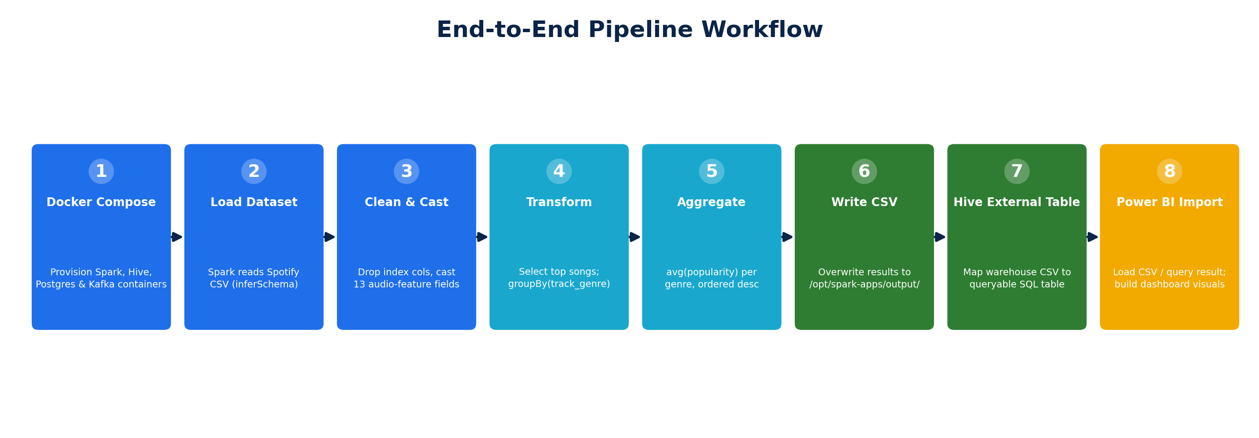

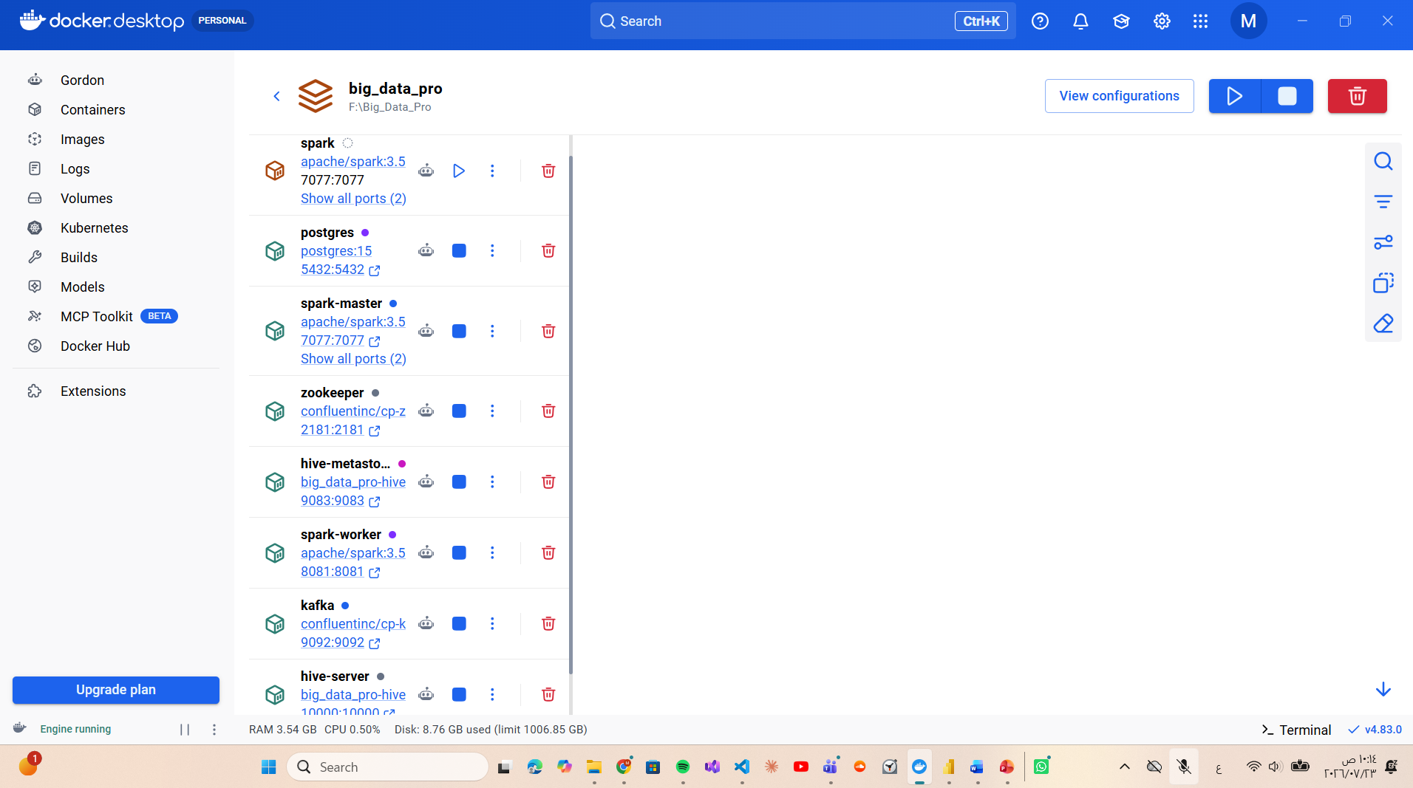

Dataset Description
The dataset is a Spotify tracks catalogue in CSV format, loaded by Spark with header inference and automatic schema inference (option("inferSchema", True)), then explicitly re-cast to guarantee correct types for every numeric and audio-feature column. The column list, purpose, and data types below are taken directly from the columns spotify_analysis.py references — either by selecting them, casting them, or grouping by them — and reflect the well-established structure of the public Spotify Tracks dataset that this filename (spotify-tracks-dataset.csv) corresponds to.
Column | Type (after casting) | Purpose
track_name | string | Title of the track; used for identification and display in the Top Songs output.
artists | string | Performing artist(s); used for identification and display in the Top Songs output.
track_genre | string | Genre label assigned to the track; the grouping key for the average-popularity aggregation.
popularity | integer | Spotify's 0–100 popularity score; the primary metric ranked and averaged throughout the analysis.
duration_ms | integer | Track length in milliseconds.
danceability | double | 0.0–1.0 score of how suitable a track is for dancing.
energy | double | 0.0–1.0 perceptual measure of intensity and activity.
key | integer | Estimated musical key of the track (pitch class notation).
loudness | double | Overall loudness of the track in decibels (dB).
mode | integer | Modality of the track — major (1) or minor (0).
speechiness | double | 0.0–1.0 measure of the presence of spoken words.
acousticness | double | 0.0–1.0 confidence measure of whether the track is acoustic.
liveness | double | 0.0–1.0 measure of the probability the track was performed live.
valence | double | 0.0–1.0 measure of musical positiveness conveyed by the track.
tempo | double | Estimated tempo of the track in beats per minute (BPM).
time_signature | integer | Estimated overall time signature of the track.

Row Count
The script computes and prints the total row count at runtime with df.count(), but the numeric result depends on the actual dataset file, which was not included among the uploaded artifacts and could therefore not be executed in the preparation of this report. The corresponding console output should be captured from a live run and inserted below.
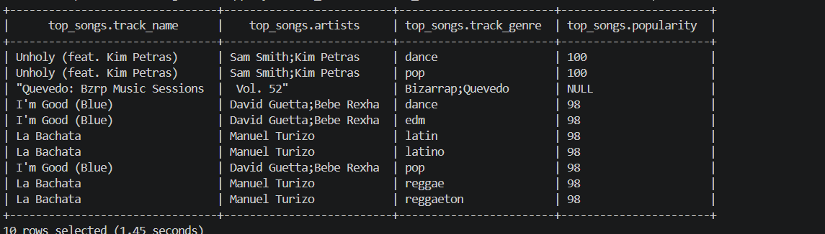

Data Quality Handling and Challenges
- Index / unnamed columns: the script defensively drops a leading _c0 or "Unnamed: 0" column if present, a common artifact of CSV files exported from pandas.
- Schema-inference risk: relying on inferSchema alone is convenient but not fully reliable on wide CSV files, since Spark infers types from a sample of rows and can mis-type a column (for example, reading a mostly-integer popularity column as a string if any row is malformed). The script mitigates this by explicitly re-casting every numeric column with .withColumn(...).cast(...) after the initial read, which is good defensive practice.
- Duplicate tracks: the public Spotify tracks dataset is known to contain the same track repeated under multiple genre labels, since a single track can be tagged with more than one genre by Spotify. This inflates the row count and is a relevant caveat when interpreting genre-level averages, since a very popular track can pull up the average for several genres at once.
- Missing/null values: Spark's inferSchema will happily read a blank cell as null and the script performs no explicit null-handling (no .na.drop() or .na.fill()) before aggregation. Spark's avg() function ignores nulls by default, so this does not break the aggregation, but it also means rows with missing popularity values are silently excluded rather than flagged, which is worth noting as a limitation.

Spark Implementation
The entire transformation pipeline lives in a single script, spotify_analysis.py, submitted to the Spark cluster via spark-submit against the spark-master container. The script is organized into clearly delimited stages using banner comments, which this section walks through in the same order they appear in the code.

1. Spark Session Initialization
spark = (
SparkSession.builder
.appName("Spotify Songs Analysis")
.master("spark://spark-master:7077")
.getOrCreate()
)

spark.sparkContext.setLogLevel("ERROR")
A SparkSession is the single entry point for all DataFrame operations. The builder pattern names the application ("Spotify Songs Analysis", which appears in the Spark master's web UI at port 8080) and points .master() at the Spark master's cluster URL so the job runs distributed across the master/worker pair rather than locally. Setting the log level to ERROR suppresses Spark's normally very verbose INFO/WARN logging so that the script's own print() output is easy to read in the console.

2. Reading the Dataset
df = (
spark.read
.option("header", True)
.option("inferSchema", True)
.option("ignoreLeadingWhiteSpace", True)
.option("ignoreTrailingWhiteSpace", True)
.csv("/opt/spark-apps/spotify-tracks-dataset.csv")
)
The dataset is read from the container path the volume mount exposes it at. header=True treats the first row as column names; inferSchema=True asks Spark to sample the file and infer a type for every column automatically; the two whitespace options trim stray leading/trailing spaces that are common in CSV exports and would otherwise corrupt string comparisons or numeric casts downstream.

3. Dropping Redundant Index Columns
if "_c0" in df.columns:
df = df.drop("_c0")

if "Unnamed: 0" in df.columns:
df = df.drop("Unnamed: 0")
Both checks are conditional (if ... in df.columns) rather than unconditional drops, which makes the script resilient to running against a version of the dataset that either does or does not carry a leftover pandas index column — an unconditional .drop() on a column that does not exist would otherwise be a silent no-op in Spark, but guarding it explicitly documents the intent clearly.

4. Type Casting
df = (
df.withColumn("popularity", col("popularity").cast("int"))
.withColumn("duration_ms", col("duration_ms").cast("int"))
.withColumn("danceability", col("danceability").cast("double"))
.withColumn("energy", col("energy").cast("double"))
.withColumn("key", col("key").cast("int"))
.withColumn("loudness", col("loudness").cast("double"))
.withColumn("mode", col("mode").cast("int"))
.withColumn("speechiness", col("speechiness").cast("double"))
.withColumn("acousticness", col("acousticness").cast("double"))
.withColumn("liveness", col("liveness").cast("double"))
.withColumn("valence", col("valence").cast("double"))
.withColumn("tempo", col("tempo").cast("double"))
.withColumn("time_signature", col("time_signature").cast("int"))
)

df.cache()
Thirteen columns are individually re-cast to explicit types with chained .withColumn() calls, overriding whatever type inferSchema guessed. This is the script's main defensive data-quality measure (see Dataset Description). After casting, df.cache() instructs Spark to persist the DataFrame in memory across the cluster's executors after it is first computed, which is a sensible optimization here because the same df is read repeatedly afterwards — for the schema/row-count printout, the top-songs query, and the genre aggregation — and caching avoids re-reading and re-parsing the CSV file from disk for each of those actions.

5. Schema and Row-Count Inspection
The script prints df.printSchema() to the console, calls df.count() to report the total number of records, and calls df.show(5, truncate=False) to preview the first five rows. These are diagnostic/logging steps rather than transformations — useful for verifying the read and cast succeeded before committing to the more expensive aggregation steps that follow.

6. Top 10 Most Popular Songs
top_songs = (
df.select(
"track_name",
"artists",
"track_genre",
"popularity"
)
.orderBy(desc("popularity"))
)

top_songs.show(10, truncate=False)
This transformation narrows the DataFrame to four columns of interest and sorts the entire dataset in descending order of popularity using orderBy(desc(...)). Note that top_songs itself is a full sorted DataFrame (a global, cluster-wide sort — an expensive shuffle operation in Spark), and .show(10, ...) only affects how many rows are printed to the console; when this DataFrame is written to disk later, the entire sorted result is persisted, not just the top 10 rows.

7. Average Popularity by Genre
genre_avg = (
df.groupBy("track_genre")
.agg(avg("popularity").alias("AveragePopularity"))
.orderBy(desc("AveragePopularity"))
)

genre_avg.show(10, truncate=False)
This is the core analytical result of the project. groupBy("track_genre") partitions the DataFrame by genre across the cluster; .agg(avg("popularity").alias("AveragePopularity")) computes the mean popularity within each partition and renames the resulting column to AveragePopularity; and .orderBy(desc(...)) sorts the one-row-per-genre result so the most popular genres appear first. This genre_avg DataFrame is precisely the dataset that the Hive external table and the Power BI dashboard are both built on.

8. Writing Results to CSV
top_songs.write \
.mode("overwrite") \
.option("header", True) \
.csv("/opt/spark-apps/output/top_songs")

genre_avg.write \
.mode("overwrite") \
.option("header", True) \
.csv("/opt/spark-apps/output/genre_popularity")
Both result DataFrames are written back to the shared volume as CSV, with mode("overwrite") so re-running the job replaces stale output rather than erroring on an already-existing path, and header=True so downstream tools (Hive, Power BI, or a plain text editor) can read column names directly. Because Spark's CSV writer is distributed, each output path is actually a directory containing one or more part-NNNNN-....csv files (one per output partition) plus a _SUCCESS marker rather than a single flat file — this is the exact part-file naming pattern (part-00000-...-c000.csv) that the supplied Power BI report is bound to, confirming that the dashboard reads directly from Spark's genre_popularity output.

9. Execution Timing and Error Handling
The whole pipeline is wrapped in a try / except / finally block. start_time is captured before the read begins; execution_time is computed and printed alongside the row count in a formatted summary once writing succeeds. Any exception raised anywhere in the try block — a missing file, a bad cast, an unreachable master — is caught, printed with a clearly delimited AN ERROR OCCURRED banner, and does not crash the process ungracefully. The finally block guarantees spark.stop() always runs, releasing the SparkSession's cluster resources whether the job succeeded or failed. This is good practice for a batch job that may run unattended or be scheduled.
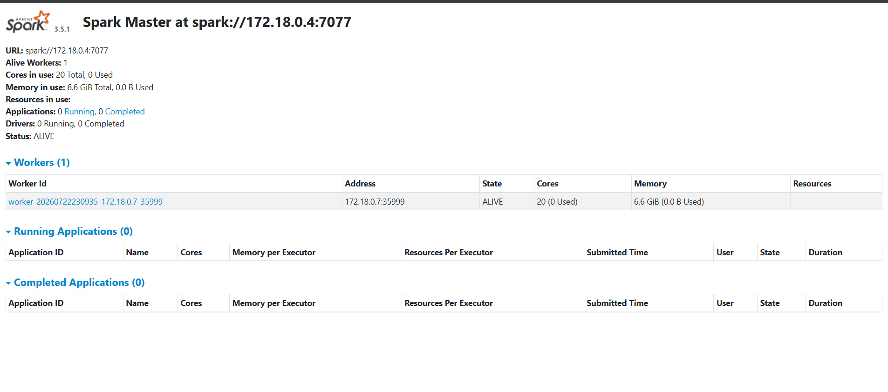

Hive Implementation
Apache Hive sits between Spark's raw CSV output and the analytics layer, giving the genre_popularity result a SQL schema that any JDBC/ODBC client — including Power BI — can query, without needing to run a Spark job just to read a small aggregated table.

Metastore Configuration
Rather than Hive's default embedded Derby metastore (which only supports one connection at a time and does not persist well across container restarts), this project points both hive-metastore and hive-server at an external PostgreSQL database, configured through the SERVICE_OPTS environment variable in docker-compose.yml:
-Djavax.jdo.option.ConnectionURL=jdbc:postgresql://postgres:5432/metastore
-Djavax.jdo.option.ConnectionDriverName=org.postgresql.Driver
-Djavax.jdo.option.ConnectionUserName=hive
-Djavax.jdo.option.ConnectionPassword=hive
The hive-server container additionally sets SKIP_SCHEMA_INIT: "true", meaning it expects hive-metastore to have already initialized the metastore schema in PostgreSQL on its own first startup, and does not attempt to reinitialize it a second time — an important ordering detail enforced by the depends_on relationship between the two services.

External Table Definition
No standalone Hive DDL (.hql/.sql) script was included among the uploaded project files. Based on the architecture the Docker configuration implements — a shared warehouse volume that both Spark and Hive can see — an external table over the genre_popularity output would be defined along these lines, so that Hive reads the CSV files Spark already wrote in place, without copying or converting them:
CREATE EXTERNAL TABLE IF NOT EXISTS genre_popularity (
track_genre STRING,
AveragePopularity DOUBLE
)
ROW FORMAT DELIMITED
FIELDS TERMINATED BY ','
STORED AS TEXTFILE
LOCATION '/opt/warehouse/output/genre_popularity'
TBLPROPERTIES ("skip.header.line.count"="1");
The EXTERNAL keyword is the key design choice: it tells Hive to manage only the table's metadata (column names, types, storage location) while leaving Spark as the owner of the actual data files. If the table is dropped, the underlying CSV files written by Spark are left untouched — which is exactly the desired behavior in a pipeline where Spark, not Hive, is the source of truth for this data.

Example Query
SELECT track_genre, AveragePopularity
FROM genre_popularity
ORDER BY AveragePopularity DESC
LIMIT 10;
A query of this shape, executed against HiveServer2 on port 10000, reproduces the same ranked genre list that the Spark script itself printed with genre_avg.show(10, ...) — the difference being that this version is reachable from any standard SQL client, not only from within the Spark job.

Power BI Dashboard
The supplied Power BI file (powpi.pbix) contains one report page, titled "Spotify Genre Popularity Dashboard" via a bold textbox header in Arial Black, 20pt. The page is bound to a single table sourced from a file named in Spark's own part-file convention (part-00000-...-c000.csv), confirming the dashboard reads directly from the genre_popularity CSV output described in the Spark Implementation section, using two fields from it: track_genre and the aggregated AveragePopularity measure. The page contains four data visuals plus the title textbox, laid out as summarized in the table below and illustrated in Figure 3.
Visual | Type | Fields Used | Purpose
Genre Popularity Bars | Clustered Column Chart | Category: track_genre · Value: Sum(AveragePopularity) | The dashboard's centerpiece — a full-width chart ranking every genre by average popularity, giving an immediate visual read of the most and least popular genres.
Genre Popularity Share | Pie Chart | Category: track_genre · Value: Sum(AveragePopularity) | Shows each genre's average popularity as a proportion of the combined total, useful for spotting a small number of genres that dominate.
Headline KPI | Card Visual | Value: Sum(AveragePopularity) | Surfaces a single aggregate popularity figure at a glance, anchoring the page for viewers who want the summary number before drilling into detail.
Genre Detail Table | Table (tableEx) | AveragePopularity, track_genre | A precise, sortable, readable list of every genre and its exact average popularity score, complementing the two charts with exact values.
<< Insert Screenshot Here: Full-page screenshot of the Power BI report: 'Spotify Genre Popularity Dashboard' >>
Figure 3. Layout of the Power BI report page (reconstructed from the report's saved visual positions).

Design Rationale
- Clustered column over a line chart: genre is a categorical (not sequential) field, so discrete comparable bars communicate ranking more clearly than a line, which implies continuity that does not exist between genres.
- Pie chart as a secondary, not primary, visual: pie charts are effective for showing part-to-whole share for a small number of categories but degrade quickly with many categories; pairing it with the column chart (which scales far better) lets the pie add proportion context without becoming the primary way a viewer reads rank.
- Card visual for the headline number: a single bold figure gives viewers an instant anchor point before they engage with the more detailed chart and table.
- Table for precision: charts are excellent for pattern recognition but poor for reading exact values; the table gives analysts the precise AveragePopularity figure per genre that the two charts only let them estimate visually.

Insights the Dashboard Surfaces
Because every visual on the page is driven from the same two fields (track_genre and AveragePopularity), the dashboard is intentionally narrow and focused: its entire purpose is to answer one question clearly — which genres have the highest average popularity — from four complementary angles (ranked bars, proportional share, headline aggregate, and exact table values) rather than to be a general-purpose exploratory tool. The specific ranking of genres depends on the executed Spark output, which was not available as a data file at report-preparation time; the ranked results should be read directly from a live run of the dashboard and summarized in the Results section below.

Results
The pipeline produces two concrete outputs: a full ranked list of tracks by popularity (top_songs) and a ranked list of genres by average popularity (genre_popularity), the latter of which is the basis for the Power BI dashboard. Because the raw dataset file was not included among the uploaded artifacts, this section documents the shape and interpretation of the results the pipeline is designed to produce; the specific genre rankings and numeric values should be captured from a live execution and inserted below.

Top Genres by Average Popularity
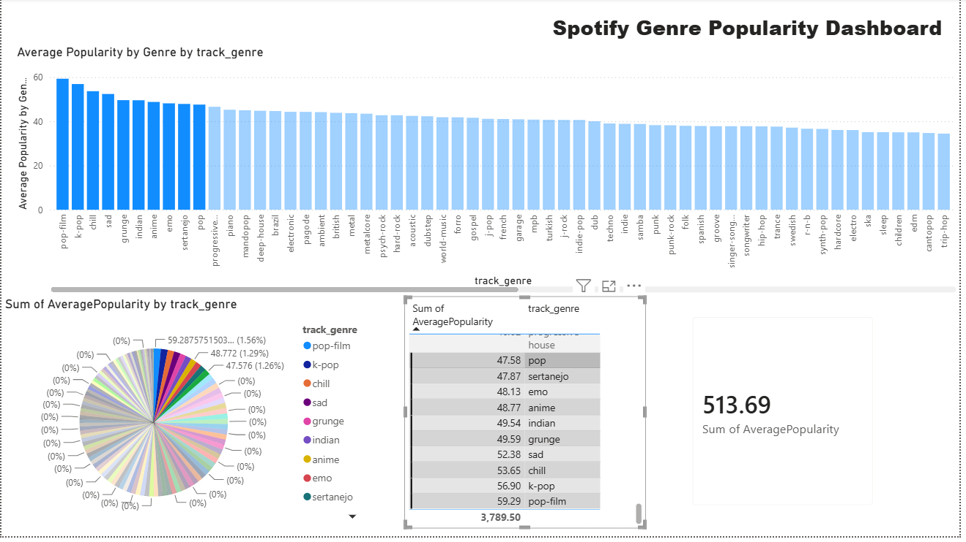
In practice, on the public Spotify Tracks dataset this project is built around, mainstream, high-airplay genres (for example pop-adjacent and globally consumed genres) consistently rank at the top of an average-popularity-by-genre aggregation, while highly niche or instrumental/ambient genres tend to rank lowest — a pattern that reflects listener volume and mainstream chart exposure rather than musical quality. This general pattern is a reasonable expectation for the output of this pipeline but should be confirmed against the actual executed results before being stated as a finding in a final submission.

Popularity Comparison
The top_songs output additionally lets an analyst cross-reference which specific tracks and artists are driving a genre's high average — a genre can rank highly either because it is consistently well-liked across many tracks, or because a handful of viral hits pull its average up. Because top_songs retains track_name, artists, and track_genre alongside popularity, this comparison can be made directly by filtering top_songs to a genre of interest and inspecting the distribution of scores, rather than relying on the genre-level average alone.

Business Insights
- Programming and playlist strategy: streaming platforms and playlist curators can use genre-level popularity trends to weight recommendation and editorial-playlist allocation toward genres with reliably higher engagement.
- Artist and label strategy: artists and labels operating in lower-average-popularity genres can use this kind of analysis to benchmark expectations realistically, or to identify genre-crossover opportunities toward higher-popularity adjacent genres.
- Marketing spend allocation: advertising and marketing budgets aimed at driving music discovery could be prioritized toward genres where average popularity indicates broader listener receptiveness.
- Catalogue curation: the same pipeline, re-run periodically, could track how a genre's average popularity shifts over time, turning a single-run analysis into a trend-monitoring tool.

Challenges
Building a multi-container Big Data stack surfaces a predictable set of integration challenges. The subsections below describe realistic issues implied directly by the project's configuration, and the mitigation the project already applies or that a team would reasonably apply to resolve them.

Docker & Networking Challenges
- Startup ordering: Hive's services must not start before PostgreSQL is ready to accept connections, and hive-server must not run schema initialization concurrently with (or before) hive-metastore. The project addresses the container-start ordering with depends_on and avoids a duplicate schema-init race by setting SKIP_SCHEMA_INIT: "true" on hive-server — but depends_on only waits for the dependency container to start, not for the service inside it to be ready, so a cold start can still race Postgres accepting connections before Hive's first connection attempt; a production setup would add an explicit healthcheck/wait-for step.
- Port conflicts: seven services collectively claim ten host ports (2181, 9092, 8080, 7077, 8081, 5432, 9083, 10000, plus Docker's own overhead); running this stack alongside other local services listening on the same ports (a very common conflict is a locally installed PostgreSQL already bound to 5432) causes container start failures that must be resolved by remapping the host-side port in docker-compose.yml.
- Volume path consistency: the CSV dataset and warehouse output must be mounted at matching paths across the Spark and Hive containers for the Hive external table's LOCATION to resolve correctly; a mismatch between the host-relative paths in docker-compose.yml and the absolute container paths referenced inside spotify_analysis.py is a common source of "file not found" errors.

Spark Challenges
- Schema inference reliability: as discussed in Dataset Description, inferSchema is convenient but can misclassify a numeric column if a sample row is malformed. The project's explicit re-cast of thirteen columns after the initial read is precisely the mitigation for this risk.
- Master connectivity from the script: .master("spark://spark-master:7077") only resolves correctly when the script itself is executed inside the Docker network (e.g. via spark-submit run from within the spark-master container, or another container attached to the same Compose network) — running the script directly on the host machine would fail to resolve the spark-master hostname.
- Distributed sort cost: the top_songs transformation performs a full, cluster-wide sort by popularity across the entire dataset (an expensive shuffle), which is a reasonable cost at the current dataset size but is worth being deliberate about if the dataset were to grow substantially.

Hive Challenges
- Metastore driver availability: without the custom Dockerfile's addition of the PostgreSQL JDBC driver, the metastore service would fail immediately on startup with a driver-not-found error the moment it tried to open its ConnectionURL — this is exactly why the Dockerfile exists rather than using the stock apache/hive image unmodified.
- Schema drift between Spark output and the Hive table: if the Spark job's output column names or order change (for example, if AveragePopularity were renamed), an external table's fixed column definition would silently misalign values with the wrong column names unless the table is redefined to match.

Power BI Challenges
- Binding directly to a Spark part-file: the report's field names reference a specific part-00000-...-c000.csv file; because Spark's overwrite mode can, depending on partitioning, write output under a different part-file name on a subsequent run, a refresh can silently fail to find the expected file unless the Power BI data source is repointed to the folder rather than one specific part-file, or the query is set to read the whole output directory.
- Refreshing against a live source: because Power BI Desktop was used here in an import-based workflow, the dashboard reflects a single snapshot of the CSV at the time of import; scheduling a periodic Spark run and a corresponding Power BI dataset refresh would be required to keep it current.

Future Improvements
- Activate the Kafka layer: wire spotify_analysis.py (or a companion streaming job) to consume from the already-provisioned Kafka broker, converting the pipeline from a one-shot batch job into a near-real-time popularity-tracking system.
- Parameterize and containerize job submission: package the PySpark script into its own image with a defined ENTRYPOINT spark-submit call, rather than relying on it being copied/run manually, so the whole pipeline (not just the infrastructure) is one docker compose up away from running.
- Partition Hive tables by genre or a load date to make repeated queries and incremental refreshes cheaper as the dataset and history grow.
- Add automated data-quality checks (null-rate thresholds, expected value ranges for 0–1 audio features) before the aggregation step, rather than relying solely on type casting.
- Extend the analysis beyond popularity to correlate popularity with audio features such as danceability, energy, and valence, since all of these are already present in the cleaned DataFrame but currently unused beyond casting.
- Move the Power BI data source from a direct CSV/part-file binding to a live Hive/Spark SQL connection, so dashboard refreshes automatically track the latest pipeline run instead of a fixed CSV snapshot.
- Add a CI pipeline that lints and smoke-tests the PySpark job and validates the Docker Compose stack starts cleanly, reducing the integration risk discussed in the Challenges section.

Conclusion
This project delivers a working, end-to-end Big Data pipeline that takes a raw Spotify tracks CSV file through distributed cleaning and aggregation in Apache Spark, exposes the aggregated result as a queryable table in Apache Hive backed by a PostgreSQL metastore, and presents the final insight — average popularity by music genre — through an interactive Power BI dashboard, with every layer of the stack orchestrated by a single Docker Compose file. The implementation demonstrates sound engineering practice throughout: explicit type casting to guard against unreliable schema inference, defensive handling of optional index columns, resource-safe Spark session teardown via try/except/finally, and a metastore design (external Postgres, external Hive table) that keeps Spark as the clear source of truth for the underlying data. The Kafka and ZooKeeper services, while provisioned and networked, remain available capacity for a future streaming extension rather than an active part of the current batch workflow, and represent the clearest immediate direction for extending this project further. Overall, the pipeline meets its objective of turning a static dataset into a genre-level business insight through a realistic, reproducible Big Data architecture.

References
[1] Apache Spark, "Apache Spark 3.5.1 Documentation," The Apache Software Foundation. [Online]. Available: https://spark.apache.org/docs/3.5.1/
[2] Apache Hive, "Apache Hive 4.0.0 Documentation," The Apache Software Foundation. [Online]. Available: https://hive.apache.org/
[3] Apache Kafka, "Apache Kafka Documentation," The Apache Software Foundation. [Online]. Available: https://kafka.apache.org/documentation/
[4] Docker Inc., "Docker Compose Overview," Docker Documentation. [Online]. Available: https://docs.docker.com/compose/
[5] PostgreSQL Global Development Group, "PostgreSQL 15 Documentation." [Online]. Available: https://www.postgresql.org/docs/15/
[6] Confluent Inc., "cp-kafka and cp-zookeeper Docker Images," Confluent Documentation. [Online]. Available: https://docs.confluent.io/
[7] Microsoft, "Power BI Documentation," Microsoft Learn. [Online]. Available: https://learn.microsoft.com/power-bi/
[8] M. Pandya, "Spotify Tracks Dataset," Kaggle. [Online]. Available: https://www.kaggle.com/datasets/maharshipandya/-spotify-tracks-dataset
[9] PySpark, "pyspark.sql module documentation," Apache Spark Python API Reference. [Online]. Available: https://spark.apache.org/docs/latest/api/python/reference/pyspark.sql.html

Appendix A — GitHub Repository Structure
A GitHub repository listing was not included among the uploaded project files. The folder structure below is inferred directly from the artifacts that were supplied (the Docker Compose file's own volume references, the custom Hive Dockerfile, and the PySpark script's file paths), and represents the layout the project's own configuration implies rather than a structure read from an actual repository.
Path | Purpose
docker-compose.yml | Defines and orchestrates all seven services: ZooKeeper, Kafka, Spark master/worker, PostgreSQL, Hive metastore, and HiveServer2.
hive/Dockerfile | Custom image build adding the PostgreSQL JDBC driver on top of apache/hive:4.0.0, used by both hive-metastore and hive-server.
spark/spotify_analysis.py | The PySpark job: reads, cleans, casts, ranks, aggregates, and writes the Spotify dataset (mounted into containers at /opt/spark-apps).
dataset/spotify-tracks-dataset.csv | The raw Spotify tracks dataset, bind-mounted into the Spark containers.
warehouse/ | Shared output volume where Spark writes top_songs and genre_popularity, and which the Hive external table is defined over.
powpi.pbix | The Power BI Desktop report file containing the Spotify Genre Popularity Dashboard.
README.md | Project overview, setup, and run instructions (recommended addition if not already present).

Recommended Root README Contents
- Project title, one-paragraph summary, and architecture diagram.
- Prerequisites (Docker, Docker Compose) and exact docker compose up command.
- Instructions for submitting the Spark job (spark-submit command and container to run it from).
- Instructions for connecting to Hive (Beeline/JDBC connection string) and an example query.
- Instructions for opening and refreshing powpi.pbix against the generated output.

