**microRNA editing in wildtype and ADAR1- *C.Elegans***

**microRNA**

microRNAs are short sequences of RNA, usually around 21-25bp in length. microRNAs serve an important function in gene regulation, by creating near-perfect(perfect?) matches to the 3’ end of an mRNA molecule, preventing it’s translation.

BB21 cells: ADAR1 mutants, significantly reduced/no RNA editing

N2 cells: Wildtype

**Differential Expression Between Wildtype and Mutant Cells:**

RNA (small rna?) sequencing data from embryonic C. elegans cells was first pre-processed (filtered to reads between 15-25 nucleotides, to avoid non-mirna sequences), then N2 and BB21 read libraries were aligned to version 35 of the miRDB mirna reference database, containing sequences of known miRNAs. The alignment files were converted into the pileup format using samtools, and gene counts were generated using these files. Using Bisek(1) and R, differential expression was done, comparing gene counts between BB21 and N2 cell lines.

Biological repeat 11311 was discarded to being a statistical outlier to the other 3 biological repeats, leaving us with 3 repeats to test for editing.

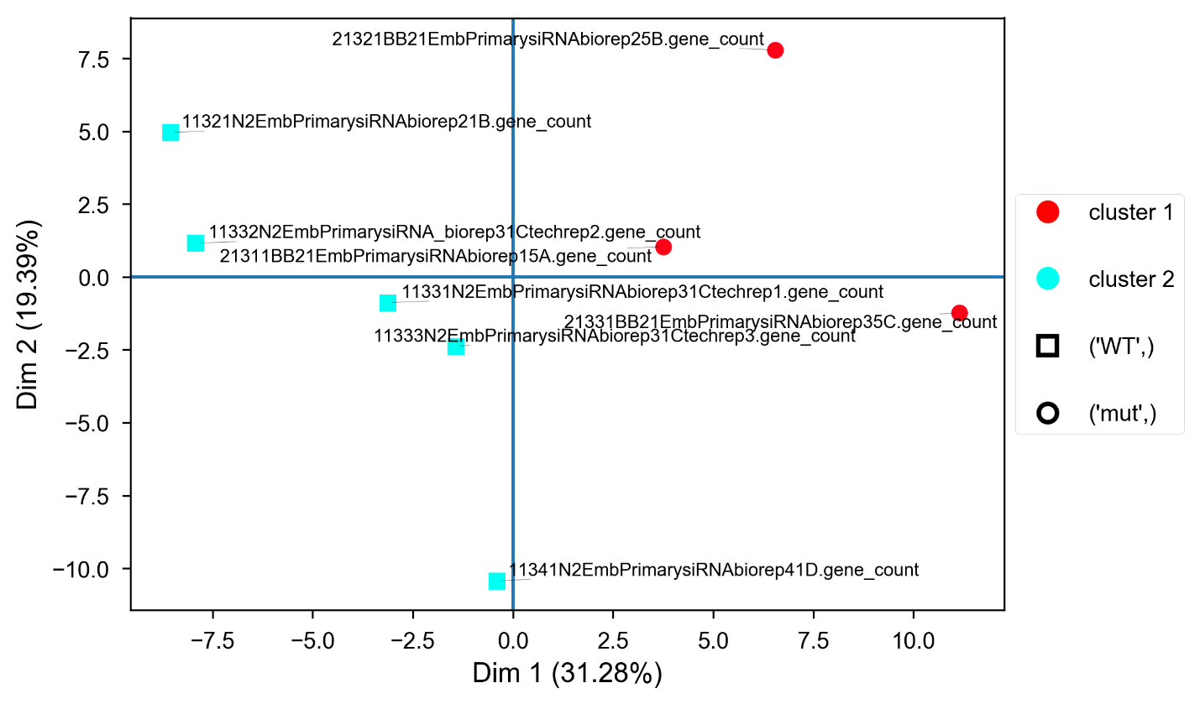

( bisek explanation?, include R script? Heatmap?)

**microRNA Editing:**

The pileup files created from alignment files for the N2 reads were combined into consensus files containing only reads that were in 2/3 biological repeats at least. The resulting consensus file was compared to each of the BB21 repeats, and reads that appeared in both the BB21 and N2 sequences were removed (e.g an A->G mutation in position 5 on a certain mirna that appears in both WT and mutant cells was discarded). After discarding such reads, a file containing only the mismatches was created, mismatches were sorted by type, and counted.

The results were not conclusive, as A->I editing is done by the missing ADAR, and there were not significant differences in the percentage/amount of A->I (which is detected as A->G in sequencing) edits, and other types of editing.