Problem 1: -Design and develop a reprogrammable embedded computer using 8051 Microcontroller.
Solution:
Source Code:

#include<reg51.H>

sbit LED = P2^0;

void Delay(void);

void main(void)
{
while(1)
{
LED = 0;
Delay();
LED = 1;
Delay();
}
}

void Delay(void)
{
int j;
int i;
for(i = 0; i < 10; i++)
{
for(j = 0; j < 10000; j++)
{
}
}
}

Output:

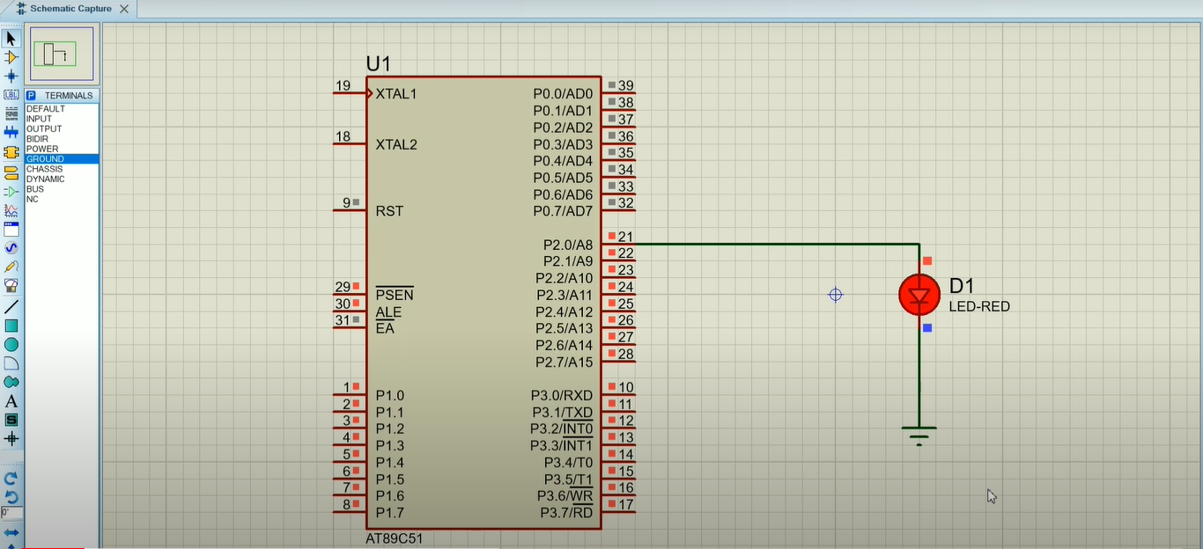

Problem 2(a): - Configure Timer control registers of 8051 and develop a program to generate delay
Solution:
Source code:
#include<reg51.H>

void Delay(void);

void main(void)
{
while(1)
{
P1 = 0xFF; // Make all bits of P1 high
Delay();
P1 = 0x00; // Make all bits of P1 low
Delay();
}
}
void Delay(void)
{
int j;
int i;
for(i = 0; i < 1000; i++)
{
}
for(j = 0; j < 1000; j++)
{
}
}
Output:

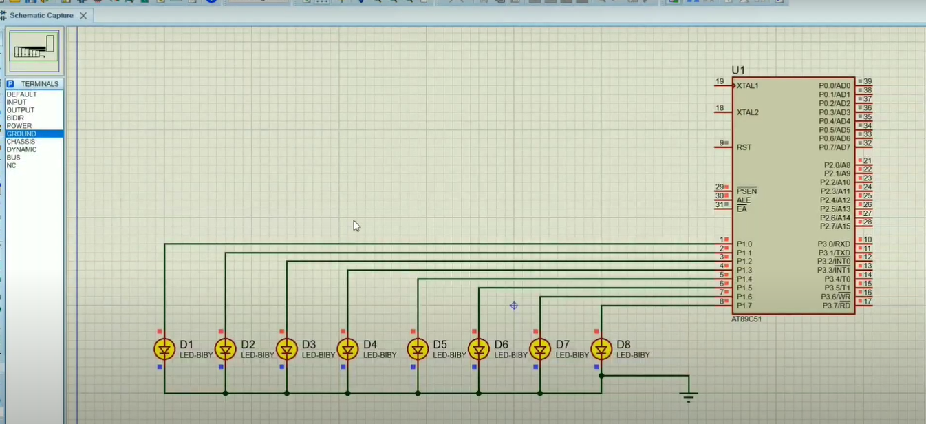

Problem 2(b): - Use of general purpose I/O port of two controllers for data transfer.
Solution:
Source code:
Controller 1-
#include<reg51.h>
void Delay(unsigned int time);
void main(void)
{
P2 = 0xAA;
Delay(1000);
P2 = 0x55;
Delay(1000);
}

void Delay(unsigned int time)
{
unsigned int i,j;
for (i = 0; i < time; i++){
for (j = 0; j < 23; j++){
}
}
}
Controller 2-
#include<reg51.h>
void Delay(unsigned int time);
void main(void)
{
while(1){
P2 = P1;
Delay(1000);
}
}

void Delay(unsigned int time)
{
unsigned int i,j;
for (i = 0; i < time; i++){
for (j = 0; j < 23; j++){
}
}
}

Output:
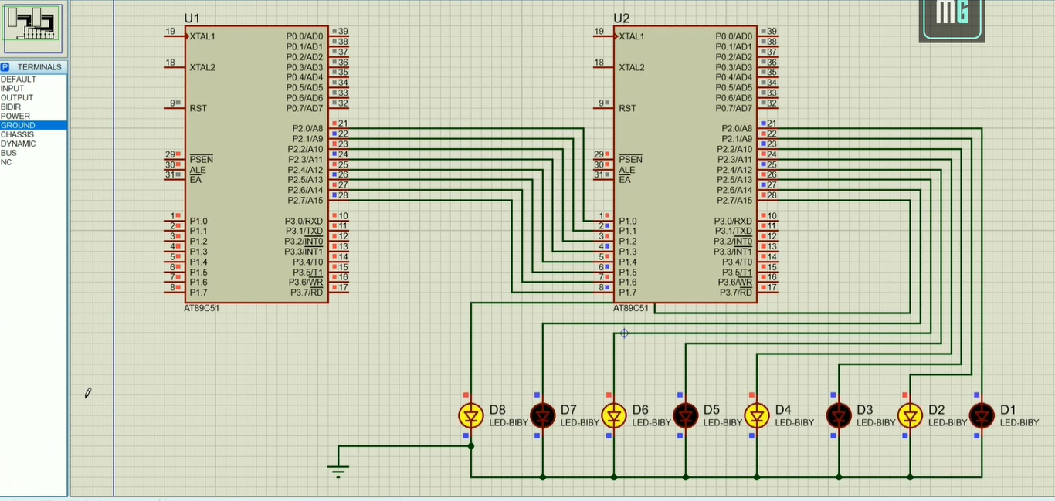

Problem 3(a): Simulate Binary counter (8 bits) on LEDs.
Solution:
Source Code:
#include<reg51.h>
void delay(int time);
void main()
{
P1 = 00000000;
while(1)
{
P1++;
delay(100);
}
}

void delay(int time)
{
int i, j;
for(i = 0; i <= time; i++)
{
for(j = 0; j <= 23; j++)
{
}
}

}

Output:
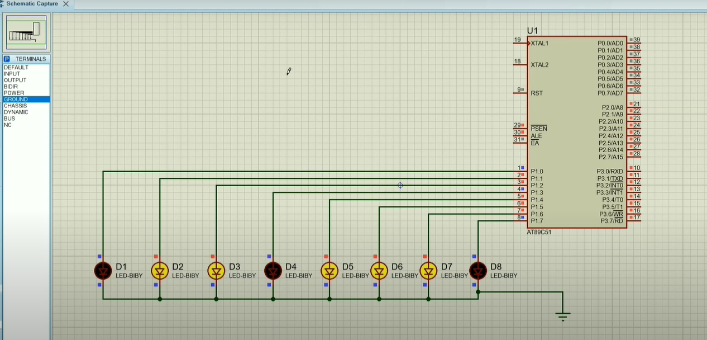

Problem 3(a): To interface 8 LED’s at I/O ports and create different patterns
Solution:
Source Code:
#include<reg51.h>
void delay();

void main()
{
while(1)
{
P1 = 0xAA; // Pattern to turn on alternate LEDs - 10101010
delay();
P1 = 0x55; // Reverse the pattern
delay();
}
}

void delay()
{
unsigned int i, j;
for(i = 0; i < 23; i++)
{
for(j = 0; j < 1000; j++)
{
}
}
}

Output:
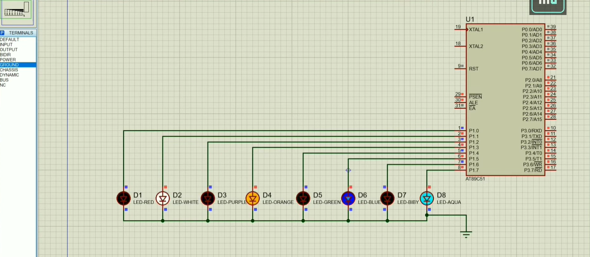

Problem 4(b): To Demonstrate Seven Segment LED Display and Generate counting from 0 to 99
Solution:
Source Code:
#include<reg51.h>
void delay(unsigned int ms)
{
unsigned int i, j;
for(i = 0; i<ms; i++)
{
for(j = 0; j<=1275; j++)
{
}
}
}

void main(void)
{
char number[] = {0x3F, 0x06, 0x5B, 0x4F, 0x66, 0x6D, 0x7D, 0x07, 0x7F, 0x6F};
int i, j;
P2 = 0x00;
P3 = 0x00;
while(1)
{
for(i = 0; i<=9; i++)
{
P2 = number[i];
for(j = 0; j<=9; j++)
{
P3 = number[j];
delay(50);
}
}
}
}

Output:

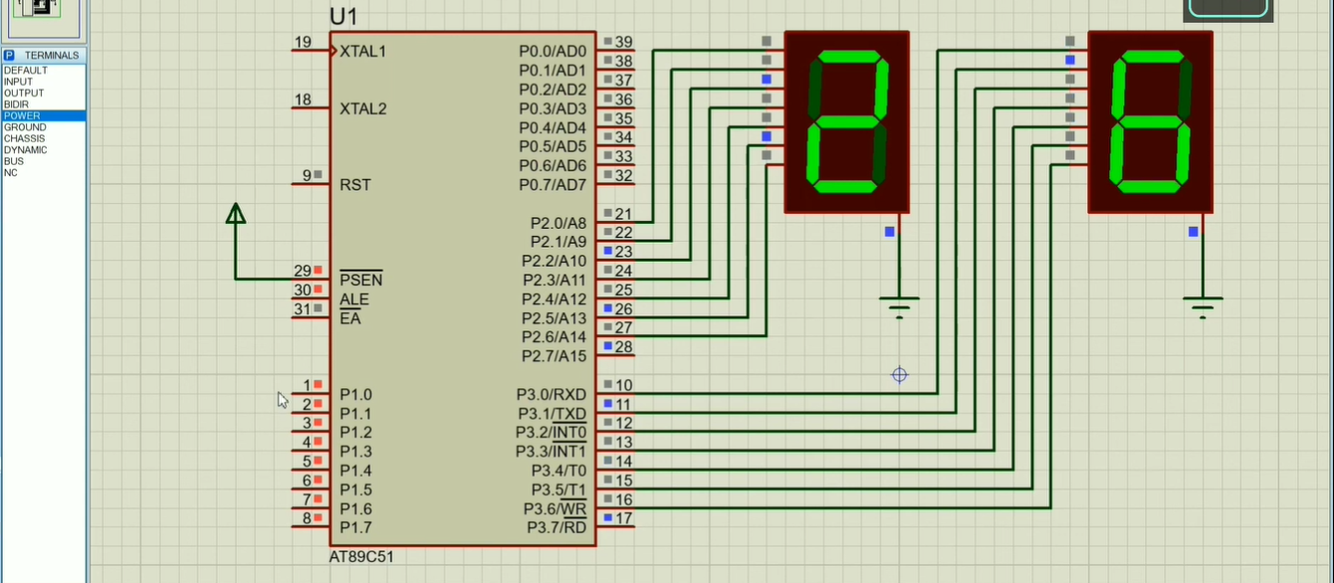

Problem 5: Develop a Program for interfacing stepper motor with 8051
Solution:
Source Code:
#include<reg51.h>
void delay()
{
int i, j;
for(i = 0; i <= 100; i++)
{
for(j = 0; j < 100; j++)
{
}
}
}

void main()
{
while(1)
{
P2 = 0x09;
delay();
P2 = 0x03;
delay();
P2 = 0x06;
delay();
P2 = 0x0C;
delay();
}
}
Output:

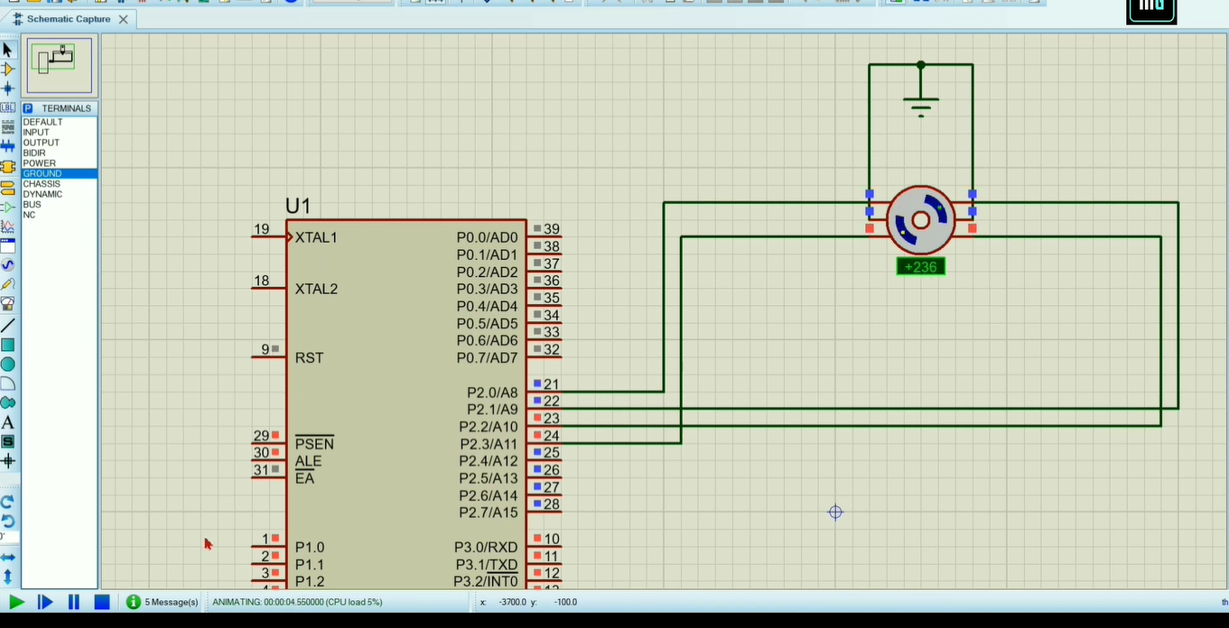

Problem 6: Generate Traffic Light Signal
Solution:
Source Code:
#include<reg51.h>

//signal 1
sbit tl1r = P2^0; // red
sbit tl1o = P2^1; // orange
sbit tl1g = P2^2; // green

//signal 2
sbit tl2r = P2^3; // red
sbit tl2o = P2^4; // orange
sbit tl2g = P2^5; // green

//signal 3
sbit tl3r = P3^0; // red
sbit tl3o = P3^1; // orange
sbit tl3g = P3^2; // green

void delay(int t);
void trafficlight(void);

void main() // main program
{
P1=0x00;
P2=0x00;
P3=0x00;

while(1)
{
trafficlight();
}

}

void delay(unsigned long int t) // delay routine
{
while(t>0)
{
unsigned long int i;
for(i=1;i<10*1275;i++);
t--;
}

}

void trafficlight(void) // traffic light system program

{

P2= 0x11; // traffic signal control
P3= 0x04;

tl1r=1; // signal 1
tl1o=0;
tl1g=0;

tl2r=0; // signal 2
tl2o=1;
tl2g=0;

tl3r=0; // signal 3
tl3o=0;
tl3g=1;

delay(100); // delay

P2= 0x0c; // traffic signal control
P3= 0x02;

tl1r=0; // signal 1
tl1o=0;
tl1g=1;

tl2r=1; // signal 2
tl2o=0;
tl2g=0;

tl3r=0; // signal 3
tl3o=1;
tl3g=0;

delay(100); // delay

P2= 0x22; // traffic signal control
P3= 0x01;

tl1r=0; // signal 1
tl1o=1;
tl1g=0;

tl2r=0; // signal 2
tl2o=0;
tl2g=1;

tl3r=1; // signal 3
tl3o=0;
tl3g=0;

delay(100); // delay

}

Output:

