EstateHub — Smart Real Estate Marketplace

1. Introduction
EstateHub is an AI-powered real estate platform that helps clients find suitable properties and connects them with brokers. Clients can search properties by location, price, size, and type, while brokers can post and manage property listings. The AI assistant understands client requirements in natural language and recommends matching or similar properties from the available database.
1.1 Background Overview
The real estate sector has many property listings, but finding a suitable property can be time-consuming. Most existing platforms mainly depend on manual search and filters. AI can improve this process by understanding user requirements and providing personalized property recommendations.

1.2 Problem Statement
Clients often need to search through many property listings to find a suitable one. Existing systems may require users to manually select multiple filters and may not provide personalized recommendations. EstateHub will reduce this effort by using AI to understand client requirements and find suitable properties from the database.

1.3 Objectives
State the goals of the project.
- General Objective: To develop a user-friendly real estate platform for searching, posting, and managing properties.
- AI Objective: To use AI to understand client requirements and recommend suitable or similar properties.

1.4 Scope
In-Scope:
- Client, Broker and Admin accounts
- Property posting and management
- Search and filter
- Comments and messaging
- Email notifications
- AI property recommendation
- Reviews and admin management

Out-of-Scope:
- Legal property verification
- Physical property inspection
- Real-time property price prediction

AI Scope:
AI will understand user requirements and recommend properties from the available database. It will not verify legal ownership or make financial/legal decisions.

1.5 Stakeholders
- Client: Searches properties and communicates with brokers.
- Broker: Posts and manages property listings and communicates with clients.
- Admin: Manages users, brokers, properties, reviews, reports and Maintains and manages the overall platform.

1.6 Proposed Solution
EstateHub will provide a centralized platform where clients can search properties and directly communicate with brokers. Brokers can create and manage listings, while admins control the platform. The AI assistant will take natural-language requirements from clients and recommend matching properties from the database.
Client → AI Assistant → Property Database → Matching Properties → Client

1.7 AI Features
- Existing AI Features: Some modern real estate platforms use recommendation systems and AI chat assistants, but their features may be limited or not personalized to local property data.
- Proposed AI Features: An AI Property Assistant will accept requirements such as “I need a 3-bedroom flat in Uttara under 80 lakh” and return suitable properties from the database.
- AI Techniques: LLM integration + Natural Language Processing + Rule-based/semantic property recommendation.
- Why AI Is Essential: I AI is a core part of EstateHub because it converts natural-language requirements into property search criteria and provides personalized recommendations, reducing the need for manual searching.

2. System Requirements
- The system shall allow clients, brokers, and admins to create and manage accounts.
- The system shall allow brokers to add, edit, and delete property listings.
- The system shall allow clients to search and filter properties.
- The system shall allow clients to comment and message brokers.
- The system shall send notifications to brokers for new interactions.
- The system shall allow admins to manage users and properties.
- The system shall understand client requirements using AI.
- The system shall recommend matching or similar properties.

3. Tools and Technologies
Category | Technology
Frontend | React.js
Backend | Node.js, Express.js
Programming Language | JavaScript
Database | MySQL
AI | LLM API + NLP
UI | Tailwind CSS
Authentication | JWT / Secure Cookies
Containerization | Docker

4. Project Timeline and Work Plan
Milestone | Main Tasks
Week 1–2 | Set up the project, database schema, backend, frontend, and environment configuration.
Week 3–4 | Implement authentication, role permissions, property CRUD, search, filters, and property details.
Week 5–6 | Build the premium homepage, circular property orbit, responsive navigation, property cards, broker profiles, and animations.
Week 7–8 | Implement comments, private messaging, favorites, reviews, and email notifications
Week 9 | Implement the AI property assistant and similar-property recommendation logic.
Week 10–11 | Implement the admin dashboard, moderation workflows, testing, documentation, and optional Docker support.

Team Work:
Team members will divide the work among Frontend, Backend & Database, AI, and Testing/Documentation.

5. Optional Sections
Existing System
Existing real estate websites mainly provide property listings, search, filters, and broker contact features. EstateHub adds an AI-based natural-language property recommendation system.
System Architecture
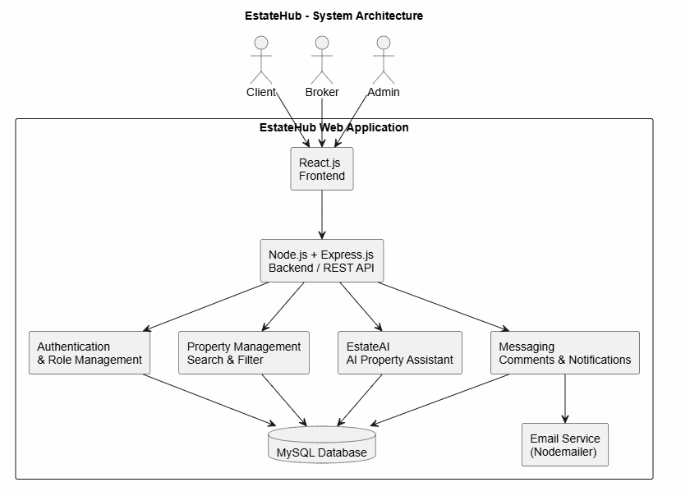
Ethical, Legal & Social Considerations
The system will protect user information and restrict access based on user roles. AI recommendations will use available property data and will not make legal or financial decisions.
Future Work
Future versions may include map-based property search, multilingual/Bangla AI support, virtual property tours, and advanced personalized recommendation models.

