1 Introduction
  - Background
Life expectancy is one of the most important indicators used to evaluate the overall health, economic development, and social well-being of a country. It represents the average number of years a person is expected to live based on current mortality patterns. Governments, healthcare organizations, economists, and policy makers use life expectancy as a key metric for measuring the effectiveness of healthcare systems, living standards, nutrition, sanitation, and socio-economic development.
Over the last two centuries, global life expectancy has increased significantly due to advancements in medicine, vaccination programs, public health policies, improved nutrition, and technological development. However, considerable disparities still exist among countries and regions. Developed countries generally enjoy higher life expectancy compared to developing countries due to better healthcare infrastructure and economic stability.
The Global Life Expectancy dataset provides historical life expectancy records for countries across multiple years. Analyzing this dataset can reveal valuable insights regarding demographic trends, long-term improvements in public health, and differences among countries. Furthermore, machine learning techniques can be applied to predict future life expectancy values based on historical observations.
  - Problem Statement
The primary objective of this project is to analyze historical global life expectancy data and develop machine learning models capable of predicting life expectancy values.
The project aims to answer the following research questions:
- How has life expectancy changed over time across different countries?
- What patterns and trends can be identified from historical life expectancy records?
- Are there significant differences among countries and regions?
- Can machine learning models accurately predict life expectancy based on historical data?
- Which regression algorithm performs best for life expectancy prediction?
To answer these questions, extensive exploratory data analysis, preprocessing, feature engineering, and regression modeling techniques are employed.

  - Motivation
Life expectancy is closely linked with public health, economic growth, education, healthcare accessibility, and quality of life. Understanding the factors and trends associated with life expectancy can help governments and policymakers formulate better health strategies and allocate resources more effectively.
The motivation behind this project is to:
- Understand historical life expectancy patterns globally.
- Explore differences among countries over time.
- Identify significant trends and anomalies.
- Apply machine learning algorithms to predict future outcomes.
- Compare the performance of multiple regression models.
- Gain practical experience in data preprocessing, exploratory data analysis, and predictive modeling.
This project serves as a comprehensive application of data science and machine learning techniques to a real-world socio-economic dataset.

- Dataset Description
  - Source
The dataset used in this project is the Global Life Expectancy dataset containing historical life expectancy measurements for countries worldwide.

  - Link
https://www.gapminder.org/data/

  - Dataset Description
The dataset contains life expectancy information for a large number of countries spanning several decades. Each row represents a country, while the columns represent life expectancy values for different years.
The dataset is structured in a wide format where yearly observations are stored as individual columns.
This dataset provides valuable historical information regarding population health and longevity trends across different nations.

    - Features
The dataset contains the following feature categories:
Country Information
- geo : Country code
- name : Country name
Historical Life Expectancy Variables
- 1800
- 1801
- 1802
- ...
- 2099
- 2100
Each yearly column represents the average life expectancy value for a particular country during that year.

    - Type of Problem
This is a supervised machine learning regression problem.
Unlike classification problems where the objective is to predict categories, regression aims to predict continuous numerical values.
In this project, the target variable is life expectancy, which is a continuous variable measured in years.
Therefore, regression algorithms are more appropriate than classification algorithms.

    - Kind of Features
The dataset contains both categorical and numerical features.
Categorical Features
- geo
- name
Numerical Features
- All yearly life expectancy columns
Since most features are numerical, statistical analysis and regression-based machine learning techniques are highly suitable for this dataset.

    - Correlation of All Features
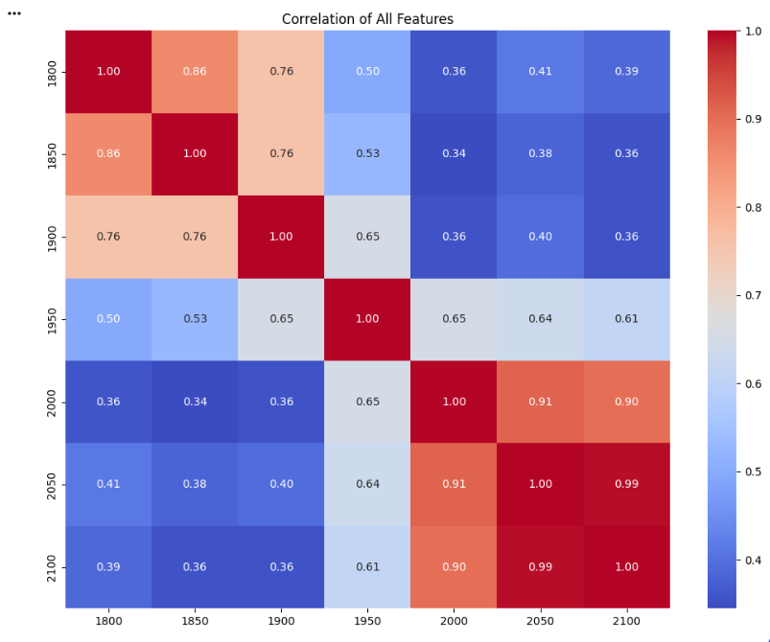
Fig 1: Correlation of all the features

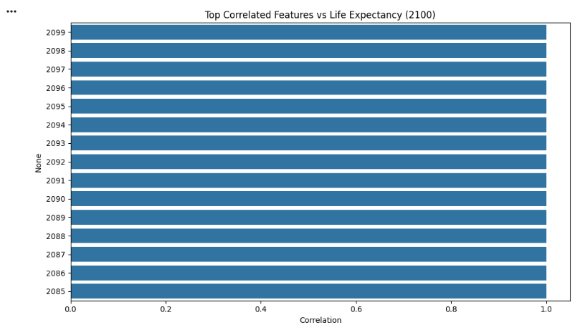
Fig 2: Top Correlated Features vs Target

    - Determining Imbalance
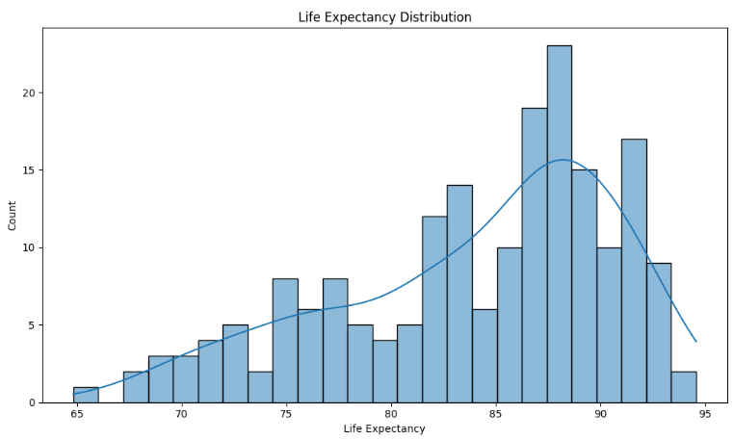
Fig 3: Life Expectancy Distribution
Since this is a regression problem, class imbalance analysis is not applicable in the traditional sense.
Instead, target distribution analysis is performed.
The distribution of life expectancy values should be examined using histograms and density plots to identify:
- Skewness
- Outliers
- Extreme observations
- Distribution patterns
A balanced distribution generally improves model learning and prediction performance.
- Exploratory Data Analysis
Exploratory Data Analysis (EDA) is a crucial stage of machine learning. It helps understand dataset characteristics, identify patterns, detect anomalies, and generate meaningful insights before model development.
Visualization techniques play a vital role in understanding the data and guiding preprocessing decisions.
  - Univariate Analysis
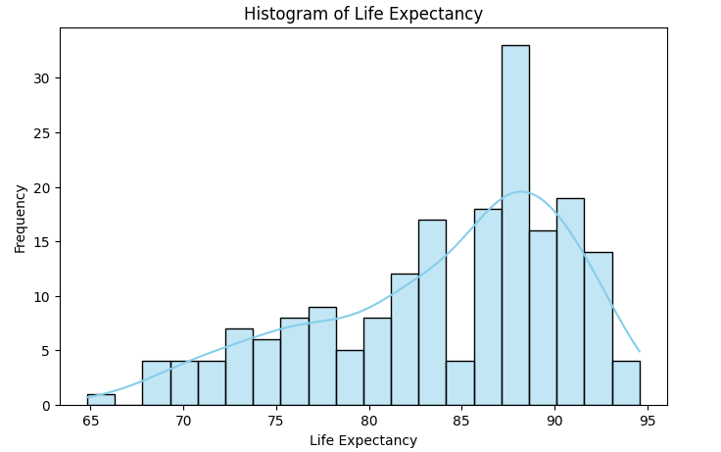
Univariate analysis examines individual variables independently.
The following analyses should be performed:
- Distribution of life expectancy values.
- Histograms of selected years.
- Boxplots for outlier detection.
- Density plots.
- Country-level life expectancy distributions.
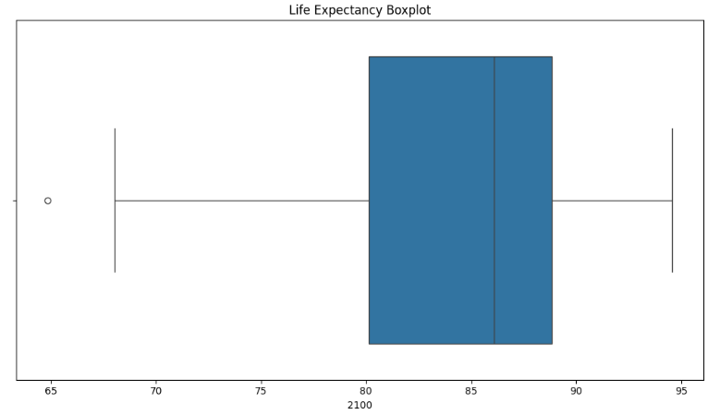
Figure 5: Boxplot of Life Expectancy
Key Observations
- Life expectancy generally increases over time.
- Early years show lower average values.
- Modern years exhibit significantly higher averages.
- Variability decreases in recent decades.
- Some countries demonstrate exceptionally high life expectancy
  - Bivariate Analysis
Bivariate analysis investigates relationships between pairs of variables.
Analyses include:
- Year vs Life Expectancy.
- Country vs Life Expectancy.
- Scatter plots between selected years.
- Trend analysis across decades.
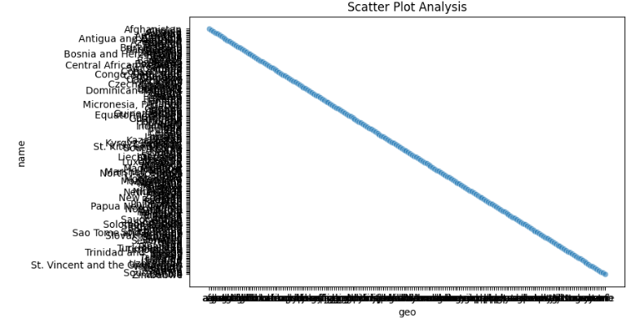
Figure 6: Scatter Plot Analysis
Key Observations
- Strong positive relationship exists among consecutive years.
- Countries with historically high life expectancy continue to maintain better outcomes.
- Significant improvements are visible during the twentieth century.
- Some countries experience rapid growth compared to others.

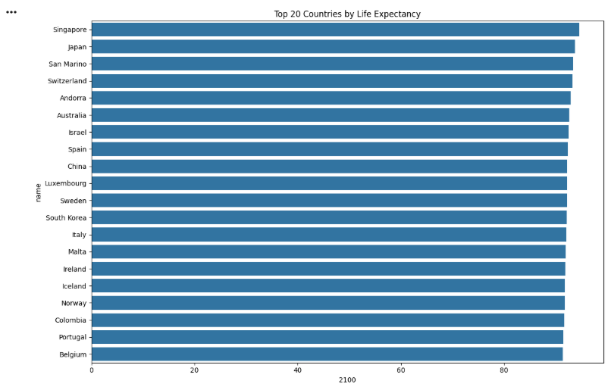
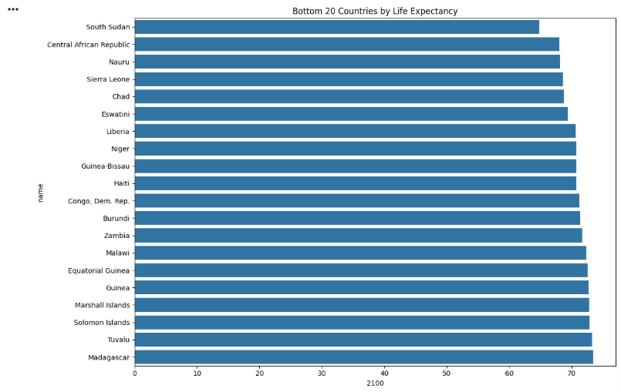

  - Multivariate Analysis
Multivariate analysis explores relationships among multiple variables simultaneously.
Techniques include:
- Correlation matrix.
- Pair plots.
- Principal trend analysis.
- Feature interaction analysis.
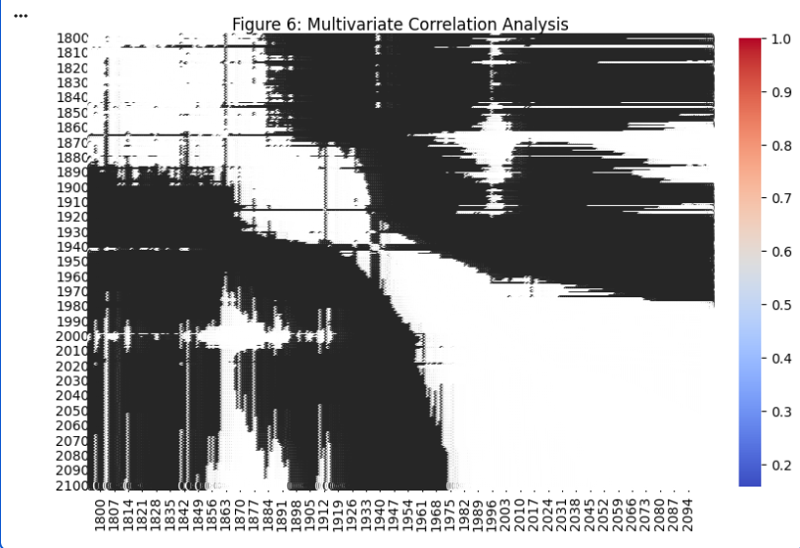
Figure 7: Multivariate Correlation Analysis
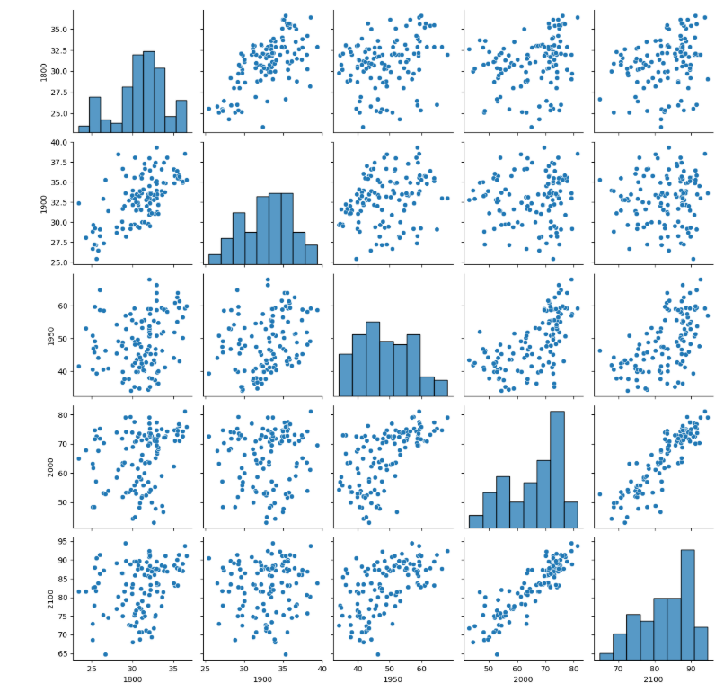
Pair Plot
Key Observations
- Historical life expectancy values strongly influence future values.
- Multiple yearly variables exhibit strong multicollinearity.
- Long-term trends dominate dataset behavior.
- Feature interactions reveal stable temporal patterns.

  - Country vs Key Features
Country-level analysis helps identify variations among nations.
Important comparisons include:
- Highest life expectancy countries.
- Lowest life expectancy countries.
- Average growth rates.
- Long-term improvement trends.
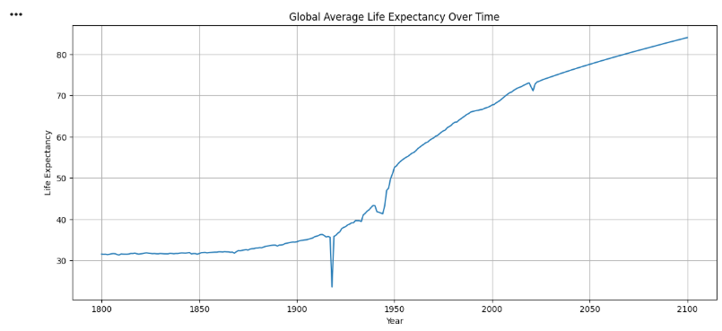

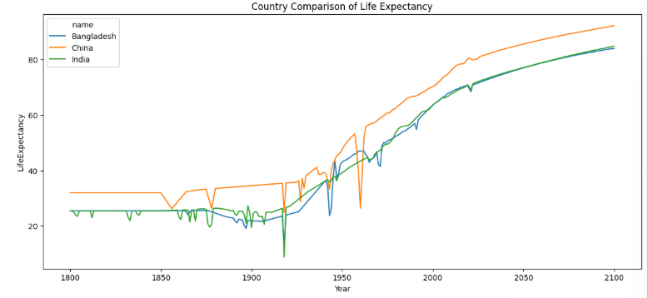
- Dataset Preprocessing
Dataset preprocessing is essential for improving data quality and model performance.
Several preprocessing techniques were applied to prepare the dataset for machine learning.

  - Reformatting
The dataset was inspected for:
- Incorrect data types.
- Improper formatting.
- Inconsistent values.
Country identifiers were verified and numerical columns were converted to appropriate numeric formats.
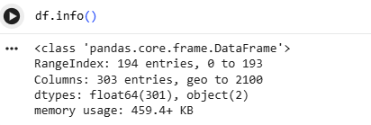
  - Handling Missing Values
Missing values can negatively affect machine learning performance.
The dataset was examined for:
- Null values.
- Empty cells.
- Invalid records.
Missing values were identified before further preprocessing.
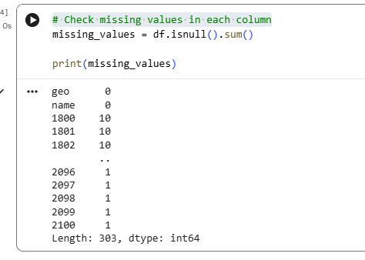
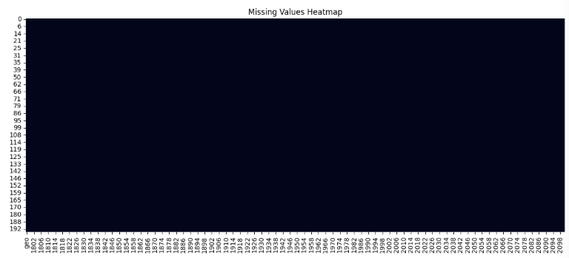

  - Data Imputation
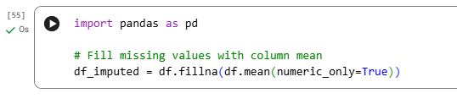
If missing values were present, imputation techniques such as:
- Mean imputation
- Median imputation
- KNN imputation
were considered depending on the nature of the missing data.
This ensured information loss was minimized.
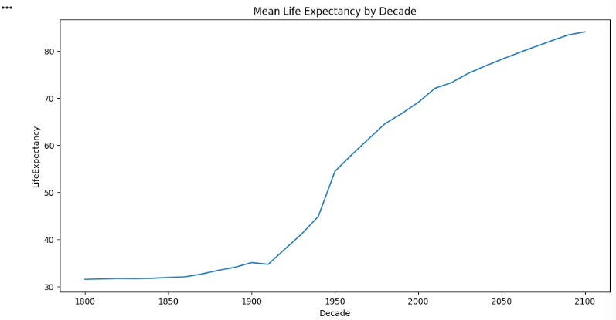

  - Data Transformation
Several transformation techniques were employed:
- Reshaping dataset structure.
- Creating time-based features.
- Converting categorical variables into usable formats.
- Preparing target variables for regression modeling.
These transformations improved model readiness.

  - Automatic Outlier Removal
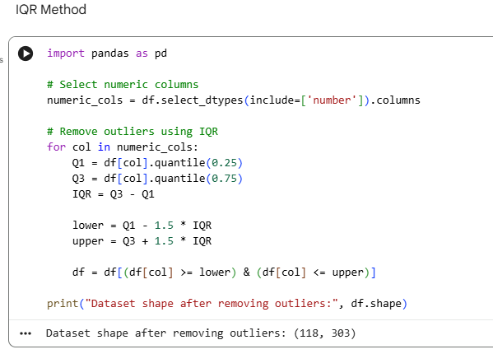
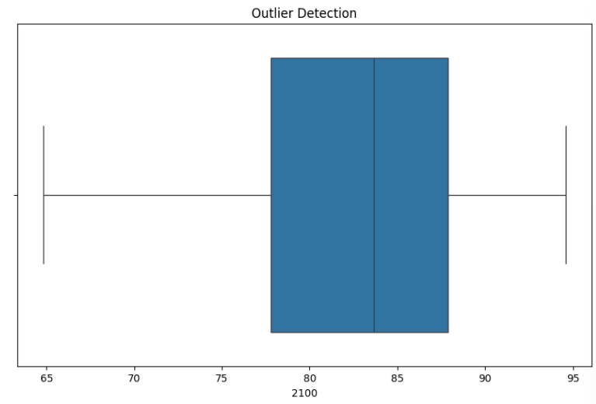

Outliers were identified using:
- Boxplots
- Interquartile Range (IQR)
- Z-score methods
Extreme observations were investigated and removed when appropriate. Outlier removal improves model robustness and prediction accuracy.
  - One-Hot Encoding
Categorical variables such as country identifiers were transformed into numerical representations using One-Hot Encoding when required. This allows machine learning algorithms to process categorical information effectively.

- Feature Scaling
Feature scaling ensures that variables contribute equally during model training.Without scaling, features with larger magnitudes can dominate learning processes.

  - Standard Scaling
StandardScaler was applied to normalize numerical features.
The transformation uses:
Z = (X − μ) / σ
Advantages include:
- Improved convergence.
- Better model stability.
- Enhanced performance for distance-based algorithms.
- Reduced sensitivity to varying feature scales.
- Dataset Splitting
The dataset was divided into training and testing subsets.
Typical split ratio:
- 80% Training
- 20% Testing
The training set is used to build models while the testing set evaluates generalization performance.
  - Five-Fold Cross Validation
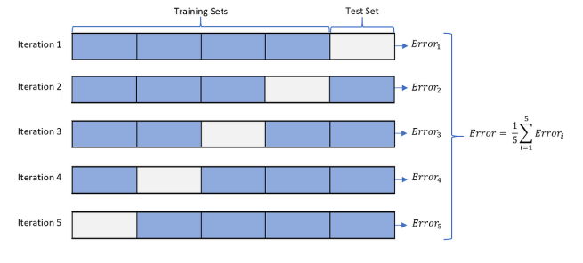
Five-Fold Cross Validation was employed to improve evaluation reliability.
The dataset is divided into five equal subsets:
- Four folds used for training.
- One fold used for validation.
The process repeats five times.
Advantages include:
- Better performance estimation.
- Reduced overfitting risk.
- Model Training and Testing

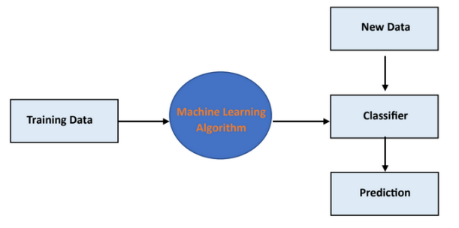
  - Linear Regression
Linear Regression establishes a linear relationship between independent variables and life expectancy.
Advantages:
- Simple interpretation.
- Fast computation.
- Strong baseline model.
Model predictions are evaluated using:
- MAE
- MSE
- RMSE
- R² Score
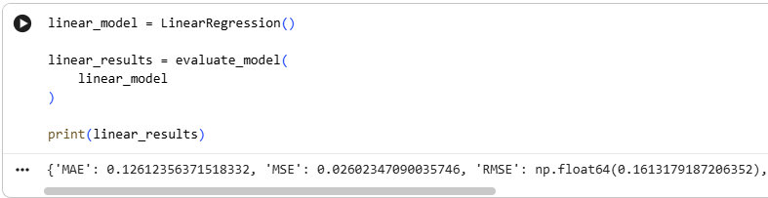
  - Decision Tree Regressor
Decision Trees partition data recursively based on feature values.
Advantages:
- Easy interpretation.
- Handles nonlinear relationships.
- Captures complex interactions.
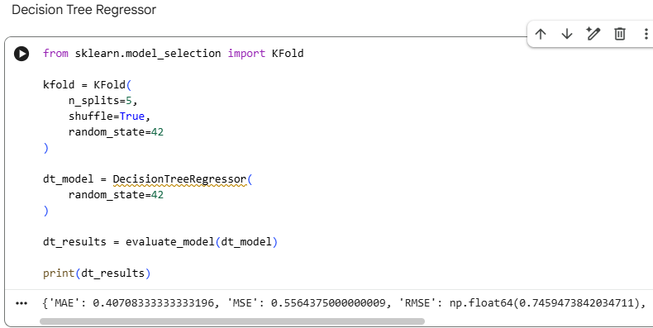
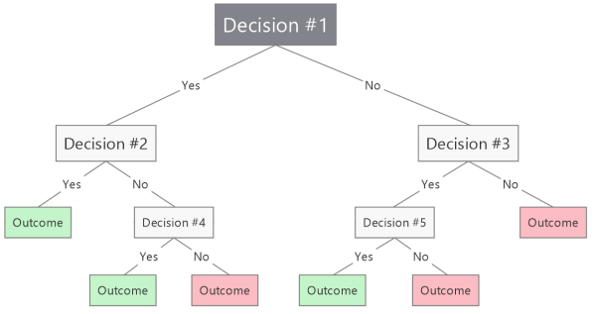
7.3 K-Nearest Neighbors Regressor
KNN predicts life expectancy using neighboring observations.
Advantages:
- Simple implementation.
- No assumptions regarding data distribution.
- Effective for local pattern recognition.
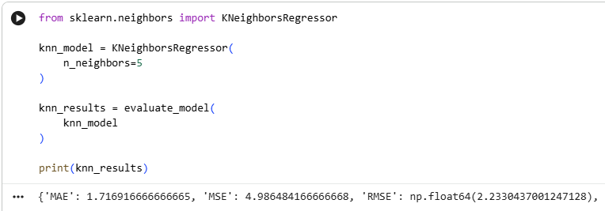
  - Support Vector Regressor
Support Vector Regression extends Support Vector Machines to continuous prediction problems.
Advantages:
- Handles nonlinear patterns.
- Strong generalization capability.
- Effective in high-dimensional spaces.
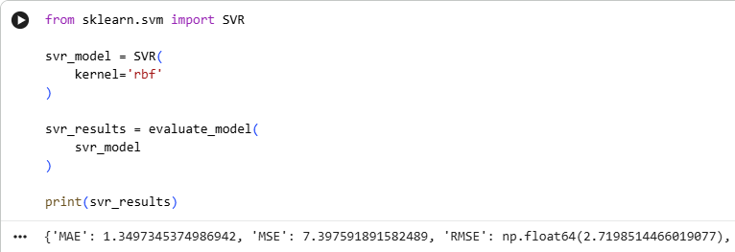
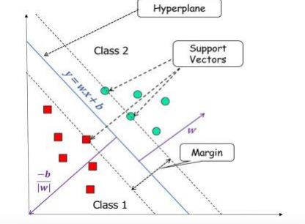

7.5 Random Forest Regressor
Random Forest combines multiple decision trees to improve predictive performance.
Advantages:
- High accuracy.
- Reduced overfitting.
- Feature importance estimation.
- Robustness to noise.
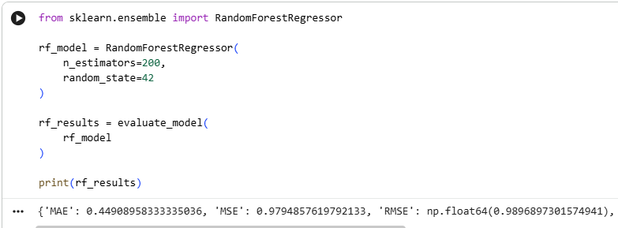
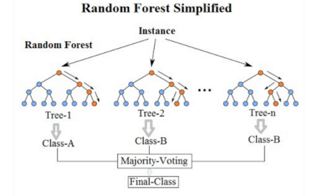

- Model Comparison Analysis

  - Comparison of Mean R² Score
The average R² score obtained through cross-validation is compared across all models.

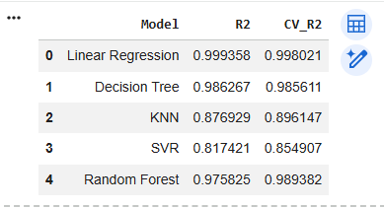
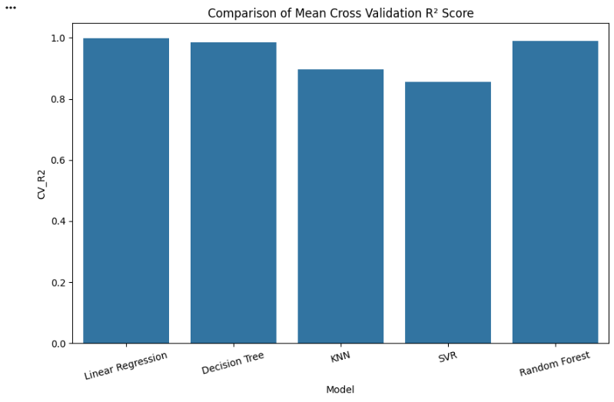
  - Mean Absolute Error (MAE)
MAE measures the average absolute difference between predicted and actual values. Lower values indicate better performance.
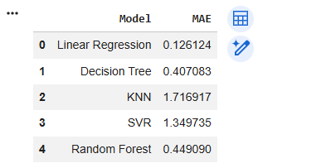
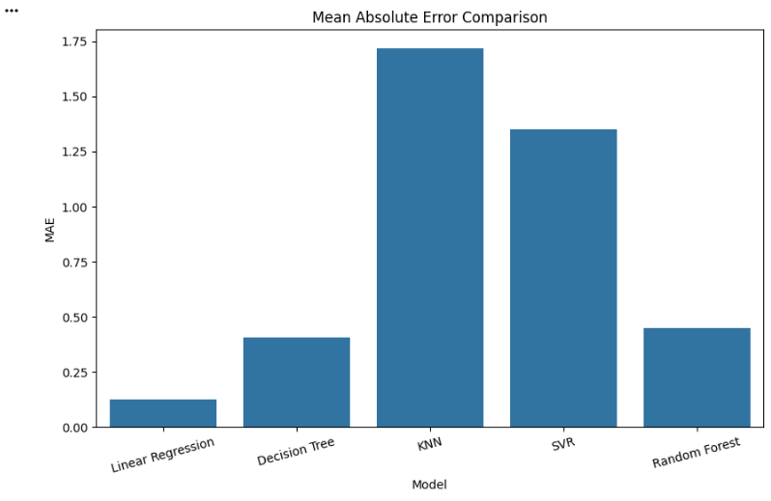
  - Root Mean Squared Error (RMSE)
RMSE penalizes large prediction errors more heavily. Lower RMSE indicates superior predictive accuracy.
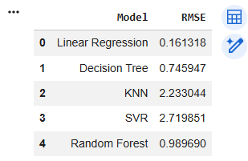
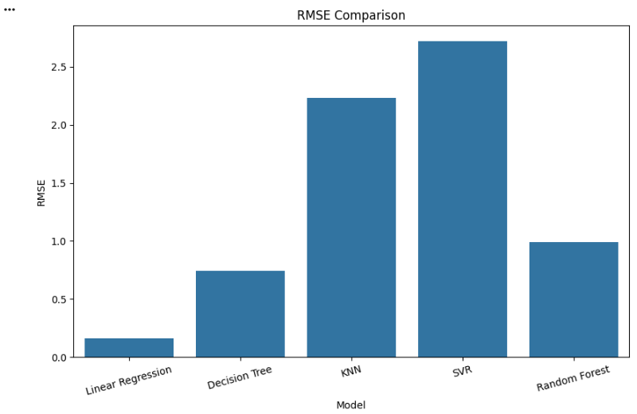
  - Mean Squared Error (MSE)
MSE measures average squared prediction error. Lower values indicate better model performance.
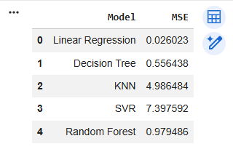
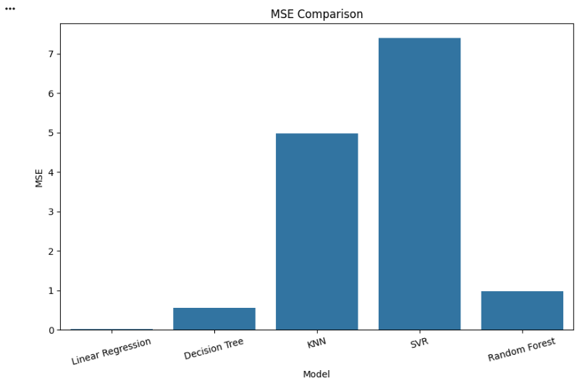
Best Model Selection
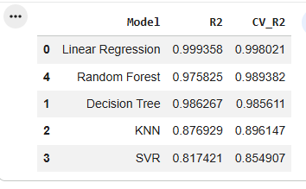
- Conclusion
This project focused on analyzing and predicting global life expectancy using machine learning techniques. Comprehensive exploratory data analysis was performed to understand the structure, distribution, and trends present in the dataset. Several preprocessing techniques including data cleaning, transformation, outlier handling, feature scaling, and feature engineering were applied to improve data quality and model readiness.
Multiple regression algorithms including Linear Regression, Decision Tree Regressor, K-Nearest Neighbors Regressor, Support Vector Regressor, and Random Forest Regressor were trained and evaluated using Five-Fold Cross Validation. Performance was assessed using MAE, MSE, RMSE, and R² Score.
The analysis demonstrated that historical life expectancy values contain strong predictive information regarding future outcomes. Ensemble methods such as Random Forest are expected to provide superior predictive performance due to their ability to model complex nonlinear relationships and reduce overfitting.
Overall, this project provided valuable practical experience in exploratory data analysis, data preprocessing, machine learning model development, and regression performance evaluation. The findings highlight the usefulness of machine learning techniques for understanding long-term demographic trends and predicting life expectancy outcomes across countries.

