Customer:
i) Create account: Customer can create account just giving user name & password. Email is optional. I used Django Authentications for creating this.

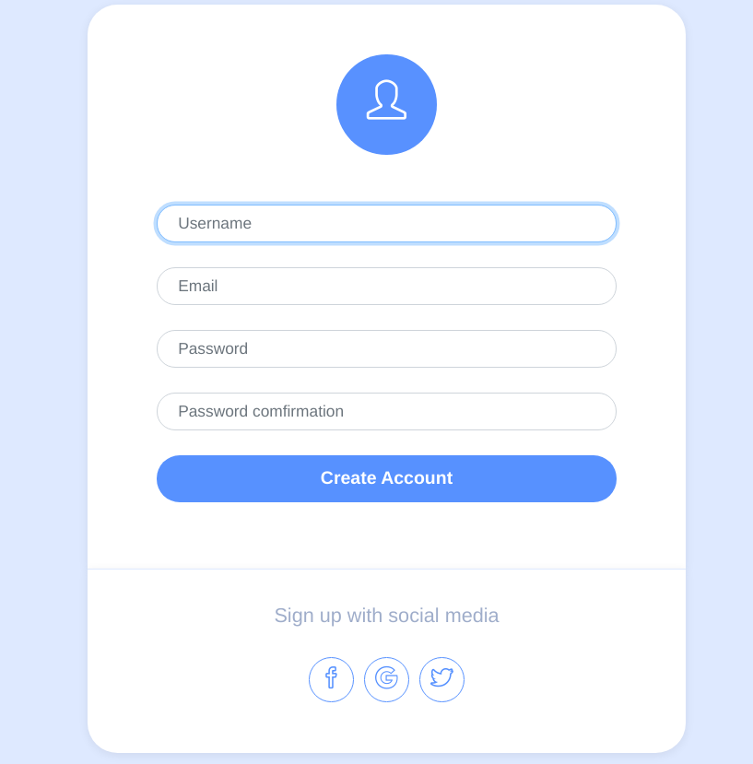

ii) Update account: After login, s/he can edit her/his profile giving first name, last name, email, birth date, address, mobile and a profile pic. I implement this using Django Signals. Customer’s pic will show on top of the form.

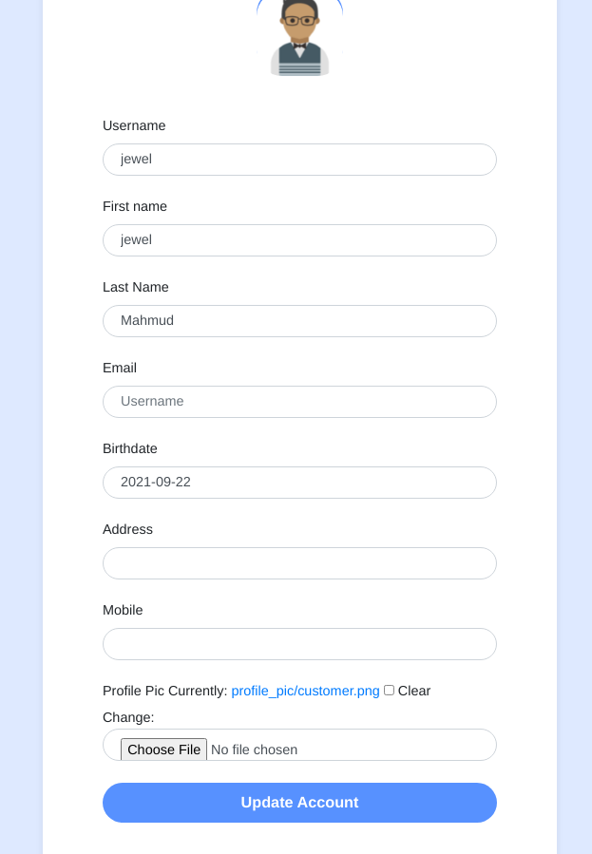

iii) Reset password:

Admin:
i) Create account: An account can be created for admin using python3 manage.py createsuperuser command.

There are some admin’s module
1) Dashboard
2) Customer
3) Products
4) Orders

1) Dashboard: After loging admin can see the total summery like total customer, total products, total orders etc.
2)Customer: In customer’s section admin can see the customer list, edit and delete customer.
3)Products: In products section admin can see the product list, add, edit and delete product.

