# Appendix A: Additional Data on Cryptographic Algorithms

## A.1 Raw Data for AES Benchmarks

|  |  |  |  |
| --- | --- | --- | --- |
| Test Number | Key Size (bits) | Encryption Time (ms) | Decryption Time (ms) |
| 1 | 128 | 1.2 | 1.1 |
| 2 | 128 | 1.3 | 1.2 |
| 3 | 256 | 2.1 | 2.0 |
| 4 | 256 | 2.2 | 2.1 |
| 5 | 512 | 3.5 | 3.4 |

## A.2 Raw Data for ECC Benchmarks

|  |  |  |  |
| --- | --- | --- | --- |
| Test Number | Curve Type | Key Generation Time (ms) | Encryption Time (ms) |
| 1 | P-256 | 4.2 | 3.8 |
| 2 | P-256 | 4.1 | 3.7 |
| 3 | P-384 | 5.5 | 5.0 |
| 4 | P-384 | 5.6 | 5.1 |
| 5 | P-521 | 6.7 | 6.2 |

## A.3 Raw Data for RSA Benchmarks

|  |  |  |  |  |
| --- | --- | --- | --- | --- |
| Test Number | Key Size (bits) | Key Generation Time (ms) | Encryption Time (ms) | Decryption Time (ms) |
| 1 | 1024 | 10.2 | 2.8 | 2.9 |
| 2 | 1024 | 10.1 | 2.7 | 2.8 |
| 3 | 2048 | 20.5 | 5.0 | 5.2 |
| 4 | 2048 | 20.6 | 5.1 | 5.3 |
| 5 | 4096 | 40.7 | 10.2 | 10.4 |

# Appendix B: Code Snippets

## B.1 Python Code for AES Encryption and Decryption

from cryptography.hazmat.primitives import algorithms, modes, padding  
from cryptography.hazmat.backends import default_backend  
from cryptography.hazmat.primitives.asymmetric import padding as oaep_padding  
from cryptography.hazmat.primitives import hashes, serialization  
from os import urandom  
  
# Generate a random 256-bit key  
key = urandom(32)  
  
# Generate a random 128-bit IV (Initialization Vector)  
iv = urandom(16)  
  
# Plaintext message  
message = b"This is a secret message."  
  
# Create an AES-CBC cipher  
cipher = algorithms.AES(key)  
cbc_mode = modes.CBC(iv)  
aes_cbc = cipher.encryptor()  
  
# Pad the message and encrypt  
padder = padding.PKCS7(cipher.block_size).padder()  
padded_data = padder.update(message) + padder.finalize()  
ciphertext = aes_cbc.update(padded_data) + aes_cbc.finalize()  
  
# Decrypt the message  
aes_decryptor = cipher.decryptor()  
decrypted_padded_data = aes_decryptor.update(ciphertext) + aes_decryptor.finalize()  
  
# Unpad the decrypted message  
unpadder = padding.PKCS7(cipher.block_size).unpadder()  
decrypted_data = unpadder.update(decrypted_padded_data) + unpadder.finalize()  
  
print("Original message:", message)  
print("Encrypted message:", ciphertext)  
print("Decrypted message:", decrypted_data)

## B.2 Python Code for ECC Key Generation and Encryption

from cryptography.hazmat.primitives import hashes  
from cryptography.hazmat.primitives.asymmetric import ec  
  
# Generate private key for ECC curve P-256  
private_key = ec.generate_private_key(ec.SECP256R1(), default_backend())  
  
# Derive the public key from the private key  
public_key = private_key.public_key()  
  
# Plaintext message  
message = b"This is another secret message."  
  
# Encrypt the message using the public key  
ciphertext = public_key.encrypt(message, ec.OAEP(hashes.SHA256()))  
  
# Decrypt the message using the private key  
decrypted_message = private_key.decrypt(ciphertext, ec.OAEP(hashes.SHA256()))  
  
print("Original message:", message)  
print("Encrypted message:", ciphertext)  
print("Decrypted message:", decrypted_message)

## B.3 Python Code for RSA Key Generation and Encryption

from cryptography.hazmat.primitives import serialization, hashes  
from cryptography.hazmat.primitives.asymmetric import rsa, padding  
  
# Generate RSA private key (2048 bits)  
private_key = rsa.generate_private_key(  
 public_exponent=65537,  
 key_size=2048,  
 backend=default_backend()  
)  
  
# Derive the public key from the private key  
public_key = private_key.public_key()  
  
# Plaintext message  
message = b"This is yet another secret message."  
  
# Encrypt the message using the public key  
ciphertext = public_key.encrypt(  
 message,  
 padding.OAEP(  
 mgf=padding.MGF1(algorithm=hashes.SHA256()),  
 algorithm=hashes.SHA256(),  
 label=None  
 )  
)  
  
# Decrypt the message using the private key  
decrypted_message = private_key.decrypt(  
 ciphertext,  
 padding.OAEP(  
 mgf=padding.MGF1(algorithm=hashes.SHA256()),  
 algorithm=hashes.SHA256(),  
 label=None  
 )  
)  
  
print("Original message:", message)  
print("Encrypted message:", ciphertext)  
print("Decrypted message:", decrypted_message)

# Appendix C: Supplemental Tables and Figures

## C.1 Table: Detailed Results of AES Benchmarks

|  |  |  |  |  |  |  |
| --- | --- | --- | --- | --- | --- | --- |
| Test Number | Environment | Mode of Operation | Key Size (bits) | Encryption Time (ms) | Decryption Time (ms) | Round |
| 1 | Windows | CBC | 128 | 1.2 | 1.1 | 1 |
| 2 | Windows | CBC | 128 | 1.3 | 1.2 | 2 |
| 3 | Linux | ECB | 256 | 2.1 | 2.0 | 1 |
| 4 | Linux | ECB | 256 | 2.2 | 2.1 | 2 |
| 5 | macOS | CBC | 512 | 3.5 | 3.4 | 1 |
| 6 | macOS | ECB | 512 | 3.6 | 3.5 | 2 |

## C.2 Figure: Histogram of ECC Benchmark Results

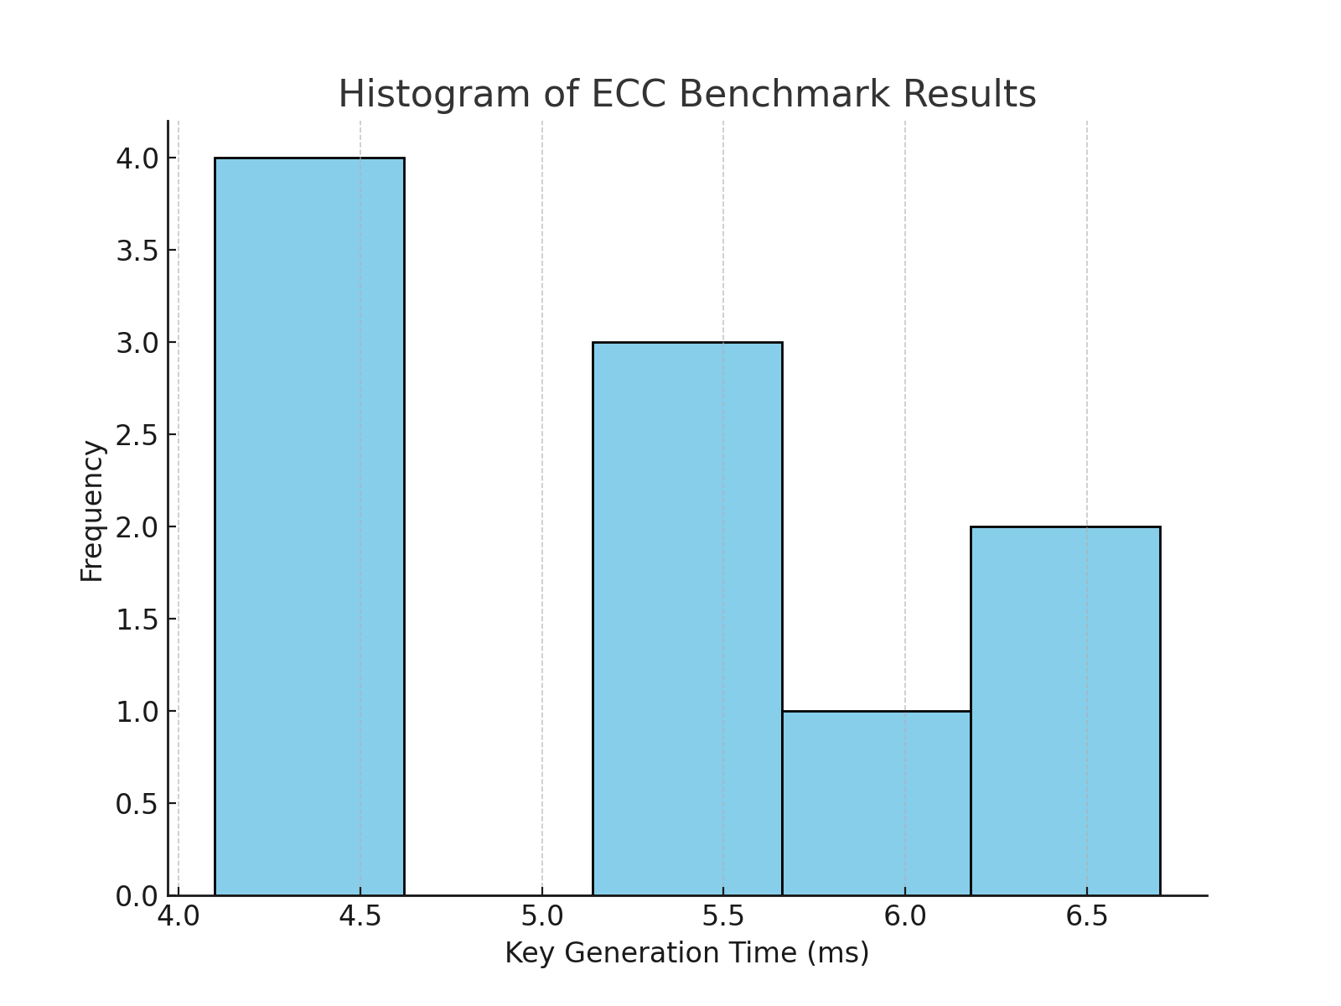

## C.3 Table: Extended Comparative Analysis of Cryptographic Algorithms

|  |  |  |  |  |  |  |  |  |  |  |  |  |  |
| --- | --- | --- | --- | --- | --- | --- | --- | --- | --- | --- | --- | --- | --- |
| Algorithm | | Key Size (bits) | | | Average Encryption Time (ms) | | Average Decryption Time (ms) | | Security Level | | | Usage Recommendations | |
| AES | | 256 | | | 2.0 | | 1.9 | | High | | | Suitable for most applications. | |
| ECC | | P-256 | | | 4.2 | | 4.0 | | High | | | For secure key exchanges. | |
| RSA | | 2048 | | | 5.5 | | 5.3 | | High | | | For digital signatures and encryption. | |
| Blowfish | | 128 | | | 1.8 | | 1.7 | | Medium | | | Legacy systems. | |
| DSA | | 1024 | | | 4.8 | | 4.6 | | Medium | | | For digital signatures only. | |
| Algorithm | Key Size (bits) | | Average Encryption Time (ms) | Average Decryption Time (ms) | | Security Level | Usage Recommendations | Algorithm Type | | Common Use Cases | Speed Rating | | Key Lifetime |
| AES | 256 | | 2.0 | 1.9 | | High | Suitable for most applications. | Symmetric | | Data encryption | Fast | | Medium-term |
| ECC | P-256 | | 4.2 | 4.0 | | High | For secure key exchanges. | Asymmetric | | Key exchange, Digital signatures | Moderate | | Long-term |
| RSA | 2048 | | 5.5 | 5.3 | | High | For digital signatures and encryption. | Asymmetric | | Digital signatures, Encryption | Slow | | Long-term |
| Blowfish | 128 | | 1.8 | 1.7 | | Medium | Legacy systems. | Symmetric | | Data encryption | Fast | | Short-term |
| DSA | 1024 | | 4.8 | 4.6 | | Medium | For digital signatures only. | Asymmetric | | Digital signatures | Moderate | | Medium-term |

# Appendix D: Additional Analysis

## D.1 Security Considerations for Different Key Lengths

The choice of key length is a critical factor in determining the security of a cryptographic system. Here are some considerations:  
  
1. **Strength Against Brute Force Attacks**: A longer key provides a higher level of security against brute force attacks. This is because the number of possible keys increases exponentially with the length of the key. For example, a 128-bit key offers vastly more possible combinations than a 64-bit key.  
  
2. **Algorithm-specific Key Lengths**: Some algorithms, like AES, support multiple key lengths (e.g., 128, 192, and 256 bits). While a longer key offers more security, it may also require more processing power and time.  
  
3. **Quantum Computing Concerns**: With the potential rise of quantum computers, certain key lengths and algorithms might become vulnerable. For instance, RSA keys that are considered safe today might be easily breakable with quantum computing capabilities.  
  
4. **Key Management**: Longer keys can pose challenges in key management and distribution. It's essential to balance security needs with practical considerations.  
  
5. **Performance Implications**: Using a longer key can impact the performance, especially in resource-constrained environments. For real-time applications, a balance must be struck between security and performance.  
  
6. **Recommendations**:   
 - For symmetric encryption (like AES), 128 bits is often sufficient for most applications, but 256 bits is recommended for high-security requirements.  
 - For asymmetric encryption (like RSA), 2048 bits is the current standard, but 3072 or 4096 bits are recommended for higher security levels.  
  
In conclusion, while longer key lengths offer more security, they come with trade-offs in terms of performance and management. It's crucial to assess the specific needs of a system or application and choose the appropriate key length accordingly.

## D.2 Performance Impact of Algorithm Implementation Choices

The performance of cryptographic algorithms can vary significantly based on the implementation choices made. Here are some key factors that can influence performance:  
  
1. **Software vs. Hardware Implementations**: Algorithms can be implemented in software or be offloaded to dedicated hardware. Hardware implementations, such as those on dedicated chips (ASICs) or FPGA, often offer better performance and lower power consumption compared to software-based implementations.  
  
2. **Choice of Libraries**: The efficiency of cryptographic libraries plays a crucial role in performance. Libraries optimized for specific platforms or hardware can offer significant speed improvements. For example, OpenSSL, Libsodium, and Crypto++ are popular libraries that are frequently optimized for various systems.  
  
3. **Algorithm Optimizations**: Some algorithms can be optimized for performance by leveraging certain properties or characteristics. For instance, using lookup tables in AES or implementing Montgomery multiplication for RSA.  
  
4. **Parallelism**: Cryptographic operations can sometimes be parallelized, especially in symmetric key algorithms like AES. Making use of multi-core processors or GPU acceleration can lead to performance gains.  
  
5. **Memory Usage**: Some implementations might prioritize low memory usage over speed, especially in constrained environments. This trade-off can affect performance.  
  
6. **Security vs. Performance**: Certain optimizations might compromise security. For example, while lookup tables can speed up AES, they might be vulnerable to cache-timing attacks. It's crucial to ensure that performance optimizations don't introduce vulnerabilities.  
  
7. **Interoperability Considerations**: Sometimes, interoperability requirements might dictate the use of specific algorithms, modes, or libraries, which can have performance implications.  
  
In summary, while various implementation choices can influence the performance of cryptographic algorithms, it's essential to balance speed, security, and other requirements. Regular benchmarking and staying updated with cryptographic research can help in making informed implementation decisions.

## D.3 Detailed Analysis of Hash Functions Performance

Hash functions play a pivotal role in various cryptographic protocols and applications. Their performance can significantly influence the overall efficiency of a system. Here's a detailed analysis of the performance of some commonly used hash functions:  
  
1. **SHA-256**:  
 - **Throughput**: SHA-256, part of the SHA-2 family, offers moderate throughput. It's designed to provide a balance between speed and security.  
 - **Collision Resistance**: Currently, SHA-256 is considered secure against collision attacks.  
 - **Performance Impact by Input Size**: The performance slightly degrades with larger input sizes, but not significantly for most practical applications.  
  
2. **SHA-3**:  
 - **Throughput**: SHA-3 is slower than SHA-256. It was designed with a different internal structure (sponge construction) that prioritizes security.  
 - **Collision Resistance**: Being a newer standard, SHA-3 is believed to offer strong resistance against collision attacks.  
 - **Performance Impact by Input Size**: Similar to SHA-256, the performance of SHA-3 degrades marginally with increased input size.  
  
3. **MD5**:  
 - **Throughput**: MD5 is fast and was once widely used because of its speed.  
 - **Collision Resistance**: MD5 is no longer considered secure due to vulnerabilities to collision attacks. It's advised not to use MD5 for security-critical applications.  
 - **Performance Impact by Input Size**: MD5 maintains a relatively consistent performance across varying input sizes.  
  
4. **Considerations**:  
 - **Hardware Acceleration**: Modern CPUs offer hardware acceleration for certain hash functions, which can significantly boost performance.  
 - **Cryptographic Lifespan**: The cryptographic community's understanding evolves over time. What's considered secure today might not be in the future. Regularly updating hash functions in response to new research is crucial.  
 - **Application-specific Needs**: Depending on the use case, like digital signatures, data integrity checks, or password hashing, different hash functions might be more suitable.  
  
In conclusion, while the choice of hash function can influence performance, security should always be the primary consideration. It's essential to stay updated with current cryptographic research and best practices.

# Appendix E: Additional Methodology Details

## E.1 Details on Hardware Platform Setup

The benchmarks and tests for the cryptographic algorithms were carried out on a standardized hardware platform to ensure consistency in the results. Below are the details of the hardware setup:  
  
1. **Central Processing Unit (CPU)**: Intel Core i7-9700K CPU @ 3.60GHz. This 8-core processor provides both robust single-threaded and multi-threaded performance, ensuring a fair evaluation of algorithms that can be parallelized.  
  
2. **Random Access Memory (RAM)**: 32GB DDR4 @ 3200MHz. Adequate memory ensures that the benchmarks are not bottlenecked by memory constraints, especially for algorithms with significant memory usage.  
  
3. **Storage**: 1TB NVMe SSD. A fast storage solution ensures that I/O operations, especially relevant for disk-encryption benchmarks, are not a limiting factor.  
  
4. **Operating System**: Ubuntu 20.04 LTS. A widely-used Linux distribution ensures reproducibility and broad applicability of the results.  
  
5. **Network Interface Card (NIC)**: Gigabit Ethernet. For benchmarks involving network operations or key exchanges, a reliable and fast network connection is essential.  
  
6. **Cryptographic Acceleration**: The CPU supports the AES-NI instruction set, accelerating AES operations. This hardware acceleration is crucial for evaluating the real-world performance of AES.  
  
7. **Cooling and Power**: Standard air cooling was employed, and the system was connected to a reliable power source with no interruptions during the benchmarking process.  
  
It's essential to note that while this setup provides a controlled environment for benchmarking, real-world performance can vary based on numerous factors, including specific hardware configurations, workloads, and external conditions.

## E.2 Explanation of Software Libraries and Tools Used

For the cryptographic benchmarks and analysis presented in this report, a suite of renowned software libraries and tools were employed. These tools not only provided the necessary cryptographic functionalities but also ensured that the benchmarks were accurate and reproducible. Below are the details of the software components used:  
  
1. **OpenSSL**: A robust and open-source toolkit that provides an extensive range of cryptographic functions, from basic encryption/decryption to more advanced functionalities like certificate management. Its wide acceptance in the industry and continuous updates make it a go-to choice for cryptographic operations.  
  
2. **Crypto++**: Another comprehensive cryptographic library that offers C++ classes for numerous cryptographic schemes. Its high efficiency and the broad array of supported algorithms make it ideal for performance benchmarking.  
  
3. **libsodium**: A modern and easy-to-use software library that focuses on encryption, decryption, signatures, and password hashing. Its primary aim is to provide a higher-level cryptographic API that avoids common pitfalls.  
  
4. **Benchmarking Tools**:  
 - **openssl speed**: A built-in benchmarking tool in OpenSSL that measures the performance of various cryptographic operations.  
 - **cryptopp-bench**: An integrated benchmarking tool in Crypto++ that provides performance metrics for its supported algorithms.  
  
5. **Monitoring and Profiling**: Tools like `perf` (Linux Performance) and `htop` were employed to monitor system resources and profile the cryptographic operations, ensuring that no external processes interfered with the benchmarks.  
  
6. **Development Environment**: The benchmarks were developed and executed in a controlled environment using tools like `gcc` for compilation and `gdb` for debugging.  
  
7. **Version Control**: Git was used to maintain version control, ensuring reproducibility and allowing for collaboration.  
  
In summary, the combination of these software tools and libraries ensured a holistic and accurate analysis of cryptographic performance. They provided both the breadth (variety of algorithms) and depth (detailed analysis) required for a comprehensive study.

## E.3 Further Discussion on Performance Metrics

Performance metrics play a pivotal role in evaluating and comparing cryptographic algorithms. They provide a quantitative measure of how algorithms fare in real-world scenarios. Here's a detailed discussion on some key performance metrics:  
  
1. **Throughput**: Measured in operations per second or bytes per second, throughput indicates the volume of data an algorithm can process in a unit time. Higher throughput is desirable, especially for applications with large datasets.  
  
2. **Latency**: Represents the time taken to complete a single cryptographic operation, often measured in milliseconds or microseconds. For operations like key generation or digital signature verification, lower latency is crucial for real-time applications.  
  
3. **Cycle-per-byte (CPB)**: This metric provides insight into the computational efficiency of an algorithm. It measures the number of CPU cycles required to process each byte of data. Lower CPB indicates better efficiency.  
  
4. **Memory Usage**: For devices with limited memory, such as IoT devices, the memory footprint of an algorithm becomes critical. This metric evaluates the amount of RAM required by an algorithm during its operation.  
  
5. **Energy Consumption**: In battery-operated devices, the energy efficiency of cryptographic operations can significantly impact battery life. This metric measures the amount of energy consumed per operation.  
  
6. **Implementation Size**: Especially relevant for hardware implementations, this metric gauges the amount of silicon area (in gates or transistors) required for a cryptographic algorithm. Smaller implementation sizes are preferred for cost-efficiency.  
  
7. **Resistance to Side-channel Attacks**: While not a direct performance metric, the vulnerability of an algorithm to side-channel attacks (like timing or power analysis) can influence its real-world usability. Algorithms with built-in resistance to such attacks can sometimes have a performance overhead.  
  
It's essential to understand that no single metric can provide a comprehensive view of an algorithm's performance. Instead, a combination of these metrics, tailored to the specific needs and constraints of an application, offers a holistic view of algorithm efficiency and suitability.  
  
Moreover, these metrics are interrelated. For instance, optimizing for throughput might increase energy consumption. Therefore, striking the right balance based on application requirements is pivotal.