Pet-Shop REST API Documentation

# Overview

This is a **Spring Boot REST API** for a **Pet Shop Adoption System** that allows:  
**Pet Management** (creation, listing)  
**User Management** (creation, listing)  
**Adoption Process** (purchasing pets, budget tracking)  
**Purchase History** (tracking successful/failed purchases)

**Base URL:** http://localhost:9111/api

# API Endpoints

|  |  |  |  |
| --- | --- | --- | --- |
| Endpoints | Method | Description | Parametars |
| /pets/create | Get | Creating a single random pet | None |
| /pets/all | Get | Lists all pets in DTO format | None |
| /pets/create-pets/{number?} | Get | Creates multiple pets (default: 20, max: 20) | Number (optional) |
| /users/create | Get | Creating a single random user | None |
| /users/all | Get | Lists all users in DTO format | None |
| /users/create-users/{number?} | Get | Creates multiple users (default: 20, max: 20) | Number (optional) |
| /users/buy | Get | Processes pet purchases | None |
| /history | Get | Returns all purchase logs (successful & failed transactions) | None |

# Response Examples

**1. Create a Pet (**GET /pets/create**)**

**Response:**

**2. List All Pets (**GET /pets/all**)**

**Response:**

**3. Create Multiple Pets (**GET /pets/create-pets/5**)**

**Response:**

It is the same as the previous one but only the newly created

**4. Create a User (**GET /users/create**)**

**Response:**

**5. List All Users (**GET /users/all**)**

**Response:**

**6. Buy Pets (**GET /users/buy**)**

**Success Response:**

**Returns list of only users the successfully bought a pet, with new budget**

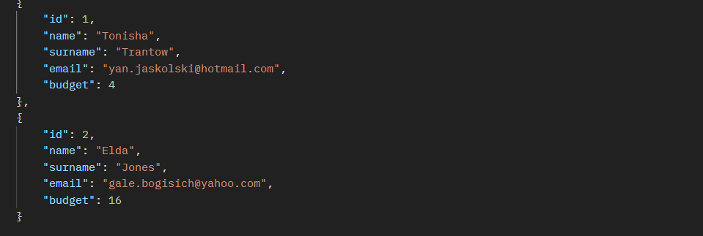

**Error Response (No Users):**

**Error Response (No Pets):**

**7. Purchase History (**GET /history**)**

**Response:**

# Business Logic

**Pet Pricing**

* **Cats:** Price = Age in years
* **Dogs:** Price = Age in years + Random rating (0-10)

**Purchase Rules**

User must have **enough budget**  
 Pet must be **available (no owner)**

# Testing

## Unit Tests

**Repository Layer** (JPA queries)  
 **Service Layer** (business logic)  
 **Controller Layer** (REST endpoints)

# Setup

**Prerequisites**

* Java 17+
* Maven 3.6+

Run

* clone or download and unzip
* open the pom.xml file and load the maven project
* build and start